EU Green Deal and Circular Economy Transition: Impacts and Interactions

Maksym Chepeliev - Center for Global Trade Analysis, Purdue University
Angel Aguiar - Center for Global Trade Analysis, Purdue University
Thomas Farole - The World Bank
Andrea Liverani - The World Bank
Dominique van der Mensbrugghe - Center for Global Trade Analysis, Purdue University

Abstract
Rapidly increasing material extraction is putting major pressure on ecosystems. Future increases in incomes and population could result in over 2.5 times growth in global material demand by 2050, putting even more pressure on environment. Thus, an absolute decoupling of material use from GDP and income is of major importance to preserve the safe operating boundaries. It is vital to understand how current policy efforts, including climate mitigation, could impact material use patterns and what complementary circular economy (CE) policies should be implemented to support dematerialization. Here we develop a special version of the Global Trade Analysis Project (GTAP) database (GTAP-CE) with detailed representation of primary, secondary, and recycling activities for metals (steel, aluminum, copper, etc.) and plastics. We also incorporate quantity flows of metal ores and non-metallic minerals. We investigate a set of scenarios focusing on Europe that include mitigation and CE-specific policies using a dynamic general equilibrium model (ENVISAGE). A set of CE-specific policies includes fiscal measures to stimulate recycling and penalize primary production, extraction levies (for non-metallic minerals), and demand-side measures, such as shifts in consumption patterns toward dematerialization, changes in the product design and product lifetime extensions. We also model various border tax adjustments covering embodied raw materials and consider alternative revenue recycling mechanisms. Our results indicate that EU mitigation measures will have a moderate impact on material use. Similarly, materials-focused measures will have only a modest impact on CO₂ emissions. Aggregate material use in the EU could decline up to 8-11% (relative to baseline in 2030) under alternative CE policies allowing to achieve absolute decoupling. We also find that using CE production taxes’ revenue to reduce labor taxes would lead to increase of growth and welfare.
EU Green Deal and Circular Economy Transition: Impacts and Interactions

1. Introduction
Over the past 70 years, humanity has experienced an unprecedented improvement in the quality of life. Extreme poverty at a global scale has decreased from over 63% in 1950 to less than 10%, the share of literate world population exceeds 86% - a 30 percentage point increase since the mid-20th century and child mortality has fallen by almost 6 times since 1940 (Roser, 2020). These changes have been accompanied with rapid income growth, as global per capita GDP has increased three times since 1960 (WB, 2021).
Constantly growing incomes have substantially increased demand for material goods and therefore materials extraction has grown from 22 billion tons in 1970 to 70 billion tons in 2010 (Schandl et al., 2017). Analyzing a longer time period, Krausmann et al. (2018) show that between 1945 and 2015 global materials extraction has increased over seven times and that the growth rate has accelerated in recent decades. Consistent with these findings, the literature reports a relatively high resource elasticity of GDP, suggesting that 1% increase in GDP leads to around an 0.8% increase in consumption-based material use both in high-income and low-income countries (Haberl et al., 2020; Steinberger et al., 2013), thus providing a rather weak evidence even for existence of a relative decoupling between GDP growth and material use.
Contributing to the improvement of consumers’ wellbeing, rapidly increasing material extraction is putting major pressure on ecosystems (Otero et al., 2020; Marques et al., 2019). According to the report of the International Resource Panel (IRP, 2019), biomass, metals, non-metallic minerals and fossil fuels together are responsible for over 90% of water stress and land-use related biodiversity loss. Future increases in incomes and population could result in over 2.5 times growth in global material demand by 2050, putting even more pressure on the Earth’s ecosystem. Such trends could also put at risk the success of future climate mitigation policies, as materials management is a major contributor of the global greenhouse gas emissions (IRP, 2019). Thus, an absolute decoupling of material use from GDP and income is of a major importance in the context of preserving safe operating boundaries (Steffen et al., 2015).
In this context, it is important to understand how the current policy efforts, in particular, in terms of climate mitigation, could impact material use patterns and what complementary circular economy policies can be implemented to support the transition towards more sustainable consumption practices. To explore this point, in the current study we focus on Europe and, in particular, four Eastern European Member States – Poland, Romania, Bulgaria and Croatia. In a first step, we introduce two major modifications to the GTAP circular economy (GTAP-CE) database that has been initially developed in Chepeliev et al. (2021). First, we implement targeted refinements to the representation of energy inputs to the production process of primary and secondary activities, which allows for a better representation of differences in energy and emission intensities across sectors (Figure 1). Second, we incorporate quantity flows of metal ores and non-metallic minerals to the developed database, thus enabling for an inclusive production- and consumption-based material accounting in terms of volume flows.

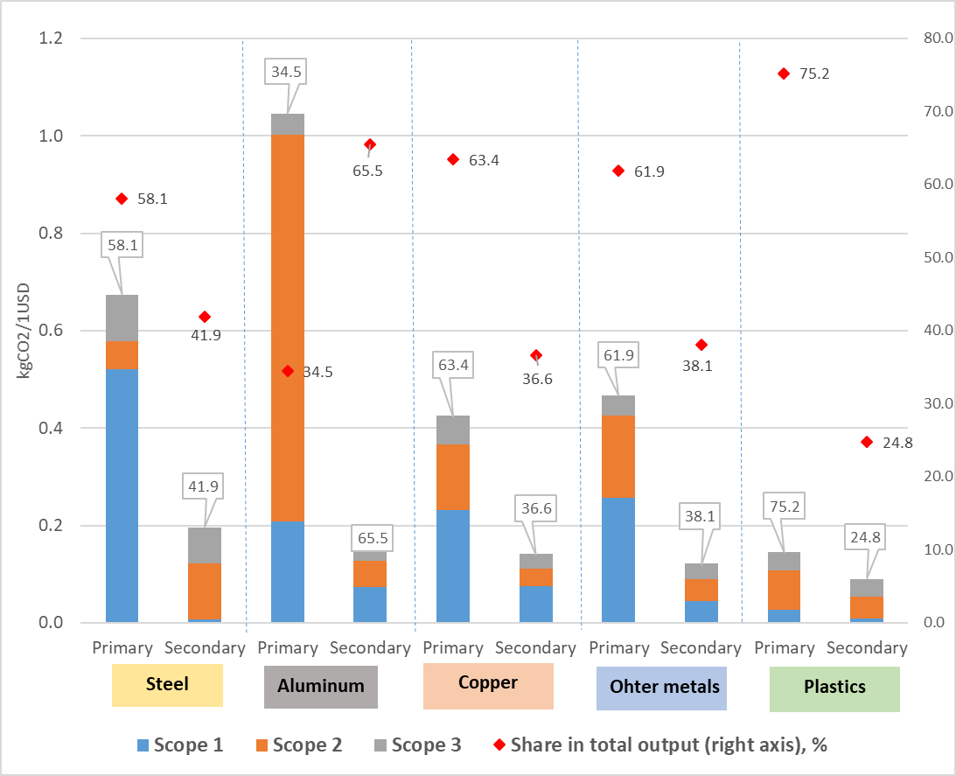
Figure 1. Carbon intensity of metals and plastic production by emission scopes (kgCO2 per 1USD, left axis) and the share of corresponding technology production in total output (%, right axis), EU-27 and UK aggregate
Notes: Only CO2 emission from fossil fuel combustion are reported on the figure. Definition of emission scopes is available at https://www.epa.gov/climateleadership/scope-1-and-scope-2-inventory-guidance

So far, only a handful of EU countries have adopted national resource efficiency or circular economy strategies/action plans (Figure 2). In some cases, especially in the Eastern European developing EU member states, policy makers are not well equipped with sufficient knowledge of the circularity principles and the potential impact of corresponding policies on their national economies (Domenech and Bahn-Walkowiak, 2019). Thus, an assessment of the regional/local measures, including identification of the potential economic implications and policy trade-offs of such transition is of a high importance for policy makers. It is also important to understand how other policy efforts implemented in the EU, such as a more ambitious climate mitigation policies (e.g., ‘fit for 55’ package), would interact with the circularity agenda, as well as how the circular economy measures can be used to complement other existing policy goals.
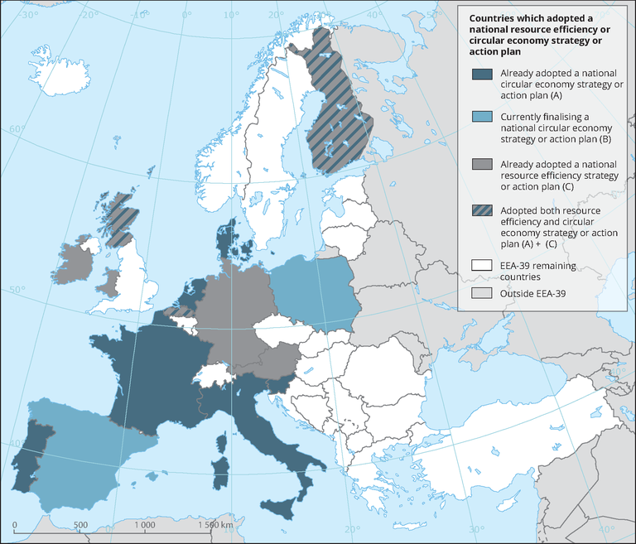
Figure 2. Circular economy strategies or action plans adoption status
Source: EEA (2020).

While most of the existing literature has a global focus (e.g. Winning et al., 2017; McCarthy et al., 2018; Wiebe et al., 2019; Aguilar-Hernandez et al., 2020), future progress in the area of circular economy transition would likely depend on country level actions. To address this point, our analysis focuses on the EU economy and, in particular, four Eastern European Member States – Poland, Romania, Bulgaria and Croatia. We develop a set of policy scenarios that include various climate mitigation and circular economy-specific policies and measures (Figure 3).

Combined scenario
(Combination of fiscal policies and demand-side measures)
Baseline scenario
Business as usual (BAU)
till 2030 -includes NDC mitigation policies
EGD mitigation (EGD-NDC)
Baseline + EU Green Deal emission reduction targets
Climate mitigation policies
EGD-NDC +
Circular economy measures
Circular economy policies
Reducing extraction and production / recycling
(30% tax on primary production + 30% subsidy to secondary production) + sensitivity analysis
Shifting consumer preferences away from materials
(20% reduction in final consumption of materials and compensating increase in other consumption)
Redesign / ‘designing out’ materials
(2% annual reduction in the intermediate use of materials and compensating increase in the use of services)
Extending product lifetime
(20% reduction in the final consumption of manufactured goods and compensating increase in the demand for services)
Extraction levy
(20% tax on mining and imports of non-metallic minerals + export rebate, following practices of selected European countries)
Figure 3. Overview of the scenario assessment framework
Source: Developed by authors.

To provide an assessment of these stylized policy scenarios in a ‘what-if’ type framework, we utilize a global dynamic computable general equilibrium model ENVISAGE (van der Mensbrugghe, 2019). We further investigate implications of the policy measures on various dimensions of economic, social and environmental wellbeing, such as resource productivity, competitiveness, environmental sustainability, inclusion, economic security and developmental impacts. First, the baseline scenario that includes implementation of the Nationally Determined Contributions (NDCs) by countries of the world is constructed. Next, a more ambitious mitigation effort is implemented for the EU, which is consistent with the EU Green Deal emission reduction targets (55% reduction in emissions in 2030 relative to the 1990 level). A set of circular economy-specific measures is implemented next. These include policies toward increased recycling, overall reduction in material use, change in consumption patterns toward dematerialization, change in the product design with an increase in material use efficiency and production life extension. All these measures provide a stylized representation of different aspects of the circular economy transition and thus allow us to quantify their potential impacts and trade-offs within an economy wide modelling framework.
The rest of the chapter is organized as follows. Section 2 provides an overview of the applied methodological framework, including a discussion of the circular economy database that was developed for this study. Section 3 discusses the modelling results. Finally, Section 4 concludes.

2. Methodological framework

2.1. Global Trade Analysis Project (GTAP) circular economy database (GTAP-CE)
For a consistent assessment of the circular economy policies and measures within an economy wide modelling framework, an explicit representation of the corresponding production technologies (i.e., primary, secondary and recycling activities, as well as material use flows (e.g., metal ores, fossil fuels, non-metallic minerals, etc.) is needed. A standard Global Trade Analysis Project (GTAP) Data Base that underlies literally all global CGE modelling efforts, including those focused on the CE policies (e.g., Winning et al., 2017; OECD, 2018; Bibas et al., 2021) does not provide such details (except for the fossil fuel material flows). To overcome this limitation, a specific version of the GTAP database (GTAP-CE) has been developed for the current report.
The GTAP-CE database introduces additional disaggregation of certain GTAP sectors and incorporates material flow accounting for the selected commodities. The starting point for the disaggregation is the GTAP-Power 10 database with 76 sectors, 141 regions and 2014 reference year (Chepeliev, 2020). Four sectors of the original GTAP-Power 10 database are further split into 23 sub-sectors, providing a more detailed representation of categories like metallic and non-metallic minerals mining, rubber and plastic products, iron and steel, as well as non-ferrous metals (Figure 4). Corresponding sectoral splits are developed for all 141 regions reported in the GTAP-Power 10 database.
The GTAP-CE database development process includes five core steps, as outlined on Figure 5. First, data on output quantities is collected from multiple data sources (Appendix A). This data is complemented by the bilateral trade quantities and values from the CEPII BACI database (CEPII, 2021). Trade-based prices are combined with quantities of output to derive the output values by sectors of interest. Second, supply and cost structure assumptions are developed based on various data sources, such as individual country input-output tables, EXIOBASE MRIO and selected studies of the energy intensity of the primary and secondary production activities (Appendix A). The third step, reconciles and harmonizes the data collected in steps 1 and 2 to further develop the targets for the database split (step four). The fourth step implements the database disaggregation procedure, where constructed use and supply structures are incorporated to the GTAP-Power 10 database via the MSPLITCOM utility, which balances the GTAP database using the RAS procedure and preserves the original flows of the underlying GTAP database (Horridge, 2008). Further data adjustments have been implemented using the GTAPAdjust utility (Horridge, 2011). Finally, in the fifth step, we incorporate energy and emission flows to the disaggregated database. We also map the quantity flows of the non-metallic minerals – production (UN, 2020) and bilateral trade accounts (CEPII, 2021) to the constructed database. As a result, the developed database represents value and volume flows of metal ores and metals, non-metallic minerals, fossil fuels and plastic. A detailed overview of the underlying data and assumptions behind the GTAP-CE sectoral splits is provided in Appendix A.

No. | New sector | New sector description | Original sector code | Original sector description
1 | nmn | Non-metallic minerals mining | oxt | Other extraction
2 | mio | Mining of iron ores | oxt | Other extraction
3 | mao | Mining of aluminum ores | oxt | Other extraction
4 | mco | Mining of copper ores | oxt | Other extraction
5 | moo | Mining of other ores | oxt | Other extraction
6 | rbr | Rubber products | rpp | Rubber and plastic products
7 | plp | Plastic products – primary | rpp | Rubber and plastic products
8 | pls | Plastic products – secondary | rpp | Rubber and plastic products
9 | plr | Recycling - plastics | rpp | Rubber and plastic products
10 | isp | Iron and steel – primary | i_s | Ferrous metals
11 | iss | Iron and steel – secondary | i_s | Ferrous metals
12 | ris | Recycling - iron and steel | i_s | Ferrous metals
13 | isc | Iron and steel casting | i_s | Ferrous metals
14 | app | Aluminum – primary | nfm | Non-ferrous metals
15 | aps | Aluminum – secondary | nfm | Non-ferrous metals
16 | ral | Recycling - aluminum | nfm | Non-ferrous metals
17 | cpp | Copper – primary | nfm | Non-ferrous metals
18 | cps | Copper – secondary | nfm | Non-ferrous metals
19 | rcp | Recycling - copper | nfm | Non-ferrous metals
20 | mpp | Other metals – primary | nfm | Non-ferrous metals
21 | mps | Other metals – secondary | nfm | Non-ferrous metals
22 | rom | Recycling - other metals | nfm | Non-ferrous metals
23 | nfc | Non-ferrous metals casting | nfm | Non-ferrous metals
Figure 4. An overview of the sectoral splits introduced to the GTAP-Power 10 database
Source: Developed by authors.

Figure 5. An overview of the GTAP-CE database construction steps
Source: Developed by authors.

2.2. Global computable general equilibrium model ENVISAGE
For the assessment of the climate mitigation and circular economy transition scenarios, we rely on a recursive dynamic global CGE model ENVISAGE (van der Mensbrugghe, 2019). The model follows a circular flow of an economy paradigm. Firms purchase input factors (for example energy, materials, labor and capital) to produce goods and services. Households receive the factor income and in turn demand the goods and services produced by firms. Equality of supply and demand determine equilibrium prices for factors, goods and services. The model is solved as a sequence of comparative static equilibria where the factors of production are linked between time periods with accumulation expressions. Production is implemented as a series of nested constant-elasticity-of-substitution (CES) functions the aim of which is to capture the substitutability across all inputs. Production is also identified by vintage—divided into Old and New—with typically lower substitution possibilities associated with Old capital.
The main strength of the CGE modelling framework, like ENVISAGE, is the consistent representation of the inter-dependencies between different sectors, agents and markets in the economy. By capturing both the supply and demand sides, the model represents adjustments in quantities and prices following the implementation of the policy shock. For instance, if carbon pricing is implemented in the model, this leads to increasing prices of energy, reducing energy supply and demand, as well as corresponding shifts in the energy supply mix, with increasing share of the low-carbon technologies.
The ENVISAGE model is calibrated to the GTAP-CE database discussed in the previous section of this report. For modelling purposes, we use an aggregation of the GTAP-CE database that includes 20 regions and 42 activities (Appendix B). Production of electricity, as well as commodities with identified primary and secondary production activities (metals and plastic) are treated using the MAKE matrix approach of ENVISAGE. In particular, it is assumed that different generation technologies and primary/secondary production activities are producing homogenous goods (e.g., electricity, steel, aluminum, etc.). A version of the ENVISAGE model used in this study includes a wage formation mechanism similar to the Monash-class of models (Dixon and Rimmer, 2002). This approach allows for short-run deviations from full-employment (induced by the policy shock), but long-term equilibrium between labor supply and demand.

3. Potential futures and impacts on material use

3.1. Description of Scenarios
The scenarios are described in Table 1. Apart from shocks in the baseline, all remaining shocks only apply to Europe. The baseline covers the period 2014-2030 with given growth rate assumptions for GDP and population and mostly static fiscal policies. The one exception is that the baseline incorporates the so-called Nationally Determined Contributions (NDCs), which are the commitments made by all countries that signed the 2015 Paris Agreement to limit greenhouse gas emissions. The NDCs are converted to country-specific prices on carbon that depend on a country’s economy and carbon intensity and the stringency of its commitment. Actual implementation of a country’s mitigation policy is likely to rely on one or more instruments, which may include a carbon price.
The actual reference point for the policy simulations, however, is based on a scenario that represents an interpretation of the EU’s Green Deal mitigation target (EGD-NDC). While the Green Deal in practice includes a broad range of environmental objectives and instruments (EC, 2019), the modelled EGD-NDC scenario focuses on achieving the EU’s enhanced NDC target of reducing CO₂ emissions by 55 percent by 2030 relative to the 1990 level (compared to 40 percent in the BAU scenario). Again, the model achieves the target primarily through a carbon price, although several fiscal policies are implemented within the EGD-NDC scenario to complement carbon pricing, including: removal of production subsidies to fossil fuels and transportation activities (production tax rates are set to 3 percent); increase in the sales tax for petroleum products (by 5 percent); and, subsidy to renewable generation (5 percent). Thus, the reference scenario in the model incorporates emissions reduction policy but no explicit measures targeting reduction of material use.
The main scenarios are structured around reduction of primary material use in the EU – i.e., improving circularity. These are specified in Table 1. Apart from BAU scenario, all policy shocks introduced in the scenarios apply only to the EU. They are introduced from 2023 and fully implemented by 2027.

Table 1: Definition of scenarios considered
Policy objective | Scenario name | Description
BAU |  | Initial scenario, which includes interpretation of global NDCs and implemented with carbon prices
EGD-NDC  =Reference scenario |  | BAU plus an interpretation of EU’s NDC commitment under the EU Green Deal intended to lead to a 55% reduction in EU CO₂ emissions in 2030 relative to 1990 and implemented with carbon prices
Reducing extraction and production / recycling | MetalFF-tax | EGD-NDC plus 30% tax on primary production of metals and plastics in Europe only.
Reducing extraction and production / recycling | MetalFF-tax*labor | (sub-scenario) MetalFF-tax with recycling of all additional tax revenue (from taxing primary production of metals and plastics) via reducing labor taxes (uniform reduction across all sectors)
Reducing extraction and production / recycling | MetalFF- subsidy | EGD-NDC plus a 30% subsidy on secondary production of metals and plastics in Europe only
Reducing extraction and production / recycling | MetalFF-total | EGD-NDC plus a 30% tax on primary production of metals and plastics and a 30% subsidy on secondary production of metals and plastics in Europe only
Reducing extraction and production / recycling | MetalFF-total*BAT | MetalFF-total with border adjustment tax based on the content of primary metals and plastic embedded into imports of manufactured goods plus a subsidy to exporters to offset the impact of the primary materials tax on the value of materials embedded in export products
Reducing extraction and production / recycling | NMN-tax | EGD-NDC plus 20% tax on mining and imports of non-metallic minerals (construction materials), with rebate for exports
Reducing extraction and production / recycling | NMN-tax*BAT | NMN-tax with border adjustment tax based on the content of non-metallic minerals embedded into imports of manufactured goods plus a subsidy to exporters to offset the impact of the primary materials tax on the value of materials embedded in export products
Redesign / ‘designing out’ materials | Design | EGD-NDC plus an improvement in the efficient use of materials in 6 activities (wood and paper products, primary and secondary plastics, metal casting, other manufacturing and construction) in Europe only. The improvement in materials use affects the use of wood and paper products, chemicals, plastics, plastic re-cycling, non-metallic minerals, iron and steel, recycled steel, aluminum, recycled aluminum, copper, recycled copper, other metal products, recycled other metals, metal casting products and other manufacturing. The improvement is 2% per year starting in 2023. These improvements are compensated by increasing use of other services per unit of output due to higher R & D, design, etc. expenditures.
Extending product lifetime | Extend | EGD-NDC plus a 20% reduction in the final consumption of other manufacturing with respect to EGD-NDC, achieved by an increase in the consumption of other services, in Europe only (demand for all other categories is fixed at the EGD-NDC level.)
Shifting consumer preferences away from materials | PrefShift | EGD-NDC plus a 20% reduction in the final consumption of material goods (including fossil fuels) achieved through changes in preferences (via phantom taxes) in Europe only. In this scenario, there is a compensating increase in the consumption of other (non-material) goods.
Combined |  | Combines MetalFF-tax + NMN-tax + Design + Prefshift scenarios

The first set of scenarios focuses on reducing extraction and production using primary materials and considers various fiscal policy approaches. For metals (e.g. steel, aluminium, copper) and plastics, the scenarios assess policies whereby a tax is imposed on primary production (MetalFF-tax), a subsidy is granted to secondary production that uses recycled materials (MetalFF- subsidy), and one in which both the tax and subsidy are combined (MetalFF-total). In the case of construction materials (non-metallic minerals such as limestone and clay), which account for the largest share of primary materials (in volume terms), recycling and secondary production is uncommon, so only a tax scenario is considered (NMN-tax).
Following the approach in the UK and elsewhere (EEA, 2008), the scenario imposes a tax on extraction of raw minerals rather than taxing the production of processed commodities. This different treatment of metals and construction materials also offers the opportunity to see how outcomes differ when imposing taxes at different stages in the value chain. For both the metals and construction materials, additional scenarios assess the implications of imposing border taxes on imports of these materials into the EU (MetalFF-total*BAT and NMN-tax*BAT). Finally, the primary metals and plastics tax scenario is chosen to illustrate the implications of differing approaches to the use of tax revenues – specifically, transferring tax revenues directly to households (in the base scenario) versus using material tax revenues to reduce taxes on labor (MetalFF-tax*labor).
The second set of scenarios focuses on CE actions that impact the upstream design and consumption of products. Such actions are likely to involve policies that are regulatory and behavioral in nature (although fiscal policy levers may also be relevant), and so scenarios in the model are more exploratory and are defined by CE outcomes rather than by specifying policies. They address the following CE objectives:
- ‘Designing-out’ materials (Design): The stylized scenario aims to reflect the outcomes of policies that would incentivize firms to invest in design that would reduce the relative use of materials in final products.
- Extending product lifetime (Extend): The stylized scenario aims to reflect the outcomes of policies (e.g. extended producer responsibility, right to repair) that would allow for extension of usable life of products and thus reduce relative material disposal and reduce demand for new material.
- Reducing consumer demand for materials (PrefShift). The stylized scenario aims to reflect the outcomes of policies (including potentially regulatory, fiscal, as well as behavioral in nature) designed to shift consumption preferences away from material goods (e.g. toward services).

3.2. Key findings from the baseline scenario
Under business-as-usual (BAU) scenario, the production and use of primary materials continues to grow, if only at a pace well below economic growth (Figure 6), maintaining recent trends towards relative, but not absolute, decoupling.
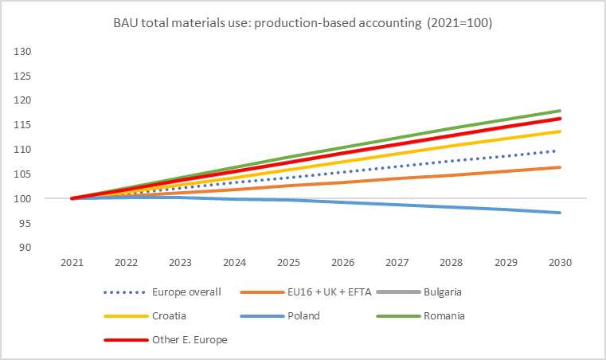 | 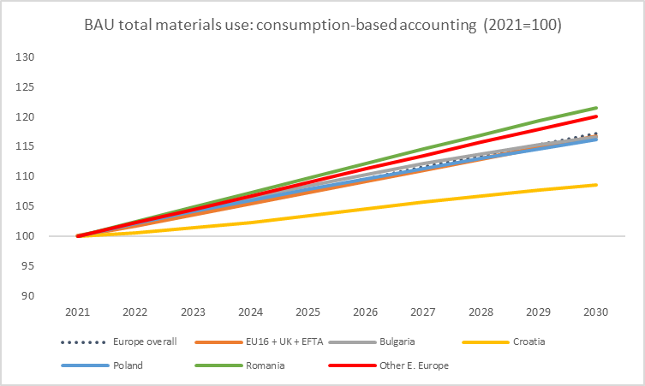
Figure 6: Index of materials use: production-based (left) and consumption-based (right) under BAU (2021=100)

The BAU scenario also shows a substitution between domestic towards imported materials. Across all of Europe, primary materials use as measured by production-based accounting grows by ten percent by 2030 (compared with 2021) under BAU. While being conceptually sound, for open economies, the production-based accounting fails to adequately quantify the life-cycle–wide environmental pressures associated with domestic consumption (Schaffartzik et al., 2014). For instance, if iron ore is used to produce steel in country A, which is further exported and actually consumed in country B, production-based accounting would attribute the iron ore use to country A (where steel was produced) and not country B (where actual consumption of steel took place).
To account for the raw commodities embedded into traded goods, consumption-based accounting is considered. From a consumption perspective, raw materials used in the production of exported goods should be accounted for in the importing country. This concept has been also applied in a similar way for the accounting of greenhouse gas emissions (e.g. Davis and Caldeira, 2010; Peters, 2008). When measured in terms of consumption-based accounting though, growth in material use increases to almost twice as much (17 percent) showing the increased relevance of imported materials.

3.3. Impact of the EU’s Green Deal
The major component of the EU Green Deal is to reduce greenhouse gas (GHG) emissions by 55 percent in 2030 relative to 1990. This involves a more stringent ETS regime for energy-intensive and trade exposed sectors (EITE) and a broadening of carbon prices to all other non-ETS activities and households. Policies targeting GHG emissions reduction under the European Green Deal (EGD-NDC) will have large impacts on fossil fuel use from a production-based accounting perspective and a smaller, but still significant, impact when measured on a consumption basis. But while these policies will also contribute to reduce metal ores (MMO) and non-metallic minerals (NMN) use, the scale of the effect will be minimal – less than 1 percent relative to BAU for metals and 1-2 percent for non-metallic minerals (Figure 7). Thus, policies that specifically target primary materials will be required.

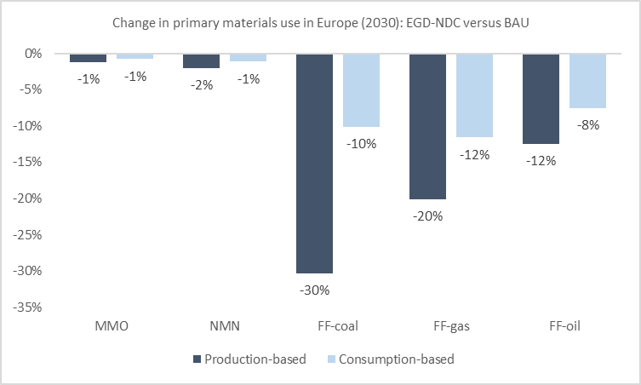
Figure 7: Impacts of EGD-NDC scenario on primary materials use in Europe
CE policies results show large reductions in primary materials use relative to BAU and absolute material decoupling by 2030 from a production accounting perspective. In the Combined scenario primary metals use falls 15 percent from 2021 levels in 2030, and nearly 30 percent from BAU, while non-metallic minerals use remains flat (and falls 15 percent relative to BAU). Fossil fuels will fall by 11 percent even under BAU, but they decline another 20 percent under Combined (although most of this is driven by EGD-NDC rather than targeted CE policies). Figure 8 summarizes the material use impacts of a comprehensive set of CE policies addressing both production and consumption sides (Combined).

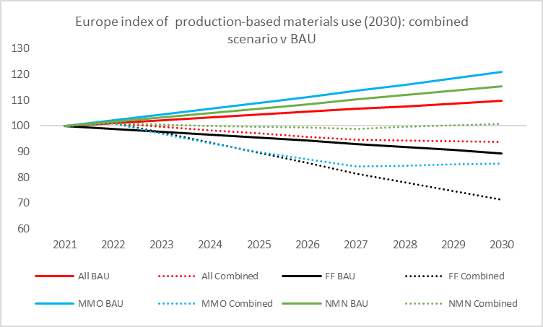
Figure 8. Impact of combined CE policies on primary materials use in Europe in 2030 (Index 2021=100) versus BAU

Overall, Bulgaria and especially Poland are expected to experience decline in (production-based) primary material use at a much faster rate than Europe overall (Table 2). However, in both cases this is driven primarily by rapid decline in fossil fuel use driven by decarbonization policies (EGD-NDC policy scenario) rather than specific CE policies. In fact, Bulgaria and Croatia actually experience a small increase in metals use, while Poland experiences a small increase in non-metallic minerals use by 2030.

Table 2: Impact of combined CE policies on primary materials use in 2030 (Index 2021=100) at country level
 | All materials |  | FF |  | MMO |  | NMN
 | BAU | Combined | BAU | Combined | BAU | Combined | BAU | Combined
Bulgaria | 105 | 82 | 84 | 59 | 129 | 104 | 117 | 97
Croatia | 114 | 97 | 91 | 70 | 111 | 107 | 115 | 99
Poland | 97 | 74 | 86 | 62 | 127 | 87 | 119 | 107
Romania | 118 | 96 | 89 | 66 | 125 | 86 | 120 | 99

The EGD-NDC scenario shows that whilst significantly increasing fossil fuel prices, there is no reduction on material use as carbon pricing has minimal impacts on metals and NMN prices. However, dedicated policies aimed at increasing materials’ pricing can reduce material use (Table 3). Where fiscal policies (in this case production taxes) are imposed, producer prices rise significantly, contributing to reduced materials use. Of course, elasticities vary across products and in the examples shown here, metals and NMN use appear to be somewhat less sensitive to price changes than fossil fuels (coal). Nevertheless, the role of pricing is clear, highlighting the importance of fiscal policy tools in delivering on CE objectives.

Table 3: Price and materials use growth to 2030
 | Coal power price growth | Coal use growth | Primary Iron and steel price growth | Primary metals use growth | NMN price growth | NMN use growth
EGD-NDC v BAU | 25.4% | -30.3% | -1.1% | -1.2% | 0.6% | -0.8%
Materials tax v EGD-NDC | NA | NA | 24.2% | -16.6% | 21.0% | -5.0%

Alternatively, fiscal policy targeting production prices to reduce primary materials use can take two broad forms – taxes or subsidies. The modelling exercise explored a scenario with a 30 percent tax imposed on primary metals and plastics production to raise prices and incentivize a shift away from primary production (either to secondary production using recycled metals) or to other materials. A second scenario provides a 30 percent production subsidy for secondary materials production, to reduce the gap in relative prices between primary and secondary metals production and incentivize a shift to secondary production. The results shown in the Figure 9 below suggest both policies would have a similar impact in reducing production-based material use.

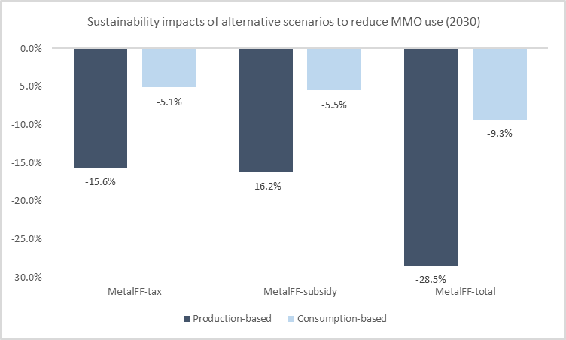
Figure 9: Impact of primary production tax and secondary production subsidy on metal ores use compared to EGD-NDC scenario

Perhaps the most important finding from the analysis comes in a scenario where both the tax and subsidy are combined. In this case, the impact on reducing material use nearly doubles. This suggests the approaches are complementary.
When limited to targeting production, however, subsidies and taxes will both have limited effects on overall consumption trends. Both also have a similar impact on consumption-based material use – in both cases a much smaller impact, which may be expected given that the policy is targeting production rather than consumption and a number of barriers may restrict pricing pass-through to consumers (e.g. leakage- as discussed later).

While the price channel will clearly play an essential role in reducing demand for primary materials, it will not be sufficient on its own. A range of policy approaches will need to be tailored to the specific dynamics of different materials, particularly to address both the production and consumption sides of the equation. Policies targeting upstream product design and downstream consumption can effectively complement fiscal policies. These include:

- designing products to reduce material usage (Design);
- extending the useable lifetime of products (Extend);
- shifting consumer preferences away from materials and toward services (Prefshift).

All three of these approaches could be supported by fiscal measures, and in fact price signals at the consumer level are likely play an important role in shifting demand. But they are also likely to benefit from regulatory (e.g. materials standards; rights to repair, extended producer responsibility) and social / behavioral policies (e.g. education and public awareness, behavioral incentives). Figure 10 presents the results on material use from combination of production-side fiscal policies as well as complementary policies targeting upstream product design and downstream consumption.

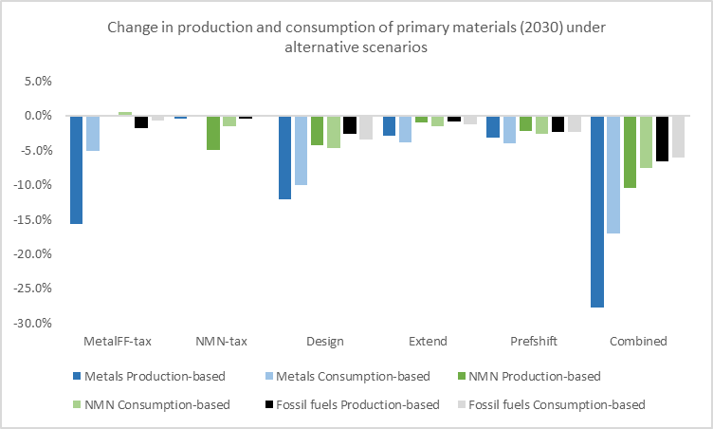
Figure 10: Impact of alternative scenarios on primary materials use relative to EGD-NDC scenario

While CE policies can be impactful on European production and consumption of primary materials, raising relative prices for domestic producers will affect their competitiveness in global and domestic markets vis-a-vis producers who are not required to comply with those policies. Figure 11 shows how material taxes compound already-eroding price competitiveness for European producers of primary metals and construction materials. European exporters are likely to be hit significantly in global markets unless some sort of export exemption or subsidy is put in place to offset the impacts of policies raising production prices.

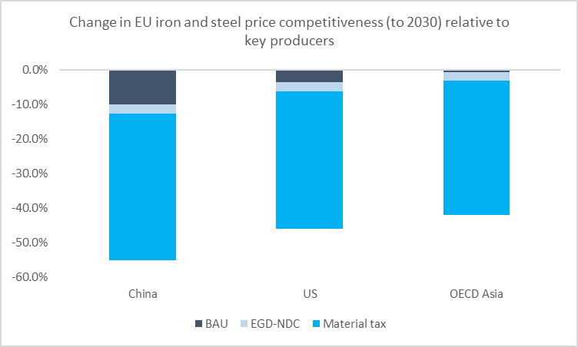 | 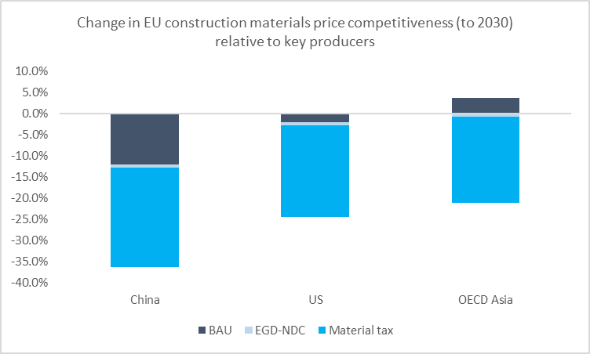
Figure 11: Price competitiveness impacts on European producers relative to key global producers of alternative policy scenarios for metals (left) and construction materials (right)

The price gap induced by the application of fiscal policies on material production can result in substantial leakage, whereby primary materials production is offshored and exported back into European markets, undermining the sustainability objectives of CE policy. This is illustrated by the gap in the decline of materials use as measured by production and consumption. Figure 12 shows how significant this problem may be, particularly in fiscal policy scenarios, where leakage is large as is the subsequent erosion of material reduction achieved by CE policies.

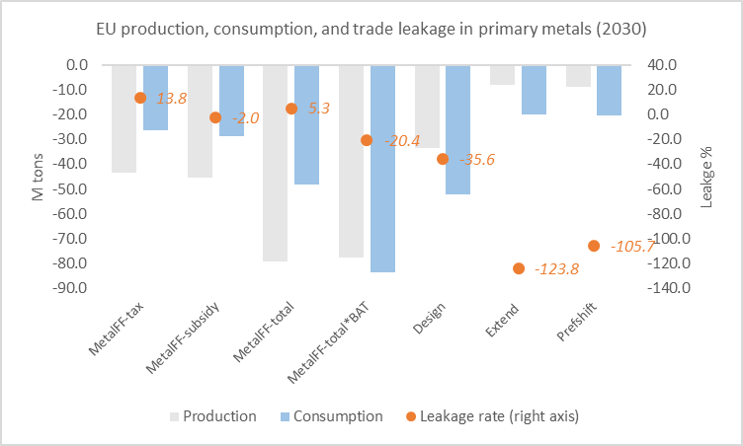 | 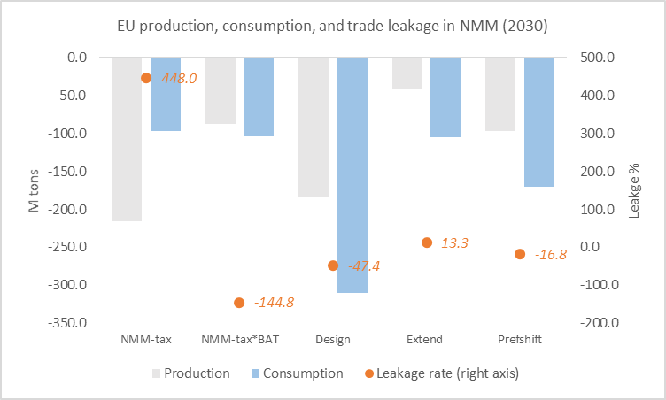
Figure 12: Production, consumption, and leakage of alternative policies, with and without border adjustments for metals

Border adjustment taxes (BATs) can address leakage and strengthen the impact of CE policies. BATs have received considerable attention of late as the EU plans to introduce them on carbon emissions (the ‘carbon border adjustment mechanism’, or CBAM) under the Green Deal to stem leakage of emissions-intensive activities (EC, 2021).
Under CBAM, exporters of emission-intensive goods to the EU would be required to pay a tax (equivalent to what EU producers pay under the emissions trading system) to ensure a level playing field between European producers and imports – in effect extending European domestic decarbonization policy to all trading partners. As material taxation would also result in considerable leakage, border adjustments may be needed to minimize negative competitiveness effects and meet the global sustainability goals of Europe’s materials reduction efforts. Figure 12 shows the impacts of adding BATs to domestic fiscal instruments applied to primary metals and non-metallic minerals. The results suggest BATs would have a powerful impact in reducing leakage and closing the gap between primary material’s production and consumption rates.
For primary metals, the introduction of BATs results on consumption of primary metals in Europe to decline by an additional 35.6 million metric tons (MMT) by 2030 relative to the fiscal policy scenario without BATs (Table 5). This is almost a 75 percent additional reduction beyond what is achieved through the fiscal policy without BAT. This is achieved without extra demand for primary metals from European producers – net demand from the production side increases by less than 1 percent over the fiscal policy scenario without BAT. The effect can also be seen in trade dynamics. Introduction of BAT has a limited additional impact in reducing exports from Europe of products using primary metals (from an already large decline resulting from the introduction of taxes on primary metals and subsidies on secondary). But while those tax and subsidy policies contribute to a (small) increase in imports of embedded primary metals, the imposition of BAT decreases imports (Figure 13).

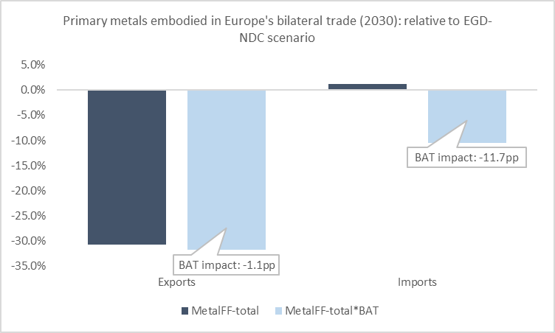
Figure 13: Impact of BAT on primary metals embedded in exports and imports

In the case of NMN, BAT has almost no additional impact in reducing overall consumption in Europe while it contributes to an increase in production-based materials demand (as a result of improving relative price competitiveness) by around 3 percent relative to the fiscal policy scenario without BAT. Two main factors explain relatively lower impact of BAT on NMN versus on metals: i) import dependence for metals is much higher than for non-metallic minerals; and, ii) in the case of metal ores, BAT is applied to processed metals and plastics while in the case of NMN it is applied to primary commodities – the latter have a much smaller value-added share in the final product being imported, thus the overall impact on price will be much lower. Border taxes on NMN, however, appear to have a large impact on production and consumption of NMN outside of Europe. BAT eliminates very large leakage from trade of NMN embedded in other manufactured products, and contributes to declining global production and consumption demand relative to the fiscal policy scenario whereby both increased substantially outside of Europe.

Table 5: Impacts of BAT scenarios on key demand and use variables for primary metals and construction materials
METALS | EGD-NDC | MetalFF-total | MetalFF-total*BAT | Impact of material tax v EGD-NDC scenario | Impact of BAT v material tax scenario
EU production-based use | 278 | 199 | 201 | -28% | 0.8%
EU consumption-based use | 518 | 469 | 434 | -9% | -7.6%
Rest of world production | 6,007 | 6,012 | 5,992 | 0.1% | -0.3%
EU exports (embedded) | 88 | 61 | 60 | -31% | -1.6%
EU imports (embedded) | 327 | 331 | 293 | 1% | -11.5%
CONSTRUCTION MATERIALS | EGD-NDC | NMN-tax | NMN-tax*BAT | Impact of material tax v EGD-NDC scenario | Impact of BAT v material tax scenario
EU production-based use | 4,302 | 4,087 | 4,215 | -5% | 3.1%
EU consumption-based use | 6,524 | 6,427 | 6,420 | -1% | -0.1%
Rest of world production | 85,472 | 86,436 | 85,346 | 1% | -1.3%
EU exports | 678 | 626 | 672 | -8% | 7.3%
EU imports | 2,900 | 2,966 | 2,877 | 2% | -3.0%

The price effects will be felt by both consumers and producers demanding primary materials in the production of value-added downstream products. Imposing BATs in the metals sector would lead to Europe’s consumer prices (CPI) to rise close to one percent over the fiscal policy scenario without BAT. Material intensive economies would be impacted more adversely – for example, prices would increase by 1.4 percent in Poland and Romania.
In addition, depending on how a BATs are implemented, they could contribute to changes in relative prices of inputs at different stages of the value chain, with potentially negative consequences for competitiveness of domestic producers in higher value-added positions further down value chain. For example, imposing BAT on primary steel levels the playing field for domestic primary producers with foreign producers who do not pay a material tax, but if the BAT is not also imposed on cars using that steel, domestic producers of cars may find themselves outcompeted by those same foreign producers. This is important because the majority of primary materials consumed in the EU come in not through primary material imports but rather through primary materials embedded in other imported products. In the scenarios presented above, BAT is imposed on all primary materials inputs embedded in imports (so, for example, not just primary steel but the value of primary steel in the import of a car). In practice imposing BAT across the value chain can be technically difficult to implement, so it is likely that, at least initially, a BAT on primary materials would not account for embedded materials in downstream products, creating a potential distortion for European producers. In the long term, however, anything short of pricing in externalities along the whole value chain will likely result in some form of leakage.
Given the importance of the trade channel in shaping CE outcomes, Europe’s CE policies will have significant global spillovers. Results from the modelling suggest that overall export impacts are modest if not insignificant (Figure 14). In most regions, and especially China, imposition of BAT substantially reduces exports. Under a comprehensive CE scenario that combines production and consumption side measures (but does not include BAT), Europe’s neighbors face the largest hit to exports, while impacts in Sub-Saharan Africa and in LMICs overall, are not more than 0.5 percent compared to the reference scenario. One reason why the impacts appear modest is that while some CE measures reduce overall demand for primary materials, others may strengthen the relative comparative advantage of LMICs as exporters (particularly if BAT is not imposed). Overall, however, the model results probably underestimate the potential negative impacts on developing country exporters as it assumes economies adjust equal to changing demand and price structures. For example, while the model shows developing countries experiencing substantial declines in primary metals exports, these are largely offset by gains in exports of recycled metals. Overall, the results imply large shifts in the structure of developing country exports – away from extractives, power, and industry and toward more services (Figure 15).

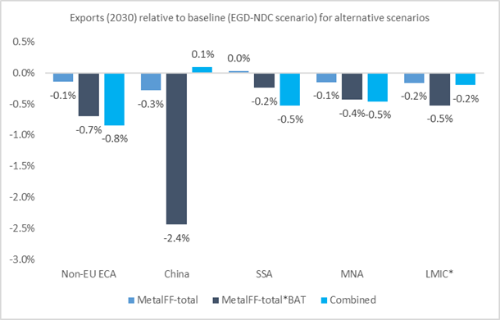  Figure 14: Impacts of selected CE scenarios on exports in regions / country groupings outside Europe | 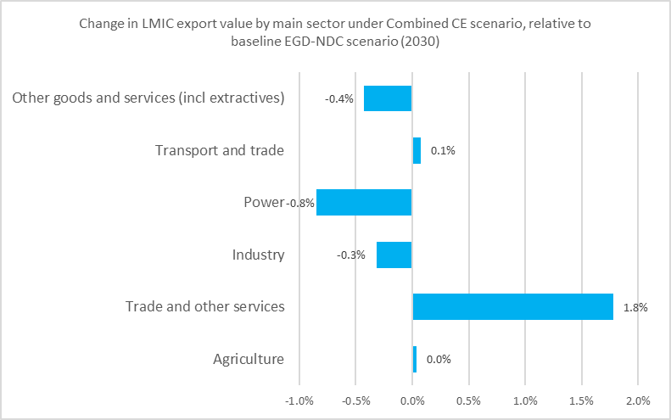  Figure 15: Change in composition of LMIC exports by broad category under Combined CE scenario
*Note: LMIC countries are defined here as low and middle income countries outside of EU, excluding China and Russia

Implementation of a broad combination of CE policies would have sizeable impacts on the structure of Europe’s economy already by 2030, with services increasing its share of output by 2.3 percentage points while industry falls by a further nearly one percentage point and ‘other goods and services’ (including extraction) falling by 1.6 percentage points (Table 6).

Table 6: Change in share of output by broad sector in 2030 relative to reference scenario
 | Agriculture | Industry | Power | Transport | Trade and other services | Other goods and services
MetalFF-total | (0.01) | 0.34 | (0.07) | (0.02) | (0.28) | 0.03
NMN-tax | 0.00 | (0.02) | (0.00) | (0.00) | 0.03 | (0.02)
Design | 0.01 | (0.64) | (0.02) | 0.01 | 1.80 | (1.16)
Extend | (0.00) | (0.13) | (0.00) | (0.00) | 0.87 | (0.72)
Prefshift | 0.02 | (0.36) | 0.07 | 0.04 | 0.92 | (0.70)
Combined | 0.0 | (0.9) | 0.1 | 0.1 | 2.3 | (1.6)

The shifts are largest under a scenario where producers ‘design-out’ materials from production, in effect replacing material inputs with services inputs. Similarly, product lifetime extension sees a substitution away from production sectors and to services sectors (e.g. repair and reuse), while overall consumer preference shifts away from materials quite obviously shifts economic activity towards services. By contrast, production side fiscal policies in the metals and plastics sectors work in the opposite direction to the consumption-side policies, increasing industry relative to plastics. This may seem counterintuitive but relates to the relative impact of tax and subsidy policies on driving secondary production to the point where it more than offsets primary production, increasing the relative share of industry.
The scale of structural shifts is larger in the newer Member States. In Bulgaria and Poland, for example, the share of the Trade and Other Services sector increases by 6 percent relative to the EGD-NDC scenario by 2030 in the Design scenario (and by 3 percent in the Extend and Prefshift scenarios) while the relative share of the Industry sector declines commensurately. For production-side policies, impacts are again relatively larger in newer Member States (5 percent growth in relative share of the industrial sector in Bulgaria, 3 percent in Croatia, and 2 percent in Romania, under the MetalFF-total scenario) and also appear to come more at the expense of the power and extraction sectors than from services.
The macroeconomic costs of achieving the circular economy will be minor. While CE will no doubt create economic opportunities, alternative policies explored in this assessment – all of which aim to reduce and shift demand – do have macroeconomic costs. In the Combined scenario, total annual GDP is around one percent lower relative to the reference scenario in 2030 – for most of the individual policy scenarios, the cost is around 0.3-0.4 percent of 2030 GDP (Figure 16). This may be considered a minor cost, particularly as it does not consider co-benefits of achieving material decoupling (e.g. improved health and productivity resulting from lower pollution, increased biodiversity, etc.). Moreover, it is important to recognize that this ‘cost’ is relative to baseline growth – real GDP in the Combined scenario is still 13.5 percent higher in 2030 versus BAU in 2021. GDP implications at the country level are broadly in line with overall EU trends, with Bulgaria and Poland most exposed to production-side policies targeting metals and fossil fuels and Poland and Romania most exposed to policies that aim to ‘design-out’ materials as inputs in production, perhaps reflecting their positions in European manufacturing value chains.

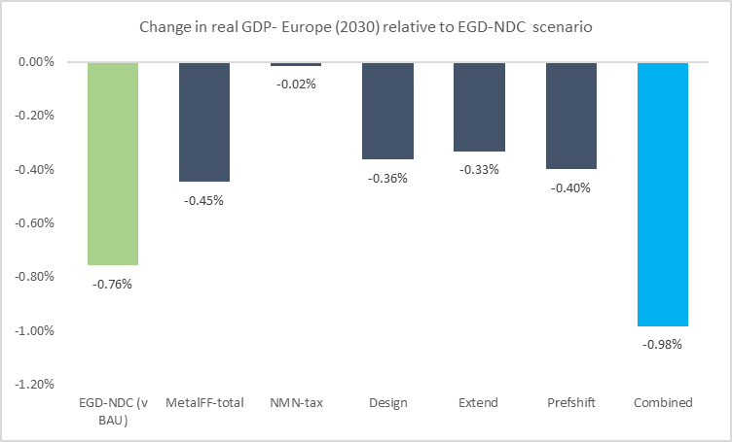
Figure 16: Change in Europe GDP relative to EGD-NDC scenario (2030)

While consumer prices are expected to rise moderately under most CE policy scenarios, the net effect under the Combined scenario shows no change compared to the reference scenario (Figure 17). As noted earlier, the impact of BAT for primary metals has the largest overall impact, increasing CPI by 0.7 percent. Demand-side scenarios (Extend and Prefshift) also result in modest increases in consumer prices. Again, the effects in some countries are higher than for Europe overall, with CPI rising close to 1 percent relative to the reference scenario for the demand-side policies in Bulgaria, Croatia, and Poland, and above 1 percent in Poland and Romania for metals taxes with BAT. Figure 18 breaks consumer prices down into key categories for selected production-side CE policy scenarios. It again highlights the impact of BAT on overall prices, and also shows how price rises will vary significantly across key goods and services. Notably, goods and services and also food prices will rise more sharply than energy and transport prices.

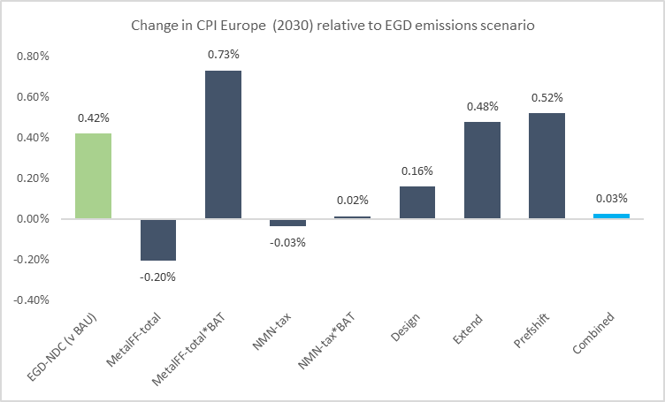
Figure 17: Change in consumer prices in Europe relative to reference scenario (2030)

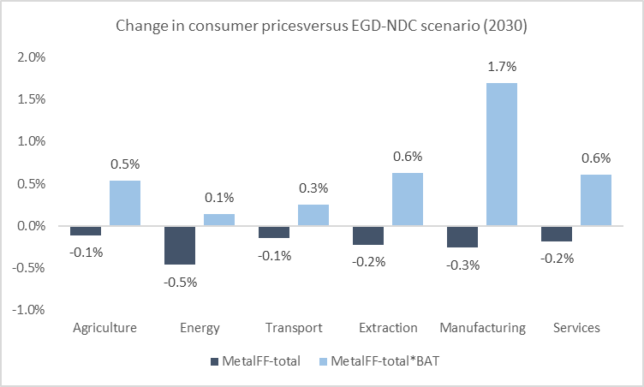
Figure 18: Change in consumer prices across key categories for primary metals scenarios (2030)

While labor market impacts from most individual CE policies are modest, in combination (Combine) they are relatively significant for unskilled workers (Figure 19) – relative to the reference scenario unskilled workers see unemployment rise by 0.6 percentage points and real wages decline by 2.6 percent. Skilled workers, by contrast, experience lower unemployment and only slightly lower wages. Impacts vary markedly across individual CE policy scenarios. Fiscal policies targeting production of primary materials has almost no impact on unemployment and wages. By contrast the upstream and demand-side scenarios show much larger effects, with a clear skills-bias. Under all three scenarios (Design, Extend, Prefshift) unemployment rises and wages fall for unskilled workers, while unemployment falls and wages rise for skilled workers.

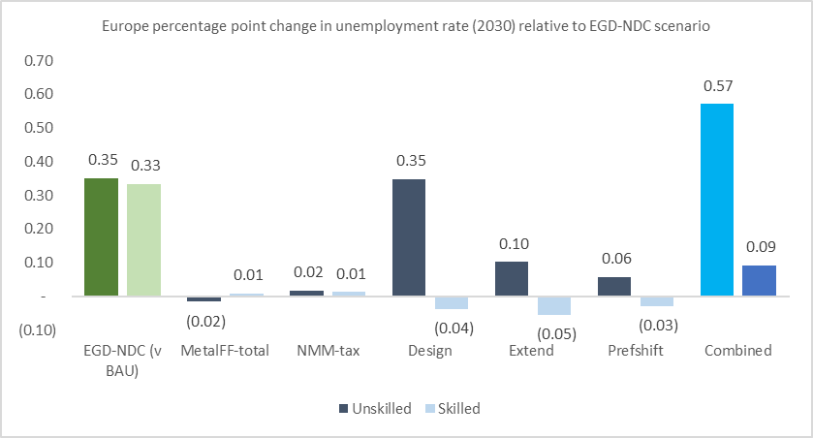 | 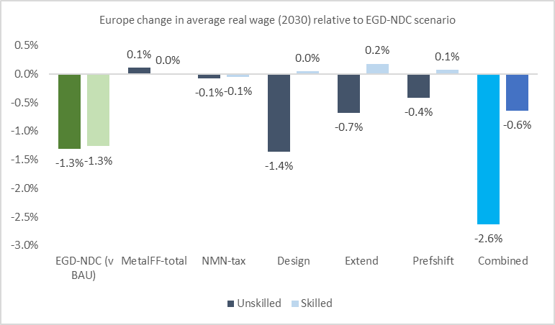
Figure 19: Change in unemployment rate (left) and real wage (right) by skill level: Europe relative to reference scenario (2030)

Country-level distributional impacts can be significant, driven by underlying sectoral and skills structures. For example, in the Combined scenario (Figure 20) Poland, real wages for unskilled workers are down 5.6 percent. Moreover, skilled workers gain considerably in all countries but Croatia. One notable difference in the newer Member States relative to Europe overall is that the largest impacts are seen through the production-side CE scenarios than through the upstream and demand-side scenarios. Specifically, skilled workers appear to fare much less well in all four countries (versus Europe overall) under the upstream and demand-side scenarios; rather their gains come mainly in the production-side CE intervention scenarios. In parallel unskilled workers in these countries see wages fall more through production-side interventions than in Europe overall. This likely reflects the higher concentration of unskilled workers in the newer Member States, resulting in greater exposure to declines in unskilled activities and at a weaker position to benefit from gains in skilled activities.

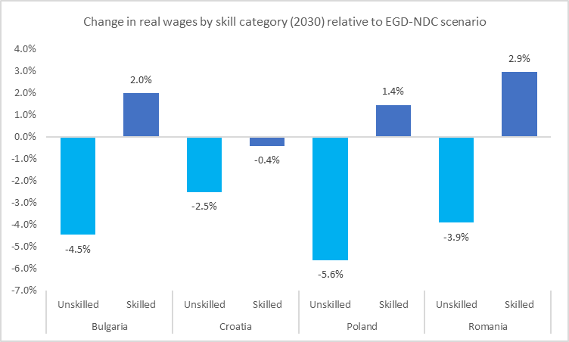
Figure 20: Change in real wages by skill level at country level (2030)- Combined scenario

4. Conclusions
- Climate and CE policies are complementary: EGD measures targeting CO₂ emissions will have an impact on material use, but only a modest one. Similarly, materials-focused measures will have only a modest impact on CO₂ emissions.
- CE measures can have a significant impact on materials consumption: Scenarios indicate aggregate material production in EU could decline 5-9% (relative to baseline in 2030) under alternative CE policies; for some products (notably metals) substantially larger declines are possible.
- Measures must be targeted: Response to CE measures varies substantially by material – e.g. metals reduce most with policies targeting production directly (recycling) and design, while construction materials respond best to design policies (and may require policies better targeting investment rather than consumption); countries’ baseline conditions will also impact outcomes.
- Leakage will be a concern for some materials: Significant gaps between production and consumption-based savings for some materials and policies are observed, however these depend on the nature of the underlying policy mechanism:
- In the case of production-based actions (scenarios with subsidies to secondary production and taxes on primary production), output of primary materials in the rest of the world increases, partly substituting domestic EU inputs, and an increase in leakage is observed.
- A different pattern is observed when consumption or intermediate use-focused measures are implemented. In this case, a substantial negative leakage is estimated, as the EU-wide material demand is falling and it does not matter whether materials are sourced domestically or imported.
- Depending on the channel of ‘circularity’, domestic output in Europe could be significantly impacted. The tax and subsidy channel have the greatest impact on domestic output—particularly in those sectors directly impacted by the taxes and subsidies.
- The EU Green Deal and the ‘circularity’ scenarios will lead to a short-term increase in unemployment—in general similar between skilled and unskilled workers. However, the impact on unskilled workers will be more pronounced due to the changing production structures that benefit services over material-based inputs.
- The negative impacts on real income in 2030 will vary from 0.6 to 1.2 percent in Europe on aggregate and between 0.4 and 2.0 percent across the individual modeled regions in Europe (excluding the two sensitivity analyses).

References

Aguilar-Hernandez, A. Glenn, Rodrigues, F.D. João, Tukker, A. 2020. Macroeconomic, social and environmental impacts of a circular economy up to 2050: a meta-analysis of prospective studies. J. Clean. Prod. (2020), p. 123421. https://doi.org/10.1016/j.jclepro.2020.123421
Bank of Korea. 2019. 2015 Benchmark Input-Output Tables. https://www.bok.or.kr/eng/bbs/E0000634/view.do?nttId=10050569&menuNo=400069
Bibas, R., J. Chateau and E. Lanzi. 2021. Policy scenarios for a transition to a more resource efficient and circular economy, OECD Environment Working Papers, No. 169, OECD Publishing, Paris, https://doi.org/10.1787/c1f3c8d0-en.
Burchart-Korol, D. 2013. Life cycle assessment of steel production in Poland: a case study. Journal of Cleaner Production, Volume 54, 1 September 2013, Pages 235-243. https://doi.org/10.1016/j.jclepro.2013.04.031
Bureau of International Recycling (BIR). 2008. Report on the Environmental Benefits of Recycling. https://www.mgg-recycling.com/wp-content/uploads/2013/06/BIR_CO2_report.pdf
CEPII. 2021. Description of BACI. http://www.cepii.fr/DATA_DOWNLOAD/baci/doc/DescriptionBACI.html
Chepeliev, M. 2020. GTAP-Power Data Base: Version 10. Journal of Global Economic Analysis, Vol. 5, No. 2, p. 110-137, 2020, doi: https://doi.org/10.21642/JGEA.050203AF
Chepeliev, M., Aguiar, A., Liverani, A., Farole, T., van der Mensbrugghe, D., & Wang, L. 2021. Circular Economy Transition in the Eastern European Member States. Presented during the 24th Annual Conference on Global Economic Analysis (Virtual Conference). https://www.gtap.agecon.purdue.edu/resources/res_display.asp?RecordID=6354
Dixon, P.B., and M.T. Rimmer. 2002. Dynamic general equilibrium modelling for forecasting and policy: a practical guide and documentation of MONASH, 1st ed., vol. 256. Amsterdam: Elsevier.
Domenech, T., and Bahn-Walkowiak, B. 2019. Transition towards a resource efficient circular economy in Europe: Policy lessons from the EU and the member states. Ecological Economics 155: 7–19.
Dong, D., van Oers, L., Tukker, A., van der Voet, E. 2020. Assessing the future environmental impacts of copper production in China: Implications of the energy transition. J. Clean Prod., 274 (2020), p. 122825, 10.1016/j.jclepro.2020.122825
European Commission (EC). 2020a. A new Circular Economy Action Plan For a cleaner and more competitive Europe. Brussels, 11.3.2020. https://eur-lex.europa.eu/legal-content/EN/TXT/?qid=1583933814386&uri=COM:2020:98:FIN
European Commission (EC). 2020b. Circular material use rate. https://ec.europa.eu/eurostat/web/products-datasets/-/cei_srm030
European Environmental Agency (EEA). 2020. Countries which adopted a national resource efficiency or circular economy strategy or action plan. https://www.eea.europa.eu/data-and-maps/figures/countries-which-adopted-a-national
Haberl, H. et al. 2020. A systematic review of the evidence on decoupling of GDP, resource use and GHG emissions, part II: synthesizing the insights. Environ. Res. Lett. 15 065003. https://doi.org/10.1088/1748-9326/ab842a
Hopewell, J., Dvorak, R., & Kosior, E. 2009. Plastics recycling: challenges and opportunities. Philosophical transactions of the Royal Society of London. Series B, Biological sciences, 364(1526), 2115–2126. https://doi.org/10.1098/rstb.2008.0311
Horridge, M. 2011. GTAPAdjust: A program to balance or adjust a GTAP database https://www.copsmodels.com/archivep.htm#tpmh0104
Horridge, M. 2008. MSplitCom. https://www.copsmodels.com/msplitcom.htm
IRP (2019). Global Resources Outlook 2019: Natural Resources for the Future We Want. Oberle, B., et al. A Report of the International Resource Panel. United Nations Environment Programme. Nairobi, Kenya.
Jambeck, J.R., Andrady, A., Geyer, R., Narayan, R., Perryman, M., Siegler, T., Wilcox, C., Lavender Law, K., 2015. Plastic waste inputs from land into the ocean, Science, 347, p. 768-771.
Kirschen, M., Badr, K., Pfeifer, H. 2011. Influence of direct reduced iron on the energy balance of the electric arc furnace in steel industry. Energy, 36 (2011), pp. 6146-6155, 10.1016/j.energy.2011.07.050
Kirchherr, J., Reike, D., Hekkert, M. 2017. Conceptualizing the circular economy: An analysis of 114 definitions. Resources, Conservation and Recycling, Volume 127, December 2017, Pages 221-232. https://doi.org/10.1016/j.resconrec.2017.09.005
Korhonen, J., Honkasalo, A., Seppala, J. 2018. Circular Economy: The Concept and its Limitations. Ecological Economics, Volume 143, January 2018, Pages 37-46. https://doi.org/10.1016/j.ecolecon.2017.06.041
Kraussman, F., Lauk, C., Haas, W., and Wiedenhofer, D. 2018. From resource extraction to outflows of wastes and emissions: The socioeconomic metabolism of the global economy, 1900–2015, Global Environmental Change, vol 52: 131:140 https://doi.org/10.1016/j.gloenvcha.2018.07.003
Liu, Z., Geng, Y., Adams, M. et al. 2016. Uncovering driving forces on greenhouse gas emissions in China' aluminum industry from the perspective of life cycle analysis. Applied Energy, 166 (2016), pp. 253-263, 10.1016/j.apenergy.2015.11.075
Marques, A., et al. 2019. Increasing impacts of land use on biodiversity and carbon sequestration driven by population and economic growth. Nature Ecology & Evolution, 3(4), 628. https://doi.org/10.1038/s41559-019-0824-3
McCarthy, A., R. Dellink and R. Bibas, 2018, “The Macroeconomics of the Circular Economy Transition: A Critical Review of Modelling Approaches”, OECD Environment Working Papers, No. 130, OECD Publishing, Paris. http://dx.doi.org/10.1787/af983f9a-en
Ministry of Internal Affairs and Communications of Japan (MIC). 2019. 2015 Input-Output Tables for Japan. https://www.soumu.go.jp/english/dgpp_ss/data/io/io15_00001.htm
Organization for Economic Cooperation and Development (OECD). 2018. Global Material Resources Outlook to 2060: Economic Drivers and Environmental Consequences, OECD Publishing, Paris. https://doi.org/10.1787/9789264307452-en
Otero, I. et al. Biodiversity policy beyond economic growth. Conserv. Lett. 13, e12713 (2020). https://doi.org/10.1111/conl.12713
Roser, M. 2020. The short history of global living conditions and why it matters that we know it. Our World in Data. https://ourworldindata.org/a-history-of-global-living-conditions-in-5-charts
Schandl, H., et al. 2017. Global material flows and resource productivity: forty years of evidence. J. Ind. Ecol. (2017), 10.1111/jiec.12626
Sosinsky, D.J., Campbell, P., Mahapatra, R., Bledje, W., and Fisher, F. 2008. The Castrip® Process – Recent Developments at Nucor Steel’s Commercial Strip Casting Plant. Metallurgist, Vol. 52, Nos. 11–12, 2008. https://link.springer.com/content/pdf/10.1007/s11015-009-9116-5.pdf
Stadler et al. 2019. EXIOBASE 3 (3.7) [Data set]. Zenodo. https://doi.org/10.5281/zenodo.3583071
Statistics Canada. 2019. Supply and Use Tables. https://www150.statcan.gc.ca/n1/pub/15-602-x/15-602-x2017001-eng.htm
Steffen et al. 2015. Planetary boundaries: guiding human development on a changing planet. Science 347: 736–746. DOI: 10.1126/science.1259855
Steinberger, J. K., Krausmann, F., Getzner, M., Schandl, H., & West, J. 2013. Development and dematerialization: An international study. Plos One, 8(10), e70385. https://doi.org/10.1371/journal.pone.0070385
The Association of Plastic Recyclers (APR). 2020. Virgin vs. Recycled Plastic Life Cycle Assessment Energy Profile and Life Cycle Assessment Environmental Burdens. The Association of Plastic Recyclers White Paper. https://plasticsrecycling.org/images/library/APR-Recycled-vs-Virgin-May2020.pdf
United Nations (UN). 2020. United Nations Environment Programme International Resource Panel Global Material Flows Database. https://www.resourcepanel.org/global-material-flows-database
United States Bureau of Economic Analysis (US BEA). 2018. Input-Output Accounts Data. https://www.bea.gov/industry/input-output-accounts-data
van der Mensbrugghe, D., 2019. The Environmental Impact and Sustainability Applied General Equilibrium (ENVISAGE) Model. Version 10.01. Center for Global Trade Analysis, Purdue University. https://mygeohub.org/groups/gtap/envisage-docs
Wiebe, K.S., M. Harsdorff, G. Montt, M.S. Simas, R. Wood. 2019. Global circular economy scenario in a multiregional input-output framework. Environ. Sci. Technol., 56 (2019), pp. 6362-6373, 10.1021/acs.est.9b01208
Winning, M., Calzadilla, A., Bleischwitz, R. et al. Towards a circular economy: insights based on the development of the global ENGAGE-materials model and evidence for the iron and steel industry. Int Econ Econ Policy 14, 383–407 (2017). https://doi.org/10.1007/s10368-017-0385-3
World Bank (WB). 2021a. GDP per capita (constant 2015 US$). https://data.worldbank.org/indicator/NY.GDP.PCAP.KD
World Bank. 2021b. Population, total. https://data.worldbank.org/indicator/SP.POP.TOTL
World Bank (2022). Squaring the Circle: Policies from Europe’s Circular Economy Transition. Forthcoming.

Appendix A. An overview of the data sources used for the GTAP-CE database construction
For the case of iron ores production, data are based on USGS 2015 Mineral Yearbook (https://s3-us-west-2.amazonaws.com/prd-wret/assets/palladium/production/mineral-pubs/iron-ore/myb1-2015-feore.xlsx). For the case of China, usable ore is reported. ‘Other’ category in the initial Yearbook included the following countries - Bhutan, Kenya, Nigeria, Portugal (manganiferous iron ore), Togo, and Uganda – and total production for these six countries was reported (150 thousand metric tons (tmt)). This was further disaggregated by individual countries, using the following assumptions. 2012 USGS data was used for Kenya (11 tmt), Nigeria (70 tmt), Portugal (14 tmt). For Bhutan, statistics for Bhutan and Nepal from USGS individual country profiles (https://s3-us-west-2.amazonaws.com/prd-wret/assets/palladium/production/mineral-pubs/country/2014/myb3-2014-bt-np.xls) was used (19 tmt). For Uganda, 2012 data from USGS individual country profiles was used (4 tmt). For Togo, remaining part of the total crude ores production (32 tmt) was assigned. Considering the reported 2014 Ferum content of 21.6 tmt for Togo provides 32 tmt of the equivalent crude ores mining can be considered a feasible estimate.
For the case of bauxite ores production, data are based on USGS 2015 Mineral Yearbook (https://s3-us-west-2.amazonaws.com/prd-wret/assets/palladium/production/mineral-pubs/bauxite/myb1-2015-bauxi.xlsx). In the case of US, data are not reported in the USGS Yearbook due to the proprietary reasons. To gap fill data for US, data from Statista (https://www.statista.com/statistics/1038450/us-bauxite-production/) was used (243.5 tmt).
For the case of copper ores, data are based on the USGS 2015 Mineral Yearbook (https://s3-us-west-2.amazonaws.com/prd-wret/assets/palladium/production/mineral-pubs/copper/myb1-2015-coppe.xlsx). Production is reported in tons of copper content are is differentiated by two technologies – concentrating and leaching (e.g. see https://copperalliance.eu/about-copper/copper-and-its-alloys/processes/).
For the case of copper production (distinguished by primary and secondary), estimates are derived from USGS 2015 Mineral Yearbook (https://s3-us-west-2.amazonaws.com/prd-wret/assets/palladium/production/mineral-pubs/copper/myb1-2015-coppe.xlsx). For smelting in North Korea, no differentiation by technologies is reported and we have assumed the same primary/secondary mix as for South Korea. For smelting in Turkey, no differentiation by technologies is reported and we have assumed the same primary/secondary mix as for Poland.
For the case of primary aluminum production, estimates are derived from USGS 2015 Mineral Yearbook (https://s3-us-west-2.amazonaws.com/prd-wret/assets/palladium/production/mineral-pubs/aluminum/myb1-2015-alumi.xls).
Secondary aluminum production data (producers capacity as of 2020) is sourced from https://www.lightmetalage.com/resources-section/secondary-producers/ and further aggregated by countries. These data can be further scaled to match secondary production volumes for 2014 using aggregate regional data from https://www.world-aluminium.org/statistics/primary-aluminium-production/ and country/region-specific data (for EU and USA). For the 2014 totals of the secondary (recycled) aluminum production we rely on https://alucycle.world-aluminium.org/public-access/#regional that reports data for 9 aggregate regions.
Total steel production is derived from USGS 2015 Mineral Yearbook. Secondary steel production quantities are sourced from the World Steel 2016 report https://www.worldsteel.org/en/dam/jcr:37ad1117-fefc-4df3-b84f-6295478ae460/Steel%2520Statistical%2520Yearbook%25202016.pdf using Electric Furnaces production volumes. Total of the world steel data for steel production exactly match the USGS total for steel production, though several minor producers are reported in the worldsteel data and not reported by USGS. These are added to the USGS volumes.
Extraction of non-metallic minerals and non-ferrous metal ores is sourced from the UNEP IRP MFA database https://www.resourcepanel.org/global-material-flows-database Extraction of other ores (moo) is estimated as total non-ferrous ores mining less bauxite and copper ores.
Output values of selected commodity groups for 2007 are sourced from the UNIDO database. Exchange rates for converting country-specific currencies to USD are sourced from the World Bank.
Plastics waste generation data by countries for 2010 is sourced from https://ourworldindata.org/plastic-pollution which is in turn based on the per capita plastic waste generation reported in Jambeck et al. (2015) http://science.sciencemag.org/content/347/6223/768/
Plastics recycling and recovery rates for EU for 2014 are sourced from https://committee.iso.org/files/live/sites/tc61/files/The%20Plastic%20Industry%20Berlin%20Aug%202016%20-%20Copy.pdf
For selected non-EU countries, including Mexico, USA, Argentina, Brazil, Morocco, South Africa, India, GCC group, China, Australia, South Korea and Japan the plastic recycling rates have been sourced from https://www.veolia.co.uk/sites/g/files/dvc1681/files/document/2018/10/Veolia%20UK%20_%20Planet%20Magazine%2016.pdf
For the case of Nigeria a 10% plastics recycling rate is used based on https://enveurope.springeropen.com/articles/10.1186/s12302-019-0254-5
For Latin America (LAC) plastic recycling rate is assumed to be 4%, somewhat lower than the average recycling rate for all waste (4.5%), a suggested in https://publications.iadb.org/publications/english/document/Plastic-Waste-Management-and-Leakage-in-Latin-America-and-the-Caribbean.pdf
For the Sub Saharan Africa (SSA) region we use an average plastic recycling rate of 3%, considering that an average recycling rate for all waste is 4% based on https://wedocs.unep.org/bitstream/handle/20.500.11822/30975/Africa_WMO_Poster.pdf
For Canada a plastic recycling rate of 9% is used from https://www.canada.ca/en/environment-climate-change/news/2020/10/canada-one-step-closer-to-zero-plastic-waste-by-2030.html
For an aggregate North America (NAM) region a plastic recycling rate of 9% is used, as an average of US and Canada recycling rates.
For the Middle East and North Africa aggregate region we use a plastic recycling rate of 10% based on the GCC group data.
For Russia, plastics recycling rate of 4% is used based on the average recycling rate https://www.ifc.org/wps/wcm/connect/news_ext_content/ifc_external_corporate_site/news+and+events/news/moscow+kids+recycling and lower than other estimate of average recycling of 5%-7% https://documents1.worldbank.org/curated/pt/702251549554831489/pdf/Waste-in-Russia-Garbage-or-Valuable-Resource.pdf
For Europe and Central Asia (ECA) plastics recycling rate of 4% is used same as for Russia.
For Afghanistan, Bangladesh and Sri Lanka plastic recycling rates are sourced from https://www.unescap.org/sites/default/files/SSWA%20Development_Paper20-02_Marine%20Plastic%20Pollution%20in%20South%20Asia.pdf
For the South Asia aggregate region plastics recycling rate of 12% is used based on data from Bangladesh.
For the case of Malaysia a plastics recycling rate of 4.5% (for 2014) was sourced from http://www.krinstitute.org/Views-@-Plastic-;_An_Undegradable_Problem.aspx
For the case of Philippines, a plastics recycling rate of 9% (for 2015) was sourced from https://wwf.org.ph/wp-content/uploads/2020/12/WWF_REPORT_EPR_Philippines_.pdf
For the East Asia and Pacific region an average of MYS and PHL of plastics recycling rate was used (7%).
Global plastics production and shares by key producing regions are adopted from https://www.corepla.it/documenti/5f2fa32a-7081-416f-8bac-2efff3ff2fbd/Plastics+TheFacts+2015.pdf
To estimate the price of other ‘nfm’ ores relative to the price of corresponding metal, we use the share of ore inputs to the metals aggregate production structure as reported in the IOTs. The corresponding share varies between around 14% in Japan, 34% in Korea and 52% in Canada. We use an average of these three shares, which is 33%.
Bilateral trade volumes, values and prices are derived from the BACI database http://www.cepii.fr/CEPII/en/bdd_modele/presentation.asp?id=37
Cost and supply structures for the disaggregated sectors are based on EXIOBASE MRIO (Stadler et al., 2019), as well as selected individual country input-output tables for the United States (US BEA, 2018), Canada (Statistics Canada, 2019), Japan (MIC, 2019) and Korea (Bank of Korea, 2019).
Further refinements for the representation of energy inputs to the production process of primary and secondary activities are implemented based on the multiple data sources: steel production and casting (Burchat-Korol, 2013; Kirschen et al., 2011; Sosinsky et al., 2008), aluminum (Liu et al., 2016), copper (Dong et al., 2020), other non-ferrous metals (BIR, 2008) and plastics (APR, 2020; Hopewell et al., 2009).

Appendix B. Regional and sectoral coverage of the ENVISAGE model used in this study

Table B.1. Regional concordance
No. | Countries/regions represented in this study | Disaggregated GTAP countries/regions
1 | United States (USA) | United States of America (USA)
2 | China (CHN) | China (CHN)
3 | Russian Federation (RUS) | Russian Federation (RUS)
4 | Poland (POL) | Poland (POL)
5 | Romania (ROU) | Romania (ROU)
6 | Bulgaria (BGR) | Bulgaria (BGR)
7 | Croatia (HRV) | Croatia (HRV)
8 | Turkey (TUR) | Turkey (TUR)
9 | EU-16+EFTA+Great Britain (X16) | Austria (AUT), Belgium (BEL), Cyprus (CYP), Denmark (DNK), Finland (FIN), France (FRA), Germany (DEU), Greece (GRC), Ireland (IRL), Italy (ITA), Luxembourg (LUX), Malta (MLT), Netherlands (NLD), Portugal (PRT), Spain (ESP), Sweden (SWE), United Kingdom (GBR), Switzerland (CHE), Norway (NOR), Rest of EFTA (XEF)
10 | Rest of EU transition economies (EU7) | Czech Republic (CZE), Estonia (EST), Hungary (HUN), Latvia (LVA), Lithuania (LTU), Slovakia (SVK), Slovenia (SVN)
11 | Other HIY OECD (XOE) | Australia (AUS), New Zealand (NZL), Canada (CAN), Israel (ISR), Rest of the World (XTW)
12 | ECA w/o Russia (ECA) | Albania (ALB), Belarus (BLR), Ukraine (UKR), Rest of Eastern Europe (XEE), Rest of Europe (XER), Kazakhstan (KAZ), Kyrgyzstan (KGZ), Tajikistan (TJK), Rest of Former Soviet Union (XSU), Armenia (ARM), Azerbaijan (AZE), Georgia (GEO)
13 | High income Asia (HYA) | Hong Kong (HKG), Japan (JPN), Korea (KOR), Taiwan (TWN), Singapore (SGP)
14 | Low-income Asia and the Americas (LAP) | Rest of Oceania (XOC), Cambodia (KHM), Laos (LAO), Rest of Southeast Asia (XSE), Bangladesh (BGD), Nepal (NPL), Rest of South Asia (XSA), Rest of South America (XSM), Dominican Republic (DOM), Jamaica (JAM), Puerto Rico (PRI), Trinidad and Tobago (TTO), Rest of Caribbean (XCB)
15 | Rest of East Asia and Pacific (XEA) | Mongolia (MNG), Rest of East Asia (XEA), Brunei Darussalam (BRN), Indonesia (IDN), Malaysia (MYS), Philippines (PHL), Thailand (THA), Viet Nam (VNM)
16 | Rest of South Asia (XSA) | India (IND), Pakistan (PAK), Sri Lanka (LKA)
17 | Middle East and North Africa (MNA) | Bahrain (BHR), Iran (IRN), Jordan (JOR), Kuwait (KWT), Oman (OMN), Qatar (QAT), Saudi Arabia (SAU), United Arab Emirates (ARE), Rest of Western Asia (XWS), Egypt (EGY), Morocco (MAR), Tunisia (TUN), Rest of North Africa (XNF)
18 | Rest of Latin America & Caribbean (XLC) | Mexico (MEX), Rest of North America (XNA), Argentina (ARG), Bolivia (BOL), Brazil (BRA), Chile (CHL), Colombia (COL), Ecuador (ECU), Paraguay (PRY), Peru (PER), Uruguay (URY), Venezuela (VEN), Costa Rica (CRI), Guatemala (GTM), Honduras (HND), Nicaragua (NIC), Panama (PAN), El Salvador (SLV), Rest of Central America (XCA)
19 | Low-income Sub-Saharan Africa (LAF) | Benin (BEN), Burkina Faso (BFA), Guinea (GIN), Senegal (SEN), Togo (TGO), Rest of Western Africa (XWF), Central Africa (XCF), South-Central Africa (XAC), Ethiopia (ETH), Madagascar (MDG), Malawi (MWI), Mauritius (MUS), Mozambique (MOZ), Rwanda (RWA), Tanzania (TZA), Uganda (UGA), Zambia (ZMB), Rest of Eastern Africa (XEC), Rest of South African Customs Union (XSC)
20 | Rest of Sub-Saharan Africa (XAF) | Cameroon (CMR), Côte d'Ivoire (CIV), Ghana (GHA), Nigeria (NGA), Kenya (KEN), Zimbabwe (ZWE), Botswana (BWA), Namibia (NAM), South Africa (ZAF)

Table B.2. Activity concordance
No. | Activities represented in this study | Disaggregated GTAP-CE activities
1 | Agriculture (AGR) | Paddy rice (PDR), Wheat (WHT), Cereal grains nec (GRO), Vegetables, fruit, nuts (V_F), Oil seeds (OSD), Sugar cane, sugar beet (C_B), Plant-based fibers (PFB), Crops nec (OCR), Bovine cattle, sheep and goats, horses (CTL), Animal products nec (OAP), Raw milk (RMK), Wool, silk-worm cocoons (WOL), Forestry (FRS), Fishing (FSH), Processed rice (PCR), Sugar (SGR)
2 | Non-metallic minerals (NMN) | Extraction of non-metallic minerals (NMN)
3 | Mining of metal ores | Mining of iron ores (MOI), mining of aluminum (bauxite) ores (MAO), mining of copper ores (MCO), mining of other metal ores (MOO)
4 | Coal (COA) | Coal (COA)
5 | Oil (OIL) | Oil (OIL)
6 | Gas (GAS) | Gas (GAS), Gas manufacture, distribution (GDT)
7 | Processed food (PFD) | Bovine meat products (CMT), Meat products nec (OMT), Vegetable oils and fats (VOL), Dairy products (MIL), Food products nec (OFD), Beverages and tobacco products (B_T)
8 | Wood and paper products (WDP) | Paper products, publishing (PPP)
9 | Refined oil (P_C) | Petroleum, coal products (P_C)
10 | Chemical products (CHM) | Chemical products (CHM), Basic pharmaceutical products (BPH), Rubber products (RBR)
11 | Plastic primary (PLP) | Plastic primary (PLP)
12 | Plastic secondary (PLS) | Plastic secondary (PLS)
13 | Plastic recycling (PLR) | Plastic recycling (PLR)
14 | Non-metallic minerals (NMM) | Non-metallic minerals (NMM)
15 | Iron and steel – primary (ISP) | Iron and steel – primary (ISP)
16 | Iron and steel – secondary (ISS) | Iron and steel – secondary (ISS)
17 | Recycling - iron and steel (RIS) | Recycling - iron and steel (RIS)
18 | Aluminum – primary (APP) | Aluminum – primary (APP)
19 | Aluminum – secondary (APS) | Aluminum – secondary (APS)
20 | Recycling – aluminum (RAL) | Recycling – aluminum (RAL)
21 | Copper – primary (CPP) | Copper – primary (CPP)
22 | Copper – secondary (CPS) | Copper – secondary (CPS)
23 | Recycling – copper (RCP) | Recycling – copper (RCP)
24 | Other metals – primary (MPP) | Other metals – primary (MPP)
25 | Other metals – secondary (MPS) | Other metals – secondary (MPS)
26 | Recycling other metals (ROM) | Recycling other metals (ROM)
27 | Metals casting (MEC) | Metals casting (MEC)
28 | Oth manu (XMF) | Textiles (TEX), Wearing apparel (WAP), Leather products (LEA), Wood products (LUM), Metal products (FMP), Computer, electronic and optical products (ELE), Electrical equipment (EEQ), Machinery and equipment nec (OME), Motor vehicles and parts (MVH), Transport equipment nec (OTN), Manufactures nec (OMF)
29 | Electricity transmisison and distri (ETD) | Electricity transmission and distribution (TnD)
30 | Nuclear power (NUC) | Nuclear power (NuclearBL)
31 | Coal power (CLP) | Coal power baseload (CoalBL)
32 | Gas and oil power (GOP) | Gas power baseload (GasBL), Gas power peakload (GasP), Oil power baseload (OilBL), Oil power peakload (OilP)
33 | Wind power (WND) | Wind power (WindBL)
34 | Hydro power (HYD) | Hydro power baseload (HydroBL), Hydro power peakload (HydroP)
35 | Other power (XEL) | Other baseload (OtherBL)
36 | Solar power (SOL) | Solar power (SolarP)
37 | Construction (CNS) | Construction (CNS)
38 | Trade incl. warehousing (TRD) | Trade (TRD), Accommodation, Food and service activities (AFS), Warehousing and support activities (WHS)
39 | Other transport (XTP) | Transport nec (OTP)
40 | Water transport (WTP) | Water transport (WTP)
41 | Air transport (ATP) | Air transport (ATP)
42 | Other services (XSV) | Water (WTR), Communication (CMN), Financial services nec (OFI), Insurance (formerly isr) (INS), Real estate activities (RSA), Business services nec (OBS), Recreational and other services (ROS), Public Administration and defense (OSG), Education (EDU), Human health and social work activities (HHT), Dwellings (DWE)

The analysis presented in this paper is a preliminary version of the material submitted to the World Bank “Squaring the Circle: Policies from Europe’s Circular Economy Transition” (WB, 2022, forthcoming).
https://www.consilium.europa.eu/en/policies/green-deal/eu-plan-for-a-green-transition/
Based on countries’ first NDC submissions to UNFCC
Extend scenario was not included in the combined scenario due to some overlaps with the Design and Prefshift scenarios
Production-based accounting can be also referred to as a territorial-based accounting that tracks the raw materials (e.g. bauxite ore) at the point of their direct consumption (e.g. country where bauxite is used to produce aluminum). Production-based accounting can be represented via the direct material consumption (DMC) indicator and is obtained by adding domestic extraction and imports of the corresponding raw commodity and subtracting exports (Eurostat, 2001).
From a consumption-based accounting perspective, however, the use of primary metals and non-metallic minerals still rises (by 4 percent and 13 percent, respectively) over the period of study.
Production-based materials use
Results shown here for metals are based on the MetalFF-tax scenario; results shown for NMN are based on the NMN-tax scenario
To model these impacts, two sub-scenarios are introduced to incorporate border adjustment taxes into the fiscal instrument scenarios for primary metals and non-metallic minerals (MetalFF-total*BAT and NMN-tax*BAT)
Note that the BAT scenarios impose a tax on imports and also subsidize exporters to offset the costs of domestic taxes on exporters competing with producers in export market who do not face such taxes.
The share of imported metal ores in the total consumption-based use is around 63% for metal ores versus 44% for NMN in BAU in 2030.
Most trade in non-metallic minerals comes through trade in downstream products (i.e. where NMMs embedded in the final product); unlike primary fossil fuels and metals, trade in raw NMM is limited.
Specifically, the tax on primary materials reduces primary production to the point where it actually becomes smaller relative to secondary production. When the subsidy to secondary production is introduced together with the tax, it is stimulating a part of the industrial sector that is now larger than the primary sector, so the net effect becomes positive for industry.
One important methodological note: upstream and consumption scenarios (Design, Extend, PrefShift) do not consider costs (investments) required to achieve them – such investments would be expected to contribute positively to growth.
Consumption-side scenarios are not shown here as they are impacted by the construction of the scenarios – specifically consumer preference shifts are induced in the model by triggering exogenous price changes.

