How well have free trade agreements performed in reducing non-tariff measures?
Tereza Rusova, UK Department for International Trade
Working Paper – 24th GTAP Conference
- Introduction
Non-tariff measures (NTM) reductions are a key input for CGE modelling and they tend to drive the majority of CGE results. This is not surprising as while tariff rates across the world are already relatively low, the benefits from FTAs are expected to come mostly from reductions in NTM. Despite their central role in CGE modelling, NTM reductions are notoriously difficult to estimate, especially on a disaggregated level (such as GTAP65) and per individual agreement. In many cases, modellers are left to assume blanket NTM reductions across aggregated sectors, which does not account for possible heterogeneous impact of FTAs across different sectors. For example, CGE modellers often have to assume the same NTM reductions across all agricultural sectors, leading to identical reductions in sectors such as paddy rice and forestry.
This paper relies on a novel tariff dataset compiled by UK DIT and builds on Baier et al (2019) estimation methods to quantify the NTMs reductions associated with the overall impact of past FTAs (‘average FTA’) and NTMs reductions associated with specific FTAs (EU-Korea and US-Korea), on a granular GTAP65 sector level.
This paper follows the approach set out by Baier et al (2019) and contributes to the existing literature on NTMs in two ways. First, using a new tariff dataset developed by the UK Department for International Trade, we estimate the gravity model on a sectoral level. Secondly, in our estimations we break down the impact of broader “trade costs” into tariff and NTMs by explicitly controlling for the impact of tariffs. We present the changes in NTMs by their corresponding GTAP65 sector.
The results of this paper should be interpreted as ‘partial’. In the context of gravity modelling, partial refers to a model set up that does not allow for third-country effects to be reflected in our results. Our key findings are as follows: first, we find that an ‘average’ FTA results in partially reduced NTMs in almost a half of the modelled sectors, with the majority of the NTMs reductions concentrated in agriculture and manufacturing. Conversely, many service sectors have seen an NTM increase under the ‘average’ FTA scenario. We also find that the results connected to specific FTAs (EU-Korea and US-Korea) tend to be of a greater magnitude than our ‘average’ FTA estimates and are mostly in line with what the FTAs were expected to deliver in the sectors that were the focus of these agreements. However, this finding needs to be treated with caution due to lower number of observations connected to individual agreements.

- Gravity theory
The gravity model of international trade has become a workhorse of international economics. In its basic form, it captures the relationship between the determinates of trade, such as GDP or distance and trade costs. The gravity equation was originally derived by Anderson (1979) and was later built on and extended by Eaton and Kortum (2002) and Andrerson & van Wincoop (2003) and Baier & Bergstrand (2007). The theoretical gravity equation is set out as follows:
- $X_{ij}= S_{i}M_{j}d_{ij}^{σ}$
Where
$X_{ij}$ are exports from country i to country j
$S_{i}$ are exporter specific characteristics, exporter’s market size
$M_{j}$ are importer specific characteristics, such as importer’s market size (or expenditure)
$d_{ij}$ are bilateral characteristics, such as distance, tariffs or other costs, such as NTMs.
  - Gravity Literature
Over the years, gravity modelling has evolved to overcome issues, including omitted variable bias, endogeneity of trade policy, zero trade flows, capturing the unobserved multilateral resistance terms or heteroskedasticity.
Using exporter-year and importer-year Hummels (2001) and Feenstra (2016) control for the unobserved multilateral resistance terms in structural gravity with panel data, defined as the barriers to trade which each country faces in its trade with all of its trading partners. The importer-year and exporter-year fixed effects control for the unobservable country-specific characteristics, such as domestic production, expenditure, national policies or institutions. Using the fixed effects, we no longer have to control for country-specific characteristics, such as GDP directly in our regression. The estimation of the impacts of trade policy may also suffer from endogeneity issues. Namely, countries are more likely to sign an FTA with a partner they already have a significant trading relationship with. To reduce the endogeneity issues, we can either control for the relationship between two countries by including a set of time-invariant bilateral trade variables (such as distance between the two, dummies to signal whether the two countries share a common language, border or common history). However, Egger and Nigai (2015) and Agnosteva et al. (2014) show that the pair-fixed effects are a better measure of bilateral trade costs than the standard set of gravity variables. Although pair fixed effects will also absorb all bilateral time-invariant covariates (e.g. bilateral distance), they do not control for the effects of bilateral trade policy (such as presence of FTA), since trade policies are time-varying by definition. Including importer-year, exporter-year and pair fixed effects captures most of the determinants of trade and greatly reduces the issue of omitted variable bias. Finally, to overcome the issue of the presence of zero trade flows and heteroskedasticity, Santos Silva & Tenreyro (2006) recommend estimating the model in multiplicative form instead of logarithmic form, using the Poisson Pseudo Maximum Likelihood (PPML) estimator.

  - Applied Literature
A lot of empirical work has focused on the average partial impact of FTAs ex post (before third-country effects are accounted for), which have been used to simulate ex ante impacts of the potential FTAs. These techniques can be found in various assessments of larger agreements such as TTIP, TPP and more recently the UK’s exit from the EU. Baier & Bergstrand (2007) led the development of the “average FTA” methodology in a structural gravity framework. Some recent applications include Carrere et al (2015), who use the estimate of an “average FTA” and obtain positive effects on trade of TTP and TTIP using a gravity model. Moreover, HM Treasury (2018) use a structural gravity model to assess the trade impact of moving from EU membership to an “average FTA” relationship. The “average FTA” approach is useful as it is easy to implement and aggregated enough to provide intuitive empirical results. More recently, Anderson & Yotov (2016) have looked at the “average FTA” impact and how it changes across industries, an important dimension we will be exploring using the new dataset.
The literature has thus far ignored any differentiation of impact between certain types of agreements on NTMs, for example, an average estimate for FTAs that include “deeper” or “shallower” provisions or heterogeneous impacts across and/or within individual agreements. Baier et al (2014) are the first to empirically examine the impact of various types of agreements on the intensive and extensive margins of trade, using dummy variables in their gravity equation for each. They find that deeper agreement types have a significant and larger impact on both intensive and extensive trade volumes. Kohl et al (2016) also look at heterogeneity across trade agreements, making use of a new dataset which disaggregates 296 trade agreements into their 17 trade related policy areas, as well as separating out legally and non-legally binding commitments. The aim of their paper is to provide empirical evidence of the differing impact of trade agreements at the provision level (rather than just including a dummy for FTA presence for country-pairs). They find that legal enforceability is crucial for trade promotion and FTAs that include standard WTO trade provisions increase trade whereas modern provisions out of scope of the WTO do not.
Alternatively, Zylkin (2015) develops a new dimension of heterogeneity coming from FTAs by introducing empirical evidence of the directional impact within an FTA on trade. This is based on the Baier and Bergstrand (2007) approach but breaks down the “average FTA” gravity variable to vary by agreements and then by direction of trade. Baier et al (2018), among other things, show that a lot of the variation in trade on the extensive margin can be explained by exogenous policy and non-policy factors, such as common institutional and cultural country characteristics. On the intensive margin, they find the variation explained by distance and adjacency. They estimate a structural gravity model and interact the FTA dummy with traditional gravity dummies (e.g. distance). They also find that the size of impact from an FTA is negatively correlated with the per capita income of the country-pair. Baier et al (2019) combine the approaches of both Zylkin (2015) and Baier (2018) into a two-stage regression to further decompose the impact of FTAs. The first stage estimates the impact of individual FTAs, with directional specific dimensions. The second stage uses these estimates as the dependant variable, with metrics for determinants of the heterogeneity in the FTA results. They find that the impacts of an FTA are explained more by “within agreement” heterogeneity (e.g. asymmetries in trade creation within pairs) than “across agreement” heterogeneity (e.g. USMCA vs CPTPP). The first stage of this analysis has been adopted by the EU Commission (2018) in their EU-Korea ex-post analysis.
To ensure our analysis is up to date with the cutting-edge techniques seen in the academic literature, we have decided that Baier et al (2019) is best placed to help us answer our key policy question: how much have FTAs reduced NTMs?
- Data
Our paper uses a comprehensive gravity dataset which combines data on tariffs, trade flows and production (ITPD-E, 2019) and standard gravity variables (Dynamic Gravity Dataset, 2021). Once combined, this data covers years 2000-2016 and 243 countries. This new tariff dataset was built by the UK Department for International Trade (DIT) for the purposes of trade modelling and it represents a comprehensive bilateral time series allowing to track product-level data over time in a consistent manner, accounting for nomenclature changes.
The dataset uses the World Bank’s World Integrated Trade Solution (WITS) dataset as the primary source for global tariff data. This is itself comprised of HS6 tariff data from UNCTAD’s Trade Analysis Information System (TRAINS), with additional data from the WTO and the ITC for later years. It covers most favoured nation and preferential AVE tariff rates for around 200 countries over the last 30 years. This is the only widely available tariff dataset covering a comprehensive time series. This quality is particularly important for econometric modelling in a panel setting, such as the model introduced in this paper, where year-on-year changes are a key source of variation. As such, WITS tends to be used for the tariff data in most gravity modelling applications, with the data aggregated to the level of the relevant trade data used in the analysis.

There are challenges connected to aggregating trade data. The Harmonised System (HS) of product codes is updated every few years to account for changes to the makeup of traded products, meaning that data is not always consistent over time. Also, even data within a given year is not necessarily comparable across countries since nomenclatures are often adopted at different times by different reporters.

We take a novel approach to producing a consistent single HS time series using tariff data from WITS, see figure 1 below for a graphical presentation. This involves creating “networks” that concord products over time at the HS6 level using the relevant conversion and correlation tables. These networks yield groupings that are consistent over the period 2000-2016. Our approach to create consistent HS nomenclatures over time is similar to that employed by Pierce and Schott (2012) on US 10-digit product codes, with our “networks” corresponding with the “families” of product codes they describe.
In more detail, the approach works by merging any codes which are intertemporally connected (either through one-to-many or many-to-one changes year-on-year). Where required, we trade weight (by BACI and COMTRADE country imports) HS6 tariffs into each network. In effect, this yields a set of tariffs between HS4 and HS6 in their level of aggregation, because HS6 codes which have changed over time are combined with those others to which they are connected. This loss of disaggregation is not a concern, given that the end use of the tariffs is at an even more aggregate level to correspond with modelling datasets.

Figure 1: Graphical example of the networks approach

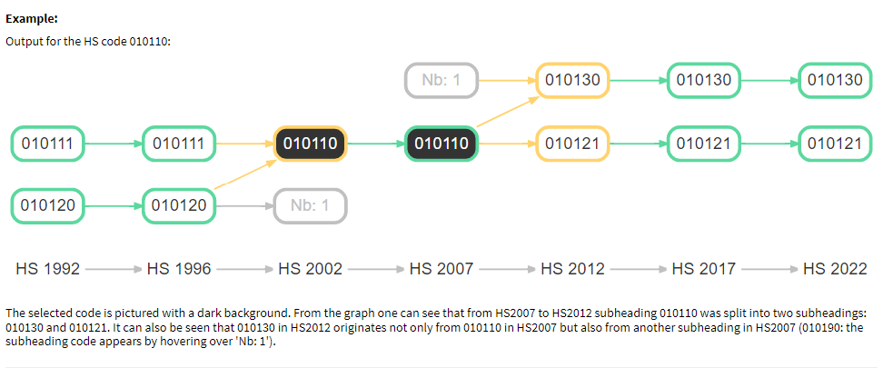

- Model specification and interpretation
Building on the theoretical foundation in the gravity equation, we use a structural gravity model and follow the methodology set out by Baier et al (2019) to isolate the impact of FTAs on NTMs.
Following Santos Silva & Tenreyro (2006) in best practice in gravity modelling, we have specified the model using PPML to account for heteroskedasticity and overcome the issue of zero trade flows. The specification in (1) below includes the partial effect of an ‘average’ FTA signed between 2000 and 2016. The specification in (2) captures the effect of an individual FTA, controlling for existing FTAs:
- $x_{ij,k}=exp\left(β_{1}{Average_ FTA}_{ij,t}+β_{2}{globalisation}_{ij}+β_{3}{EU}_{ij}+π_{i,t}+ x_{j,t}+γ_{ij}\right)+\left(ε_{ij,t}\right)$
- $x_{ij,k}=exp\left(β_{1}{Average_FTA}_{ij,t}+β_{2}{globalisation}_{ij}{+ β}_{3}{EU_KOR}_{ij}{+ β}_{4}{KOR_EU}_{ij}+π_{i,t}+ x_{j,t}+γ_{ij}\right)+\left(ε_{ij,t}\right)$

Where:
- $x_{ij,k}$ is a trade flow between I and j in sector k
- $β_{1}{Average_FTA}_{ij}$ is equal to 1 if i and j have signed an FTA at time t and 0 otherwise
- $β_{1}{Average_FTA}_{ij}$ in equation (2) is equal to 1 if i and j have signed an FTA at time t and 0 otherwise, the individual agreements (such as EU-Korea) are turned to 0 to allow for isolated impact to be captured by the individual FTA variables (EU_KOR or KOR_EU)
- $β_{2}{globalisation}_{ij}$ is equal to year at time t if exporter and importer differ, 0 otherwise to control for effects of openness, effectively creating another fixed effect variable.
- $β_{3}{EU}_{ij}$ is equal to 1 if exporter and importer are both EU members, 0 otherwise
- $β_{4}{KOR_EU}_{ij}$ is equal to 1 if trade partners are EU members or South Korea, 0 otherwise
- $π_{i,t}$ are the exporter-time fixed effects
- $x_{j,t}$ are the importer-time fixed effects
- $γ_{ij}$ are the pair fixed effects
- $ε_{ij,t}$ is the error term

As the variance in trade flows caused by tariffs is accounted for via the adjustment set out in equation 3 below, the FTA variable should be capturing the residual removal of barriers other than tariffs. In other words, this allows us to capture the change in NTMs following an FTA.
We can interpret our key coefficient of interest (the FTA variable) as that of an impact of average FTA other than membership of the European Union. As the key source of variation comes from an FTA being signed between two partners over our time period, the result is relative to the state of the world before FTAs were signed. In case of the individual FTAs, we take these agreements out of the ‘average FTA’ variable to allow for their impact to be isolated by the individual FTA variables. The coefficients on individual FTA variables (such as EU_KOR) should be understood as the drop in NTM relative to the period prior to FTA signature (2011 in case of EU-Korea). In equation (1), we control for membership of the EU because of the depth of the trading relationship within the EU, which is unprecedented and unlikely to be matched by most FTAs. We find that the inclusion of the EU dummy has very minimal impact on the magnitude of the average FTA results, although it slightly reduced the number of significant results. This is likely due to the time period covered in our dataset, which spans the 2000-2016 period and only captures the 2004, 2007 and 2013 EU expansions. Membership of the EU in case of countries that joined prior to 2000 is captured in the pair fixed effects.
Controlling for globalisation has a more pronounced impact on services compared to goods sectors. For example, including the globalisation variable lowers the magnitude of NTM reduction (in AVE terms) in financial services (ofi) and other business services (obs) by approximately 9 and 7 percentage points respectively.
Following best practice in gravity modelling, we have used the exporter-year, importer-year to account for the theoretical ‘multilateral resistance terms and pair fixed effects that control for all time-invariant determinants of trade between i and j. In other words, as the fixed effects control for all time-invariant importer and exporter characteristics (such as national policies or GDP) and determinants of bilateral trade (such as distance between two partners), we can isolate the effect that trade policy (such as tariffs or presence of an FTA) has on trade.
We also control for the presence of tariffs, such suggested by Shepherd (2021). Tariffs, more so than FTAs, are subject to endogeneity issues due to policy makers being able to adjust them more readily compared to signing an FTA. We apply an adjustment to the trade flows using equation 3 below to account for the impact of a tariff on trade. This also has an effect of reducing the endogeneity caused by the tariff variable. Key sensitivity of this adjustment is the reliance on $σ$ (elasticity estimates).
- $\frac{X_{ij}}{{(1+τ_{ij})}^{σ}}= X_{i}M_{j}d_{ij}^{σ}$
The model is set up at a sectoral level, controlling for the effects of countries’ openness and globalisation through the inclusion of a globalisation dummy that takes on a value of 0 for intranational observation and the year value otherwise, effectively creating another fixed effect variable.

- Limitations
- The aim of this paper is to explore more gradual results (per individual FTA, per sector) than what is currently available in the literature, using the ITPD-E dataset. The key limitation of exploring such gradual impacts is the limited variation in the data available, which increases the level of noise and is estimated with some unobserved error. Such estimates could still be used for insights through a second-stage regression, for example using FTA-level provisions, which we want to explore in our future work.
- The model set out in this paper is an estimation model and the results should be interpreted as partial before third-country effects are accounted for. FTAs have an effect on third-countries in spite of them not signing the agreement, which will not be captured in our estimates. As we only run one stage regression to obtain the FTA coefficients, our model does not allow for third-country effects to adjust.
- As the gravity model infers NTM changes from trade flows, it could be that the reduction in NTMs faced by exporters after an FTA comes into effect does not translate directly to an increase in exports. This could be due to exporters ‘absorbing’ the reduction in cost in the form of rent. Even though the NTM would reduce in the real world, our model would not capture such a reduction.
- The inclusion of importer-year, exporter-year and pair fixed effects controls for the importer, exporter and bilateral characteristics. However, is it possible that the FTA variable captures other factors aside from NTMs, such as changes in consumer preference.
- FTA effects on trade flows may take a few years to transpire. To account for this, Olivero and Yotov (2012) allow for phased-in effects by creating 5-year lags. We want to explore directional impact of FTAs and lagged FTA effect in the future, mostly in cases of FTAs that were signed closer to 2000 (beginning of the time period covered by our dataset).
- Although we have controlled for endogeneity through using pair fixed effects to the extent possible within the gravity framework, trade policy, including signing of an FTA can suffer from endogeneity. Coefficients should therefore be interpreted with caution.
- Results
The following section outlines the results of our model. Note that all results should be interpreted as partial impacts as opposed to general equilibrium impacts. That is, they do not account for third-country effects. See point 2 above for more information on why this is the case.

  - Average FTA
The coefficients on the Average_FTA variable listed in table 1 and individual FTAs (EU-Korea, US-Korea) can be converted to an ad-valorem equivalent (AVE) using the following formula from the WTO Advanced gravity guide:
- $AVE=\left(exp\left(\frac{β}{-σ}\right)-1\right)$*100
Where $σ$ is the GTAP Armington elasticity.
Taking the example of paddy rice (pdr) $β$ coefficient of 1.3 and $σ$ of 10.1, an average FTA (controlling for EU membership and tariffs), has had a partial reduction effect on NTMs in this sector of 12.03% in tariff equivalent terms.
6.2 Average FTA results
Using the specification in (1) above, our gravity model estimates statistically significant results at p<0.1 for under a half of the modelled GTAP65 sectors (25 out of the 58 sectors). All statistically significant results in goods sectors have a positive coefficient, implying that FTAs are trade promoting and have reduced NTMs, once we control for tariffs and EU membership. Broadly, agricultural sectors saw the largest NTM reductions, followed by manufacturing sectors which showed similar level of reductions across. Some service sectors, such as financial or business services saw an NTM reduction.
In the case of services sectors, 65% of coefficients on the FTA variable turn negative, implying an increase in NTMs in sectors where the coefficient is below zero. This is in contrast to the sign we would normally expect the FTA variable to have (FTA is expected to have a trade-enhancing effect) although it is not uncommon in the literature to come across ‘negative’ impacts. See graph 1 for a graphical summary of the NTM reductions (in AVE terms) across sectors that have showed significant results.
Graph 1: Distribution of NTM changes (significant results only)
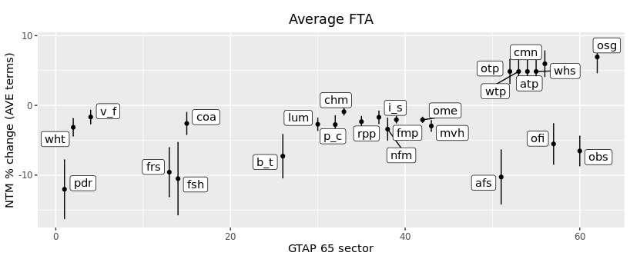
Goods
Services
Amongst the significant goods results, FTAs have, on average, reduced NTMs in agricultural sectors the most. This included rice (12.03%), fishing (10.51%) and forestry (9.58%). The smallest NTM reductions were in chemicals, vegetables and fruit (v_f) and iron and steel (i_s). NTM reductions in manufacturing sectors were clustered close together; most of them were in the range from 0.91% to 3.41% (AVE terms).
In services sectors, accommodation and food services, other business services and financial services and have seen an NTM reduction of 10.27%, 6.54% and 5.54% in AVE terms respectively. Conversely, other services (such as government services) or information and communication services have seen an increase in NTMs of 6.94% and 5.97% in AVE terms respectively.
6.3 Average FTA specification, results tables
For presentational purposes, only statistically significant results are included in this section. Please see annex A for full list of GTAP65 codes and their description.
Table 1: FTA coefficients, significant results only
Sector code | Average_FTA | Standard error | SE type
pdr | 1.295*** | (0.435) | Pair
wht | 0.284** | (0.112) | Pair
v_f | 0.062* | (0.036) | Pair
frs | 0.504*** | (0.179) | Pair
fsh | 0.278** | (0.133) | Pair
coa | 0.16* | (0.097) | Pair
b_t | 0.174** | (0.073) | Pair
lum | 0.187*** | (0.061) | Pair
p_c | 0.117** | (0.054) | Pair
chm | 0.06* | (0.031) | Pair
rpp | 0.156*** | (0.049) | Pair
i_s | 0.101* | (0.053) | Pair
nfm | 0.292** | (0.135) | Pair
fmp | 0.156*** | (0.036) | Pair
ome | 0.169*** | (0.03) | Pair
mvh | 0.168*** | (0.044) | Pair
afs | 0.412*** | (0.151) | Pair
otp | -0.181*** | (0.066) | Pair
wtp | -0.181*** | (0.066) | Pair
atp | -0.181*** | (0.066) | Pair
whs | -0.181*** | (0.066) | Pair
cmn | -0.22*** | (0.07) | Pair
ofi | 0.216* | (0.112) | Pair
obs | 0.257*** | (0.082) | Pair
osg | -0.255*** | (0.087) | Pair

  - Effects of individual FTAs
The second group of results is focused on the impact of individual FTAs using specification in (2). The two FTAs we focus the analysis on are between EU-Korea and US-Korea. To isolate the impact of the FTA under examination, we exclude the individual FTA from the average FTA variable. For example, when modelling US-Korea FTA, we turn all US-Korea FTA observations under the Average_FTA to 0. A separately dummy variable US_KOR is then created and equals 1 for all US-Korea observation after 2012 (when the agreement came into force). The coefficient on the US_KOR FTA variable can be interpreted as the total reduction or increase in NTMs between the US and Korea after the FTA came into effect, once all existing FTA signed by the two partners are accounted for.

As highlighted by Baier et at (2019), a sizable portion (1/3) of the variation amongst FTAs originates from the is due to asymmetric effects “within pairs”. We therefore also allow for the effect of the FTA to vary directionally by including a dummy for directional pairs. The coefficients on the EU_KOR and KOR_EU variables can now be interpreted as the NTM reduction or increase faced by the EU when exporting to Korea and reduction or increase experienced by Korea when exporting to the EU respectively.

The magnitude of individual FTA coefficients is higher compared to average FTA estimates, likely due to the small number of observations connected to individual agreements in the data as opposed to data points connected to an average FTA as shown in tables 1 to 5 below.

  - EU-Korea FTA, directional effects
The EU-Korea FTA was signed in 2009, provisionally applied from 2011 and officially ratified in 2015. The agreement eliminated duties on industrial and agricultural goods in a progressive, step-by-step manner. The majority of import duties were removed in 2011 and the FTA also addresses non-tariff barriers to trade, specifically in the automotive, pharmaceutical, medical devices and electronics sectors. Our model estimates positive and significant reductions in NTMs faced by EU exporters in Korea in the automotive and electronics sectors and a drop in chemicals based by Korean exporters to the EU. This is broadly is in line with the ex-ante expectations of the FTA. Overall, the EU-Korea NTMs followed a similar pattern to the average FTA results – somewhat higher reductions in agricultural sectors, manufacturing reductions were of similar magnitude and services saw more sectors in which NTMs increased.

NTMs faced by EU exporters to Korea
The agreement lowered NTMs in over a half of the significant sectors faced by EU exporters to Korea. Contrasting these to the ex-ante expectations set out by the European Commission, our analysis suggests that EU exporters experienced a drop in NTMs in the automotive sector (mvh) of 11.92% (in AVE terms). This drop in automotive NTMs could reflect the fact that following the FTA, EU manufacturers were no longer required to produce cars specifically for the Korean market or conduct expensive tests to demonstrate compliance with safety standards. The NTMs in the electronics sector (eeq) were lowered by 4.31% in (AVE terms). The FTA aimed to lower barriers in services, mostly in telecommunication, transport, construction, financial or business services however those sectors come out as insignificant in our model. Out of the significant services results, most (83%) were negative.

Graph 2: Distribution of EU_Korea NTM changes (significant results only)
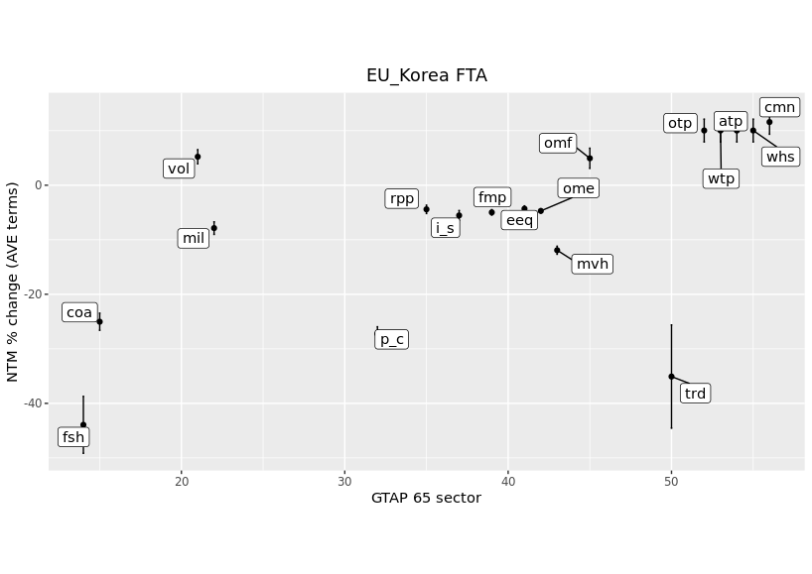
Goods
Services
NTM faced by Korean exporters to the EU
Chemicals (chm) saw a reduction in NTMs of 6.65% and agricultural sectors experienced reductions in all significant NTMs, as high as 57.3% in ‘other grains’ (gro). Conversely, Korean exporters faced an increase in NTMs in the electronics sector (ele) of 4.26% (AVE terms) while motor vehicles came out as insignificant.

Graph 3: Distribution of Korea_EU NTM changes (significant results only)
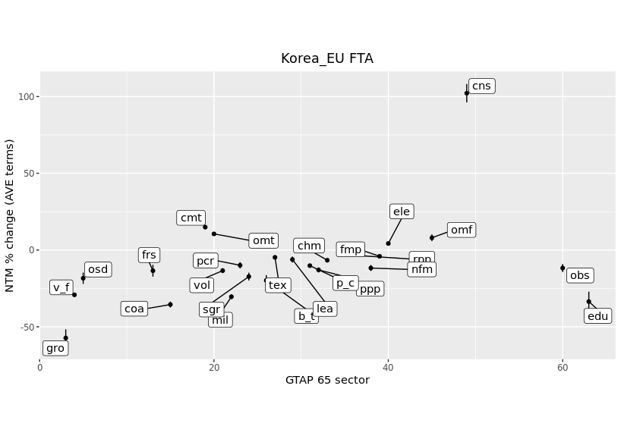
Services
Goods

Regression tables
Table 2: EU-Korea FTA coefficients
Sector code | EU_KOR | Standard error | SE type
fsh | 1.447*** | (0.296) | Pair
coa | 1.758** | (0.71) | Pair
vol | -0.336*** | (0.123) | Pair
mil | 0.598** | (0.268) | Pair
p_c | 1.336*** | (0.257) | Pair
rpp | 0.298*** | (0.098) | Pair
i_s | 0.336** | (0.15) | Pair
fmp | 0.383*** | (0.13) | Pair
eeq | 0.388** | (0.179) | Pair
ome | 0.391*** | (0.123) | Pair
mvh | 0.711*** | (0.104) | Pair
omf | -0.362* | (0.187) | Pair
trd | 1.642*** | (0.46) | Pair
otp | -0.363* | (0.217) | Pair
wtp | -0.363* | (0.217) | Pair
atp | -0.363* | (0.217) | Pair
whs | -0.363* | (0.217) | Pair
cmn | -0.417** | (0.207) | Pair

Table 3: Korea-EU FTA coefficients
Sector code | KOR_EU | Standard error | SE type
gro | 2.212*** | (0.637) | Pair
v_f | 1.276*** | (0.194) | Pair
osd | 0.994*** | (0.299) | Pair
frs | 0.724*** | (0.268) | Pair
coa | 2.676*** | (0.456) | Pair
cmt | -1.071** | (0.42) | Pair
omt | -0.88** | (0.366) | Pair
vol | 0.951*** | (0.36) | Pair
mil | 2.648*** | (0.757) | Pair
pcr | 0.544** | (0.221) | Pair
sgr | 1.025** | (0.439) | Pair
b_t | 0.507** | (0.246) | Pair
tex | 0.367** | (0.148) | Pair
lea | 0.516* | (0.279) | Pair
ppp | 0.633*** | (0.161) | Pair
p_c | 0.582** | (0.246) | Pair
chm | 0.454*** | (0.119) | Pair
rpp | 0.204** | (0.102) | Pair
nfm | 1.046*** | (0.293) | Pair
fmp | 0.313*** | (0.112) | Pair
ele | -0.367*** | (0.13) | Pair
omf | -0.577*** | (0.185) | Pair
cns | -2.675*** | (0.634) | Pair
obs | 0.474* | (0.273) | Pair
edu | 1.554** | (0.728) | Pair

  - US-Korea FTA
The US-Korea FTA came into force in 2012 and focused primarily on tariff removal, as opposed to NTMs. Most NTM clauses were drafted to have a cross-sectoral impact, such as stronger protection and enforcement of intellectual property rights in Korea or enhanced market access to services market for US companies. The FTA also aimed to harmonise automotive and testing standards to enable US car exporters to enter the market. Services sectors, particularly finance and legal services also saw liberalisation, including in data flow transfer. Our results are broadly in line with the ex-ante expectations of the FTA; motor vehicles, manufacturing and financial and business services saw a drop in NTMs faced by US exporters to Korea. Korean exporters also faced lower NTMs in motor vehicles.

NTMs faced by US exporters to Korea
In line with the expectations of the FTA outlined by the USTR, our model shows that the US-Korea FTA lowered NTMs faced by US exporters to Korea in the automotive sector (mvh) by 13.4% (in AVE terms) as well as other manufacturing sectors (eeq, ome). The FTA also lowered NTMs in agricultural sectors. Additionally, four out of ten of the significant services results showed a reduction in NTMs (csn, ofi, obs, edu). The reduction in other business services (obs) and financial services (ofi) NTM are as expected ex-ante and could be a result of IP or data flow transfer liberalisation.

Graph 4: Distribution of US_Korea NTM changes (significant results only)
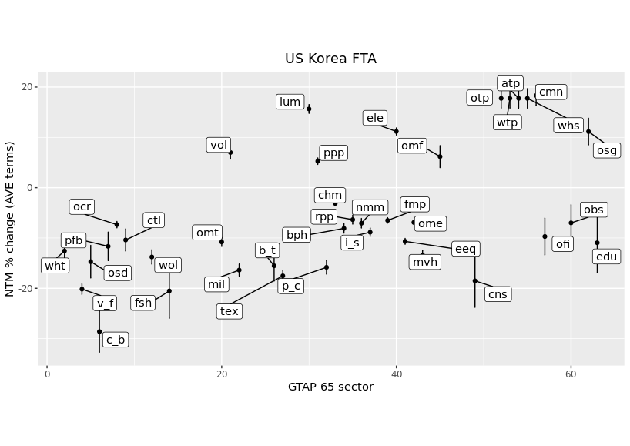
Services
Goods

NTMs faced by Korean exporters to the US
NTMs in the automotive sector (mvh) decreased by 7.39% in AVE terms as well as manufacture of machinery and equipment (ome), as expected ex-ante. The electronic manufacturing sector (eeq) saw a fall in NTMs of 6.41% while manufacturing of computers (ele) saw an increase of 7.71%. Services sectors saw mostly an increase in NTMs, except for the education sector (edu). Financial and business services came out as insignificant. In contrast to the NTMs faced by EU exporter to Korea, Korean exporters to the US saw an increase in some agricultural NTMs, such as cane and beet and fibres and crops (c_b and pfb). As noted above, positive results are likely a consequence of estimating changes on a granular sectorial level and per individual agreement.

Graph 5: Distribution of Korea_US NTM changes (significant results only)
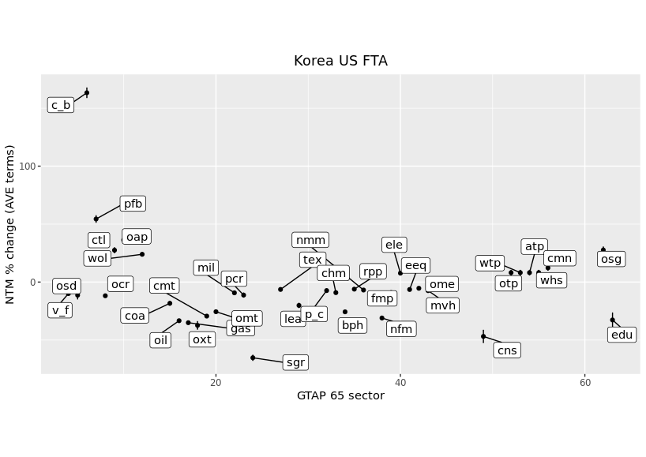
Services
Goods
US-Korea regression tables
Table 4: US-Korea FTA coefficients
Sector code | US_KOR | Standard error | SE type
wht | 0.511** | (0.199) | Pair
v_f | 0.856*** | (0.109) | Pair
osd | 0.605*** | (0.093) | Pair
c_b | 1.28*** | (0.346) | Pair
pfb | 0.471*** | (0.146) | Pair
ocr | 0.29*** | (0.111) | Pair
ctl | 0.417* | (0.241) | Pair
wol | 0.563** | (0.265) | Pair
fsh | 0.873*** | (0.194) | Pair
omt | 0.434** | (0.185) | Pair
vol | -0.257* | (0.138) | Pair
mil | 0.68*** | (0.158) | Pair
b_t | 0.642** | (0.29) | Pair
tex | 0.732*** | (0.171) | Pair
lum | -0.552*** | (0.161) | Pair
ppp | -0.195** | (0.088) | Pair
p_c | 0.655*** | (0.159) | Pair
chm | 0.121** | (0.048) | Pair
bph | 0.321** | (0.126) | Pair
rpp | 0.25*** | (0.067) | Pair
nmm | 0.279*** | (0.096) | Pair
i_s | 0.352*** | (0.099) | Pair
fmp | 0.256*** | (0.096) | Pair
ele | -0.402*** | (0.117) | Pair
eeq | 0.429*** | (0.142) | Pair
ome | 0.272*** | (0.068) | Pair
mvh | 0.547*** | (0.166) | Pair
omf | -0.228** | (0.113) | Pair
cns | 0.778* | (0.452) | Pair
otp | -0.621*** | (0.094) | Pair
wtp | -0.621*** | (0.094) | Pair
atp | -0.621*** | (0.094) | Pair
whs | -0.621*** | (0.094) | Pair
cmn | -0.639*** | (0.107) | Pair
ofi | 0.388** | (0.155) | Pair
obs | 0.276* | (0.145) | Pair
osg | -0.402** | (0.185) | Pair
edu | 0.441* | (0.267) | Pair

Table 5: Korea-US FTA coefficients
Sector code | KOR_US | Standard error | SE type
v_f | 0.397*** | (0.106) | Pair
osd | 0.456*** | (0.102) | Pair
c_b | -3.679*** | (0.456) | Pair
pfb | -1.651*** | (0.46) | Pair
ocr | 0.477*** | (0.113) | Pair
ctl | -0.923* | (0.525) | Pair
oap | -1.177*** | (0.188) | Pair
wol | -0.816* | (0.469) | Pair
coa | 0.769** | (0.389) | Pair
oil | 1.541*** | (0.43) | Pair
gas | 1.64*** | (0.288) | Pair
oxt | 1.778*** | (0.201) | Pair
cmt | 1.321*** | (0.265) | Pair
omt | 1.123*** | (0.175) | Pair
mil | 0.37* | (0.21) | Pair
pcr | 0.453* | (0.274) | Pair
sgr | 4.021*** | (0.227) | Pair
tex | 0.249* | (0.148) | Pair
lea | 0.854*** | (0.273) | Pair
p_c | 0.289** | (0.139) | Pair
chm | 0.363*** | (0.071) | Pair
bph | 1.127*** | (0.17) | Pair
rpp | 0.239*** | (0.084) | Pair
nmm | 0.27** | (0.125) | Pair
nfm | 1.41*** | (0.263) | Pair
fmp | 0.36*** | (0.074) | Pair
ele | -0.282*** | (0.087) | Pair
eeq | 0.252*** | (0.08) | Pair
ome | 0.209*** | (0.051) | Pair
mvh | 0.292*** | (0.068) | Pair
cns | 2.403*** | (0.547) | Pair
otp | -0.297*** | (0.086) | Pair
wtp | -0.297*** | (0.086) | Pair
atp | -0.297*** | (0.086) | Pair
whs | -0.297*** | (0.086) | Pair
cmn | -0.439*** | (0.098) | Pair
osg | -0.928** | (0.375) | Pair
edu | 1.504* | (0.819) | Pair
- Policy implications and conclusion
Following gravity theory, our model was set up in line with the latest developments and best practice in gravity modelling to estimate the impact of past FTAs on NTMs across GTAP65 sectors in three FTA scenarios. We run to model specifications: first to focus on the overall pooled sample of FTAs to understand ‘average FTA’ impacts on NTMs and second to investigate the analogous impacts for two particular FTAs: US-Korea and EU-Korea.
In the case of an ‘average FTA’, agricultural sectors saw the largest NTM reductions, followed by manufacturing sectors which showed similar level of reductions across. Although traditionally traded service sector, such as financial or business services saw NTM reductions, services mostly experienced an NTM increase as opposed to reduction. This is likely due to lower number of observations connected to individual agreements. The average FTA has lowered NTMs all goods sectors that produced significant results, such agriculture (paddy rice, wheat) and manufacturing (motor vehicles or petroleum) and services sectors such as financial services and other business services.
Estimating the effect of the ‘average’ FTA gives us results of lower magnitude, compared to individual FTAs (EU-Korea and US-Korea). The results of both individual FTAs we examine (EU-Korea and US-Korea) are broadly in line with what the FTAs were expected to deliver in sectors that were the focus of the agreements. Specifically, the EU-Korea FTA lowered NTMs in motor vehicles and electronics faced by EU exporters to Korea. The FTA was also expected to lower NTMs in pharmaceuticals and medical devices, which remain unconfirmed by our results. Conversely, the NTMs faced by Korean exporters to the EU increased in electronics sectors and decreased in agricultural sectors. The US-Korea results show NTM reduction in the motor vehicle sector, which was a focus of the FTA and is therefore in line with expectations. US exporters to Korea also saw a drop in financial and other business services, most likely impact by data flows and IP liberalisation.
This paper constitutes a first step in the exploration of methodologies that can be used to estimate NTMs at the UK Department of International Trade. We are currently exploring the next steps we can take to ultimately produce NTM reductions tailored to the contents of new FTAs signed by the United Kingdom. Future steps include extending the estimation to more FTAs in our sample. Subject to obtaining reliable estimates in the first stage estimation, a second stage regression will follow to explore the contents of specific FTAs, using the World Bank database of Free Trade Agreements. This exercise could provide insights into which provisions are driving the overall impact of the agreement.

Bibliography
Baier, Scott L., Yoto V. Yotov and Thomas Zylkin. "On the Widely Differing Effects of Free Trade Agreements: Lessons from Twenty Years of Trade Integration." Journal of International Economics 116 (2019): 206-226. https://doi.org/10.1016/j.jinteco.2018.11.002.
Borchert, I., Larch, M., Shikher, S., and Yotov, Y. (2021), “The International Trade and Production Database for Estimation (ITPD-E)”, International Economics, 166, 140–166.
Olivero, M. P. and Yotov, Y. V. (2012) Dynamic Gravity: Endogenous Country Size and Asset Accumulation. Canadian Journal of Economics 45[1], 64-92.
Santos Silva, J. M. C. and Tenreyro, S. (2006) The Log of Gravity. The Review of Economics and Statistics 88[4], 641-658.
Shepherd, B. (2021) Gravity Modelling Tips and Traps: A Crash Course for Practitioners. Trade Policy Research Forum.
Yotov and Piermartini “The Advanced Guide to Trade Policy Analysis: The Structural Gravity Model”, 2016 WTO Press

Annex A: GTAP sectors, codes and description
Sector number | Sector code | Sector description
1 | pdr | Rice: seed, paddy (not husked)
2 | wht | Wheat: seed, other
3 | gro | Other Grains: maize (corn), sorghum, barley, rye, oats, millets, other cereals
4 | v_f | Veg & Fruit: vegetables, fruit and nuts, edible roots and tubers, pulses
5 | osd | Oil Seeds: oil seeds and oleaginous fruit
6 | c_b | Cane & Beet: sugar crops
7 | pfb | Fibres crops
8 | ocr | Other Crops: stimulant; spice and aromatic crops; forage products; plants and parts of plants used primarily in perfumery, pharmacy, or for insecticidal, fungicidal or similar purposes; beet seeds (excluding sugar beet seeds) and seeds of forage plants; natural rubber in primary forms or in plates, sheets or strip, living plants; cut flowers and flower buds; flower seeds, unmanufactured tobacco; other raw vegetable materials nec
9 | ctl | Cattle: bovine animals, live, other ruminants, horses and other equines, bovine semen
10 | oap | Other Animal Products: swine; poultry; other live animals; eggs of hens or other birds in shell, fresh; reproductive materials of animals; natural honey; snails, fresh, chilled, frozen, dried, salted or in brine, except sea snails; edible products of animal origin n.e.c.; hides, skins and furskins, raw; insect waxes and spermaceti, whether or not refined or coloured
11 | rmk | Raw milk
12 | wol | Wool: wool, silk, and other raw animal materials used in textile
13 | frs | Forestry: forestry, logging and related service activities
14 | fsh | Fishing: hunting, trapping and game propagation including related service activities, fishing, fish farms; service activities incidental to fishing
15 | coa | Coal: mining and agglomeration of hard coal, lignite and peat
16 | oil | Oil: extraction of crude petroleum, service activities incidental to oil and gas extraction excluding surveying (part)
17 | gas | Gas: extraction of natural gas, service activities incidental to oil and gas extraction excluding surveying (part)
18 | oxt | Other Mining Extraction (formerly omn): mining of metal ores; other mining and quarrying
19 | cmt | Cattle Meat: fresh or chilled; meat of buffalo, fresh or chilled; meat of sheep, fresh or chilled; meat of goat, fresh or chilled; meat of camels and camelids, fresh or chilled; meat of horses and other equines, fresh or chilled; other meat of mammals, fresh or chilled; meat of mammals, frozen; edible offal of mammals, fresh, chilled or frozen
20 | omt | Other Meat: meat of pigs, fresh or chilled; meat of rabbits and hares, fresh or chilled; meat of poultry, fresh or chilled; meat of poultry, frozen; edible offal of poultry, fresh, chilled or frozen; other meat and edible offal, fresh, chilled or frozen; preserves and preparations of meat, meat offal or blood; flours, meals and pellets of meat or meat offal, inedible; greaves
21 | vol | Vegetable Oils: margarine and similar preparations; cotton linters; oil-cake and other residues resulting from the extraction of vegetable fats or oils; flours and meals of oil seeds or oleaginous fruits, except those of mustard; vegetable waxes, except triglycerides; degras; residues resulting from the treatment of fatty substances or animal or vegetable waxes; animal fats
22 | mil | Milk: dairy products
23 | pcr | Processed Rice: semi- or wholly milled, or husked
24 | sgr | Sugar and molasses
25 | ofd | Other Food: prepared and preserved fish, crustaceans, molluscs and other aquatic invertebrates; prepared and preserved vegetables, pulses and potatoes; prepared and preserved fruits and nuts; wheat and meslin flour; other cereal flours; groats, meal and pellets of wheat and other cereals; other cereal grain products (including corn flakes); other vegetable flours and meals; mixes and doughs for the preparation of bakers' wares; starches and starch products; sugars and sugar syrups n.e.c.; preparations used in animal feeding; lucerne (alfalfa) meal and pellets; bakery products; cocoa, chocolate and sugar confectionery; macaroni, noodles, couscous and similar farinaceous products; food products n.e.c.
26 | b_t | Beverages and Tobacco products
27 | tex | Manufacture of textiles
28 | wap | Manufacture of wearing apparel
29 | lea | Manufacture of leather and related products
30 | lum | Lumber: manufacture of wood and of products of wood and cork, except furniture; manufacture of articles of straw and plaiting materials
31 | ppp | Paper & Paper Products: includes printing and reproduction of recorded media
32 | p_c | Petroleum & Coke: manufacture of coke and refined petroleum products
33 | chm | Manufacture of chemicals and chemical products
34 | bph | Manufacture of pharmaceuticals, medicinal chemical and botanical products
35 | rpp | Manufacture of rubber and plastics products
36 | nmm | Manufacture of other non-metallic mineral products
37 | i_s | Iron & Steel: basic production and casting
38 | nfm | Non-Ferrous Metals: production and casting of copper, aluminium, zinc, lead, gold, and silver
39 | fmp | Manufacture of fabricated metal products, except machinery and equipment
40 | ele | Manufacture of computer, electronic and optical products
41 | eeq | Manufacture of electrical equipment
42 | ome | Manufacture of machinery and equipment n.e.c.
43 | mvh | Manufacture of motor vehicles, trailers and semi-trailers
44 | otn | Manufacture of other transport equipment
45 | omf | Other Manufacturing: includes furniture
46 | ely | Electricity; steam and air conditioning supply
47 | gdt | Gas manufacture, distribution
48 | wtr | Water supply; sewerage, waste management and remediation activities
49 | cns | Construction: building houses factories offices and roads
50 | trd | Wholesale and retail trade; repair of motor vehicles and motorcycles
51 | afs | Accommodation, Food and service activities
52 | otp | Land transport and transport via pipelines
53 | wtp | Water transport
54 | atp | Air transport
55 | whs | Warehousing and support activities
56 | cmn | Information and communication
57 | ofi | Other Financial Intermediation: includes auxiliary activities but not insurance and pension funding
58 | ins | Insurance (formerly isr): includes pension funding, except compulsory social security
59 | rsa | Real estate activities
60 | obs | Other Business Services nec
61 | ros | Recreation & Other Services: recreational, cultural and sporting activities, other service activities; private households with employed persons (servants)
62 | osg | Other Services (Government): public administration and defense; compulsory social security, activities of membership organizations n.e.c., extra-territorial organizations and bodies
63 | edu | Education
64 | hht | Human health and social work
65 | dwe | Dwellings: ownership of dwellings (imputed rents of houses occupied by owners)

Note that this paper does not represent UK government views or policy in any way.
The magnitude of financial services AVE is reduced from -14.81% to -5.54% while other business services AVE decreases from -13.16% to -6.54%
We use the GTAP Armington elasticities at the GTAP65 level.
WTO Advanced guide to gravity modelling, page 30
Armingtons used in this paper have been taken from the GTAP database Version 10.1.
We have not modelled all of 65 GTAP sectors for the following reasons: sectors 11 (rmk – raw milk) and 25 (ofd – other food) were not modelled due to missing tariffs in the dataset. Sectors 48 (wtr – Water, sewerage, purification), 59 (rsa – Real Estate Activity), 61 (ros – recreational and other services), 65 (dwe – dwellings) have missing data or are not traded internationally. Sector 47 (gdt) tends to cause the model not to converge and has therefore been dropped.
See equation (5) on page 6 for the relationship between coefficient and AVE.
We use 2011 as the year when the agreement came into effect.
European Commission
European Commission: Market access following the EU-Korea FTA
European Commission: Market access following the EU-Korea FTA
Factsheet on US-Korea FTA, Office of the United Sates Office Representative
Congressional Research Service, 2022

