Conservation benefits from retiring land in neighboring locations offset welfare costs
Cisneros-Pineda, Alfredo; Ray, Srabashi
Background and Motivation
Natural land provides society with services that are not always recognized in markets, such as habitat for native species and services provided to neighboring farmland by non-agricultural land. Apart from material services (e.g., honey, wax), biodiverse and healthy ecosystems offer several intangible services to farmers, such as regulating (e.g., pollination, increased yields) and non-material services (e.g., recreational), that current markets do not fully recognize (IPBES 2019). When market prices do not reflect the full array of the uses and (environmental) costs of conserving land, there is a market failure that arises from the disconnect between who benefits from and who provides these services. To address this issue, the Conservation Reserve Program (CRP) was launched in 1985 by the Farm Service Agency (FSA) to promote land retirement from agricultural production (FSA, 2024).
The CRP is a land conservation program that pays an annual rent for up to 15 years to farmers that agree to remove environmentally sensitive land from production and plant species that will improve environmental health and quality (FSA, 2024). The Honey Bee Habitat Initiative enhances CRP covers by establishing cost effective seed mixes to provide better nutrition for bees (FSA, 2015). The FSA (2015) reports that bee pollination supports about $15 billion in agricultural production, including over 130 fruits, vegetables, and crops in North America. Nonetheless, the commercial honey bee colonies fell by more than 30% from 1989 to 2008 (USDA, 2024) while the CRP program was active. Furthermore, the acres under CRP contract have steadily decreased since 2007 (Coppess, 2017) and agricultural activities may be contributing to stress bee colonies by increasing the presence of pesticides (ARS, 2022). In this context, localized policies, such as CRP, are very likely to generate market-mediated spillovers such as the ecosystem services provided by bees, but also agricultural activities create negative externalities on neighboring natural land.
Methodology
The Simplified International Model of agricultural Prices, Land use, and the Environment Gridded version (SIMPLE-G), is a framework that allows the interplay between economic and environmental systems (Baldos et al. 2020). Cisneros-Pineda et al. (2023) describe the challenge of modelling spillover effects to study the propagation of local conservation policies into large-scale economic outcomes; to address this challenge, they propose linking models such as GTAP to spatially explicit models of ecosystem services. Here we add a spatial mechanism based on neighboring grid-cells to the SIMPLE-G model.
The types of spillover effects associated with the ecological impacts of the CRP program depend upon the surrounding spatial characteristics of the land enrolled. Land retirement leads to agricultural output reduction in the regions where farmers enroll cropland into the CRP program, which could have a price impact, and this market information will be conveyed to other regions where farmers can be expected to respond. Simultaneously, land conservation reduces local use of pesticides and promotes bee pollination of neighbor agricultural land, and other farmers’ responses may increase the regional use of pesticides.
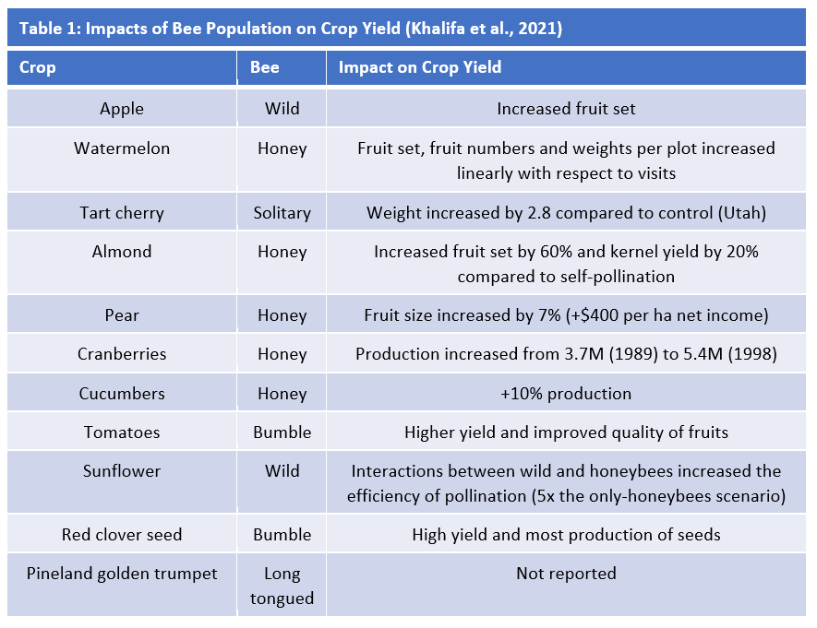
In this paper, we propose an application of the SIMPLE-G model that accounts for spatial patterns of natural and agricultural land based on the grid cells defined in the model. The goal is to evaluate the ecological benefits of land retirement under the CRP program in the United States (US). Prior analyses of the CRP have omitted the non-market spatial benefits of retiring land for conservation purposes (Birur, Hertel, and Tyner 2010). In this paper, we compare two scenarios of the impact of cropland retirement historically under the CRP program, using SIMPLE-G. The baseline scenario ignores the non-market benefits of CRP land on neighboring grid-cells, such that the resulting prices and other economic variables will reflect only the private economic costs and ignore the social benefits. The second scenario incorporates the non-market benefits of land retirement on land productivity in the Fruitful Rim region.

Shocks
We test a basic spillover case as shown in Figure 1 We assume different scenarios of the increase in total factor productivity (TFP) ranging from XX-XX% as reported by Seibert and Hertel (2022).
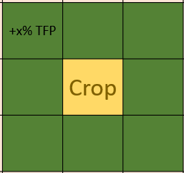
Figure 1. Only cropland grid-cells completely surrounded by natural land receive the maximum amount of TFP boost.
First, we look at the Natural Land Cover Dataset (NLCD, 2024) and isolate the grid cells that are considered cultivated cropland (code 82) and natural land within the Fruitful Rim region. We define natural land as the union of all grid cells considered woody wetlands (code 90), emergent herbaceous wetlands (code 95), deciduous forest (code 41), evergreen forest (code 42), or mixed forest (code 43).
Second, we count the number of natural-land grid-cells that are directly neighboring cropland grid-cells in a queen style arrangement. The highest number of grid-cells that can be accounted for is 8: three in the upper row, three in the lower row, and two on each side.
Third, we assume that all cropland grid-cells that are neighboring a single natural-land grid-cell will be subscribed to the CRP program and all other cropland grid-cells that are not near natural land or that are surrounded by 2 or more natural-land grid-cells remain unchanged.
Fourth, we consolidate the resulting cropland before and after shocks into big grid-cells that match the size of SIMPLE-G grid-cells, which is the equivalent to 33 by 33 NLCD grid-cells. For each SIMPLE-G grid-cell, we compute the change in the share of cropland before and after the shock and the change in productivity. In the example depicted in figure 2, before the shock there is a $\frac{2+3+4+5+6+6}{{33}^{2}}$=2.39% cropland share; and after the shock there is $\frac{1+2+3+4+5+6}{{33}^{2}}$=1.93%. The difference in the share of cropland is the land retired from agricultural land to CRP; in the example of figure 2, the change in cropland share is 1.93-2.39=-0.46%. Meanwhile, the productivity is calculated by averaging the number of natural-land grid-cells surrounding all the cropland grid-cells. In the example of figure 2, there are $\frac{0*17+1*5+2*1+3*3}{26}$=0.62 natural-land grid-cells neighboring the average cropland grid-cell before the shock; and there are $\frac{0*6+1*6+2*5+3*1+5*2+6*1}{21}$=1.67. The difference in average productivity represents ecological benefits arising from being close to natural land, such as pollination; in the example of figure 2 the productivity shock is $\frac{1.67-0.62}{8}=13\%$
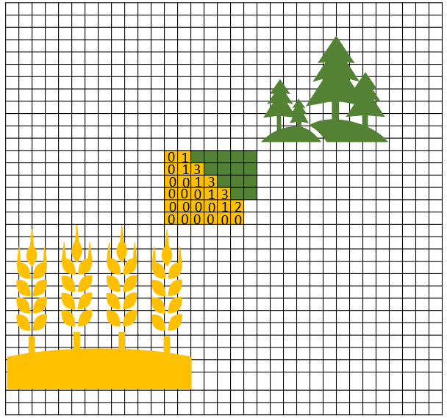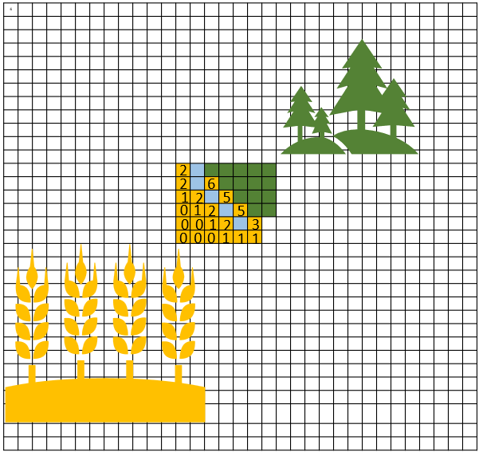
Figure 2. Aggregation of NLCD grid-cells into SIMPLE-G grid-cells before and after CRP. Each cell in the diagram represents a NLCD grid-cell. They can either be considered cropland (yellow), natural land (green), or other irrelevant land-use (blank); the light blue grid-cells indicate the land committed to CRP. All 33x33=1,089 grid-cells form a single grid-cell in SIMPLE. The numbers indicate the number of neighboring natural-land grid-cells; only cropland grid-cells are considered.
The increase in TFP only occurs if a cropland grid-cell is surrounded by natural land grid cells in the immediate vicinity. If the cropland grid-cell only touches one grid cell with natural land, with at least one grid-cell

Expected results
Comparing the impacts of the CRP program with or without modelling the non-market benefits will provide a more complete representation of the CRP program and can contribute towards the future design of the program.
References
Agricultural Research Service (2022) ARS Honey bee health. https://www.ars.usda.gov/oc/br/ccd/index/
Baldos U. L. C., Haqiqi I., Hertel T. W., Horridge M., and Liu J. (2020). SIMPLE-G: A multiscale framework for integration of economic and biophysical determinants of sustainability. Environmental Modelling & Software 133: 104805.
Birur D., Hertel T. W., and Tyner W. (2010). Impact of large-scale biofuels production on cropland-pasture and idle lands. GTAP Resource 3385. https://www.gtap.agecon.purdue.edu/resources/res_display.asp?RecordID=3385
Cisneros-Pineda A., Dukes J. S., Johnson J., Brouder S., Ramankutty N., Corong E., and Chaudhary A. (2023). The missing markets link in global-to-local-to-global analyses of biodiversity and ecosystem services. Environmental Research Letters 18: 041003.
Coppess, J. (2017) Historical background on the Conservation Reserve Program. farmdoc daily (7):82, Department of Agricultural and Consumer Economics, University of Illinois at Urbana-Champaign https://farmdocdaily.illinois.edu/2017/05/historical-background-on-the-crp.html
Farm Service Agency (2015) Conservation Reserve Program. Honey Bee Initiative https://www.fsa.usda.gov/Assets/USDA-FSA-Public/usdafiles/FactSheets/2015/CRPProgramsandInitiatives/Honey_Bee_Habitat_Initiative.pdf
Farm Service Agency (2024) Conservation Reserve Program https://www.fsa.usda.gov/programs-and-services/conservation-programs/conservation-reserve-program/index
IPBES (2019) Global assessment report on biodiversity and ecosystem services of the Intergovernmental Science-Policy Platform on Biodiversity and Ecosystem Services Brondizio E, Settele J, Díaz S, Ngo HT (Eds.) IPBES secretariat, Bonn, Germany https://doi.org/10.5281/zenodo.3831673
Khalifa, S. A. M., et al. (2021) Overview of bee pollination and its economic value for crop production. Insects 12(8): 688.
National Agricultural Statistics Service. (2024). Quick Stats https://quickstats.nass.usda.gov./#B96B64FD-11AC-32CE-9104-9C55BE616F34
Natural Land Cover Dataset (2024)
Otto C., Zheng H., Gallant A. L., Iovanna R., Carlson B. L., Smart M. D., and Hyberg S. (2018). Past role and future outlook of the Conservation Reserve Program for supporting honey bees in the Great Plains. PNAS 115(29): 7629-7634.
Siebert, R., Hertel, T.,

