Mainstreaming Ecosystem Services in the World Bank’s MANAGE-WB Model
Galindev. R, Britz. W, Banerjee. O and Arin. T
(draft report)
April 2025

Background
Changes in the economic environment can affect natural capital and ecosystem services (ESS) in various ways. In economic models, a common transmission mechanism is the changes in land use and land cover (LULC). The changes in the ecosystem services have feedback impacts on the economy, for example, through the soil quality and productivity in the agricultural sector.
This note discusses the LULC changes in MANAGE-WB, a recursive dynamic Computable General Equilibrium (CGE) model. In CGE models, land is treated as a production factor alongside capital and labor but typically used in agricultural activities (such as crops, livestock and forestry) and the owners of land receive payments which is reflected in the Social Accounting Matrix (SAM), the main database for CGE models. The optimality conditions for both producers and landowners determine the demand and supply of land for different uses. The market clearing yields the equilibrium rental rate and the size of land – i.e., total land as well as the allocation between activities. The overall size of land in an economy is fixed but it can be divided into different (land cover) categories such as cropland, pastureland, forest, waste land, build-up land, unmanaged forest etc. In general, it can be divided into two broad categories – managed and unmanaged – depending on whether it generates a stream of revenue for its owners and such revenue is reflected in the national accounts. While cropland, pastureland and forest land are considered as managed land, the others are usually considered as unmanaged land. Land can be converted from one type to another. For example, an increase in cropland must decrease either forest or pastureland or any other unmanaged land as the total land is fixed. The size of managed land could increase over time as its returns increases by decreasing the size of unmanaged land.
MANAGE-WB considers more than one category of land – economywide land and regional lands. For an illustrative purpose, we discuss the data from the GTAP center related to the so-called GTAP-AEZ (Agro-Ecological Zone) data and model (Lee et al. 2009), using the recently release for GTAP Version 11 (Aguiar et al. 2022). The GTAP center classifies locations by 6 climate zones and 3 growing lengths, resulting in 18 AEZs globally.
AEZ | Description
1 | Tropical-Arid
2 | Tropical-Dry
3 | Tropical-Moist
4 | Tropical-Sub-humid
5 | Tropical-Humid
6 | Tropical-Humid (year-round)
7 | Temperate-Arid
8 | Temperate-Dry
9 | Temperate-Moist
10 | Temperate-Sub-humid
11 | Temperate-Humid
12 | Temperate-Humid (year-round)
13 | Boreal-Arid
14 | Boreal-Dry
15 | Boreal-Moist
16 | Boreal-Sub-humid
17 | Boreal-Humid
18 | Boreal-Humid (year-round)

For each AEZ in a country (or group of countries in the GTAP data base), the GTAP-AEZ data base reports:
- Harvested areas by GTAP crop activities (paddy rice (PDR); wheat (WHT); other coarse grains (GRO); oilseeds (OSD); fruits and vegetables (V_F); sugar cane and beet (C_B); fiber crops (PFB); other crops (OCR) including cropland used for fodder production)
- Areas by GTAP livestock activities (cattle (CTL); other animal products (OAP); raw milk (RMK); wool (WOL))
- Areas of five broad land cover categories of which three relate to GTAP activities (cropland, pastureland, forest) and the remainder can be termed as “unmanaged” from a GTAP perspective (savanna and grass lands; shrubland; built-up land; other land).
- Returns to land at agent and market prices for land-using activities.
Note that pastureland is not allocated to individual livestock activities.
For example, the following table has the information for Australia which has 12 AEZs and 13 land-using activities (PDR, WHT, GRO, V_F, OSD, C_B, PFB, OCR, CTL, OAP, RMK, WOL, FRS). There are 8 land cover categories (cropland; pastureland; forest; savanna and grass lands; shrubland; built-up land; other land; unmanaged forest). For each AEZ, the total land used by crop activities is equal to the size of cropland, the total land used by livestock activities is equal to the size of pastureland and the land used by forestry is the same as the size of forest.
The advantages of using the GTAP-AEZ approach in MANAGE-WB are the following:
- A better depiction of competition between different activities for land. For instance, certain crops might not be found (or at very small shares) in certain AEZs such that they cannot (or almost do not) compete in these AEZs for land.
- Carbon stocks per ha and land use class differ across AEZs.
- Improved interfacing with geo-referenced modelling approaches, for instance, crop and livestock productivity impacts from Climate Change might differ across the AEZs in a country.

Land use in physical term
In MANAGE-WB, the demand for land is defined in physical terms. One of the codes in the MANAGE-WB system reads the data on harvested areas for crop activities, pastureland areas for livestock activities and managed forest area from an available data base – e.g., the GTAP-AEZ data base in the MANAGE-WB system. Different data using different land cover categories can be introduced as well.
The size of land used by activities are read into the parameter land0, along with data on the area of broader land cover categories stored in the set lCov and related carbon stocks per unit of land (carbCnt).
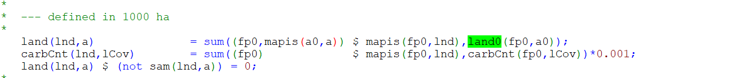
The MANAGE-WB system assigns land0(fp0,a0) to the land-using activities in the SAM (the second statement will remove the information on physical land use if data for some activities is missing).
If the AEZs are available, the set lnd covers the AEZ lands. Otherwise, it refers typically to one economywide land category.
The above statement initializes land demand (xfac) by activities with the data embedded in land(lnd,a). As land is defined in physical term, the prices of land by activities are expressed in per ha.

Land use cover accounting
The data on land cover categories stored in lCov covers three categories of managed land (cropland, pastureland, forest) which can be linked to the activities in the SAM.
When using the GTAP-AEZ data base, the mapping between cropland, pastureland, forest and the production activities in the SAM is done automatically based on the mapping provided in the MANAGE-WB data base. The code defines three new sets of broader activities (crops, anim, frs) to do so:
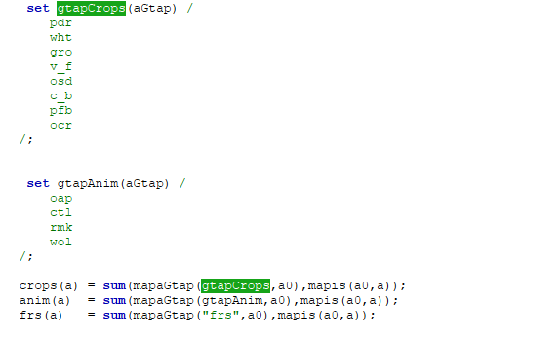
The managed (land cover) for these three categories (in million ha) is defined using the definition of xfac for land in physical terms which is the quantity of land demanded.
The unmanaged (land cover) categories are defined as those which are not linked to the SAM accounts. With the exemption of otherLand (glaciers, water bodies etc.) and built-up land, the changes in the summed-up area of managed categories implies the changes in unmanaged ones:
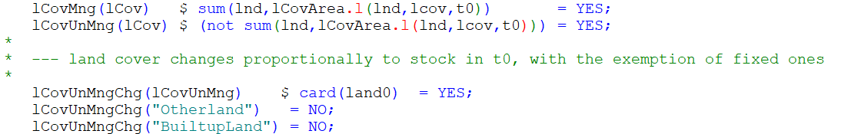
Note that this mechanism is not part of the original GTAP-AEZ model where the stock of total managed land is fixed. However, a version in development by the center will add this.
The three changing categories of unmanaged land are shrubland, SavnGrassLnd and unManagedForest. The data for unManagedForest are not reported by the GTAP center. They are calculated as the difference between the summed-up size of the AEZs of a country based on GIS analysis and the area of all the reported land cover categories. The area of managedForest is calculated by the GTAP center based on a definition of accessibility.
This land cover accounting is implemented in the model based on the equation lCovAreaEq:
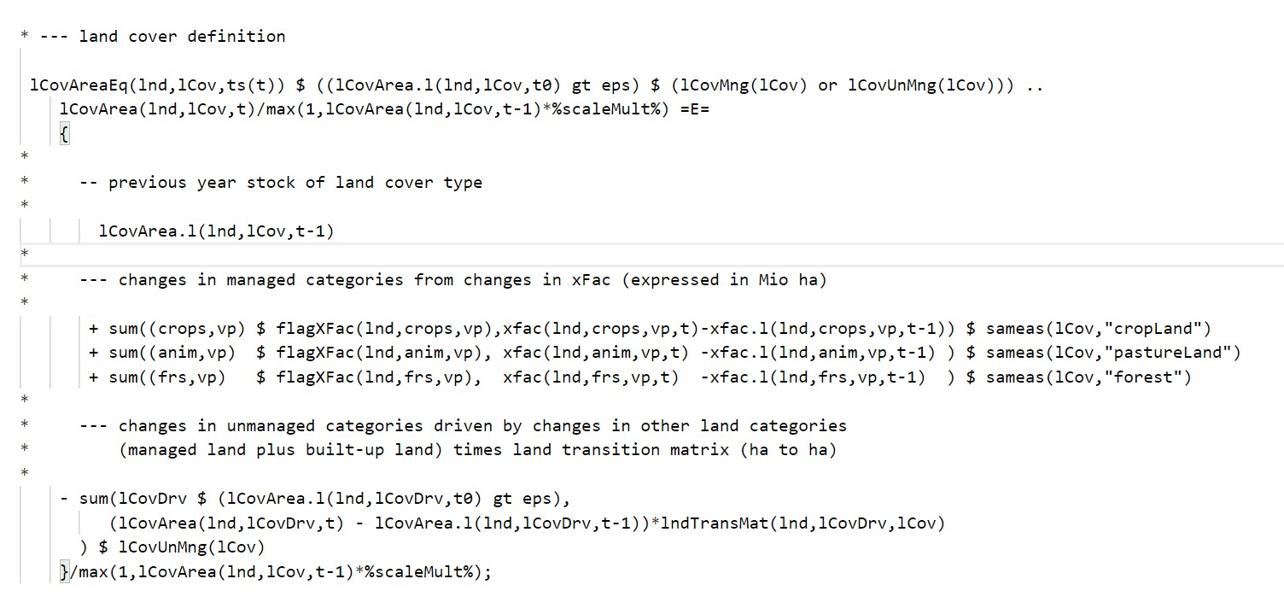
The first and second blocks of this equation relate to the three managed land cover categories. Their acreage is calculated by adding up their acreage in t-1 and the change in the land demand xfac for the three blocks of activities (crops, animals, forest) mapped to the three managed land categories (cropland, pastureland, forest).
The first and third blocks define the size of the unmanaged (land cover) categories – based on their level in t-1 minus the changes in the managed ones multiplied by the land transition matrix, lndTransMat.
It is recommended to use the additive CET functional form in factor nestings for land use to ensure that the changes in land cover types add-up to zero. In an extreme case, solely one activity is mapped to each of the three managed GTAP-AEZ land use categories. From an economic perspective, the AEZs can be understood as a dis-aggregation of the land account. For an individual activity using land, the GTAP-AEZ introduces a nest which aggregates the land use in each AEZ to total land use.
In the MANAGE-WB data base, this is implemented by the following table which shows the demand system of the production activities. As can be seen, a water and land bundle in the production, wtr_land, is a CES function of f-land and aez_land while aez_land is a CES function of all f-AEZ1-18. The substitution elasticities of 7.5 implies that the share of total land allocated to the AEZ sub-regions react quite sensitive to the changes in the land rents across AEZs. This implementation assumes that the production function across the AEZs for one activity is identical, the sole difference is the cost share of land relative to all other cost shares. wtr_land is then another component alongside labor and capital in an upper-level nesting which is the value-added nest.

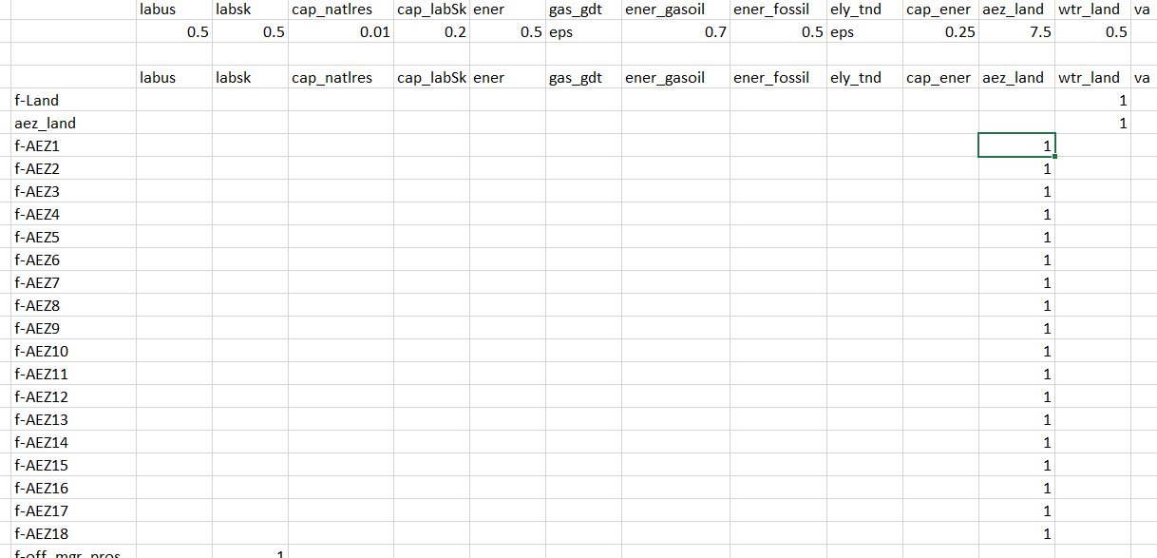
The following table shows the factor supply nesting structure for land. According to this, f-land is allocated between agrLand and a-frs (forestry) and agrland is then allocated between cropland and grassland through an additive CET function. Cropland is then allocated between crops activities while grassland is allocated between livestock activities through an additive CET function. Here factSupElas for f-land is 0.1 implies that the elasticity of land supply with respect to real rental rate is 0.1. omegaCET for f-land being the elasticity of transformation of land between a-frs (forestry) and agrland is 0.25. omegaCET for agrLand being the elasticity of transformation between cropland and grassland is 0.5. omegaCET for grasLand and cropland being the elasticities of transformation within crop activities and livestock activities respectively are 0.75.
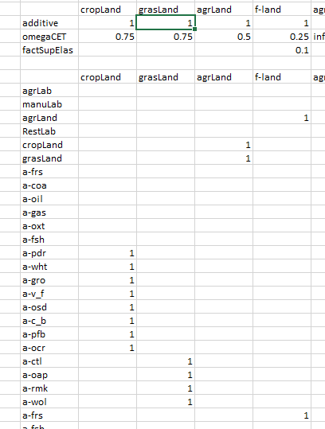
When AEZs are used, the implementation on the factor supply side is less elegant as it requires extended lists of sub-nests as seen below. The implementation uses the three-layered nesting approach from GTAP-AEZ already implemented before:
- The same as the general case as above, each AEZ land supply of managed land (f-AEZ1, …, f-AEZ18) responds to the real rental rate.
- The top layer allocates the total managed land to forestry (a-frs) and agricultural land (e.g., AEZ1_agrLand, …, AEZ18_agrLand ) in each AEZ.
- The second layer allocates the agriculture land to crop land (cropLand) and pastureland (grasLand). Again, these land use classes are dis-aggregated to the 18 AEZ if available in the data base.
- The bottom layer allocates crop land to individual crops and pastureland to livestock activities.

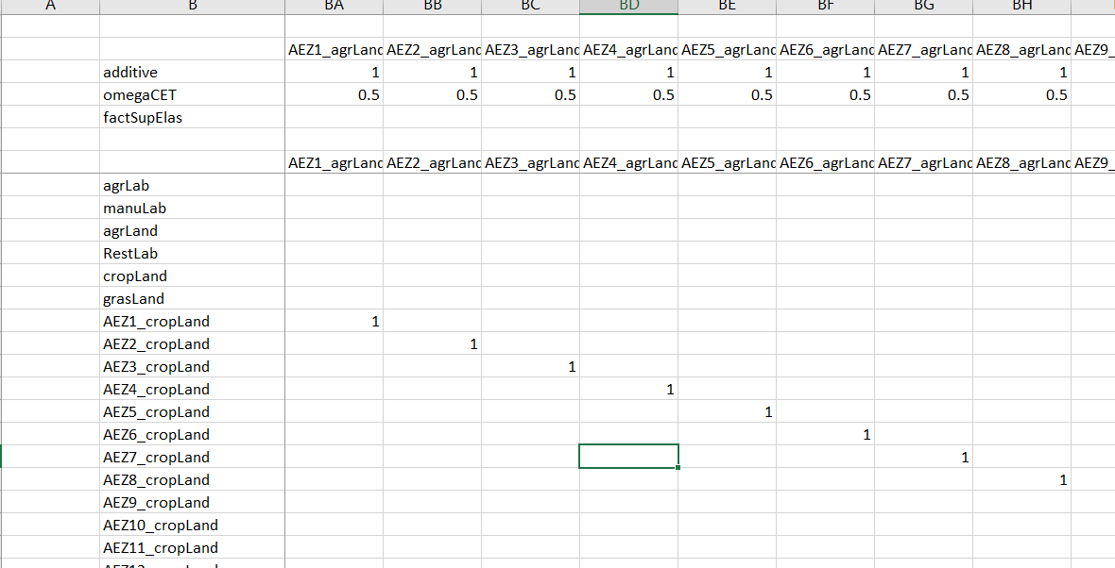

Carbon stock changes
Carbon stock changes are calculated from the land cover changes and above- and below-ground carbon content. GTAP center reports carbon content for the different land cover type at the AEZ level. The data on carbon content are aggregated from AEZ to country level using the acreage of the land cover types at AEZ level as weights. The following table shows the carbon content by land cover categories and countries in the GTAP data base.
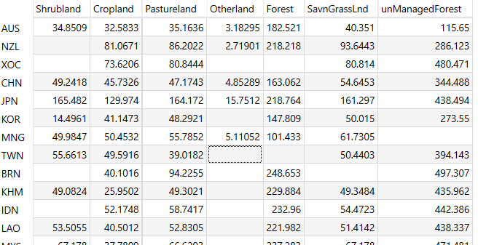
These carbon content factors allow to calculate the carbon stock changes in the equation dCarbonEq for each land cover type lcov from the simulated change in land cover as shown above.
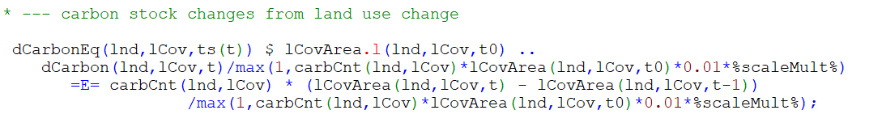
The carbon changes are subtracted from the GHG emissions as positive carbon changes act as a sink by removing carbon from the atmosphere. Note the conversion factor 3.67 from carbon (C) to CO2:

Applications of nature-aware MANAGE-WB
Although the model outlined above has been used in many applications, the use of it in relation to accounting for the impact of the regulating ESS is growing. In this section, we discuss two of such applications.

Application 1: Afforestation in India
Recent work by Banerjee and Cicowiez of RMGEO Consultants Inc titled “Integrating Natural Capital in Evidence-Based Public Policy Making in India” applies the IEEM+ESM approach (a link between three models – a CGE model known as Integrated Economic-Environmental Modeling (IEEM), spatially disaggregated LULC model and Ecosystem Services Modeling (ESM)) in examining the economic impact of an ambitious afforestation and forest restoration initiative in India in the context of India’s Nationally Determined Contributions (NDC) and long-term climate change mitigation goal.
In this section, we try to repeat this work in MANAGE-WB. The IEEM+ESM approach considers the initiative as exogenous changes in LULC. Since we capture the changes in LULC, its feedback effect through the ecosystem services is the same – i.e., there is no need to rerun the spatial LULC model and ESM to generate the feedback shocks which are pollination and soil erosion shocks.
The following are the main features.
- We use the same SAM.
- There 3 activities are using land – crops, livestock and forestry.
- There is one economywide land.
- The land cover categories are different from the AEZ – i.e., the set lCov has: moderate_to_dense_forest, cropland, grassland, shrub, wasteland, fallowland, swamp_runn, water_ice, urban_built and open_forest.
- We consider 3 scenarios: NDC, forest restoration and combined. There is investment cost and the benefits coming from the ecosystem (pollination and soil erosion) as positive shocks to the productivity in crops activity in each scenario.
  - In the NDC scenario, the land size of moderate_to_dense_forest increase by reducing that of wasteland through afforestation and agroforestry and the land size of cropland increases through agroforestry by reducing the size of fallowland.
  - In the forest restoration scenario, the size of open_forest decreases to increase the size of moderate_to_dense_forest.
  - The combined scenario has the above shocks.

Flexible nesting
The flexible production nesting is depicted in Figure 1 (a cutoff). As can be seen, land (f-lnd1, f-lnd2, f-lnd3) is mapped to the wland nest through a CES function while wland is component of the va nest.
Figure 1. Flexible production nesting
The following figure (a cutoff) shows the flexible nesting for the factors of production. Three lands, f-lnd1, f-land2 and f-land3 are supplied to a-crp, a-lvs and a-frs activities, respectively with zero (eps) elasticities with respect to real rental price as given exogenous in this application.
Figure 2. Flexible nesting for production factors

Baseline
In the baseline run until 2070 from 2015, we impose the GDP growth rates. In exchange, the economywide total factor productivity is endogenous. Consequently, GDP increases in 17.7 folds. Population follows the UN projection and increases from 1.322 billion to 1.690. We impose the upper-limit on the government debt-to-GDP ratio at 90 percent so that if the actual debt-to-GDP ratio reaches it, the government spendings are adjusted. The transfers from the rest-of-the-world follows the population dynamics. The ratio of nominal foreign saving and GDP remains at its initial value. We also assume that the land use does not change in the relevant activities.

Scenarios and shocks
The following table has the supply shocks (in million ha) to the respective lands in each scenario.
Table 1. Land use changes by scenarios (in million ha)
The following table has the positive feedback shocks (percentage changes) to the productivity of the value-added nest in the crop activity.
Table 2. ESS shocks from the InVEST model (%)
The cost of the investment is considered as nonproductive as it does not increase the capital stock of the economy. Rather, it increases the land uses as in Table 1. 15% of the investment is financed by foreign sources so that foreign saving to GDP ratio is adjusted.

Simulations results
The following table compares GDP in market prices in different scenarios.
Table 1 presents the impacts on key economic indicators as a difference from the BASE scenario in four time slices: 2030, 2047 (100 years since India’s Independence), 2050 and 2070. In the year 2070, the NDC scenario would be GDP enhancing and compared with the BASE in that year, US $826 billion greater. The NDC scenario would result in a US $16,647 billion increase in cumulative GDP by 2070 (Table 3 and Figure 3). To understand these impacts in relative terms, India’s agricultural sector GDP in the base year of the modelling exercise was US $396 billion. The NDC+Forest Restoration scenario would generate a cumulative US $19,982 billion in additional GDP with respect to the BASE. Figure 4 and Figure 5 present the trajectory of GDP as a difference from the BASE for the entire period in percent and USD terms.
Impacts on employment would be favorable with jobs growing by 0.01 percent more by 2070 as a difference from BASE.
Table 3. Scenario impacts on macroeconomic indicators (difference from the BASE in billions of USD)
Year | 2030 | 2047 | 2050 | 2070 | 2030 | 2047 | 2050 | 2070 | 2030 | 2047 | 2050 | 2070
Scenario | NDC |  |  |  | Forest Restoration |  |  |  | NDC + Forest Restoration
GDP | 45 | 345 | 394 | 826 | (4) | 109 | 122 | 217 | 45 | 393 | 456 | 1,079
Private Consumption | 53 | 346 | (7) | 820 | (2) | 66 | 84 | 190 | 50 | 387 | 458 | 989
Investment | 4 | 9 | (1) | (13) | 0 | 49 | 46 | 23 | 8 | 17 | 10 | 42
Exports | (47) | (195) | (246) | (742) | (14) | (26) | (39) | (195) | (51) | (201) | (252) | (643)
Imports | (43) | (186) | (236) | (704) | (12) | (27) | (40) | (199) | (45) | (189) | (238) | (613)
Employment (mlln) | 0.1 | 7.6 | 7.9 | 6.9 | -0.1 | 1.6 | 1.6 | 1.6 | 0.0 | 7.0 | 7.4 | 6.8
Source: MANAGE-WB estimation
Figure 3. GDP as a percent difference from BASE
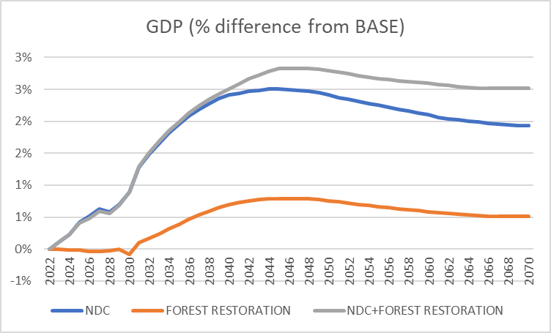
Source: MANAGE-WB estimation
Figure 4. GDP as a difference from the BASE in millions of USD
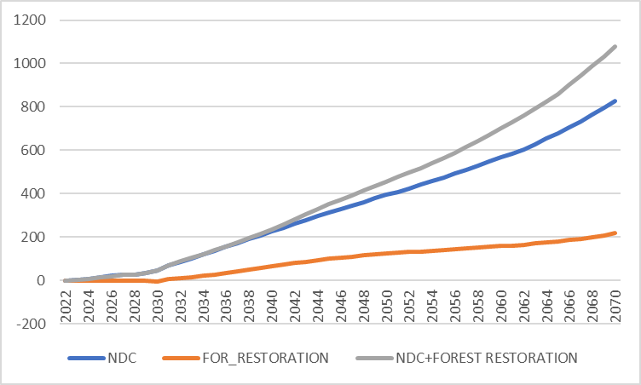
Source: MANAGE-WB estimation
The following table shows the impact of the regulating ecosystem services. In doing so, we shock the productivity of the crop activities with those in Table 2 with the same fixed use of lands as in the BASE. There are no other shocks.
Table 4. Impact of regulating services (% difference from the BASE)
Regulating ecosystem services (% change in GDP from the baseline)
 | Crop pollination
 |  | NDC | 0.08% | 0.08% | 0.07%
 |  | Forest Restoration | 0.00% | 0.00% | 0.00%
 |  | NDC+Forest Restoration | 0.08% | 0.15% | 0.14%
 | Erosion mitigation
 |  | NDC | 0.15% | 0.14% | 0.09%
 |  | Forest Restoration | 0.01% | 0.07% | 0.05%
 |  | NDC+Forest Restoration | 0.17% | 0.31% | 0.21%

Application 2: Endogenous land allocation
We test MANAGE-WB in different scenarios in which a land allocation mechanism is partially and fully endogenous to the changes in economic environment. We consider a hypothetical policy intervention – the subsidy rate to the crop sector increases in 5 folds permanently in 2026 in the following three scenarios.
- Scenario 1: The aggregate land supply remains constant. However, the land use between crops, livestock and forest is endogenous depending on the relative rental rates.
- Scenario 2: The aggregate land supply is endogenous – i.e., it is an isoelastic function of the economywide real rental rate with an elasticity of 0.2. The allocation of land between uses (crops, livestock and forest) was also endogenous.
- Scenario 3: Same as scenario 2, but the supply elasticity is 0.5. The allocation of land between uses (crops, livestock and forest) was also endogenous.
In the three scenarios, the LULC (Dyna-CLUE) and the ESM (InVEST) models were interacted on a periodic (5-year) basis. For each period, erosion and pollination shocks were calculated and inputted into the MANAGE-WB model. The changes in ESS flows affect economic outcomes through the erosion mitigation and crop pollination impacts on the productivity of the crop sector.
Figures 5-6 show the changes in cropland, pastureland, forest and total land in the three scenarios. As the total land is fixed, the increase in the subsidy rate in the crop sectors increases the demand for cropland which reduces the pastureland and forest in Scenario 1. In Scenario 2, the cropland expands more by reducing pastureland and forest. As can be seen, the changes are more profound in scenario 3.

Figure 5. Cropland and pastureland

The changes in the land use in the InVEST model through Dyna-CLUE create the following regulating ecosystem services – soil erosion and crop pollination. These are percentage changes that affect the productivity of the crop sector.
Figure 6. Regulating ecosystem services from the InVEST model (%)

The following figure shows the impact of the policy on GDP. The figure on the LHS shows the percentage deviation of GDP from the baseline in each scenario which is the total impact including that of the ecosystem services. The RHS shows the difference between the ones with and without the regulating ecosystem services in scenario 3. As can be seen, the difference is small at this aggregate level.

Figure 7. GDP impact (% deviation BASE)

Although the impact of the regulating ecosystem services is small on macroeconomic indicators, the impact can be significant at the micro levels. The following figure shows the impact on the sectoral output in 2050. If the model allows, a further analysis could be conducted at the regional level where the ESS could have more profound effect.
Figure 8. Impact of regulating ESS on sectoral output (% deviation from no-ESS scenario)

Conclusions
This technical paper aims to show the details of extensions of the MANAGE-WB model with the LULC accounts (GTAP-AEZ data base and flexible nestings) and its pilot applications.
The pilot applications indicate that the economywide impacts of polices leading to changes in the regulating ecosystems services could be limited. The reasons are in two folds. First, the share of crop sector affected by ESS is small. Second, there are many other ecosystem services are not accounted for. The impact of erosion reduction and sediment control on the economy go beyond crop productivity. Other prominent impact channels include livestock sector productivity hydropower generation capacity, irrigation reservoir capacity, water quality. Forests and agroforestry also help control inland flooding and thus reduce damages to assets. Importantly, they also help regulate seasonal water availability for downstream uses in agriculture and drinking water provision. Furthermore, forest and other vegetation also help purify water which averts cost of water purification. A complete inclusion of the ecosystem services and impact channels would allow a much more comprehensive account of the contributions to the economy.
Although the macroeconomic impacts policy through the regulating ecosystem services are small, the impacts at the microeconomic levels could be much larger. For instance, the crop pollination and soil erosion shocks in the hypothetical policy scenario (subsidy increase to crops activities) for India could have significant effect on those operating in the crops activities. In addition, the subregional impacts could be considerable on the wellbeing of the households and workers.
References
Beyene, L, M., Britz, W., Christensen, M., Dudu, H., Galindev, R., 2024. MANAGE-WB: The Mitigation, Adaptation and New Technologies Applied General Equilibrium Model of the World Bank. https://thedocs.worldbank.org/en/doc/77351105a334213c64122e44c2efe523-0500072021/related/MANAGE-WB-Documentation.pdf
Lee, H. L., Hertel, T. W., Rose, S., & Avetisyan, M. (2009). An integrated global land use data base for CGE analysis of climate policy options. Economic analysis of land use in global climate change policy, 42, 72-88
Aguiar, A., Chepeliev, M., Corong, E., & van der Mensbrugghe, D. (2022). The global trade analysis project (GTAP) data base: Version 11. Journal of Global Economic Analysis, 7(2)
FAO (1996). Agro-ecological Zoning. Guidelines. FAO Soils Bulletin 73, 78 pp. Soil Resources, Management and Conservation Service, FAO Land and Water Development Division. Food and Agriculture Organization of the United Nations, Rome, Italy. ISBN 92-5-103890-2
Banerjee, O., Cicowiez, M., and others? (2023). Integrating Natural Capital in Evidence-Based Public Policy Making in India, draft

The concept of the AEZs was developed by the FAO (FAO 1996) to categorize land by bio-physical attributes relating to soil and climate and is closely related to efforts to provide geo-referenced data for crop modelling at global scale (https://gaez.fao.org/). Compared to rather fine-grained categorization by the FAO, the GTAP center uses a highly aggregated one.
The area of managed forest cover is based on accessibility criteria and derived by GIS analysis. It is important to note that the data base codes do not cover the area of natural forest. It is estimated here as the difference between the total area of an AEZ polygon and the reported areas.
Note that Figure 1 is a cutoff. All the remaining commodities except for electricity are in the nd (intermediate) nest while electricity is in nrgER. The first column indicates that this nesting applies to all activities. An analyst can create a sector-specific nesting by spelling out the name of the activities followed by this general nesting. The elasticities of substitution (subselas) for the value-added nest by activities are the same as those in the GTAP which are defined in the actPar sheet.

