Decomposing the Drivers of Natural or Policy Induced Shocks: Case of Groundwater Conservation in South Asia
Summary. Any natural or policy-driven shock induces multiple margins of adaptation by food producers. These margins of adaptation depend on local bio-physical and socio-economic conditions. Understanding how producers adjust along these distinct margins is crucial for drawing policy-relevant insights and anticipating unintended consequences. In this paper, we use the case of groundwater conservation efforts and its associated downstream impacts on surface water availability in South Asia to decompose the net changes in output production at a fine scale into 6 margins of response: i) change in source of irrigation; ii) change in irrigated or rainfed production; iii) change in land-use; iv) change in non-land input use; v) spatial relocation of production; and vi) and change in crop-mix. Preliminary results highlight hotspots where ignoring the downstream impacts would overestimate producers’ adaptability by switching the source of irrigation water. It also highlights the role of market-mediated adaptations where producers switch to rainfed production and change the crop-mix to be better suited to restricted water availability. However, it also exposes producers to variability in rainfall.

1. Introduction
Groundwater depletion is one of the most pressing resource constraints facing agricultural systems in South Asia. In regions such as the Indo-Gangetic Plain, decades of subsidized pumping, rising cropping intensity, and weak regulation have driven sustained declines in groundwater tables, threatening food security, rural livelihoods, and downstream surface water systems. In response, governments are increasingly considering groundwater conservation policies, including pumping restrictions, electricity pricing reforms, and irrigation efficiency programs. While the hydrological consequences of such interventions are relatively well studied, their economic and market-mediated impacts remain poorly understood. For global and regional economic models, inclusion of the likely response mechanisms is critical. Any natural or policy-driven shock to water availability induces multiple margins of adaptation by producers, including changes in irrigation source, land use, input intensity, crop choice, and spatial allocation of production (Haqiqi et al.). These responses are shaped by local biophysical conditions and market signals. Models that collapse adaptation into a single margin often risk mischaracterizing both resilience and vulnerability. This paper asks a question of direct relevance to the GTAP community: How do the effects of groundwater conservation policies propagate through multiple, spatially heterogeneous margins of producer adaptation, and what are the implications for output, risk exposure, and market adjustment in South Asia? We address this question by developing a fine-scale decomposition of production responses to groundwater conservation that explicitly accounts for downstream surface water interactions and market-mediated adjustments. The goal is not only to improve policy interpretation, but also to inform how water constraints should be represented in partial and general equilibrium modeling frameworks.

2. Current Studies
The economic literature has extensively documented groundwater overextraction in South Asia and its links to agricultural intensification, energy subsidies, and institutional failure (Rodell et al.; Shah). These studies emphasize heterogeneity: impacts vary sharply across space depending on aquifer characteristics, access to surface water, and infrastructure (Sekhri). Hydro-economic models have highlighted the interdependence between groundwater and surface water systems. Pumping reductions upstream can increase downstream surface flows, creating spatial externalities that complicate policy evaluation (Harou et al.). In GE and PE models used for trade and food policy analysis, water constraints are often represented in aggregate. More recent extensions introduce water as a factor of production or impose irrigation constraints, improving realism but still relying on aggregate representations (Berrittella et al.; Calzadilla et al.; Koopman et al.; Liu et al.; Ponce et al.). While some studies capture substitution between irrigated and rainfed production at a coarse scale, they typically do not disentangle how producers adjust across multiple margins simultaneously.
A smaller but growing literature emphasizes the importance of decomposing responses to shocks into interpretable economic mechanisms. In trade and land-use modeling, decomposition techniques have been used to separate scale, composition, and relocation effects (Haqiqi et al.). However, these insights have not been systematically integrated. Existing GE and PE studies typically report net output or welfare changes, leaving unclear whether resilience arises from technological substitution, land reallocation, crop switching, or spatial displacement of production.

3. Contribution
There are three limitations in existing GE and PE studies of water. First, groundwater conservation impacts are rarely decomposed into multiple, simultaneous margins of producer adaptation. Second, downstream surface water feedbacks are often ignored, leading to overestimation of adaptive capacity in upstream regions. Third, spatial heterogeneity within regions is largely obscured in aggregate economic models. This paper addresses these gaps by providing a fine-scale, market-consistent decomposition of production responses to groundwater conservation, explicitly linking hydrological feedbacks with economic adjustment.
The paper makes multiple contributions. First, it introduces a six-margin decomposition of producer responses to water shocks: (i) changes in irrigation source, (ii) shifts between irrigated and rainfed production, (iii) land-use adjustment, (iv) changes in non-land input intensity, (v) spatial relocation of production, and (vi) crop-mix change. Second, it explicitly accounts for downstream surface water impacts, revealing where adaptation is overstated when such feedbacks are ignored. Third, it provides a framework that can be directly embedded within or used to interpret GE and PE models.

4. Methods
The analysis employs SIMPLE-G South Asia, a spatially explicit economic modeling framework that combines partial equilibrium crop production responses with market-mediated price adjustments. This extended version includes 8 crop types (pdr, wht, osd, pfb, c_b, ocr, v_f, pfb) for the reference year of 2017. Groundwater conservation is introduced based on Water Balance Model (Grogan et al.). Hydrological linkages determine changes in downstream surface water availability. Production outcomes are resolved at a fine spatial scale (more than 50,000 grid cells) and decomposed into the six margins defined above. Land use, irrigation status, and crop choice respond endogenously to relative prices, water availability, and local biophysical suitability. Market clearing ensures consistency between local production decisions and regional demand.

5. Results and Discussion
We expect that restricting groundwater access will initially induce substitution toward alternative irrigation sources where available. Once this margin is exhausted, producers shift toward rainfed production, adjust crop mixes toward less water-intensive crops, and reduce input intensity. Spatial relocation emerges as production moves toward regions with better surface water access. We expect that ignoring downstream surface water effects will affect adaptive capacity in upstream regions. Market-mediated responses are likely to smooth aggregate output losses but increase exposure to rainfall variability, introducing new forms of risk not captured by average production metrics. We have identified multiple indirect spill-over mechanisms that are difficult to capture in analytical studies.
Apparent resilience in aggregate output may conceal increased volatility and regional vulnerability. For policy, this underscores the need to evaluate groundwater conservation not only in terms of mean production effects but also in terms of redistribution. The findings argue for richer representation of water constraints and adaptation margins. Explicit decomposition improves both credibility and interpretability, and it provides a bridge between fine-scale biophysical processes and global economic analysis. As water scarcity intensifies, such approaches will be essential for robust policy assessment.
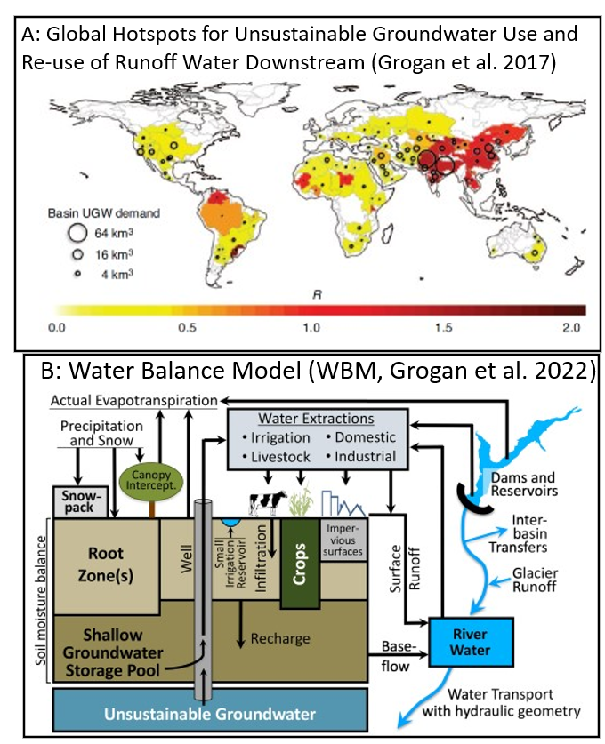 | 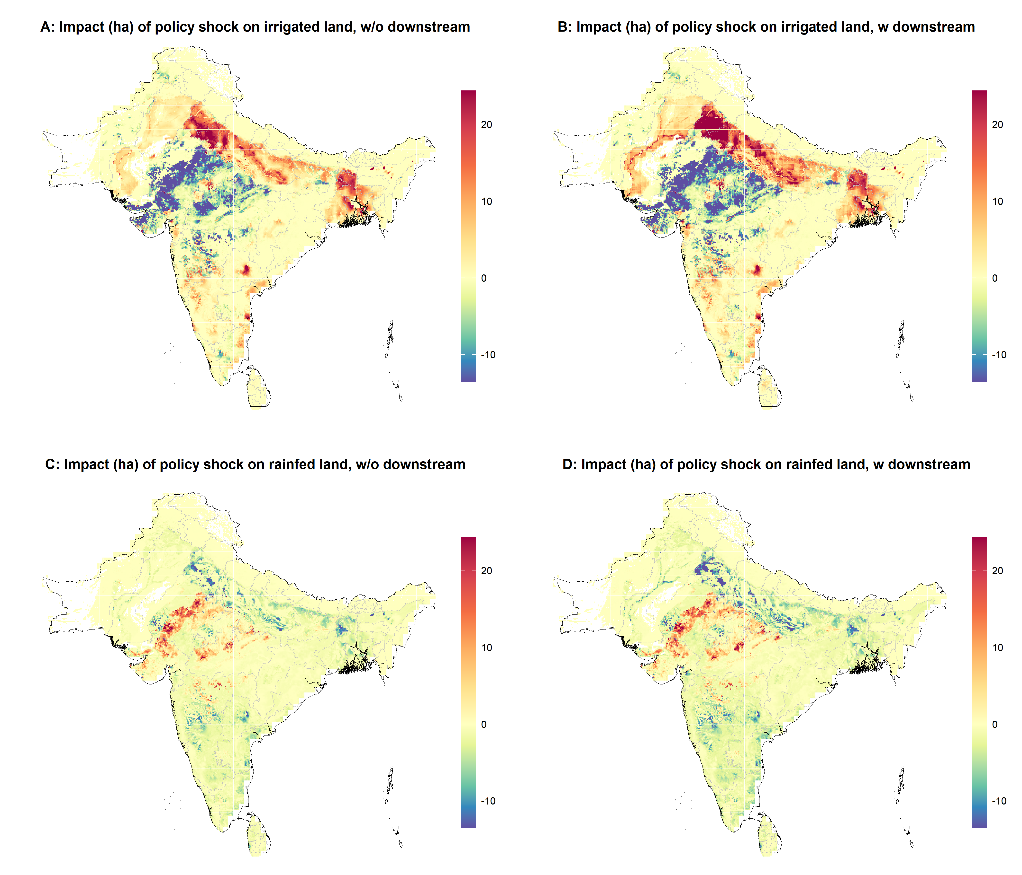
Figure 1. Inputs for experiment design | Figure 2. Estimated impact of policy on land area

References
Berrittella, Maria, et al. “The Economic Impact of Restricted Water Supply: A Computable General Equilibrium Analysis.” Water Research, vol. 41, no. 8, Apr. 2007, pp. 1799–813. DOI.org (Crossref), https://doi.org/10.1016/j.watres.2007.01.010.
Calzadilla, Alvaro, et al. “Review of CGE Models of Water Issues.” The WSPC Reference on Natural Resources and Environmental Policy in the Era of Global Change, edited by Calzadilla Alvaro et al., WORLD SCIENTIFIC, 2016, pp. 101–23. 4 vols. worldscientific.com (Atypon), https://doi.org/10.1142/9789813208179_0004.
Grogan, Danielle S., et al. “Water Balance Model (WBM) v.1.0.0: A Scalable Gridded Global Hydrologic Model with Water-Tracking Functionality.” Geoscientific Model Development, vol. 15, no. 19, Oct. 2022, pp. 7287–323. DOI.org (Crossref), https://doi.org/10.5194/gmd-15-7287-2022.
Haqiqi, Iman, et al. “Global Groundwater Sustainability and Virtual Water Trade.” SIMPLE-G, edited by Iman Haqiqi and Thomas W. Hertel, Springer Nature Switzerland, 2025, pp. 253–82. DOI.org (Crossref), https://doi.org/10.1007/978-3-031-68054-0_16.
Harou, Julien J., et al. “Hydro-Economic Models: Concepts, Design, Applications, and Future Prospects.” Journal of Hydrology, vol. 375, nos. 3–4, Sept. 2009, pp. 627–43. DOI.org (Crossref), https://doi.org/10.1016/j.jhydrol.2009.06.037.
Koopman, Jason, et al. The Economic Impact of Irrigation Water Scarcity from Climate Change: A CGE Analysis Distinguishing between Surface and Ground Water. 2017. Google Scholar, https://ageconsearch.umn.edu/record/332884/.
Liu, Jing, et al. “Analyzing Future Water Scarcity in Computable General Equilibrium Models.” Water Economics and Policy, vol. 02, no. 04, Dec. 2016, p. 1650006. DOI.org (Crossref), https://doi.org/10.1142/S2382624X16500065.
Ponce, Roberto, et al. Integrating Water Resources into Computable General Equilibrium Models-a Survey. 2012. Google Scholar, https://services.bepress.com/feem/paper708/.
Rodell, Matthew, et al. “Satellite-Based Estimates of Groundwater Depletion in India.” Nature, vol. 460, no. 7258, Aug. 2009, pp. 999–1002. DOI.org (Crossref), https://doi.org/10.1038/nature08238.
Sekhri, Sheetal. “Wells, Water, and Welfare: The Impact of Access to Groundwater on Rural Poverty and Conflict.” American Economic Journal: Applied Economics, vol. 6, no. 3, July 2014, pp. 76–102. DOI.org (Crossref), https://doi.org/10.1257/app.6.3.76.
Shah, T. “Groundwater and Human Development: Challenges and Opportunities in Livelihoods and Environment.” Water Science and Technology, vol. 51, no. 8, Apr. 2005, pp. 27–37. DOI.org (Crossref), https://doi.org/10.2166/wst.2005.0217.

