A Low Carbon Economy in Brazil: Policy Alternatives, Costs of Reducing Greenhouse Gas Emissions and Impacts on Households.

Aline Souza Magalhaes – Federal University of Minas Gerais – Brazil
Edson Paulo Domingues – Federal University of Minas Gerais – Brazil
Geoffrey Hewings – University of Illinois at Urbana-Champaign – USA

ABSTRACT

Developing countries have increased their importance as emitters of GHG and, increasingly, it has become necessary that these countries also contribute to curbing emissions. Brazil already has taken the first step in this direction at conferences in Copenhagen (2010) and Cancun (2011), to confirm voluntary national targets to reduce GHG emissions. In this context, this paper aims to study alternative, market-based, policies to reduce emissions such as a carbon taxes. The distributive impact on households, for example, is a new result in the Brazilian literature. We used a dynamic recursive general equilibrium model, built for the Brazilian economy, specially tailored for the analysis of GHG emissions. The results indicate that ambitious emissions reduction should be associated with longer periods of time, with less ambitious goals for shorter periods. In terms of the effects on income classes, the carbon tax is moderately regressive, even when considering the return of revenue via subsidizing consumption of all households. If the aim is to make more progressive policy, then compensation policies via income for the poorest deciles may be the solution

KEYWORDS: Low-carbon economy, Carbon Taxes, Distribution Impacts, Computable General Equilibrium.
INTRODUCTION

In May 2011, the city of São Paulo adopted a law providing for a ban on plastic bags in the city's supermarkets, starting in January 2012. After a long discussion and legal impasses, the measure was implemented and generated complaints by consumers, supermarkets, and the plastic industry. In May 2012, the prosecutor canceled the agreement including a ban on bags, and these were again distributed for free. A similar process occurred in the third largest city in Brazil, Belo Horizonte. The city law had banned the sale of plastic bags and also their free distribution, forcing the use of reusable material by consumers; but again, this generated a long legal controversy. These examples illustrate the difficulty of replacing a product with notable negative environmental externalities (plastic bags) and the problem of the incidence of the costs of this change (plastics industry, supermarkets, consumers). This paper examines a similar environmental problem, but one with a large global negative externality: emissions of greenhouse gases (GHG) and the problems arising from climate change. The solution may involve significant costs to the Brazilian economy.
One of the most discussed effects of economic activity on the environment is climate change, caused by the accumulation of greenhouse gases (GHG). Since the beginning of XXI century, empirical evidence has strengthened that human activity has significantly altered the concentration of greenhouse gases in the atmosphere. This accumulation of greenhouse gases has been seen as the most likely cause of the temperature rise and other climate changes observed in the twentieth century. Climate projections indicate that the magnitude of the impact would be enough to change the climate on Earth and negatively affect, with different intensities, different regions, countries and continents.
Currently, the question that arises is not centered on the uncertainty of climate change, but who would be responsible for mitigation and how it should be mitigated. From these findings, a set of international policies (such as the Kyoto Protocol) have been established. What they seek, in general, is a "low carbon economy." This term was first used in the Department of Transportation and the Half UK Environment report in 2003 entitled "Our energy future creating a low carbon economy." A low carbon economy can be defined as an economy with low emissions of greenhouse gases, including, among other actions, implementation of GHG mitigation policies (UK ENERGY WHITE PAPER, 2003).
There are many uncertainties about goals, policies and responsibilities for mitigation policies. The international negotiations on the Kyoto Protocol, which expired in 2012, involve a number of difficulties and also possibilities, as suggested by some studies. (see OLMSTEAD and STAVINS, 2010; METCALF and WEISBACH, 2012; NORDHAUS, 2008; RONG, 2010; ZHANG, 2009; KLEPPER, 2011; FRANKEL, 2008). Commonly debated issues for countries such as Brazil are the effectiveness and scope of a new agreement. These questions will certainly be a major focus of future negotiations. Developing countries, especially Brazil, China and India, will be required to position themselves in relation to the mitigation of greenhouse gases not by the absolute size of its population, economy, energy consumption or CO2 emissions (carbon dioxide), but notably by the rapid growth of GDP and emissions. It is expected that CO2 emissions in developing countries will represent more than half of global emissions by 2030, although in per capita terms, developed countries are still well ahead (BOSETTI and BUCHNER, 2009). These countries have already faced increasing pressure to reduce their carbon emissions.
On the other hand, the opportunities for low-cost emission reductions can be higher for developing countries (WATSON, 2001). According to the estimate of Edmonds et al. (1997), if the major developing countries were be included among the countries of the Kyoto Protocol with binding emissions targets, the total costs involving the overall reduction of GHG could be reduced by up to 50%. Therefore, considering appropriate differences with regard to China and India, Brazil may also have binding targets for reducing emissions in a future post-Kyoto Protocol agreementthat, at least in theory, encourages the country to contribute more actively to the combat climate change phenomenon after 2012.
A first step has been taken in this direction at the conferences in Copenhagen (2009) and Cancun (2010). Brazil confirmed voluntary national targets for reducing greenhouse gas emissions, with reductions of 36.1% and 38.9% of projected emissions by 2020. The National Policy on Climate Change (NPCC) defined these targets, approved by National Congress (Law 12.187) in 2009. In Brazil, the authorities have pointed to deforestation control, especially in the Amazon, as the main focus of the country for GHG emission reductions. It should be noted, however, that as pointed the latest estimates, there was a decrease in the rate of deforestation and therefore the emissions associated with the change in land use (INPE, 2012). It is likely that in the coming years, the share of this source of emissions will be reduced considerably and is no longer considered the main source of GHG emissions in Brazil.
We cannot forget, therefore, the important role of emissions from the use of fuels and production processes, such as agriculture, for example. This importance is heightened, especially because of the increasing trends of emissions from the energy sector, transport (especially regarding the use of diesel), petroleum refining and industry in Brazil. By 2030, for example, the projected emissions in the energy sector, excluding transportation fuels, suggest an increase of 97% or more than 25% of national emissions (GOUVELLO et al., 2010, VIOLA, 2009).
There is considerable debate about the form of mitigation policies: through economic mechanisms, such as taxes, subsidies and carbon market or by regulations (government regulations, performance standards and voluntary programs). A post-Kyoto alternative scenario, with the non-ratification of a global agreement, would be the creation and strengthening of national policies to reduce GHG emissions, which could take the form of taxation or carbon markets policies. There are many examples of national policies already in place. Denmark and Sweden, for example, are the main countries to adopt carbon taxes and achieve the goals of reducing emissions proposed in the Kyoto Protocol. The world's largest carbon market is the European Union, the EU ETS (European Union's Emissions Trade Scheme). This carbon market has served as an example in proposing similar schemes in the United States, Canada and New Zealand.
In the Brazilian case, the NPCC is based on monitoring actions, inspection, control, licensing and financing lines. However, no instrument specifically designed to create a price signal for the reduction of GHG emissions was proposed, although these instruments widely discussed in the international arena. The creation of price-induced economic instruments for emissions (carbon tax, cap-and-trade system) can be a lower cost alternative to enlarge the range of options available under the NPCC proposed by Brazil. However, these analyzes need to be complemented by the estimation of the cost-effectiveness ratios of such policies.
A topic not yet discussed in the Brazilian economy is the feasibility and the cost of price-induced policies aimed at reducing GHG emissions. There have been few estimates of the impacts that these mechanisms might have on the economy, on sectors and on emissions. The incidence of these policies on households (through carbon prices or taxes) and the impacts of likely compensation policies remain gaps in the literature. An aggressive GHG emission reduction policy could represent an obstacle to growth or turn out to be regressive from a distributional point of view. Like other developing countries, Brazil faces the double challenge of promoting development and reducing emissions.
This article examined alternatives to reduce price-induced emissions policies (such as a carbon tax) and its impact on economic activity and welfare. In the new international scenario of global climate negotiations, it is important to study the prospects and policies for the development of a "low-carbon economy” in Brazil. In methodological terms, we used a dynamic-recursive general equilibrium model, built for the Brazilian economy. The model presents detailed energy and environmental specifications, specially aimed for the analysis of GHG reduction policies. The model is innovative in many ways. It has amsignificant disaggregation of energy sectors and productsit incorporates recursive dynamic mechanisms and presents different energy and environmental specifications. This paper has four sections, including this introduction: the next section discusses the economics of mitigation policies addressed by this paper. Thereafter, details are provided of the methodology developed to project the effects mitigation policies on the Brazilian economy. The main results of the simulated mitigation policies are reported next before a final section offering some conclusions and reflections on future research needs.

Economic aspects of national climate policies

Recently, the greenhouse effect generating global warming is one of the predominant themes within the Environment Economics. Some researchers argue that the magnitude of the impact of this phenomenon is significant enough to change the climate on Earth and intensely affect some regions, countries and continents. Mitigation of greenhouse gases has the character of a "public good" global whose benefits reach all, while the costs pass on to those who fund the mitigation. In contrast to other public goods such as public safety, benefits of mitigation are not immediate. Instead, the benefits will only be felt in the future, which makes policy implementation much more difficult.
An important element of any policy related to climate it that it must address the externalities arising from environmental problems, such as greenhouse gas emissions. From an economic point of view, the purpose of an environmental policy must be to ensure that the external costs of pollution are fully absorbed by those responsible for it. Traditionally, regulatory instruments have been more frequent in the development of environmental policies for GHG reduction. However, such policies have limits; in particular, such policies have been criticized for rigidity and lack of economic efficiency, especially regarding the issue of climate change. Given the nature of the problem, in which gases such as CO2 can be emitted from a number of different sources, there is the requirement for developing a particularly complex set of regulatory instruments to achieve an effective result in terms of emission reduction. In general, regulatory policies are uniform for different sources. In practice, however, the adaptive measures and emission control costs vary substantially among sectors and companies. (BEHR, 2009).
Beyond these considerations, the conventional regulatory rules also do not provide dynamic incentives for the development, adoption and diffusion of the best environmental and economic technologies. Once a company meets a standard of performance, it has little incentive to develop or adopt cleaner technologies. Technology standards are less appropriate that the performance standards because they inhibit innovation. By their very nature, they limit the technological choices to be made by companies (ALDY and STAVINS, 2009).
In response to these limitations of environmental regulations for the issue of climate change, approaches based on market mechanisms have been widely discussed. As one of the more efficient mitigation instruments, carbon pricing has been highly recommended by economists and international organizations (ALDY et al., 2008; GOULDER and PARRY, 2008; HEPBURN, 2006; NORDHAUS, 2008, WATKINS, 2007; REQUATE, 2005; IMF, 2008). As pointed out by the Human Development Report of the Development Programme of the United Nations, based on market mechanisms, policies such as carbon taxation, are necessary conditions for the transition to a low carbon economy. These policies coupled with the role of governments in setting regulatory standards and encouraging research and development can bring effective results in the reduction of emissions (WATKINS, 2007). Denmark, Finland, Sweden, the Netherlands and Norway were the first to adopt carbon taxes and, as such, form the basis for implementations in other countries and cities. (BARANZANI, 2000).
The Pigovian tax (PIGOU, 1932) is the theoretical basis for the development of carbon taxation policies; such a tax corrects for externalities caused by external marginal costs. Such costs are rarely accounted for by the decisions of economic agents. The carbon tax is designed to be a tax on the consumption of carbon-intensive goods, being proportional to the carbon content and the marginal damage of CO2 emissions. When an emissions reduction target replaces the criterion of damage, the ideal tax is determined by the point at which the target is met (PROOST and REGEMORTER, 1992). In this case the economic valuation concerns only the abatement costs of reducing emissions. While most taxes distort incentives, an environmental tax corrects a distortion, that is, the negative externalities arising from GHG emissions, improving environmental quality (PEARCE, 1991; CANSIER and KRUMM, 1997). Thus, a carbon tax should be considered a beneficial tax because it corrects a market failure.
A tax raises the relative prices of goods and services according to their carbon intensity, discouraging their use. Carbon pricing, according Nordhaus (2008), allows policy-makers to achieve four objectives: i) signals to consumers that goods and services with high carbon content should be used sparingly; ii) shows the firms which inputs are more carbon-intensive and which are less, inducing them to substitute for low-carbon inputs; iii) provides market incentives for innovation and development of low carbon products; and iv) allows the three prior mechanisms to be implemented at the lowest information cost as possible. Thus, the overall effect is the minimization of cost control (BAUMOL and OATES 1988). Simulations suggest that the use of carbon pricing (taxes or tradable permits) can reduce the costs of compliance with targets by up to 50% (TIETENBERG, 1990). In addition, carbon taxes work as a continuous incentive for the adoption of clean technologies and energy conservation.
Several studies have been interested in the impact that carbon taxation policies would have on developing countries, especially China (LIANG et al., 2007, LU et al., 2010, XIE et al., 2012, ZHOU et al., 2011, WANG et al., 2011, among others). The results are ambiguous in terms of the costs associated with mitigation policies.
Even considering carbon taxes cost-effective instruments to achieve an emissions reduction target, the costs to the economy may be not negligible. Thus, it is essential to consider indirect incentives that may arise from the use of tax revenues. Governments can then adopt a fiscally neutral position, using the revenues to finance investments in clean technologies and minimize the negative effects of taxes on the economy. The revenue management is, therefore, essential to increase the acceptability and possibly even increase the effectiveness of other instruments. A number of authors have emphasized the importance of adopting a neutral fiscal policy when it comes to carbon taxation, using the revenues to finance reductions in other taxes or minimize adverse effects of policy (Pearce, 1991; Poterba, 1991; Weyant, 1993; Goulder, 1995, Parry, 1995). This feature of "double dividend" is critical to corporate and public acceptability (Pearce, 1991). There are several options of revenue redistribution (“recycling”), such as (BARANZANI, 2000):
- Tax Reform (or revenue neutrality). In this option, the "green" taxes are used to reduce other distortionary taxes. The government's budgetary position does not change, and the tax burden remains the same.
- Distribution of revenue to finance specific environmental programs (e.g., funds environmental projects, or research and development of new technologies)
- Compensatory actions: in this case, tax revenues are used to offset some of those most affected by the tax.

Distributional impacts have also been a major issue on the political agenda of the introduction of carbon taxes. Even though they are used to correct a negative externality or "bad" economic good in a cost-effective way, the distribution of the cost seems a key element in its acceptability. Many of the existing studies on the distributional implications focus on the elucidation of the impacts on different income groups. At first glance, it might be expected that carbon taxes would be regressive, i.e., a proportionately greater impact would be felt on low-income families because these families spend a higher fraction of their income on energy goods. However, this initial assumption deserves further analysis since the distributional impacts can be complicated to predict since it depends on several factors (BARANZANI, 2000):
- Structure of household consumption, that includes the cost of energy goods (e.g., coal, natural gas and fuel).
- Imposition of tax, i.e., if the carbon tax will be fully passed on to consumers through higher prices for energy and products, or if producers and workers will bear the burden in terms of lower profits and wages, respectively.
- Distribution of the benefits of improved environmental quality. The distributional impacts of a carbon tax depend not only on the allocation of costs, but also by the way the environmental benefits are distributed among the population.
- Use of the revenues generated from a carbon tax could reduce "ex-post" potential regressive impacts on the population. In this context, the options range from a lump-sum revenue reallocation to reduce distortionary taxes such as those on labor and added value.
Most empirical studies show that imposing a price on carbon is often regressive, in which the households with low income pay a relatively larger share of their income on taxes. There are examples of Ireland (CALLAN et al., 2009), United Kingdom (FENG et al., 2010), France (BUREAU, 2011), Denmark (WIER et al., 2005) United States (WEST and WILLIANS, 2004; RAUSCH et al., 2011; ) and Canada (ARAAR et al. , 2011). Some other results, however, show a progressive impact on households, even without redistribution of fiscal revenues (BARKER and KOHLER, 1998), including some developing countries. Patterns of household expenditure and energy use in developing countries are likely to differ from those in industrialized countries. Brenner, et. al(2007), for instance, depict that a carbon tax would have fewer severe impacts on low-income households in China. Ojha (2011), on the other hand, indicates thatdomestic carbon tax policy Indian households imposes heavy costs in terms of lower economic growth and higher poverty, even considering recycling mechanisms to households. . For Mexico, Gonzalez (2012) show that distribution of the costs is driven by the way the revenue is recycled: regressively when the revenue is recycled as a manufacturing tax cut and progressively when it is recycled as a food subsidy. This literature provides motivation for an exploration of the impact on households in Brazil, distributed in income deciles.

Methodology

The computable general equilibrium approach to assessing impacts of environmental policies on an economy has been increasingly utilized. The reason for this interest is natural. An environmental policy that aims to reduce pollution emissions significantly can have significant effects on prices, quantities and also on the structure of an economy. The behavior of producers and consumers is affected by the impact of pollution emissions in production and consumption, and in the implementation of pollution control policies. It is also possible to analyze distributional impacts of policies from different fiscal instruments, such as quotas, taxes, subsidies or income transfers. These effects can be transmitted through the various markets (WING, 2004; TOURINHO et al., 2003). In recent years, the literature has also evaluated the effects of policies for reducing emissions of greenhouse gas (NORDHAUS, 2008; MANNE, 2005; ROSE, 2009; WEYANT, 1996; SPRINGER, 2003; CLARKE et al., 2009; JORGENSON and WILCOXEN, 1993 among others).
In Brazil, the literature on the subject is relatively recent. Applications that consider greenhouse gas reduction policies include: Tourinho et al., (2003); Rocha (2003); Hilgemberg et al., (2005), Ferreira Filho and Rocha (2007); Feijó and Porto Jr. (2009); Silva and Gurgel (2012), Gurgel (2012). Ferreira Filho and Rocha (2007) evaluated a set of carbon taxation policies under different assumptions on simulations with a CGE model for Brazil. In the consideration of taxation on fuel use and activity level of the sectors, the results of imposing a tax at $ 10 / tonne of CO2 indicate a decrease of -0.39% of GDP in the long term to a reduction of -4.96% in total emissions.
In more recent work and closer to the subject of this paper, Silva and Gurgel (2012) and Gurgel (2012) estimate the economic impacts of climate policy scenarios for Brazil, using the EPPA model (Emissions Prediction and Policy Analysis) (PALTSEV et al., 2005). In the work of Silva and Gurgel (2012), simulations with progressive emissions reduction targets of 3% to 30% between 2015 and 2050, represent taxes that amount to $ 209, US $ 151 and US $ 142 per tonne of CO2 equivalent in 2050 in the service sector, transport and energy-intensive, respectively. The targets, however, generate small negative impacts, leading to a cumulative loss of 1% to 2% of GDP.
The results presented by Gurgel (2012) suggest that emissions reduction targets policies in Brazil, depending on the deadlines for achieving the goals, may have more severe effects in terms of the cost of the policy. An emission reduction target of around 5% for agriculture and energy resulted in a decline of 56% in emissions derived from land use by 2020 creating a small cost relative to GDP (-0.2% compared the baseline scenario). However, the intensification of goals can lead to increasing losses, which amount to 4% of GDP in 2050.
As can be seen, the national literature on the analysis of mitigation policy impacts or low carbon still requires further elaboration and testing. The most widely used models are based on input-output templates or static equilibrium models. Despite these benchmarks, there is room for the development of more sophisticated models with greater energy and environmental detail for assessing the impacts of mitigation policies of climate change in Brazil. They also do not capture the distributional impacts of carbon taxation and revenue recycling focusing on households. This paper contributes to this literature by developing a national, dynamic CGE model, specially built for the Brazilian reality and specificity.

2.1 Model BeGreen: specification and calibration

The computable general equilibrium (CGE) model used in this article is called BeGreen (Brazilian Energy and Greenhouse Gas Emissions General Equilibrium Model). The BeGreen model incorporates three significant developments in relation to Brazilian CGE models: i) a detailed energy specification module, ii) an environmental module that allows the projection of emissions reduction policies, and iii) a recursive dynamic structure. The first two elements are essential to the objectives of this paper providing a way to analyze consistently the mitigation of greenhouse gas policies (GHG) for the Brazilian economy. This is possible by incorporating a detailed module energy and environmental specification. In addition, the model is calibrated to the latest national accounts data, the input-output matrix and the Brazilian emissions inventory (2005). The recursive dynamic structure adds another differential. Because of the issues are long-term, the policy responses significantly depend on projections of a base scenario for the economy, involving assumptions about growth rates of many determining variables, such as GDP, population, consumption, and investment. This aspect allows the implementation of simulations dated in the GHG emission restrictions is relative to a reference scenario as proposed by the NPCC in Brazil.
These features in CGE models are relatively new in Brazilian literature. The BeGreen model is configured as the first CGE model of recursive dynamics for the Brazilian economy directed to environmental and energy analysis. The database facilitates a high level of disaggregation of products and sectors, enabling the detailed treatment of energy and emissions. This disaggregation enhances the model's ability to analyze the impacts of mitigation of greenhouse gas policies. The multi-product model is composed of 58 sectors and 124 products, as shown in tables 3 and 4, respectively. Added to 14 components of final demand (household consumption - 10 representative households, government consumption, investment, exports and inventories), three elements of primary factors (capital, labor and land), two margins sectors (trade and transport ), imports by product for each of the 58 sectors and 14 components of final demand, an aggregate of indirect taxes and a tax added to production.
In general, the central structure of the CGE model consists of equation blocks that determine supply and demand relationships, derived from optimization assumptions and market equilibrium conditions. In addition, several national aggregates are defined in this block, such as employment, trade balance and price indices. The productive sectors minimize production costs subject to constant returns to scale technology. One of the model distinguishing features refers to the technological vectors of specified energy-intensive sectors and energy compounds to the other sectors.
In the BeGreen model, an effort was made to move towards a more realistic approach for "bottom-up" in the modeling of energy-intensive sectors. Thus, the BeGreen model contributes an innovation for Brazilian models, the bottom-up approach known as "Technological Bundle" (MCDOUGALL, 1993; HINCHY and HANSLOW, 1996; ABARE, 1996). This approach includes particular energy-intensive sectors where the input substituting options are relevant for the purpose of simulating mitigation of greenhouse gas policies. Different technologies can be partially replaced (using an hypothesis of imperfect substitutability) using CRESH production functions (constant ratio of elasticities of substitution, homotheticity) (HANOCH, 1971; DIXON et al., 1982). This structure was inspired by the ABARE-GTEM model (Australian Bureau of Agricultural and Resource Economics Global Trade and Environment Model), a dynamic CGE model for the treatment of global environmental issues (ABARE, 1996). The specification of "technology bundle" provides a restriction on the substitution between inputs, making it consistent with the characteristics of well- known technologies. This avoids the possibility of obtaining replacement or technically infeasible combinations of inputs. In the BeGreen model, two sectors fall into this category due to their production technologies well characterized: Electricity generation and Steel and iron industry. In the production process of the others sectors, firms choose the composition of energy inputs of three composite: Renewable composite, self-generation of electricity and non-renewable composite.
Households are disaggregated according to income deciles obtained from Brazilian Consumer Expenditure Survey (POF data), providing ten representative households. This nationwide survey provides detailed information on household income and expenditures including electricity, gasoline and other energy goods. The household demand is specified by a non-homothetic Stone-Geary utility function (PETER et al., 1996). The composition of consumption by domestic and imported products is controlled by constant elasticity of substitution functions (CES). Exports are linked to the demand curves negatively associated with domestic production costs and positively affected by an exogenous expansion of international income. We have adopted the hypothesis of a small country in international trade. Government consumption is typically exogenous and can be associated or not with household consumption or tax collection. Stocks accumulate in accordance with the variation of production.
The recursive dynamic specification is based on the modeling of intertemporal behavior and results of previous periods (backward looking). Current economic conditions, such as the availability of capital, are endogenously dependent on the later periods but remain unaffected by forward-looking expectations. Thus, investment and the capital stock follow accumulation mechanisms and inter-sectoral shifts from pre-established rules associated with the depreciation rate and rates of return. Moreover, it assumes a dampening of the investment responses. The labor market also presents an intertemporal adjustment process involving three variables: real wages, current employment, and employment trends.
In the model of core specifications, previously reported, the BeGreen model has an environmental module inspired by the MMRF-Green model (ADAMS et al., 2002). The model treats emissions in detail, separating them by issuing agent (fuel, industries and households), and issuing activity. Emissions in the model are associated with the use of fuel (twelve fuels in total) or the level of sector activity, such as agricultural emissions (whose cause lies in the enteric fermentation of ruminants, rice cultivation and use of fertilizers especially, an important source of Brazilian emissions). The model calculates the carbon price or cost of emission reductions by imposing GHG emissions targets endogenously. This module is responsible for the transformation of these prices or carbon taxes on ad-valorem rates, feeding the core model. From the results of certain variables (fuel use by sectors, level of activity and household consumption), the environmental module calculates changes in emissions.
Emissions from fuel use are modeled proportionally to iuse and emissions of activity for the product-related industries. There are no endogenous technological innovations to the case of fossil fuels that allow, for example, the burning of coal to release less CO2 per ton used.
However, endogenous abatement measures are possible on emissions related to the level of productive activity in response to GHG mitigation policies. Another important mechanism of the model is the possibility of returning the amount of revenue from taxes through income compensation or an allowance (negative tax) on household purchases. This process, however, is specified to allow only a certain portion of revenue to be compensated. Therefore, there is the possibility of both total revenue return (100% return), as the return at an intermediate level.
Table 1 summarizes the basic model of Begreen emissions data, which are based on information from the Brazilian Energy Balance and Emissions Inventory, indicating a volume of 882 018 Gg CO2-e in 2005.

TABLE 1 Emissions associated with the use of fuels and production process in Brazil (base year 2005)
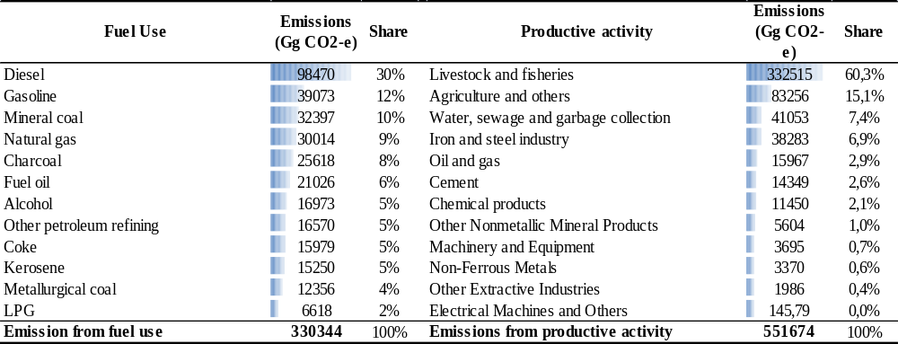
Source: Author's elaboration based on the Brazilian Inventory of Emission and Energy Balance Publications (MCT, 2010; MME, 2005).

The emissions from the use of fuels account for 37% of the emissions while the other 63% are associated with productive activity sectors. Livestock and Fisheries, Agriculture and Other are the sectoras that account for the largest sources of emissions in this category; of these, livestock alone accounted for 60% of emissions from production activities in Brazil.

2.2 Simulations and definition of GHG mitigation policy shocks
In this section, the procedures used in the simulations are related to GHG mitigation policies for a low-carbon economy. The recursive dynamic mechanisms allow a temporal dimension to be explored with the CGE model. The endogenous variables are adjusted throughout the period of analysis after the initial shock, both in the base scenario (or baseline) and in the policy scenario that includes specific shocks simulations.
The policy studied in this article refers to the imposition of emission reduction targets on the economy, achieved through carbon taxation. Under this policy, the limits on emissions apply to emissions from energy use and production activity of industries including, for example, emissions from livestock production. The price of carbon to achieve certain goals can be interpreted not only as a Pigouvian corrective tax, but can also be analyzed as the emission reduction cost that companies or industries would face with a target (or limit) of their emissions. Endogenously, the model calculates this cost or carbon price.
The baseline scenario represents what would be the path of the economy without emissions restriction policies. The evolution of the economy over the period 2012-2030 is based on a GDP growth scenario, household consumption, government, investment, exports, and exogenous assumptions about increasing energy efficiency and land productivity. The baseline scenario is anchored in an average growth of the Brazilian economy of 4% per year by 2030.
The difference between these trajectories (base scenario and the scenario with the policy shock) represents the additional effect of the imposition of emissions controls. In 2011, the emission control policies are applied in the Brazilian economy, to compose the political scenario. Thus, new nested simulations, year by year, allow analysis of the results by 2030, from accumulated deviations from the base case by 2030.
With the motivation of the emission reduction targets proposed by Brazilian national policy, simulations were performed for different reduction targets relative to the baseline scenario in 2030: 5, 10, 15, 20 and 25%. These goals translate into carbon prices (or carbon tax) on the different sources of greenhouse gas emissions (fuel and productive sectors) and users (sectors, households). If this market covers all emissions and is competitive as is the case for the BeGreen model, the carbon price will be equal to the marginal cost of abatement for a given goal. It reflects the emission reduction cost and can also be considered as an implicit price. In addition, the marginal abatement cost will be the same for all users, a condition for the cost-effectiveness of the policy.
As there is some uncertainty about emissions reduction mechanisms, for each goal, three simulations were implemented with different hypotheses: the first (Scenario 1), is the simulation in which only emission restrictions are imposed on the amount of specified goals. Scenario 2 includes a technological progress hypothesis in which the sectors experience endogenous technological innovations when facing carbon prices (innovating for the reduction of emissions). Scenario 3, in turn, represents the scenario in which, in addition to imposing targets that represents a tax on the carbon content, the tax revenue is returned in the form of income or subsidy to households.

Results of GHG Emissions Reduction Policies simulations in the Brazilian Economy

This section presents the economic impacts of emissions reduction targets on the economy, achieved by imposing a price on carbon. It should be noted that only emissions from the use of fuel, energy and productive activity sectors are considered. This portion is a more reasonable set of price-induced instruments to control emissions. Thus, the restrictions imposed on this portion of emissions represent around 40% of Brazil's total emissions in 2005. The remaining 60% were related to the change of land use (deforestation, conversion of forest to pasture or agricultural areas, for example).

3.1 Scenario 1 - Emissions Reduction Targets
Table 2 summarizes and compares the major aggregate effects of emissions control in Brazil for each emissions reduction target. The simulations consider only the imposition of goals met through taxation of inputs and carbon intensive goods. The fall in real GDP is not surprising under scenarios of emission targets. A target of 5%, for example, could result in a cumulative decline of GDP compared to the baseline scenario of -0.65% in 2030 and up to -8.93% if an ambitious target of 25% emission reduction is imposed. As a reminder, this result represents a relative reduction in 2030 and, therefore, should not be read as an absolute decline in GDP. In other words, this means that GDP growth would decrease from 4.00% per year to around 3.97% on average by 2030, considering the 5% emissions reduction policy. In the case of a more significant reduction in emissions (25% reduction), GDP growth would decrease from 4.00% to 3.53% on average by 2030. This drop cab be traced to the increase in production costs associated with the payment of carbon taxes or, alternatiuvely, it can be consided as the increases in emissions abatement costs due to emission reduction measures imposed on sectors
The fall in GDP is associated with the behavior of household consumption, investment and exports. Household consumption decreases under a carbon tax scenario. One reason is the increase in the price of goods since a carbon tax adds additional cost to production, and prices tend to rise as producers pass on the higher costs to consumers. Hence, households respond with lower consumption. This fall, however, can be partially offset by a carbon tax return for households that will be analyzed in more detail in the next section.

TABLE 2 - Macroeconomic Impacts of emissions reduction targets on the economy (var% in 2030- cumulative deviation from the baseline scenario.)
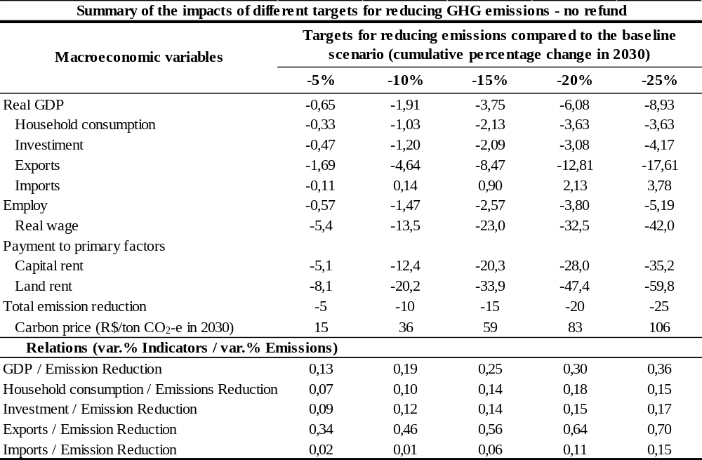
Source: Authors' calculations based on the results of Begreen model.

The reduction of investment, in turn, is linked to increased costs of producing and the consequent reduction of production. This result may be related to the profitability of the primary factors, especially for capital, that declines. It is reasonable to have the effect of a drop in profitability of the primary factors, due to the decline in demand for these factors, as a result of reduced production and economic activity. Declines in profitability of the primary factors indicate that the incidence of the carbon tax is not fully passed on to final consumers, and is partially absorbed by the factor prices.
Exports also represent a negative impact of greater magnitude when compared to consumption and investment. This drop is due to the price effect, by rising production costs since, under the small country hypothesis, exports change inversely with domestic prices. For imports, the results indicate a slight decrease or even an increase in growth rate. With the increase of domestic prices, and with a real appreciation of the Brazilian currency (nominal exchange rate is fixed in the model), imports in general would benefit from the imposition of emissions reduction targets. This even happens in the early years of the policy, in which there is a slight increase in imports. However, with the decline in economic activity over the years, there is a reduction of domestic prices for some goods, which together with a simultaneous drop in income produces a fall in imports.
Table 2 provides indicators that measure the relationship between the costs of the policies for each of the macroeconomic aggregates and emissions reduction targets. The relationship GDP/emissions reduction, for example, indicates that for each of the more ambitious targets of reducing emissions, there is a marginal cost reduction for the growing emissions. This result is in agreement with the literature (Nordhaus, 1991), since the extent that the economy is becoming more "clean," it is increasingly difficult to curb emissions, which means increasing costs. This can be confirmed by the trajectories of emission reduction costs, shown in figure 1. The first figure shows, for each of the emissions reduction targets, the trajectory of accumulated change (decrease) of GDP compared to the baseline scenario, the left to right starting in 2012. Each point represents the cost in terms of GDP each year. Is noticeable that in seeking to achieve a higher goal, the slope and distance of the points are modified in the sense that it becomes more costly for the economy to achieve ever more ambitious goals during the same time period.
The figure of the second column (figure 1) corroborates this result to portray the path, year by year, of the implicit carbon price in dollars per ton of CO2-e emissions for each goal. A progressive goal of 5% emission reduction by 2030, for example, requires carbon prices of R$3/ton CO2-e to R$ 15/ton CO2 at the end of the period. As can be seen, these escalating costs are increasing, although at a declining rate. Thus, we can turn to the debate between Stern (2006) and Nordhaus (2007). The Stern Review (Stern, 2006) has revived debate between mitigation costs and timing of action, arguing in favor of the benefits of a rapid transition to a low carbon economy, which outweigh the costs and risks of delayed action. The Nordhaus’ critique (2007), on the other hand, expresses that the immediate control of global emissions could represent high costs to economies. As Nordhaus (2007), “one of the major findings in the economics of climate change has been that efficient or “optimal” economic policies to slow climate change involve modest rates of emissions reductions in the near term, followed by sharp reductions in the medium and long term”. Thus, according to our results, in Brazil, emission reduction ambitious targets should be associated with longer periods of time; and less ambitious goals to shorter periods. The strategy for an ambitious goal in a short period of time would impose too high a cost for the Brazilian economy.

FIGURE 1 - Trajectories of the accumulated variation of GDP compared to the baseline scenario and carbon prices for each of the emissions reduction targets 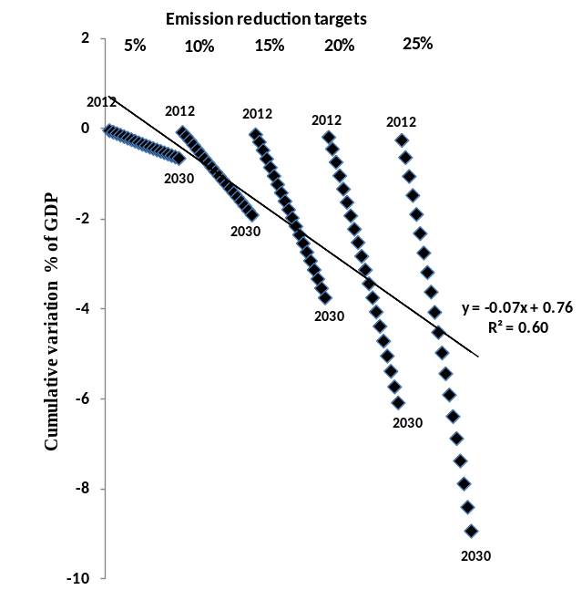 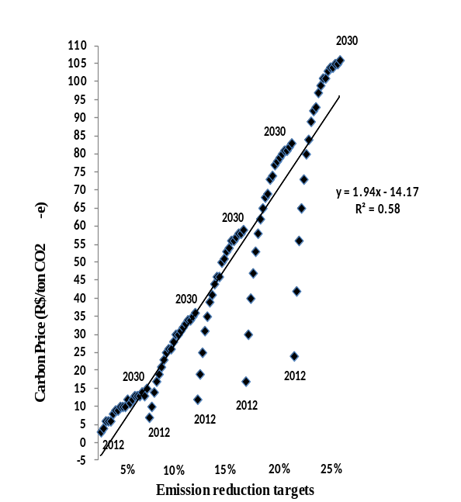
Source: Authors' calculations based on the results of Begreen model.

Although these results suggest a relative decline compared to the base scenariothe costs imposed on the Brazilian economy by imposing emissions restrictions are not negligible. A comparison of the results for the major emitters of developing countries can be made, despite the different patterns of GHG emissions and simulation’s assumptions (endogenous technological change, emissions coverage) in each reference. Table 3 provides a comparison of results in terms of reducing emissions and cost of GDP.

Table 3: Comparison of results for developing countries of carbon tax policies in terms of reducing emissions and cost of GDP
References | Country | GHG Emission reduction compared to the baseline scenario (%) | GDP loss (%)
Liang etal. (2007) | China | 5% in 2020 | -0.1 to -0.3
Liang etal. (2007) | China | 10% in 2020 | -0.4 to -0.8
Lu et al. (2010) | China | 17.5% in 2050 | -1.1
Wei and Glomsrod (2002) | China | 14% in 2050 | -0.85
Shukla and Dhar(2006) | India | 25% in 2050 | -6.7
Silva and Gurgel (2012) | Brasil | 3 to 30% in 2050 | -1 to -2
Gurgel (2012) | Brasil | Sectoral targets in 2050 | -4
Source: Authors' elaboration.

The cost of the policy in our simulation may be justified in this first scenario for three main reasons. The first is related to the objective of this work, which is to estimate the costs and the impact of price-induced policies for the portion of Brazilian emissions from energy use and production activity, inspired in international discussions underway. Thus, only emissions are considered from the use of fuels, energy and sectors of activity level.
The second reason relates to the theoretical characteristics of the model that assume constant returns to scale and, in the case of environmental module, emissions that are proportional to the activity levels of the sectors and the use of energy and fuels. A difference that can be highlighted in relation to previous studies; in the Brazil application, greater disaggregation is provided in the model, involving more interactions and sectors interdependencies that can intensify the results. The sensitivity analysis performed on the parameters and elasticities revealed that the results, considering the methodological specification, are robust for most variables.
Finally, the results of this section do not consider the existence of any technological change or alternative scenarios that could reduce emissions from sectors or compensate individuals affected by emissions targets. The only possibility in this first scenario is the substitution of energy inputs via changes in relative prices. To deal with these issues and expand the range of possible outcomes, the next two sections deal with the possibility of returning the tax revenue from the carbon tax and also an endogenous technological change.

3.2 Scenario 2: Emission reduction targets via taxation and emissions abatement

The first scenario discussed does not take into account technological changes in the production process that may occur by the imposition of emissions reduction targets. This hypothesis, however, may not be realistic in the long term scenarios (FERREIRA FILHO and ROCHA, 2007). To answer this possibility, the scenario presented in this section considers the introduction of a carbon tax that generates a reaction on the part of sectors and firms, so that there is an incentive for the adoption of technologies that reduce emissions from production processes rather than face the prospect of reducing producing or facing declining demand from elevated prices. Moreover, this innovation has an investment cost for the sectors. Technological change is modeled based on the value of the tax, being directly proportional to it, through a proportionality constant. Since there are no estimates for the value of this parameter for the Brazilian economy, conservative values will be used as an illustration. It is assumed that a R$ 100 tax per ton of CO2 equivalent would cause a reduction of 10% in emissions associated with the level of activity sectors (see ADAMS et al., 2002). Although this specification of technological change follow an ad-hoc method, it is an initial step to introduce a specification of endogenous technological change in a future work. Even with the limitations of the current specification, the results suggest the importance of considering this assumption in mitigation policies simulations. Table 4 thus presents the impacts of emissions reduction targets under this scenario as accumulated deviation from the baseline scenario in 2030.

TABLE 4 - Macroeconomic impacts of emissions reduction targets on the economy with technological innovation hypothesis. (var.% in 2030- cumulative deviation from the baseline scenario)
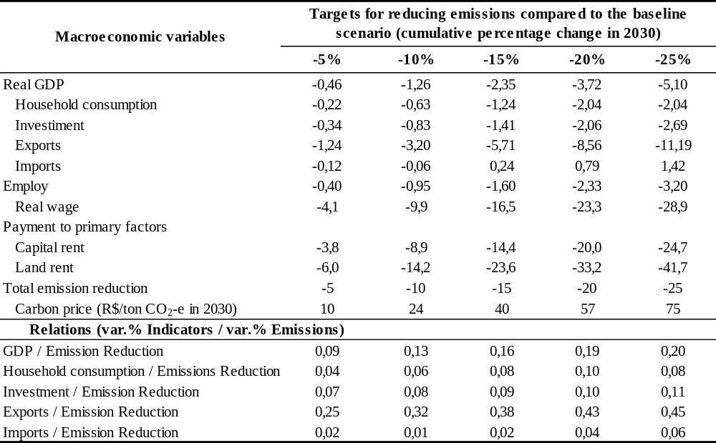
Source: Authors' calculations based on the results of Begreen model.

The emission abatement assumption through technological innovation has an important impact to minimize the costs of GHG reduction, as expected. In this case, real GDP only retreats 0.46% compared to the baseline scenario in 2030. This means that GDP growth between 2011 and 2030 would drop from 4.00% per year (baseline scenario) to about 3.98% per year considering the 5% emissions restriction policy. The investment in the adoption of cleaner technologies by sectors tends to maximize the reduction of emissions, and consequently reduce the marginal cost of mitigate emissions. Emissions reduction targets through market mechanisms such as a carbon tax and anchored by policies that facilitate technological change in the sectors, can be configured as an alternative cost-efficient alterantive for a GHG mitigation policy in the Brazilian economy.
Analyzing the results of table 4, we find that, in general, household consumption, investment and exports performs better (smaller decreases) compared to scenario 1. These results may be explained by the fact that the introduction of technological change alters the emission reduction costs for the achievement of goals. In this case, emitting sectors by the productive activity can reduce more effectively emissions at a lower cost, avoiding the payment of tax. This cost is reflected in the various sectoral production costs, now less intense than projected in scenario 1. This has consequences in terms of the smallest reduction in household consumption, investment and exports across scenarios.

3.3 Scenario 3: Emission reduction targets with the return of the tax revenue to households

It can be assumed that to achieve the emission reduction targets, the government effectively introduces a carbon tax on the emission sources of GHGs. We simulated in this section, the impact of the return of revenue from carbon taxes to households. This approach is widely discussed in the literature as a neutral approach to the formulation of tax policies, in order to minimize the adverse effects of policy on the economy. In the literature, there are several possibilities of returning the collected tax, such as lump-sum transfer, compensation in income, among others. In this paper, three revenue recycling possibilities were simulated: i) return via increased household income in constant proportion to all deciles; ii) return via increased income for the two lowest deciles of income; iii) return via a uniform subsidy on consumption goods of households. This could be seen as revenue that is used to reduce existing consumption taxes on all goods by a uniform percentage. These revenue recycling hypotheses are plausible, as has been practiced by the Brazilian government in recent years. Moreover, in the particular case of subsidies, a significant portion of fuel prices can be controlled by the federal government. In this case, the policy simulation assumes that only the amount of direct taxation that falls on household consumption would be returned in the form of subsidies (decreasing indirect taxes on consumption) to all goods. The return value is therefore equivalent to the amount collected on household emissions after the tax is imposed. The government still capture the revenue from carbon tax paid by sectors on intermediate consumption and production.
Given the scope of this paper, we present the results for the emission reduction target by 5% compared to the baseline scenario. Table 5 projects the aggregate impacts of the 5% reduction target by adding to this scenario the different possibilities of returning the tax to households.

TABLE 5 - Macroeconomic Impacts of emissions reduction targets with the hypothesis of return the tax to households. (var.% in 2030- cumulative deviation from the baseline scenario)
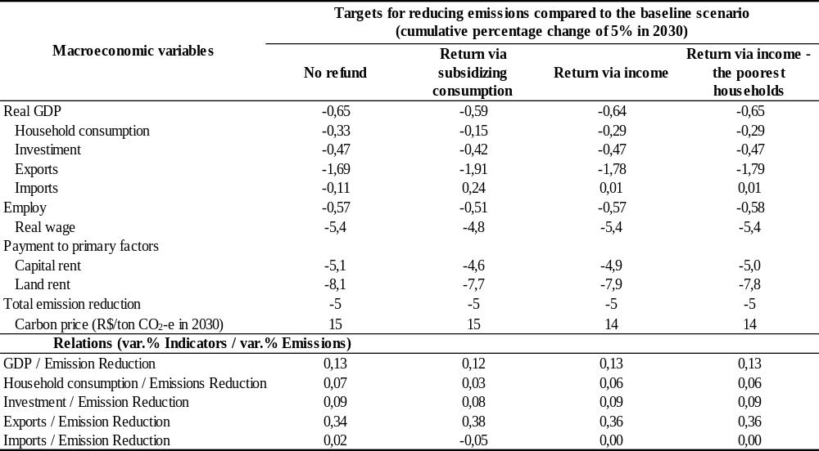
Source: Authors' calculations based on the results of Begreen model.

The first column of the table reports the results of the imposition of targets without any revenue recycling. In aggregate terms, under the assumption of different possibilities of return, a less intense fall in household consumption is observed compared to the scenario without return, especially for the hypothesis of subsidizing consumption, which reduces household consumption by 0.15 %. This result is also reflected in a smaller drop in GDP, falling 0.59%.

3.3.1 Results for groups of households

A policy that raises the prices of carbon intensive goods such as energy goods, or that impacts on the food chain, can have disproportionate impacts on households. A major concern when introducing taxes or increased costs on the economy relates to equity. This paper is the first to consider the distributional effects on households imposing emission reduction targets on the Brazilian economy. The BeGreen model is especially specified for the analysis of these impacts, as it features in its specification 10 representative households, defined according to the total income deciles per family unit. The denominations H1 to H10 represent the breakdown of households based on income deciles in which H1 refers to the first decile (households with a low income), whereas in H10 are households in the highest income group. Table 6 depicts the share of households in consumption, according to the model database.

TABLE 6 - Household share in consumption and average income, by income decile - 2005.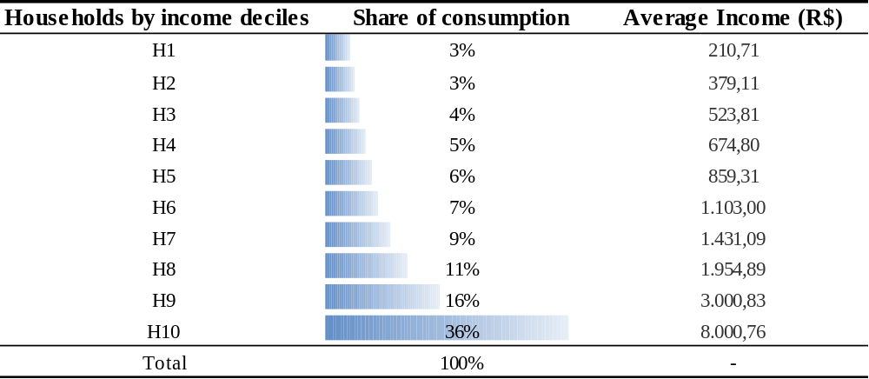
Source: BeGreen database based on the POF data

These numbers reflect the high income concentration and inequality of the Brazilian economics. The two “richest ” deciles (H9 and H10) account for over half of household consumption (52%). This participation in the consumption can be broken down by energy goods, to highlight the pattern of expenditures for each decilethat will be reflected in the results of the simulations. As can be seen in table 7, the lowest deciles spend a larger proportion of their income on electricity compared to the upper deciles. In contrast, the lower income deciles have a high proportion of spending on fossil fuels, with particular emphasis on gasoline. In total, the households of the lowest income decile spend about 5.2% of income in the consumption of energy goods, while the highest decile, reaches 9.4%. On the contrary, the poor deciles spent more money in agriculture and food products; the richer deciles spent more money on services. As services have a low carbon emission, and agriculture is a big GHG emitter, the numbers point to a regressive impact of carbon prices. This hypothesis will be tested in the simulations.

TABLE 7 - Share of energy goods in household consumption - 2005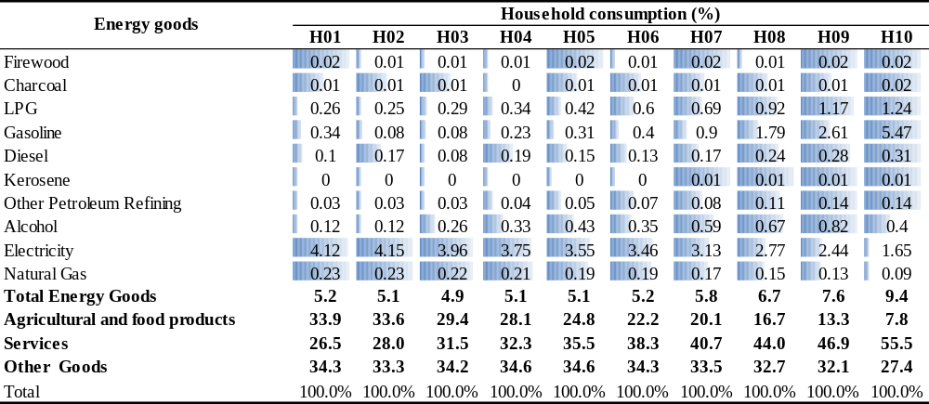
Source: BeGreen database based on the POF data

Based on these indicators, table 8 reflects the impacts of a carbon tax on the consumption of each household to the target of 5% reduction in emissions for each of the simulation scenarios.

TABLE 8 - Impacts on household consumption (% var. - Accumulated deviation from the baseline scenario)
Households | Targets for reducing emissions compared to the baseline scenario (cumulative percentage change of 5% in 2030)
Households | No refund | Return via subsidizing consumption | Return via income | Return via income - the poorest households
Households | Consumption | Consumption | Consumption | Consumption
H01 | -0.89 | -0.72 | -0.39 | 2.18
H02 | -1.03 | -0.86 | -0.65 | 1.45
H03 | -0.76 | -0.58 | -0.47 | -0.92
H04 | -0.71 | -0.53 | -0.49 | -0.87
H05 | -0.67 | -0.49 | -0.51 | -0.82
H06 | -0.53 | -0.35 | -0.41 | -0.68
H07 | -0.47 | -0.29 | -0.40 | -0.61
H08 | -0.36 | -0.18 | -0.34 | -0.50
H09 | -0.21 | -0.02 | -0.22 | -0.34
H10 | -0.04 | 0.16 | -0.11 | -0.16
Indicators
Decile H01/Decile H10 | 24.83 | -4.52 | 3.56 | -13.96
Decile H01/Decile H05 | 1.34 | 1.47 | 0.77 | -2.65
Decile H05/Decile H10 | 18.47 | -3.08 | 4.61 | 5.27
GINI Coefficient Variation | 0.3% | 0.4% | 0.2% | -0.1%
Source: Authors' calculations based on the results of Begreen model.

In general, the results indicate that taxation policy has less intense effects on the share of households with the highest share in consumption. This is due to the fact that taxation imposes additional costs on households, mainly by raising the price of taxed products and those that are part of the consumption basket. In the scenario without "recycling," for example, households with the lowest income (decile H1), suffer the greatest relative impact in terms of consumption, approximately 24 times higher than the highest income class (decile H10). Households with higher income, despite having a larger share of spending on fuel, they have a higher consumption reallocation capacity. In addition, they are less affected by carbon taxation, since the share of their budget on services is higher (the consumption of services, for example, the lowest income decile is 26.5%, whereas households with higher decile consume 56.5% of services). As services are falling relative prices, since they do not emit, the effect on consumption of the richest households is lower. Added to this is the smallest share of agricultural products and food for this level of income. These products accumulate price increases as a result of taxation on the sectors of Agriculture and Livestock. These price changes are shown in table 9, which depicts the cumulative impact in 2030 with the emissions reduction target policy of 5% for some selected goods.
Extending the analysis to all scenarios, we can see a different standard to specify the different forms of revenue recycling. It may be noted that the classification of deciles more and less affected in the hypothesis of "recycling" via subsidizing consumption varies very little compared to the scenario without return. The change is only one of magnitude. The highest income decile (H10), for example, is replaced by a positive change in consumption, 0.16%, in 2030.
Significant changes occur on "recycling" scenarios via income. When considering a homogeneous return (same proportion among deciles), the return of income minimizes the effect of taxation mainly on the lowest decile. When the compensation policy aims to reduce the impact on the most affected deciles, returning the revenue in the form of income to the deciles H1 and H2, the change in consumption for these deciles becomes positive and significant in 2030. According to the indicators shown in table 8, the impact on lower-income households (decile H1) becomes now about 14 times higher compared to the effect on the richest households.

TABLE 9 - Effects on prices for the households of the target of 5% reduction compared to the baseline scenario in 2030 for selected goods. (cumulative deviation from the baseline scenario in 2030)
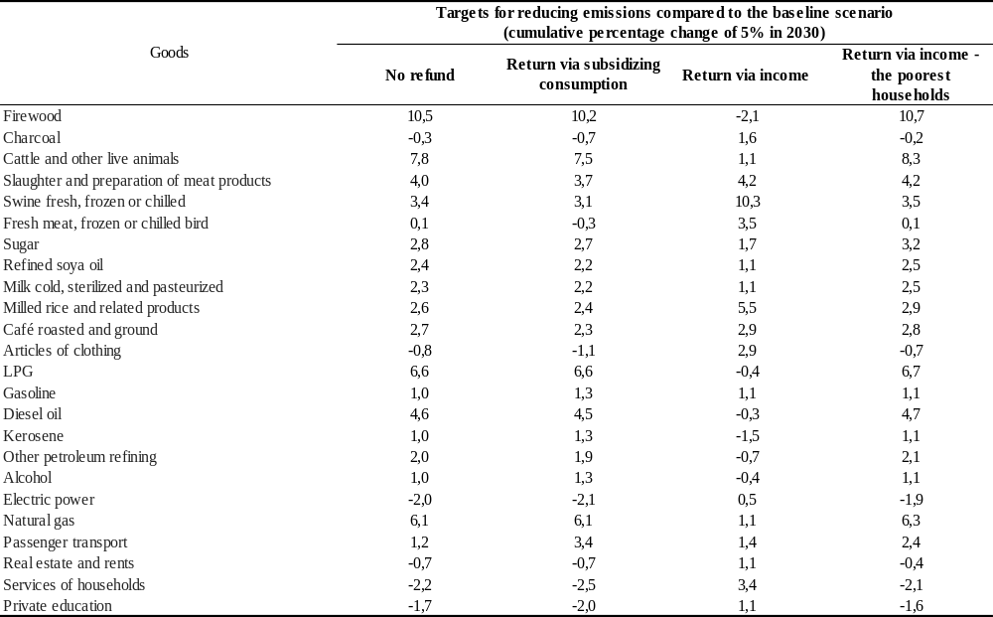
Source: Authors' calculations based on the results of Begreen model.

The last line of the table shows the change in the Gini coefficient for each hypothesis. The Gini coefficient measures the degree of inequality in income distribution among income groups. The calculations are based on the expenses for each decile (considered a more consistent metric) and expressed as percentage changes on the 2005 benchmark index. Carbon tax results suggest a greater negative impact on the poorest households. The GINI coefficient variation, which considers the entire distribution of the deciles confirms that the introduction of a carbon tax could worsen the coefficient on the initial level. The alternative without return of taxation revenues worsens the Gini coefficient by 0.3% in 2030. The alternative of a consumption subsidy even further worsens the distribution of income; in the latter case, theGINI coefficient in 2030 would be 0.4% higher, mainly due to increased consumption of the highest income deciles.
However, when the alternatives that are considered compensation via income policies are viewed, the index retreats, especially the recycling return via income for deciles H1 and H2. In this case, the coefficient falls by 0.1% in 2030. In fact, the index improvement happens in the scenarios where the two lowest deciles lose less due to the compensation policies. If we analyze the share in consumption before and after the policy, the offset option to the poorest households increases the participation of deciles H1 and H2 from 6.1% to 6.3%, and decreases the last two deciles from 51.6 % to 51.3%. It is a marginal but significant effect. In monetary terms, for example, would be transferring 18 billion reais in 15 years (2005 Brazilian currency) of the last two deciles for the first two. This transfer would be equivalent to 5% of the “Bolsa Família” Brazilian transfer program in a typical year.

4. CONCLUSIONS

The objective of this research was to evaluate alternative mitigation policies for the Brazilian case, policies that have recently been widely discussed and adopted in several countries. The problem addressed in this work is a result of one of the most complex and diffuse environmental externalities: GHG emissions. The elucidation of the main elements involving the causes and consequences of the accumulation of these gases linked to appreciation of the major international discussions on climate change, highlight the importance of considering this issue in the decisions of Brazilian society.
In Brazil, the results of the imposition of emissions reduction targets on the use of fuels and productive activities indicate that ambitious targets must be linked to longer periods of time; and less ambitious goals to shorter periods. This is justified by the current structure of the Brazilian energy matrix, with more intensive "clean" energy sources such as hydroelectric. The strategy for an ambitious goal in a short period of time would impose a high cost for the Brazilian economy. Such costs, however, could be alleviated both by redistributive policies of revenue and also policies promoting technological progress (in terms of production processes that emit less greenhouse gases). The technological progress scenarios induced by carbon taxation highlight the relevance of this possibility to the objectives of policy. This result shows that the adoption of technology policies that can support the innovation practices in the sectors would increase the effectiveness of the policy. Thus, credit lines combined with industrial policies that enable the technological and scientific innovation with the goal of reducing the use of fuel or increased energy efficiency, are some of the options that could make this more likely scenario.
The distributional impact on households of greenhouse gas mitigation policies is a new result in the context of Brazilian literature. Table 10 summarize the effects on efficiency and equality across scenarios.

TABLE 10 - Summary table highlighting effects on efficiency and equality across scenarios
Indicators/ Policies | Differtent option for revenue recycling (refund) of a carbon tax policy to reduce emissions in 5% in 2030
 | No refund | Return via subsidizing consumption | Return via income | Return via income - the poorest households
Efficiency (Real GDP cost) | -0,65 | -0,59 | -0,64 | -0,65
Household consumption
All | -0,33 | -0,15 | -0,29 | -0,29
H1 | -0,89 | -0,72 | -0,39 | 2,18
H10 | -0,04 | 0,16 | -0,11 | -0,16
Equity (GINI coefficient) | Regressive (0.3%) | Regressive (0.4%) | Regressive (0.2%) | Slightly Progressive  (-0.1%)
Source: Authors' calculations based on the results of Begreen model.

In terms of the effects on income classes, the carbon tax is moderately regressive, even when considering the return of revenue via subsidizing consumption of all households. This is an interesting result. The assumption of revenue recycling via subsidies to consumption, or otherwise reducing a distortionary consumption tax, reduces the total cost of the policy. However, it contributes to an increase in income inequality among households: a classic result of the trade-off between efficiency and inequality.
If the aim is to make more progressive policy, then compensation policies via income for the poorest deciles may be the solution. When we introduced the assumption of income compensation for the poorest families, the regressive result can be eliminated. These families are the most affected under the carbon tax scenario.
An analysis beyond the results presented in this paper suggests that the GHG mitigation policy in the Brazilian case must include the control of deforestation as one of the main fronts for the cost-effectiveness of climate policy objectives, as already outlined in the National Change Policy Weather.
Some considerations about limitations of this work should be noted. One of them refers to the assumptions of the methodology, which is based on a model with constant returns to scale and without endogenous technological change mechanisms on the use of fuels that potentially reduce the emissions intensity of the use of fossil fuels in policy simulations. The endogenous technological change specification is an issue for future work.
One can conjecture hypothetically that the results are the "upper limit" of the costs that would be imposed on the Brazilian economy with GHG mitigation policies, given these restrictive assumptions of modeling. In addition, the benefits that mitigation of greenhouse gases could generate are not considered due to the difficulty and uncertainty involved in the measurement of possible impacts that would be caused by climate change.

REFERENCES

ABARE (1996). The Megabare Model: Interim Documentation. Australian Bureau of Agricultural and Resource Economics. Canberra, 71 p.
ADAMS, P. D., HORRIDGE, M., PARMENTER, B. R. (2000). MMRF-GREEN: A Dynamic, Multi-sectoral, Multi-regional Model of Australia. Australia: Monash University, Centre of Policy Studies, Impact Project.
ALDY, J. E., KRUPNICK, A. J., NEWELL, R. G., PARRY, I. W. H., PIZER, W. A. (2008). Climate economics and policy. RFF Discussion Paper. Washington, DC: Resources for the Future.
ALDY, J. E., STAVINS, R. N. (2009). Post-Kyoto International Climate Policy: Summary for Policymakers. New York: Cambridge University Press.
ARAAR, A., DISSOU, Y., DUCLOS, J. (2011). Household incidence of pollution control policies: A robust welfare analysis using general equilibrium effects, Journal of Environmental Economics and Management, 61(2), 227-243.
BARANZINI, A., GOLDEMBERG, J., SPECK, S. (2000). A future for carbon taxes. Ecological Economics 32 (3), 395–412.
BARKER, T., KOHLER, J. (1998). International Competitiveness and Environmental Policies. Edward Elgar, Cheltenham.
BAUMOL, W. J., OATES, W. E. (1988). The Theory of Environmental Policy. Cambridge University Press, 2nd edition.
BEHR, T., WITTE, J.M., HOXTELL, W., MANZER, J. (2009). Towards a Global Carbon Market Potential and Limits of Carbon Market Integration, GPPI Policy Paper 5, Berlin: Global Public Policy Institute.
BRENNER, M., RIDDLE, M., BOYCE, J. K. (2007). A Chinese sky trust?: Distributional impacts of carbon charges and revenue recycling in China. Energy Policy, 35(3), 1771-1784.
BOSETTI, V., BUCHNER, B. (2009). Data Envelopment Analysis of different climate policy scenarios. Ecological Economics 68 (5), 1340 –1354.
MCT - Ministry of Science and Tecnology (2010). The second Brazilian Inventory of Anthropogenic Emissions by Sources and Removals by Sinks of Greenhouse Gases not Controlled by the Montreal Protocol. (in Portuguese) . (Available online at: http://www.mct.gov.br/index.php/content/view/310922.html). Accessed June 2013.
CALLAN, T., LYONS, S., SCOTT, S., TOL, R. S., VERDE, S. (2009). The distributional implications of a carbon tax in Ireland. Energy Policy, 37(2), 407-412.
MME - Ministry of Mining and Energy (2005). National Energy Balance 2006: Base year 2005 (in Portuguese). Available online at https://ben.epe.gov.br/downloads/Relatorio_Final_BEN_2012.pdf. Accessed June 2013.
CLARKE, L., EDMONDS, J., KREY, V., RICHELS, R., ROSE, S., TAVONI, M. (2009) International climate policy architectures: Overview of the EMF 22 International Scenarios. Energy Economics 31, S64–S81.
BUREAU, B. (2011). Distributional effects of a carbon tax on car fuels in France. Energy Economics33 (1), 121–130.
CANSIER, D., KRUMM, R. (1997). Air pollutant taxation: an empirical survey. Ecological economics, 23(1), 59-70.DIXON, P. B., PARMENTER B. R., SUTTON, J. M., VINCENT D. P. (1982). ORANI: A Multisectoral Model of the Australian Economy. Amsterdam: North-Holland.
EDMONDS, J., KIM, S. H., McCRACKEN, C. N., SANDS, R. D., WISE, M. A. (1997). Return to 1990: The Cost of Mitigating United States Carbon Emissions in the Post-2000 Period. Washington, D.C.: Pacific Northwest National Laboratory.
FEIJO, F. T.; PORTO Jr., (2009). The Kyoto Protocol and the Economic Welfare in Brazil:An Analysis Using Computable General Equilibrium. (in Portuguese) Análise Econômica (UFRGS)51, 127-154.
FENG, K., HUBACEK, K., GUAN, D., CONTESTABILE, M., MINX, J.; BARRETT, J. (2010).Distributional effects of climate change taxation: the case of the UK. Environmental Science and Technology, 44 (10),3670–3676.
FERREIRA FILHO, J. B. S.; ROCHA, M. T. (2007). Economic evaluation of public policies aimed at reducing emissions of greenhouse gases in Brazil. (in Portuguese). In: CONGRESSO DA SOCIEDADE BRASILEIRA DE ECONOMIA E SOCIOLOGIA RURAL, 45., Londrina. Anais ... Londrina: SOBER.
FRANKEL, J. (2008). An elaborated proposal for global climate policy architecture: Specific formulas and emission targets for all countries in all decades. Discussion Paper 2008-08, Cambridge, MA: Harvard Project on International Climate Agreements.
FRISCH, R. (1932). New methods of measuring marginal utility (V. 3). Mohr.
GOULDER,L.H. (1995). Effects of carbon taxes in na economy with prior tax distortions: na intertemporal general equilibrium analysis. Journal of Environmental Economics and Management, 29(3), 271–297.
GOULDER, L. H., PARRY, I. W. (2008). Instrument choice in environmental policy. Review of Environmental Economics and Policy, 2(2), 152-174.
GOUVELLO, C. (2010). (Ed.) Low Carbon Study for Brazil. Available online at: <http://siteresources.worldbank.org/BRAZILINPOREXTN/Resources/3817166- 1276778791019/Relatorio_Principal_integra_Portugues.pdf> Acessed July 2011.
GURGEL, A. C.( 2012). Impacts of the global low carbon economy over Brazil (in Portuguese) Anais da ANPEC.
GUILHOTO, J. J. M. (1995). A computable general equilibrium model for planning and analysis of agricultural policies (PAPA) in the Brazilian economy. (in Portuguese) (Habilitation Thesis). ESALq, Universidade de São Paulo, Piracicaba.
HANOCH, G. (1971). CRESH production functions. Econometrica. USA, 39(5), 695–712.
HEPBURN, C. (2006). Regulating by prices, quantities or both: an update and an overview. Oxford Review of Economic Policy, 22 (2), 226–247.
HILGEMBERG, E. M.; GUILHOTO, J. J. M.; (2006). Use of fuels and CO2 emissions in Brazil: an interregional input-output model. (in Portuguese). Nova Economia, Belo Horizonte, 16 (1), 49-99.
HINCHY, M.; HANSLOW, K., 1996. The MEGABARE model: interim documentation. Australian Bureau of Agricultural and Resource Economics. (Available at: < http://www.abareconomics.com>) Acessed July 2013..
IMF - International Monetary Fund (2008). The Fiscal Implications of Climate Change. Fiscal Affairs Department.
INPE – Brazilian National Institute for Space Research (2012). PRODES and Monitoring of the Brazilian Amazon rainforest by Satellite (in Portuguese). Available at http://www.obt.inpe.br/prodes/index.php Accessed February 2014.
JORGENSON, D. W., WILCOXEN, P. (1993). Reducing US carbon dioxide emissions: an assessment of different instruments. Journal of Policy Modeling, 15(5), 491–520.
KLEPPER,G. (2011). The future of the European Emission Trading System and the Clean Development Mechanism in a post-Kyoto world, Energy Economics 33(4), 687-698.)
LIANG, Q. M., FAN, Y., WEI, Y. M. (2007). Carbon taxation policy in China: How to protect energy-and trade-intensive sectors?. Journal of Policy Modeling, 29(2), 311-333.
LU, C., TONG, Q., LIU, X.M. (2010). The impacts of carbon tax and complementary policies on Chinese economy. Energy Policy 38 (11), 7278–7285.
MANNE, A. S. (2005). General Equilibrium Modeling for Global Climate Change. In: KEHOE, T. J.; SRINIVASAN, T. N.; WHALLEY, J. (Ed.). Frontiers in Applied General Equilibrium Modeling. New York: Cambridge University Press, 255-276.
MCDOUGALL, R. (1993). Energy taxes and greenhouse gas emissions in Australia. Working Paper. Centre of Policy Studies/IMPACT Centre: Monash University, g-104.
METCALF, G., WEISBACH, D. (2012). Linking Policies When Tastes Differ: Global Climate Policy in a Heterogeneous World. Review of Environmental Economics and Policy6(1), 110-129.
NORDHAUS, W. D. (1991). To Slow or Not to Slow: The Economics of The Greenhouse Effect. The Economic Journal, 101(407), 920-937
NORDHAUS, W. D. (2008). A question of balance: weighing the options on global warming policies. New Haven: Yale University Press.
OJHA, V. (2011) Carbon emissions reduction strategies and poverty alleviation in India. Environment and Development Economics, 14 (3), 323–348.
OLMSTEAD, S. M., STAVINS, R. N. (2010). Three key elements of post-2012 international climate policy architecture. HKS Faculty Research Working Papers Series RWP10-030.
PALTSEV, S., REILLY, J. M., JACOBY, H. D., ECKAUS, R.S., MCFARLAND, J., SAROFIM, M., ASADOORIAN, M., BABIKER, M. (2005). The MIT Emissions Prediction and Policy Analysis (EPPA) Model: version 4. MIT Joint Program on the Science and Policy of Global Change. Cambridge. Report n. 125.
PARRY, I. W.H., 1995. Pollution Taxes and Revenue Recycling, Journal of Environmental Economics and Management,29(3), S64-S77.
PEARCE, D. (1991). The role of carbon taxes in adjusting to global warming. The economic journal, 938-948.
PETER, W. W., HORRIDGE, M., MEGUER, G.A., NAVQUI, F., PARMENTER, B. R. (1996). The theoretical structure of MONASH-MRF. Cayton: Center of Policy Studies, 121 p.
PIGOU, A. C. (1932). The economics of welfare, 1920. McMillan&Co., London.
PROOST, S., VAN REGEMORTER, D. (1995). The double dividend and the role of inequality aversion and macroeconomic regimes. International Tax and Public Finance, 2(2), 207-219.
POTERBA, J.A. (1991). Tax policy to combat global warming. On designing a carbon tax. In: Dornbusch, R., Poterba, J. (Eds.), Global Warming: Economic Policy Responses. MIT Press, Cambridge.
RAUSCH, S., METCALF, G.E.; REILLY, J. M. (2011). Distributional impacts of carbon pricing: A general equilibrium approach with micro-data for households. Energy Economics, 33, S20-S33.
REQUATE, T. (2005) Dynamic incentives by environmental policy instruments - a survey. Ecological Economics 54 (2), p.175–195.
ROCHA, M. T. (2003). Global warming and the carbon market: an application of the CERT model (in Portuguese). PhD Thesis – Escola Superior de Agricultura Luiz de Queiroz – USP, Piracicaba.
RONG, F. (2010). Understanding developing country stances on post-2012 climate change negotiations: Comparative analysis of Brazil, China, India, Mexico, and South Africa, Energy Policy, 38(8), 4582-4591.
ROSE. A. (2009). The Economics of Climate Change Policy: International, National and Regional Mitigation Strategies. Edward Elgar, Massachusetts.
SILVA, J. G, GURGEL, A. C. (2012). Economic impacts of climate policy scenarios for Brazil (in Portuguese). Pesquisa e Planejamento Econômico, 42(1).
SHUKLA, P. R., DHAR, S. (2011). Climate agreements and India: aligning options and opportunities on a new track. International environmental agreements: Politics, law and economics, 11(3), 229-243.
SPRINGER, U. (2003). The market for tradable GHG permits under the Kyoto Protocol: a survey of model studies, Energy Economics 25(5), 527-551.
TIETENBERG, T.H. (1990). Economic Instruments for Environmental Regulation. Oxford Review of Economic Policy6(1), 17-33.
TOURINHO, O. A. F., DA MOTTA, R. S., ALVES, Y. L. B. (2003). An Environmental Application of a General Equilibrium Model (in Portuguese). Rio de Janeiro: IPEA. Texto para discussão n. 976.
UK Energy White Paper. (2003). Our Energy Future-Creating a Low carbon Economy.
VERDE, S. F., TOL, R. S. J. (2009). The distributional impact of a carbon tax in Ireland. The Economic and Social Review, 40, 317–338.
VIOLA, E. (2009). Brazil in the global and regional politics climate. Global Summit on Sustainable Development and Climate Change. New Delhi.
WANG, X., LI, J. F., ZHANG, Y. X. (2011). An analysis on the short-term sectoral competitiveness impact of carbon tax in China. Energy Policy, 39(7), 4144-4152.
WATKINS, K. (2007). Human Development Report 2007/2008: fighting climate change.
WATSON, R. T. (2001). (Ed.) Climate Change 2001: Synthesis Report. Contributions of Working Group I, II, and III to the Third Assessment Report of the Intergovernmental Panel on Climate Change. Cambridge, UK: Cambridge University Press.
WEST, S. E., WILLIAMS, R. I: (2004). Estimates from a consumer demand system: implications for the incidence of environmental taxes, Journal of Environmental Economics and Management, 47, 535–558.
WEYANT, J. (1993). Costs of reducing global carbon emissions. Journal of Economics Perspectives. 7(4), 27-46.
WEI, T., GLOMSROD, S. (2002). Effects and policy responses of carbon tax. World Economy and Politics, 2002, 47-49.
WIER, M, BIRR-PEDERSEN, K., JACOBSEN, H. K., KLOK, J. (2005). Are CO2 taxes regressive? Evidence from the Danish experience, Ecological Economics, 52(2), 239-251.
WING I. S. (2004). Computable General Equilibrium Models and Their Use in Economy-Wide Policy Analysis. The MIT Joint Program on the Science and Policy of Global Change, Technical Note N. 6.
XIE, J., SALTZMAN, S. (2000). Environmental policy analysis: an environmental computable general-equilibrium approach for developing countries. Journal of Policy Modeling, 22(4), 453-489.
ZHANG, Z.X. (2009). Multilateral trade measures in a post-2012 climate change regime? What can be taken from the Montreal Protocol and the WTO? Energy Policy 37(12),5105-5112.
ZHOU, P.; ANG, B.W. (2008). Decomposition of aggregate CO2 emissions: a production theoretical approach. Energy Economics 30(3), 1054–1067.

Public goods are defined as those goods where individuals cannot be excluded from its consumption (non-excludable) and the supply is independent of the number of affected agents (non-rival). Thus, the public goods property rights are not defined. Trade with other goods end up not performing efficiently in the competitive market. Thus, policy intervention becomes necessary public in order to achieve efficiency.
Pigou proposed internalization of externalities through market mechanisms (Pigouvian taxes) as a means to match the private costs to social costs.
In renewable composite through a CES function, firms choose the composition of renewable energy inputs (firewood, charcoal, alcohol, sugar cane bagasse, hydropower). In turn, the non-renewable composite, they choose among non-renewable inputs (oil, natural gas, LPG, diesel oil, fuel oil, gasoline, kerosene, coke, other refinery products).
The sectors, on the other hand, can reduce emissions by replacing energy inputs, via change in relative prices.
Emission factors were needed for the processing of emissions in a common unit, CO2 equivalent (CO2-e), obtained from the Stern Review (Stern, 2006), from the Global estimates Warming Potential (GWP).
It should be noted that the share of these emissions is likely to grow, given the growth of emissions in the energy sector linked to the significant reduction of emissions from deforestation (INPE, 2012).
Emissions due to changes in land use, which is configured as the main source of emissions in Brazil (about 60% of total emissions) are not considered. This is justified by the fact that mitigation policies of this large portion of Brazil's emissions are based on the control of deforestation, which has a focus of regulation, supervision and control. If the mitigation of these issues were considered, through economic incentives as financial compensation mechanisms as REDDs (Reducing Emissions from Deforestation and forest Degradation) or enforcement policies, the costs of achieving the goals proposals could reduce considerably.
These results are available by request from the author.
The results for the other targets are similar, differing only the magnitude of impacts.
The simulations were carried out with constant FRISCH parameter for all households (-2.48). This parameter measures the ratio between expenses of subsistence and non-subsistence expenses (luxury) per product for households. It is expected, therefore, that this ratio is higher for poor households than for richest households, as is used in the literature (FRISCH, 1932).
Bolsa Família is a social welfare program of the Brazilian government, that provides financial aid (income transfer) to poor Brazilian families. If they have children, families must ensure that the children attend school and are vaccinated.

