Crop Yields, Food Security, and GHG Emissions: An Analysis of Global Mitigation Options for Rice Cultivation

Robert Beach,¹ Jared Creason,² Zekarias Hussein², Shaun Ragnauth,² Sara Bushey Ohrel,² Changsheng Li,^{3,4} and William Salas⁴

¹ Agricultural, Resource & Energy Economics and Policy Program, RTI International, Research Triangle Park, NC, USA
² Climate Change Division, U.S. Environmental Protection Agency, Washington, DC, USA
³ Complex Systems Research Center, Institute for the Study of Earth, Oceans, and Space, University of New Hampshire, Durham, NH, USA
⁴ Applied Geosolutions, LLC, Durham, NH, USA

Submitted for Presentation at the 19th Annual Conference on Global Economic Analysis , Washington, DC, June 15-17, 2016

Keywords: Climate change policy, Food prices and food security, Trade and the environment

Abstract

Global agriculture faces the dual challenges of improving food security for a growing population while simultaneously reducing the environmental footprint of agricultural production, including net greenhouse gas (GHG) emissions. Paddy rice production is the 5th largest source of methane emissions, globally.

But the impacts of crop production decisions extend beyond the economic costs and benefits. Fueled by concerns over ethanol, a lively debate has emerged over food security issues (Searchinger, et al 2013). Rice is a staple crop produced in areas with fast-growing populations that have been plagued by food shortages. CH4 mitigation might have an adverse impact on food security.

Extending prior work on GHG mitigation to examine food security implications, we used the GTAP model is to examine domestic consumption and trade flows between 140 countries in the v9 GTAP data set. Food security is assessed using food balance sheet data from the FAO. We find that at carbon prices up to $50 the result on food security is mixed. This analysis provides valuable insights into the potential tradeoffs and synergies between food security and GHG mitigation from rice cultivation in different parts of the world.

1.0 Introduction

Rice cultivation is an important global source of methane (CH₄) and nitrous oxide (N₂O) emissions. Paddy rice production is the 5th largest source of CH₄ emissions, globally, emitting between 520 MTCO₂e in 2010 (EPA, 2012). Rice production also results in N₂O emissions from fertilizer applications. Total GHG emissions from rice production in 2010 were 565 Mt CO₂e (EPA, 2013). GHG emissions from rice are projected to increase 1.5% per year through 2030 (EPA, 2013). Cultivation also creates fluxes in soil organic carbon (C) stocks.

EPA examined the potential for GHG mitigation in rice cultivation in its MAC report (EPA, 2013; Beach et al. 2014). They found that 26% of emissions could be reduced in 2030 by adopting a range of mitigation measures. However, rice is a staple crop produced in areas with fast-growing populations that have been plagued by food shortages.

This paper extends prior work on GHG mitigation to examine food security implications for agricultural GHG mitigation, along with some discussion of potential for mitigation incentives to help encourage adoption of activities that may offer food security benefits in terms of productivity and climate resilience.

The paper is organized as follows. Section 2 provides some background into rice production, GHG emissions and the marginal abatement cost analysis. Section 3 describes the food gap measures used and compares to similar measures used in the literature. Section 4 provides a summary of the MAC data and GTAP experiments used.
Section 5 presents results.

2.0 Background

When paddy fields are flooded, decomposition of organic material gradually depletes the oxygen present in the soil and floodwater, causing anaerobic conditions in the soil. Anaerobic decomposition of soil organic matter by methanogenic bacteria generates CH₄. Some of this CH₄ is dissolved in the floodwater, but the remainder is released to the atmosphere, primarily through the rice plants themselves.

EPA (2013) provides an update to previous “bottom-up” analyses (Beach et al., 2008; USEPA, 2006) that develop Marginal Abatement Cost (MAC) curves. The abatement measures included changes in water management, residue management, tillage practices, and fertilizer use, shown in Figure 1. Yield and production changes were also estimated, primarily as a way of estimating the cost associated with the mitigation measures. Switching to dry land production provides the greatest mitigation potential, although it results in large reductions in yield.

Figure 1 : GHG Abatement Potential in Rice
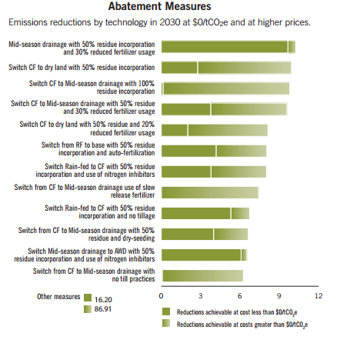
Source: EPA, 2013

But the impacts of crop production decisions extend beyond the economic costs and benefits. Fueled by concerns over ethanol, a lively debate has emerged over food security issues (Searchinger, et al.; Valin, et al. 2013; ). USDA publishes an annual international Food Security Assessment that tracks 76 countries that are classified by the World Bank as areas of food insecurity (USDA, 2014). Major rice producing countries such as India, Indonesia, Bangladesh, and Vietnam are included in the USDA report, suggesting that CH₄ mitigation might have an adverse impact on food security.

Some authors have investigated the connection between climate change and food (in)security. For example, Valin et al. (2014) find that the maximum effect of climate change on calorie availability is -6% at the global level. Nelson et al. (2014), summarizing the AGMIP study find that by 2050, climate change reduces food consumption by 3 percent. Climate change impacts on US agriculture are analyzed in Beach, et al. (2015) and Wing et al. (2015). To be clear, our aim is different from this literature. Rather than looking at the impact of climate change on agriculture and food security, we examine the impact of GHG mitigation on yield and food security. Agriculture has a lot at risk under a changing climate, and furthermore the agricultural sector is an important source of GHG emissions, suggesting that agriculture can somewhat affect its own destiny. But there are yield and food security tradeoffs associated with both climate change and GHG mitigation. In this paper we focus on the latter. We develop estimates of food insecurity and estimate the impact of GHG mitigation on measures of food insecurity. The next section describes the methodology.

- Model Description

This section describes the creation of baseline food security estimate and the relationship between food security and carbon prices.

Baseline food security status

The USDA reports only food gaps – estimated as food supplies that fall short of food demands defined by a 2100 calorie daily per capita nutrition standard. The USDA calculation is given by

 | $$FC_{cnt}=\left({PR}_{cnt}+CI_{cnt}+CSTK_{cnt}+FA_{cnt}\right)-\left(SD_{cnt}+FD_{cnt}+EX_{cnt}+OU_{cnt}\right)$$ | (1)

Where FC is food consumption, PR is production, CI is commercial imports, CSTK is changes in stocks, FA is food aid, SD is seed demand, FD is feed demand, EX is exports, OU is other use, and c is and index of crops c = {grains, roots & tubers, other}, n is an index of countries ( n ϵ N), and t is time. Food consumption, converted to calories, is compared to the standard of 2100 calories per person per day using population estimates.

However, we were unable to use the USDA estimates as published because they are truncated at zero and could understate the food security impacts of a decline in rice yields. Also, the list of countries (N) is limited to countries that have received food aid in the past, limiting the usefulness of the data for scenario analysis. We used FAO food balance data to construct an analogous measure,

 | $$FC_{cnt}=\left({PR}_{cnt}+CI_{cnt}+CSTK_{cnt}\right)-\left(SD_{cnt}+FD_{cnt}+EX_{cnt}+W_{cnt}+OU_{cnt}\right)$$ | (2)

Where food aid is excluded and waste (W_{cnt}) is separated from OU_{cnt}.

Following USDA, we used data for three years (2008-2010) to limit the effect of annual variations. However, USDA uses a three years of historical data to project the base year of 2010, as the report estimates current conditions before the year has ended. We have used revised, historical data. The USDA and FAO-based data for 2010 are summarized in Table 1: USDA estimated positive food gaps in 15 countries with a total gap of 11.5 million tons. Using FAO data, we calculated food gaps in 11 countries with a total gap of 2.0 million tons. Most (72%) of the difference owes to a single country, the Democratic Republic of the Congo, which is estimated to have a 6.8 million ton food gap in the USDA estimates but is not present in the FAO data set. Two other countries with smaller food gaps, Burundi and Eritrea, are also not present in the FAO statistics. Adjusting for these differences brings the two totals closer but significant differences remain. USDA estimated gaps for Central African Republic, Kenya, Mozambique, Niger, and Senegal, countries for which FAO data indicates surpluses (shown in Table 1 as negative gaps).

Table 1: USDA Food gaps and calculated food gaps (1,000 tons)
Country | USDA Food gap¹ | Calculated food gap
Afghanistan | 85 | 127
Burundi | 468 | *
Central African Republic | 113 | -52
Chad | 0 | 127
Congo, Dem. Rep. | 6,868 | *
Eritrea | 346 | *
Ethiopia | 792 | 760
Haiti | 303 | 38
Kenya | 301 | -484
Korea, Dem. Rep. | 1,013 | 57
Madagascar | 71 | 168
Mozambique | 443 | -499
Namibia | * | 15
Niger | 277 | -1,326
Rwanda | 125 | 10
Senegal | 1 | -775
Somalia | 433 | *
Tajikistan | 0 | 46
Timor-Leste | * | 9
Zambia | 0 | 654
Total (excludes negative gap estimates in FAO data) | 11,553 | 2,010
- Nutrition gap: gap between available food and food needed to support a per capita nutritional standard

Non- CO₂ mitigation and the effect on food security

In this section we look at changes in the production of rice and how that affects food consumption. To begin, we rewrite (2) in percentage change terms using lowercase variable names to represent percentage change terms, and introducing the shares $S_{X}= X_{cnt }/ Y_{cnt}$.

 | $${fc}_{cnt}=S_{PR}∙{pr}_{cnt}+S_{CI}∙{ci}_{cnt}+S_{CSTK}∙{cstk}_{cnt}-S_{SD}∙{sd}_{cnt}-S_{FD}∙{fd}_{cnt}-S_{EX}∙{ex}_{cnt}-S_{W}∙w_{cnt}-S_{OU}*{ou}_{cnt}$$ | (3)

We assume that changes in stocks, seed demand, feed demand waste and other uses remain constant, so 3 can be simplified to

 | $${fc}_{cnt}=\frac{1}{S_{C}}[{pr}_{cnt}+S_{CI}∙{ci}_{cnt}-S_{EX}∙{ex}_{cnt}]$$ | (4)

4.0 Data

Our estimates of the “yield penalty” or the change in rice production associated with an increase in GHG mitigation come from the marginal abatement cost curves in EPA (2103). For the percentage changes in imports, exports and domestic consumption, we relied on simulation results in GTAP. These are discussed below, in turn.

Economic Data and the EPA MAC Model

The EPA MAC Model calculates annual GHG mitigation potentials at various levels of a price (in CO₂ equivalent units). For EPA, a modified version of the DNDC 9.5 Global database was used to simulate crop yields and GHG fluxes from global paddy rice cultivation systems. The DNDC 9.5 global database contains information on soil characteristics, crop planted area, and management conditions (fertilization, irrigation, season, and tillage) on a 0.5 by 0.5 degree grid cell of the world. The model considers all paddy rice production systems, including irrigated and rainfed rice, and single, double and mixed rice as well as deepwater and upland cropping systems. For EPA, baseline and mitigation scenario modeling was carried out for all rice-producing countries in the world that produce a substantial quantity of rice. Costs include changes in labor, fertilizer, and other inputs associated with each option. Capital cost are assumed zero. Only those options that result in lower emissions are evaluated in the MAC model.

The MAC analysis assimilates the abatement measures’ technology costs, expected benefits, and emission reductions to compute the cost of abatement for each measure. EPA computed a break-even price for each abatement option for 195 countries to construct MAC curves illustrating the net GHG mitigation potential at specific break-even prices for 2010, 2020, and 2030, shown in Figure 2.

Figure 2 : Global MAC curve showing mitigation potential at various mitigation values

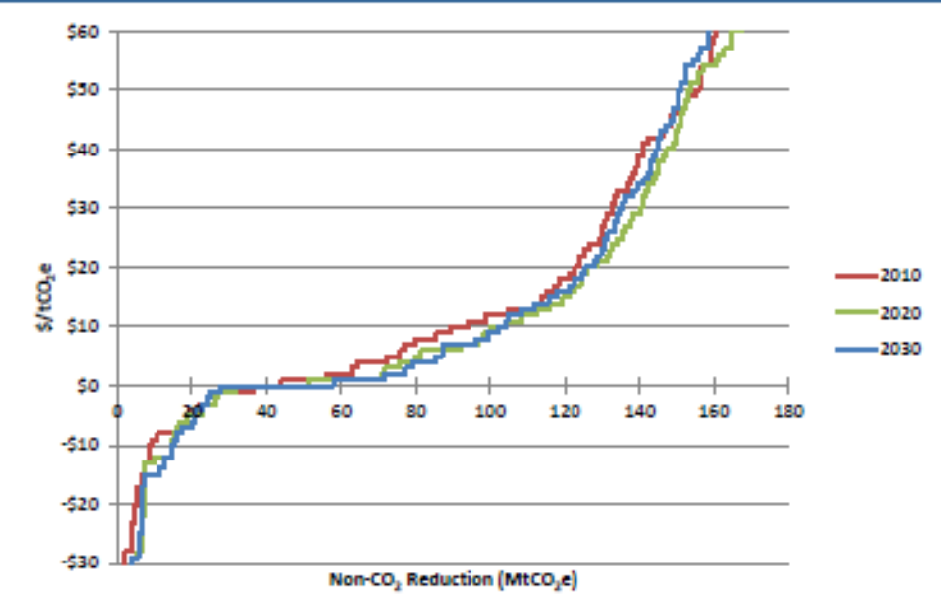
Source: EPA, 2013

Table 2: Rice GHG Mitigation Potential, Results of Break-Even Analysis
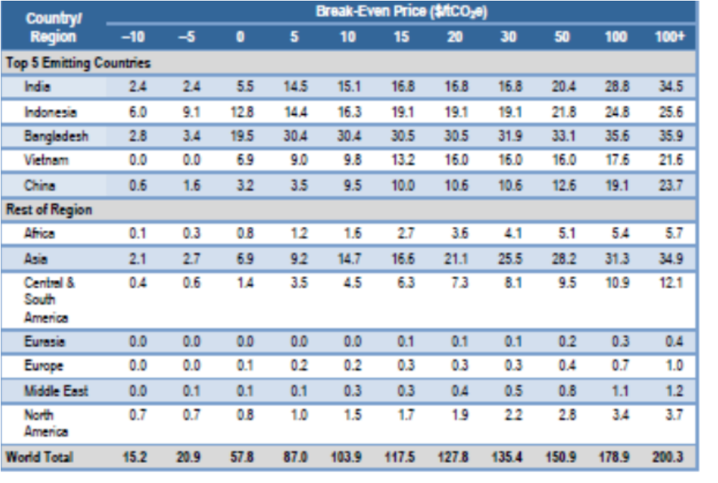
Source: EPA, 2013

Mitigation potential and its cost-effectiveness vary significantly by country or region. At the regional level, Asia (in particular South and Southeast Asia), Africa, Central and South America and the European Union show the most significant potential for reducing GHG emissions from rice cultivation. For instance, in 2030 mitigation potential in Asia is estimated to be 27 Mt CO₂e with no carbon price and 34 Mt CO₂e at a carbon price of $20/t CO₂e. Central and South America can achieve mitigation potential of 12 Mt CO₂e in 2030 at no carbon price, and mitigation potential can increase to 22 Mt CO₂e at a carbon price of $20/t CO₂e.

There are a large number of mitigation options included for rice cultivation and almost all provide net GHG reductions. The options providing the largest quantify of GHG reductions are the two that involve switching to dryland production, which significantly reduces or eliminates CH₄ emissions. Those options do result in major reductions in yields, however. Other options that account for large reductions include nitrification inhibitors in combination with midseason drainage or alternate wetting and drying, along with switching to no-till, fertilizer reductions, and optimal fertilization options on non-irrigated lands. The relative share of mitigation provided by different options varies across years due to the dynamics of GHG emissions, especially for changes in soil C.

Figure 3: Percentage change in quantity of rice produced for mitigation values $10-$50 for selected countries

Figure 3 shows the rice production changes associated with mitigation activities. At a low price of $10 per ton, the changes are all positive (increases in output). The MACs reveal a fair bit of mitigation that has negative cost, and up to a point there is a kind of a subsidy effect going on. For a country like Indonesia, the subsidy effect is robust throughout the range of carbon prices examined here, although diminishing as expected. For most other countries, the implicit subsidy is overshadowed by yield losses at carbon prices above $20 per ton.

One might attempt to apply the production changes directly to the food balance estimates and food gaps in Table 1. This produces some unexpected results. For example, Vietnam started out with a food surplus, but with large GHG mitigation potential especially at the higher prices levels shown in Figure 3, direct application of the production changes flipped Vietnam into food deficit status.

In the next section we discuss the GTAP global trade model, and the experiments we ran in GTAP to estimate the sensitivity of domestic consumption, imports and exports to changes in production of rice.

GTAP

What happens when rice production falls? Rice is a staple crop, and for some countries it is an important export. For other countries rice production seems less important in the trade mix than other sectors such as industry. Economic theory suggests that rice is an inferior good, and as incomes rise the demand for starchy crops like rice should fall and be replaced by other foods such as meat, fats and oils (Bennett’s Law). More generally, as incomes rise the income elasticity of food demand falls the relationship known as Engel’s Law. So much of the response depends on a country’s development status, the importance of national income and substitution effects. We designed several experiments In GTAP to attempt to isolate these effects and their impacts on food security for different countries.

We used the standard GTAP model, version 9.1 with 140 countries, because food security is a localized phenomenon.

Our shock was a production shock (variable qo in GTAP). We also imposed an offsetting shock to taxes (variable to in GTAP) to compensate for the reduction in tax revenue to the government sector. As described above, the production shocks were the changes in output associated with the non-CO₂ mitigation strategies employed at equivalent CO₂ prices $10-$50 per ton.

We entered 2010 shocks from the MAC model in the base year of GTAP. While the MAC model estimates changes for 2010, 2020 and 2030, analyzing a longer time period would have required calibrating the GTAP model to match the baseline growth factors which serve as the basis of the MAC estimates.

Carbon prices are implicit in the GHG mitigation scenarios, we also designed a set of experiments that included the same output shocks, run together with an economy wide global carbon price. In these experiments, the impact of the carbon price was much larger than the impact of the production shock, and the results obscured the relationships between output and consumption that we sought to empirically obtain. These results are not presented here.

We also ran a full sensitivity analysis on the results, details are available from the authors.

5.0 Results

Prices:

The GTAP model operates on variables that represent economic value measures. In using the GTAP model for a calorie-based investigation like food security, we have to address the fact that the model results include a quantity change component along with a price change component. Figure 4 shows price changes, specifically prices paid by consumers for domestically produced rice (ppd) across the various mitigation levels for the top 5 rice producing countries. Price changes are themselves an indicator of scarcity, but also useful for interpreting the value measures in real terms. Note that at prices of up to and including $20 ton CO₂e, the price of rice is falling. This is because of the above-mentioned subsidy effect of all the low cost mitigation opportunities. Above $30 per ton CO₂e, prices faced by consumers rise moderately. Also note that for any scenario, the price changes here are small – less than about half of one percent.

Figure 4 : Changes in consumer’s price of domestic rice, selected countries
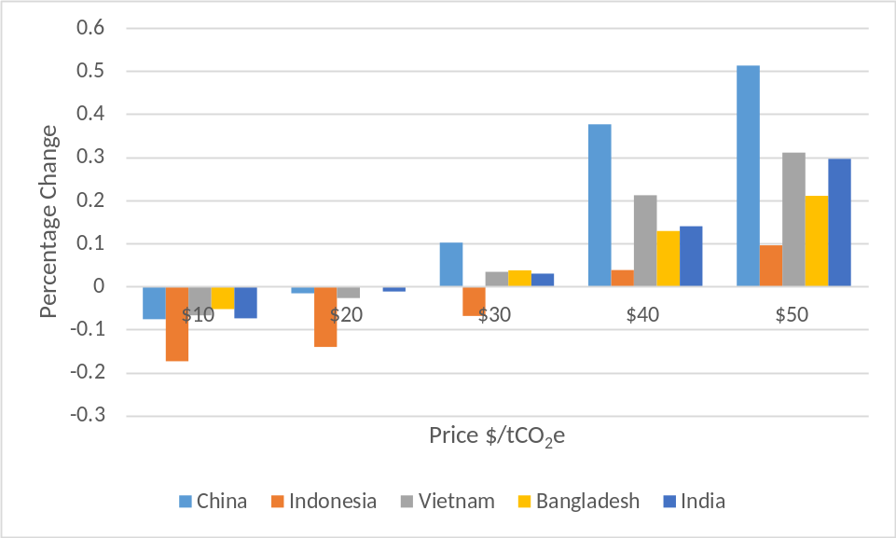

Consumption:

Consumption (VDM) of rice is presented in Figure 5 both in value terms as output from the model at market prices, and in real terms, adjusted by the price data in Figure 4. The graph of consumption value in the top panel shows the same pattern as the price graph and consequently, the real consumption graph in the bottom panel shows values grouped around zero percent change in quantity of rice consumed.

Figure 5: Percentage change in rice consumption, value (top) and quantity (bottom)
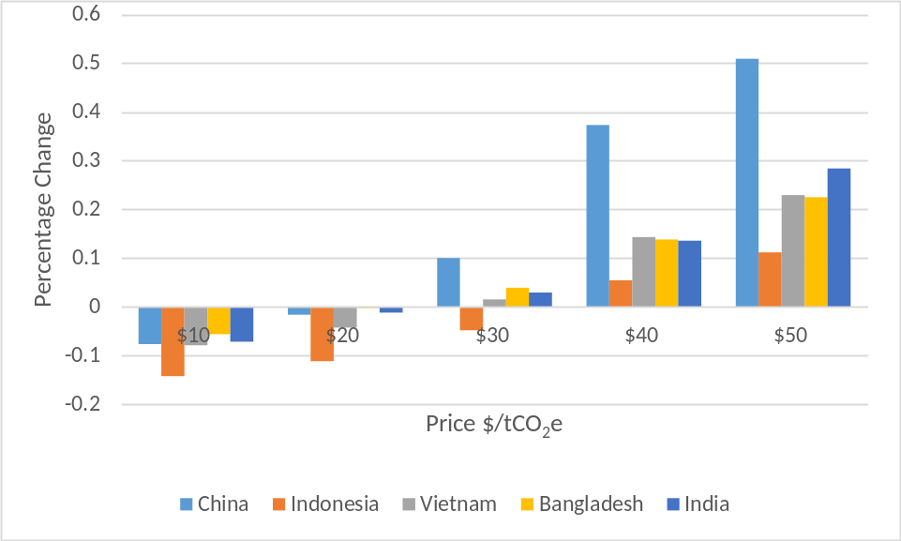
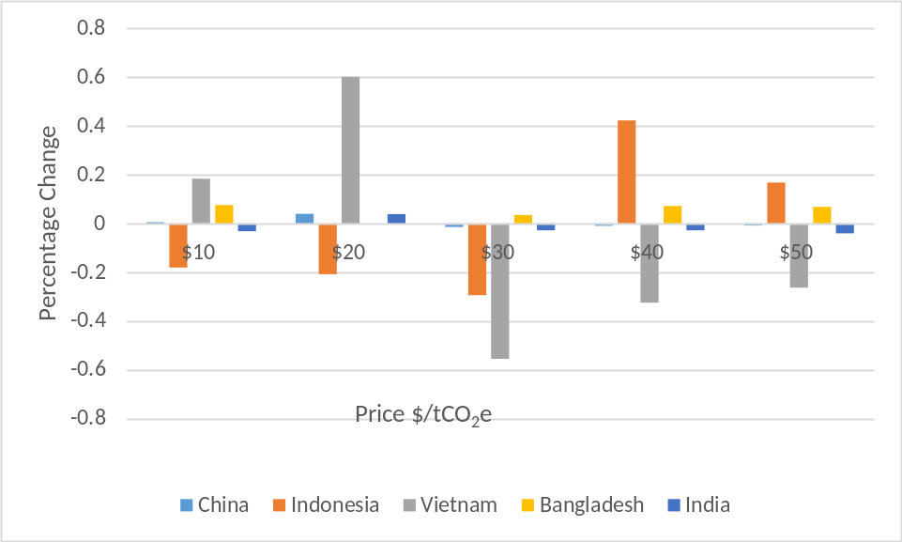

Sufficiency

GTAP output includes a “sufficiency” variable or domestic share in total use, defined for tradable commodities, given by

$$SUFFICIENCY=\frac{VOM}{(VDM+VIMS)}$$

Where VOM is the value of output at market prices, VDM is the value of domestic consumption at market prices, and VIMS is the value of imports at market prices. If imports are zero, then the country is self-sufficient and VOM ≥ VDM. VOM is the initial value of output in the GTAP framework to which the qo shocks are applied.

Figure 6: Sufficiency in rice
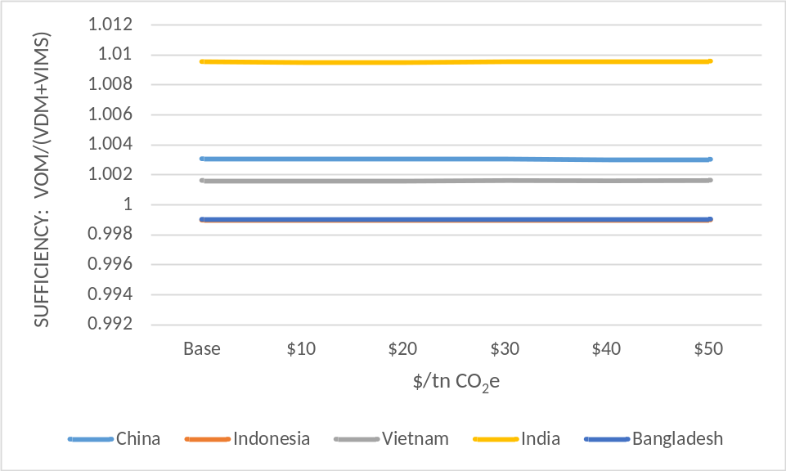

As shown in Figure 6 above, there is virtually no change in the sufficiency in rice among the top 5 rice producing countries despite the production shocks due to mitigation.

Food security

The data on real consumption changes resulting from the GTAP experiments can be applied to the food balance data in Table 1. The results are shown in Table 3.

Table 3: Changes in Food Gaps (reductions in food gaps shaded)
 |  |  | Percentage chg. in Food Gap
Country | Food Gap (1000tons) | Rice Share | $10 | $20 | $30 | $40 | $50
Afghanistan | 127 | 5% | 0% | 0% | 0% | 0% | 0%
Chad | 127 | 3% | 0% | -1% | -2% | -0% | 3%
Haiti | 38 | 11% | -1% | -2% | -3% | -1% | -1%
PDR Korea | 57 | 15% | -1% | -3% | 0% | 0% | 0%
Madagasgar | 168 | 24% | -11% | -5% | 6% | 5% | 4%
Namibia | 15 | 56% | 0% | -2% | 0% | 0% | 0%
Timor-Leste | 9 | 18% | -5% | -4% | -4% | -4% | -4%
Rwanda | 10 | 1% | 0% | -5% | -1% | 0% | 0%
Tajikistan | 46 | 1% | 0% | 0% | 0% | 0% | 0%
Ethiopia | 760 | 0% | 0% | 0% | 0% | 0% | 0%
Zambia | 654 | 1% | 0% | 0% | 0% | 0% | 0%

Compensatory Yield Changes

The above analysis explored the relationship between rice production and GHG mitigation. The final task is to make some preliminary assessments of the magnitude of the changes in production.

Because we are talking about changes over time, it makes sense to interpret the results as a change in productivity. Overall, GHG mitigation decreases rice productivity. Table 4 shows the yield changes needed to compensate for the production changes associated with maximum potential GHG mitigation. In the baseline, rice yields are expected to increase by 0.21% per year. If all mitigation options were implemented in 2030 the compensatory change in yield is 0.53%. In other words, GHG mitigation in 2030 can be ‘purchased’ at by increasing yield improvement by a roughly a factor of 2.

Table 4: Compensatory Yield Changes
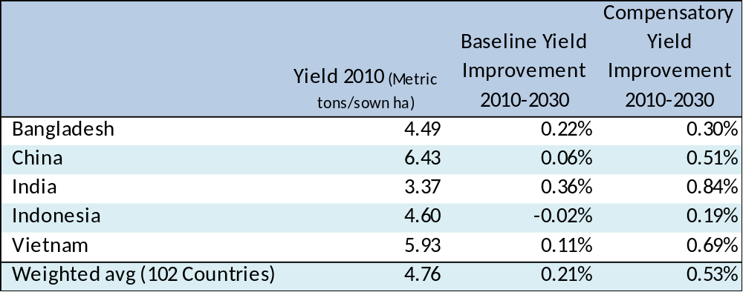

Conclusions

Global agriculture faces the dual challenges of improving food security for a growing population while simultaneously reducing the environmental footprint of agricultural production, including net greenhouse gas (GHG) emissions. Rice is a particularly important commodity from this standpoint in that accounts for a large share of global agricultural GHG emissions (EPA, 2012) while also being a primary staple crop for billions of people in developing regions, particularly in Asia, but also parts of Africa.

References

Alexandratos, N., and Brunisma, J., 2014. World Agriculture Toward 2050: the 2012 revision. ESA Working Paper No. 12-03. Rome, FAO.
Beach, R.H., Y. Cai, A. Thomson, X. Zhang, R. Jones, B. McCarl, A. Crimmins, J. Martinich, J. Cole, S. Ohrel, B. DeAngelo, J. McFarland, K. Strzepek, B. Boehlert. 2015. Climate Change impacts on US agriculture and forestry: benefits of global climate stabilization. Environmental Research Letters.
Beach, R.H., J. Creason, S. Ohrel, S. Ragnauth, S. Ogle, C. Li, and W. Salas., 2016. Global Mitigation Potential and Costs of Reducing Agricultural Non-CO₂ Greenhouse Gas Emissions through 2030. Journal of Integrative Environmental Sciences.

FAO. 2014. Database of the Food and Agricultural Organization of the United Nations (www.faostat.fao.org). Food Balance Sheets. Accessed August 2015.

IPCC, 2014. Agriculture, Forestry, and Other Land Use (AFOLU). Chapter 11 in Mitigation of Climate Change, Working Group III Final Report. Intergovernmental Panel on Climate Change http://report.mitigation2014.org/drafts/final-draft-postplenary/ipcc_wg3_ar5_final-draft_postplenary_chapter11.pdf

U.S. EPA, 2012. Global Anthropogenic Non- CO₂ Greenhouse Gas Emissions: 1990-2030. United States Environmental Protection Agency, Washington, DC. http://www.epa.gov/nonco2/econ-inv/international.html.
U.S. EPA, 2013 Global Mitigation of Non- CO₂ Greenhouse Gases: 2010-2030. United States Environmental Protection Agency, Washington, DC. EPA Report 430-R-13-011. http://epa.gov/climatechange/EPAactivities/economics/nonco2mitigation.html.

USEPA 2015. Technical Support Document: Technical Update of the Social Cost of Carbon for Regulatory Impact Analysis Under Executive Order 12866 (May 2013, Revised July 2015)

U.S. USDA, 2014 International Food Security Assessment 2014-24. United States Department of Agriculture, Washington, DC. EPA Report GFA-25. http://www.ers.usda.gov/publications/gfa-food-security-assessment-situation-and-outlook/gfa-25.aspx

Wing, I.S., E. Monier, A. Stern, and A. Mundra. 2015. US major crops’ uncertain climate change risks and greenhouse gas mitigation benefits. Environmental Research Letters.
Appendix

Table A1: Sufficiency in Rice : VOM/(VDM+VIMS)
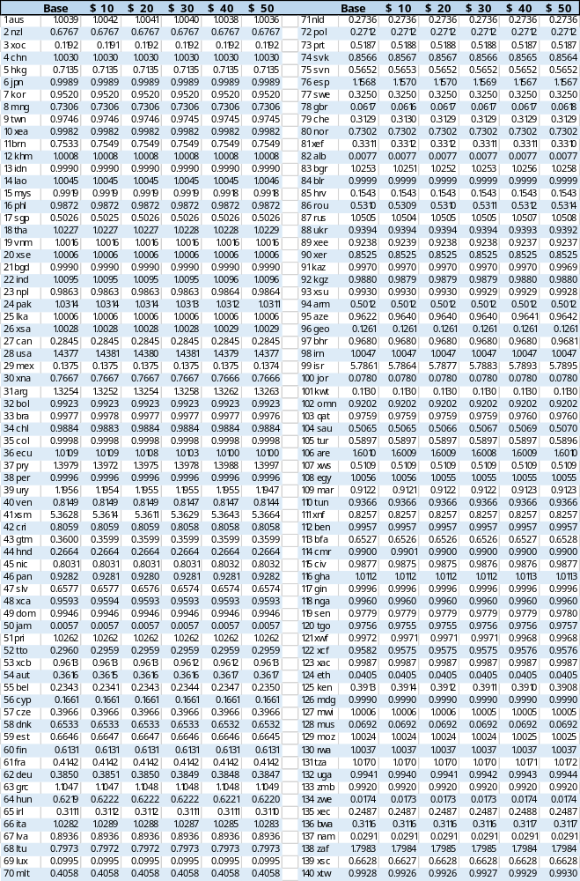
Table A2: “Yield Penalty” Production Shocks from Methane Mitigation
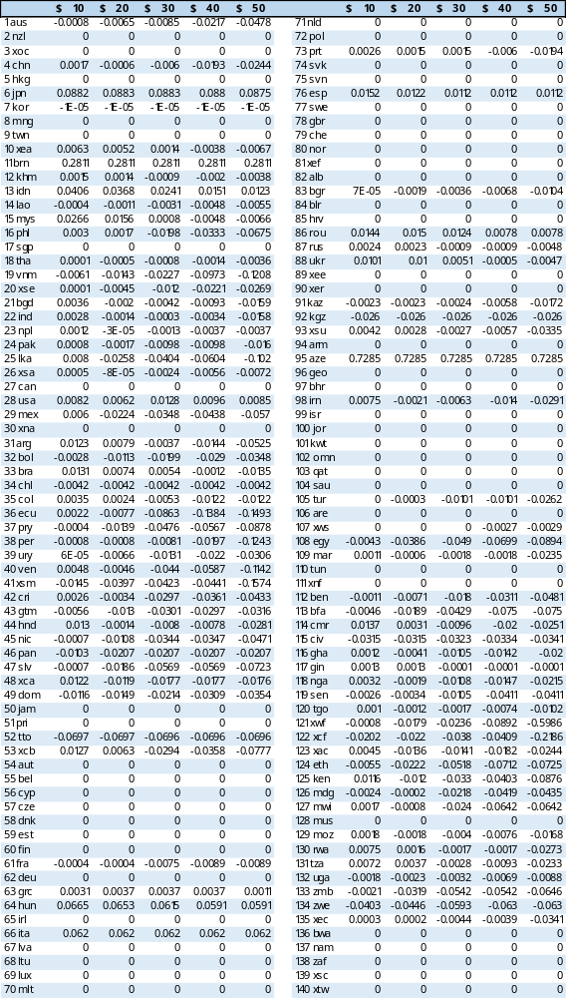

Table: A3 Real Rice Consumption Changes
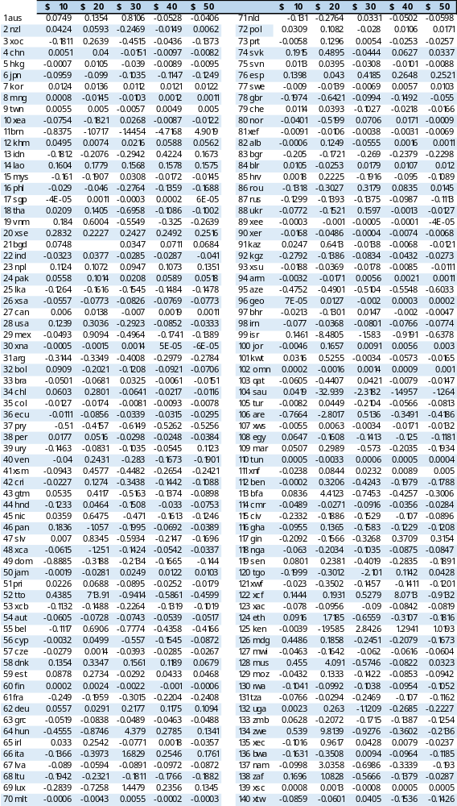

EPA (2012) report lists the top global methane sources in 2010 as Enteric Fermentation (1,932 MTCO2e), Natural Gas and Oil Systems (1,677 MtCO2e), Landfills (847 MtCO2e), Rice (520 Mt CO2e).
USDA estimates national average food gaps as well as food gaps by income group. The distributional analysis is beyond the scope of the present study and is not discussed further.
The literature actually contains a range of values for average caloric intake with light activity. USDA’s value of 2100 is within the range we found from 1720 kcal/person/day (FAO) to 2300 kcal/person/day (WRI).

