Firms, Trade and Employment in Tunisia
Leila Baghdadi∗, Hassen Arouri**

October, 2015

Abstract

This paper aims to investigate whether exposure to international trade increases the firm’s ability to create jobs, improve its productivity and profitability using a unique Tunisian firm level data set. Several types of firms are considered: onshore non-exporters and importers, onshore exporters and non-importers, onshore exporters and importers, offshore exporters and non-importers and offshore exporters and importers. Findings are mixed concerning firm’s involvement in trade and job creation. Onshore firms exclusively importing and offshore firms (exporters and two way traders) appear to be the only ones to create jobs compared to non traders. Evidence related to the relationship between firm’s performance and trade status is more clear-cut. Tunisian firms involved in foreign markets are more productive and profitable than non-traders.

JEL Classification: F14, L15

Keywords: trade, productivity, profitability, job creation, SME

Introduction
Policy makers as well as researchers have agreed during the last decades on the benefits of international trade to both developed and developing countries. Research on the subject has underlined the various benefits. These studies are mainly based on macro analysis.
Most recently, researchers have turned to firm level data to explore the effects of foreign exposure on enterprises. They find that firms exposed to international trade are able to create more jobs(Moser et al, 2010) and are more productive (Iacovone et al, 2012). Exporters may learn from their foreign partners, more productive than themselves. Exporters are forced to upgrade their products to stay in markets. Exporting firms becoming more productive are potentially able to create more jobs and to grow.
These studies focus mainly on exporters in the manufacturing sector in the developed world. Evidence for developing countries is still scarce. Importers as a group are also less studied. These issues are particularly relevant in Tunisia, where a series of economic reforms targeting unemployment issues, SMEs assistance, regulations and export led growth are debated.This paper aims to explore these questions using a unique Tunisian firm level data set. We investigate whether exposure to international trade increases the firm’s ability to create jobs, its productivity and profitability. A particularity of the Tunisian economy,the onshore-offshore dichotomy, which is actually at the heart of the policy debate in the country, is also investigated. Several types of firms are considered: onshore non-exporters and importers, onshore exporters and non-importers, onshore exporters and importers, offshore exporters and non-importers and offshore exporters and importers. Our results are mixed concerning firm’s involvement in trade and job creation. Onshore firms exclusively importing and offshore two way traders appear to be the only ones to create jobs compared to non traders. Evidence related to the relationship between firm’s performance and trade status is more clear-cut. Tunisian firms involved in foreign markets are more productive and profitable than non-traders.
The remainder of the paper is as follows. In the first section, we describe trade policy in Tunisia and its efforts to increase its exports. In the second section, we present the data used, provide statistics on firms’ dynamic in Tunisia and discuss the results concerningthe relationship between firm’s engagement in international markets and their ability to create jobs.Third, we analyze the impact of these different statuses on internationalized firm’s productivity and profitability.

Trade Policy in Tunisia
After Tunisia’s independence, in the fifties, the country adopted a policy of import substitution with high trade barriers, with the aim to protect domestic producers. In 1972, the government started to change gradually its trade policy and shifted toward more openness by creating an offshore regime to attract foreign direct investment for export-oriented production. Several incentives were offered to these exporting manufacturing companiesin the investment law (Law 72-38), such as:partial or total tax exemption for periods of 10-20 years, and 50 per cent reduction thereafter (granted also to partially exporting firms); full tax exemption on reinvested profits and income; total exemption from customs duties on imported capital goods, raw materials, semi-finished goods and services. The State also often provides the necessary infrastructure and assumes employers’ social security contributions during 5 years.These firms were not bounded geographically.Fully exporting firms benefit from tax exemptions on profit and income taxes during the first ten years of their activity, a 50-percent reduction for another ten years, and full tax deduction for reinvested profits. The state also grants duty-free access to all inputs and equipment.
In the mid-eighties, major reform policies were adopted with the implementation of the Structural Adjustment Program, which included unilateral tariff liberalization, the reform of import procedures, and the removal of many quantitative import restrictions. Tunisia took also a very important step by joining the World Trade Organization since its creation in 1990.
Besides unilateral trade liberalization, Tunisia has negotiated preferential trade agreements within the MENAregion and beyond. The agreement signed with the European Union is seen as one of the most important country’s preferential trading arrangements. It was signed in 1995, entered into force in 1996 and resulted in the dismantling of industrial tariff barriers forthe country’s main trading industrial products by January 1st, 2008.
Moreover, all imports from the 16 other members of the Greater Arab Free Trade Area (GAFTA) have been admitted completely duty-free since January 2005. Since 2000, Tunisia has also adopted a number of export development programs targeting in particular trade facilitation and the support of exporting firms. These policies have resulted in a significant decrease in tariff levels as well as an important increase in trade flows, even if these changes impacted mostly the industrial sector.
Trade policies were also reinforced by the implementation of several trade support institutions. Their stated objective is to help the private sector face the increasing competition from global markets, and to help new exporters to reach them by overcoming the lack of information and various barriers. These institutions, created in 1973, are theIndustry Promotion Agency (API) andthe Export Promotion Centre (CEPEX). API’stask is to promote governmental policies in the industrial sectorunder the control of the Ministry of Industry. CEPEX aims to support Tunisian exporters providing them with wide range of services. It is supervised by the Ministry of Trade, Tourism and Handicrafts.
Alongside CEPEX and API, there are several programs intended to help Tunisian SMEs in general to develop their activities such as several Technical Centers and the Office of Product Upgrade (Bureau de Mise à Niveau, BMN). They have the mission to modernize private enterprises providing them professional and technical expertise.
In addition, there are also other key non-governmental entities such as the Employers Trade Union (Union Tunisienne de l’Industrie, du Commerce et de l’Artisanat, UTICA) and the Arab Institute of CEOs (InstitutArabe des Chefs d’Entreprises, IACE). The aim of the first organization is to protect the interest of employers and to insure the representation of its members in several public institutions such as CEPEX. The second organizationaims to deliver solutionsto the problems faced by Tunisian firms in their development.
Trade policies adopted during the last two decades by Tunisia were relatively successful. As Figure 1 shows, exports increased significantly during the period 2000-2010. Some sectors such as manufactured products have gained competitiveness in international markets dueto the introduction of the offshore sector. Tunisia became an open economy compared to other upper middle income countries. Tunisia’s trade openness is similar to Costa Rica and Gabon. Tunisia is more open than Lebanon, Algeria and Romania but is less open than Jordan and Mauritius.
Figure 1: The evolution of Tunisia’s exports for the period 2000-2010
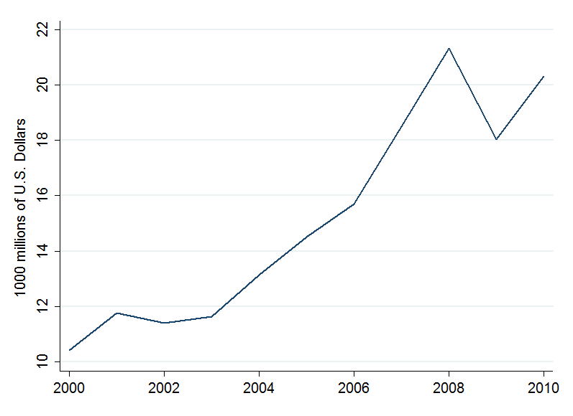
Source: WITS
Figure 2 reveals that Tunisia has an average level of trade openness andit is not an outlier compared to other upper middle income countries. Despite this relative success in expanding its exports, Tunisia still suffers from many shortcomings unveiled by the World Bank (2014). First, export sophistication is low and significantly below what would have been predicted by its level of income. Second, more than half of Tunisia’s exports are final goods, many of which are only assembled in Tunisia. Using input-output tables, the World Bank (2014) demonstrates that value added to Tunisian exports ratio was only 33 percent in 2009. Third, the French and Italian markets are the main destination countries of Tunisian final goods. The structure of exports suggests that Tunisia assembles intermediates for these two major partners. Firms in these countries take naturally advantage of the offshore regime.
Figure 2: Tunisia’s Trade openness compared to upper middle income countries during 2000-2010
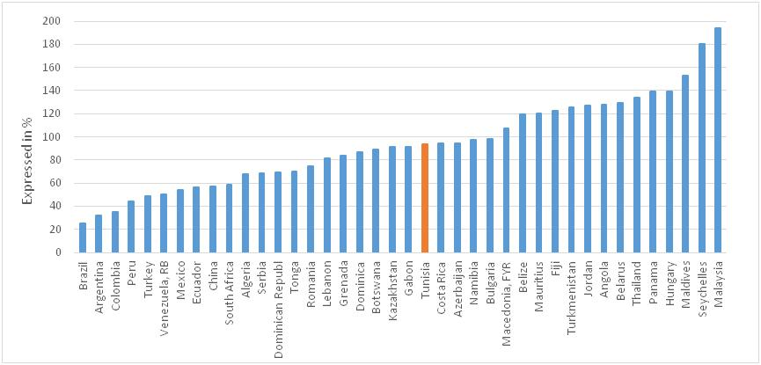
Source: World development indicators; author’s calculation
Tunisia made also several efforts to attract Foreign Direct Investment. Figure 3 shows that Tunisia is relatively underperforming compared to other upper middle income countries such as Lebanon, Romania and Jordan even if Tunisia is more open than the two first countries, as shown in Figure 2. Moreover, the level of FDI received is lower than a typical country of its trade openness level (Figure 4). The World Bank, in its report “Unfinished Business” (2014), reveals that FDI inflows are mainly targeting natural resources (60% in average during 2006-2012). Investment in manufacturing are concentrated in low value added and assembly activities (26% during 2006-2012). In addition, FDI in the services sector is still low (below 10%).

Figure 3: FDI inflows as share of GDP, 2000-2010 average
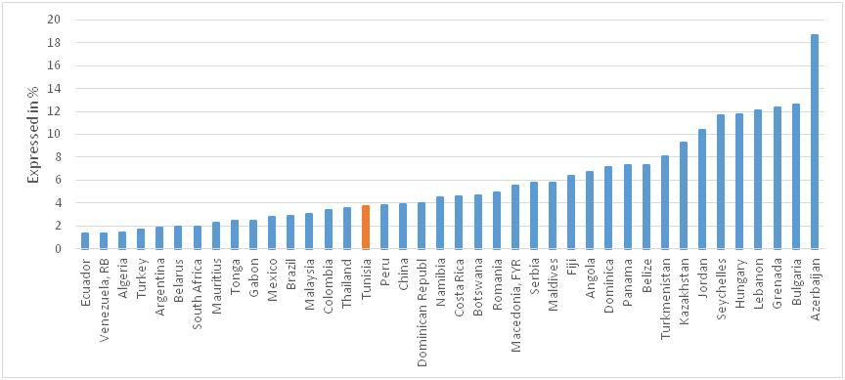
Source: World development indicators; author’s calculation
Figure 4: FDI inflows and trade openness; comparison of Tunisia with some upper middle income countries, 2000-2010 average
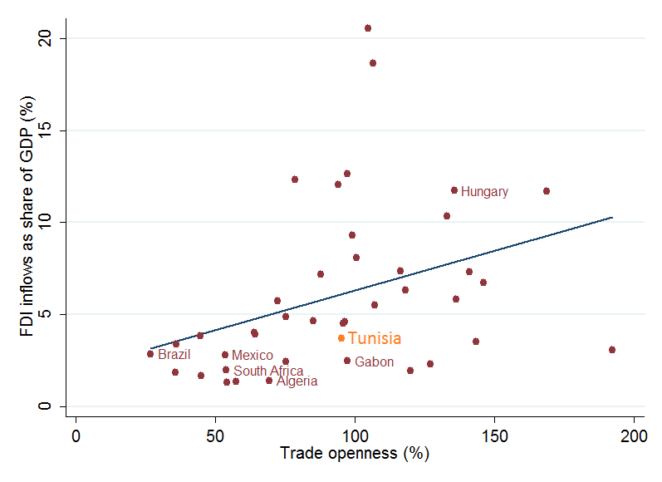
Source: World development indicators; author’s calculation
To sum up, Tunisia trade policies helped the country to underscore an overall good performance in terms of exports’flows and trade openness. Nonetheless, there are still shortcomings:exports in terms of content and sophistication are quite disappointing; Tunisian final products lack sophistication; and the added value to the export ratio is very low. Similarly, FDI inflows are concentrating in natural resources and in low manufacturing products. Therefore, it seems that Tunisia is stuck with producing low quality goods and mainly assembling intermediates.
For the World Bank (2014), the investment policy of Tunisia represented by the offshore-onshore dichotomy explains partially this underperformance. Firms in the protected onshore sector survive thanks to privileges and rents, whereas the offshore regime is more competitive. However, these firms, competing globally, cannot use low quality inputs produced by onshore firms and are forced to import their input. As a result, both types of firms register low productivity and low added value.
Because of its importance in the Tunisian economy, the offshore-onshore divide is given full attention in this study while investigating the effects of firm exposure to international markets on firm’s performance and job creation.

Literature Review
The recent trade literature based on heterogeneous firms involved in international markets shows that they are more productive and employ more workers. The seminal work of Melitz (2003) underlines that trade liberalization will lead to within-industry reallocation of economic activity towards internationalized firms. The latter are more likely to expand and create jobs. Levinsohn (1999) and Davis, Haltiwanger and Schuh (1996) have linked exports and imports to job creation, destruction and reallocation. Their analyses focus on employment shifts between import- and export-oriented industries. Their findings imply that employment shifts explain only partially total job reallocation. Pisu (2008), using firm-level information about exports and imports, finds that firms operating in international markets have higher growth rates of employment on average than enterprises involved only in local markets. Firms engaged in international markets appear to create and destroy jobs simultaneously. More recently, Jaud and Freund (2015) and Rijkers et al (2014) provide evidence of the employment creation premium associated with participating in international trade in Tunisia. Exporters employ one third of all wage jobs, importers employ more than half, and firms that export and/import account for over 55 percent of total wage jobs. These studies also underline the importance of the offshore regime. While these firms account for only 5 percent of exporters in 2010, they employ 33 percent of wage employment. They also find that importers are performing extremely well.
The recent literature on firms in international trade shows that exporters are more productive than non exporters. Two hypotheses are advanced (see Bernard and Jensen 1999; Bernard and Wagner 1997). The first hypothesis is self-selection of more productive firms into export markets. Entering new markets imply facing additional costs of selling goods (transportation costs, distribution or marketing costs, personnel with skills to manage foreign networks, or production costs in modifying current domestic products for foreign consumption). These new barriers can be overcome only by the most successful firms. Furthermore, a firm that plans to export in the future will engage in an improvement process in order to be competitive on the foreign market. The second hypothesis is the role of learning-by-exporting. Internationalized firms learn from international buyers and competitors who will help them improve their post-entry performance. In addition, firms participating in international markets are exposed to fierce competition and must improve rapidly their productivity. These hypotheses are confirmed by growing empirical evidence. As shown by Greenaway and Kneller (2007) and Wagner (2012) in their literature surveys, exporters are superior to non-exporters along several firm-level characteristics, such as productivity, employment and research and development expenditures. Wagner (2012) showsresults are mixed concerning learning-by-exporting hypothesis. Exporting does not necessarily improve firms’ performance.
Thus far, imports have been relatively under looked in the empirical literature. The few studies tackling this subject rely on the two hypothesis discussed earlier i.e. self selection of more productive firms into import markets and learning by importing. Concerning the self-selection hypothesis, two arguments are discussed. First, the use of foreign intermediates increases firm’s productivity. Second, only already productive firms are able to import intermediates due to fixed costs (search process for potential foreign suppliers, inspection of goods, negotiation, contract formulation, customs procedures (see Kasahara and Lapham (2013), Andersson et al. (2008), Castellani et al. (2010)).
Withregard to learning-by-importing, several points are advanced. First, importing firms can use higher quality inputs. Furthermore, the choice of importing allows a firm to allocate its resources and to specialize on activities where it has particular advantage. If importing increases productivity, this might lead firms to self-select into export markets and help to improve their success in these markets, which might contribute to an explanation why two-way traders are the most productive firms on average (see Andersson et al. (2008), Castellani et al. (2010), Altomonte and Békés (2010), Halpern et al. (2005) and Muuls and Pisu (2009)).
Most studies concentrate on manufactured goods. Few of them focus on the services sector. Nonetheless, the empirical literature points out that: (i) exporters are more productive than non-exporters, (ii) productive firms self select into services exports but no evidence for learning-by-exporting effects on productivity growth (Vogel and Wagner (2011)).
Surprisingly, the effect of international trade on profitability is also undercovered. Till now, the small number of studies gives mixed empirical results. There is still no consensus on the positive effects of engaging in international activities on firm’s profitability. Wagner (2011) investigates the relationship between profitability and three types of German manufacturing firms: exporters, importers and two-way traders. Findings are not conclusiveconcerning trade effects on profits. The author explains that productivity advantages of trading firms in Germany are counterbalanced by extra costs related to selling and buying on foreign markets.
Evidence on Tunisian firms in international trade is rather limited. Indeed, very few studies explored this topic using firm level data. Marouani and Mouelhi (2014, 2015), employing respectively firm’s data anda mixed sectoral and firm’s sample data, explain that trade did not contribute much to the increase in Tunisian firm’s productivity in the last three decades. Mattoussi and Ayadi (2014), exploiting a Tunisian firm’s sample during 2004-2006, give evidence of the self selection of fully exporting firms into export markets.
The present study aims to fill this gap in the knowledge of Tunisian firm’s performance in international trade. It explores the impact of three trade statuses, importers, exporters and two way traders on job creation, profitability and productivity. In addition, we investigate another characteristic of the Tunisian firms which is the onshore-offshore divide. We look to three sectors, manufacturing, non manufacturing and services sectors. To that end, we use a unique dataset, le Repertoire National des Enterprises (Tunisian registery of firms) which is described in the following section.

Trade, Firms’ dynamic and employment
Data used
The main data set used for this study is the Tunisian registry of firms, the Répertoire National des Entreprises (RNE) for the period 2000-2010, collected by the National Institute of Statistics in Tunisia (Institut National de la Statistique). The RNE uses information from the social security fund (CaisseNationale de la SécuritéSociale – CNSS) which is the source for the employment data, as well as from Tunisian Customs, the Tunisian Ministry of Finance, and the Tunisian Investment Promotion Agency (l’Agence de Promotion de l’Industrie et de l’Innovation – APII). It has information on the employment, age and main activity of all registered private firms. The Répertoire covers all enterprises including firms without employees, i.e. registered self-employed. This allows us to examine the dynamics of these firms, which are often not covered by firm censuses, and to assess their contribution to aggregate net job creation, which we demonstrate to be very important. It covers also all sectors, agricultural and non agricultural, for a long period of time and record the entry or exit of firms.
Productivity and profitability variables are constructed using profit and turnover data from the Tunisian Ministry of Finance spanning the universe of private firms’ tax records for the period 2006 through 2010. The latter was merged to RNE. A detailed description of the RNE can be found in Rijkers et al (2014).
We present first the firms’ dynamic in Tunisia. Second, we will investigate firms’ ability to create jobs,with a focus onfirms that are connected to international trade.

Firms’ dynamic in Tunisia:
Tunisian firm size distribution is skewed toward small firms
During 2000-2010, 96,6% of private firms in Tunisia are employing less than 6 employees. 2,7% of private firms in Tunisia employ between 6 and 49 employees. 0,5% of private firms employ between 50 and 199 employees. 72% of these firms are importers and/or exporters. Big firms employing more than 200 employees account for only 0,15%of private firms. 76% of these firms are importers or exporters. 38% of them are offshore. Despite their important share in the Tunisian economy, Rijkers et al (2014) show that Tunisian small firms contribute the least to employment creation. Furthermore, they demonstrate that the lack of entry and growth of medium and large enterprises is the main reason of Tunisia’s weak job creation.
The importance of the offshore sector
Data show that 2% of private firms in Tunisia during the period 2000-2010 are offshore. They employ 29% of the total employed population. Their turnover accounts for 20% of the economy. The share of their exports represents 78% of total exports. Figure 5 reports the share of offshore firms and the share of importing and/or exporting firms over the total number of firmsby activity. Figure 6 shows the percentage of employees employed by offshore firms and the percentage of employees employed by importing and/or exporting firms over total employees in a specific activity. As discussed earlier, offshore firms are a subgroup of importing and/or exporting firms. Figure 5 reveals thatthey are mostly concentrated in “Textile, clothing, leather and footwear”. 24% of firms operating in this activity are offshore. Offshore firms employ 85% of employees in “Textile, clothing, leather and footwear” as it can be observed in Figure 6. 15% of firms operating in “Machinery and Mechanical equipment, electrical and electronic manufacturing” are offshore and they employ 76% of employees in this sector(see figure 6).
Importing and/or exporting firms including the offshore sector represent 44% of total firms. As it is shown in Figure 5, 27% of these firms operate in “Textile, clothing, leather and footwear”. They employ 96% of total employees in this activity (see figure 6). 24% of these firms operate in “Machinery and Mechanical equipment, electrical and electronic manufacturing” and “Chemical industries”. They employ in their respective sectors 90% of the total employed population.
Figure 5: Shares in the number of firms by activity2000-2010

Source: Tunisian registry of firms; author’s calculation
Figure 6: Shares in employment by activity,2000-2010

Source: Tunisian registry of firms; author’s calculation

Firms’ growth and job creation
The transition of firms, differentiated by their relation to international trade and by broad size-classes during the period 2000-2010, as displayed in Figure 7, unveils the overall low rates of growth. Figure 7 is based on employment transitions matrices during 2000-2010 presented in Appendix I. Micro enterprises are defined as firms employing less than 6 workers. Small enterprises are defined as firms employing 6 to 49 employees. Medium enterprises are firms employing 50 to 199 employees. Large firms are those employing more than 199 workers.
Figure 7reveals that most firms do not grow. For example, only 0.47% of micro enterprises have beengrowing during 2000-2010.Figure 7also shows that firms involved in international trade (offshore, exporter, importer and/or exporter) are more likely to register growth rate. The probability to increase in the firm’s size is highly related to their connection to international trade. For instance, small offshore firms register the highest rate of growth. 9% of them became medium firms during 2000-2010. 4,9% of medium offshore firms became large firms. 5,16% of exporter and/or importer small firms became medium. 4,28% of medium firms became large.
During the period 2000-2010, 216,000 formal jobs are created by importing and/or exporting firms, including 155,000 created by offshore companies.
Figure 7: Percentage of firms registering growth 2000-2010

Source: Tunisian Registery of Firms; author’s calculation

Do Tunisian firms in international trade create more jobs?
Our aim is to investigate the effect of the firm’s trade status on creating jobs for the period 2000-2010. To this end, we follow Rijkers et al (2014), Jaud and Freund (2015), Davis et al., 1996, and Haltiwanger et al (2013). We use a measure of firm-level employment growth,$g_{it}$, which refers to a change in employment from year t-1 to year t, divided by average size: $g_{it}=2 \frac{E_{it}-E_{it-1}}{(E_{it}+E_{it+1})}$ where $E_{it}$is employment in firm $i$at in year $t$. We call $g_{it}$net job creation.
Our estimation strategy consists on the following specification:
$$g_{it}=β_{1}{Onshore non exporting and importing firms}_{it}+β_{2}{Onshore firms exporting and non importing}_{it}+β_{3}{Onshore firms exporting and importing}_{it}+β_{4}{Offshore firms exporting and non importing}_{it}+β_{5}{Offshore firms exporting and importing}_{it}+ β_{2 } Size+β_{3} Age+β_{4}Legal Status+β_{5 }Dynamic Effects+β_{6 }I+ β_{7 }τ+ε (1)$$
Where $Size$ is a vector of size dummies, $Age$is a vector of age dummies, $Legal Status$is a vector of the various legal types of firms (physical person, anonimous entity, limited liability company, single member limited liability company), $Dynamic Effects$ is a vector of dummies capturing the history of the firm (active firm, entry and exit), $I$ is a vector of industry dummies and $τ$ is a vector of time dummies. Differently from Rijkers et al (2014), Jaud and Freund (2015), we differentiate firms following both their trade activity (imports and/or exports) and tax regime (onshore, offshore). Thus, we consider five firm’s trade status i.e. onshore non exporting and importing firms, onshore firms exporting and non importing, onshore firms exporting and importing, offshore firms exporting and non importing, offshore firms exporting and importing. We take the category of onshore firms non exporting and non importing as our reference group which we refer to as the non trading firms. Rijkers et al (2014), Jaud and Freund (2015) identify offshore firms, onshore firms, exporting (both offshore and onshore), importing (offshore and onshore) and finally exporting and importing (offshore and onshore).
Before turning to empirical results, Figure 8gives us the contribution of different types of firms to net job creation during the period 2000-2010.This figure reveals the important contribution of firms with international trade activities (offshore, exporting and/or importing firms, etc.) in job creation. As an example, total net job creation in 2008 is 63,853. 54,74 % of the overall job creation in 2008 is created by exporter and/or importer firms. Offshore firms contribute significantly to job creation as well. They add up 36,27% to overall job creation in 2008.
Figure 8: Net job creation by firm's international trade status2000-2010

Source: Tunisian registry of firms; author’s calculation
Table 1 displays the empirical findings of specification (1). It showsmixed results and unveils a lot of heterogeneity among firms connected to international trade. Not all of them contribute significantly to net job creation compared to non traders (firms not exporting and not importing). For instance, non-exporting and importing onshore firms create 5.4% morejobs compared to non traders in the manufacturing activities and 1.2% in the services sector during the period 2000-2010. Interestingly, offshore exporters are creating 9.9% more jobs compared to non traders and only in the services sector. Offshore exporting and importing firms are adding 7% of jobs in the manufacturing activities and 11.9% in the services sector compared to non traders during 2000-2010.
To sum up, three main elements emerge from Table 1. First, not all internationalized firms are creating more employment than non traders. This heterogeneity might explain the result of Marouani and Mouelhi (2014, 2015) who find that trade did not impact significantly employment. Second, importing activities seem to affect positively employment. Our results confirm the findings of Rijkers et al (2014) and Jaud and Freud (2015). They are also in line to a certain extent with those of Pisu (2008). The author reveals the differences between internationalized firms in terms of job creation. Importing activities impact positively job creation in manufacturing contrary to exporting activities. Third, a last finding gives further insights to the analysis of Rijkers and al (2014) and Jaud and Freund (2015). The authors find that offshore firms create more jobs in net than onshore firms (traders and non traders). Our estimations show that offshore firms contribute to more net job creation than non traders mainly in the services sector, while onshore firms create more jobs than non traders in the manufacturing sector.
Table 1: Firms in international trade and net job creation 2000-2010
 | All firms | Firms with more than one employee
 | All firms | All | Manufacturing | Non manufacturing | Services
Onshore non exporting and importing firms | 0.030*** | 0.024*** | 0.054*** | -0.037*** | 0.012***
Onshore firms exporting and non importing | -0.032*** | -0.029*** | -0.032*** | -0.095** | -0.010
Onshore firms exporting and importing | -0.009* | -0.028*** | -0.019** | -0.045* | -0.012*
Offshore firms exporting and non importing | -0.073*** | 0.0400*** | -0.0103 | 0.0979 | 0.099***
Offshore firms exporting and importing | 0.058*** | 0.05*** | 0.07*** | 0.173* | 0.119***
Firm's size effects | Yes | Yes | Yes | Yes | Yes
Firm’slegalstatuseffects | Yes | Yes | Yes | Yes | Yes
Firm’s dynamic (active. entry. exit) Effects | Yes | Yes | Yes | Yes | Yes
SectorEffects | Yes | Yes | Yes | Yes | Yes
Time Effects | Yes | Yes | Yes | Yes | Yes
N | 1362582 | 372706 | 90220 | 28553 | 247304
R2 | 0.5765 | 0.4559 | 0.4492 | 0.3428 | 0.4777
Source:Tunisian registry of firms;author’s calculation

Firms’ productivity and profitability and international trade
We present in this sectionthe effects of firm’s international trade connection on its productivity and profitability in Tunisia, for the period 2000-2010.

Firms connected to international trade are more productive
To estimate the effect of firm’s trade status on productivity; we use the following specification:
$${Productivity}_{it}=β_{1}{Onshore non exporting and importing firms}_{it}+β_{2}{Onshore firms exporting and non importing}_{it}+β_{3}{Onshore firms exporting and importing}_{it}+β_{4}{Offshore firms exporting and non importing}_{it}+β_{5}{Offshore firms exporting and importing}_{it}+ β_{2 } Size+β_{3}Age+β_{4}Legal Status+β_{5 }Dynamic Effects+β_{6 }I+ β_{7 }τ+ε (2)$$
Where ${Productivity}_{it}$ is proxied by gross output per worker for a firm $i$ at time $t$, $Size$ is a vector of size dummies, $Age$is a vector of age dummies, $Legal Status$a vector of the various legal types of firms (physical person, anonymous entity, limited liability company, single member limited liability company), $Dynamic Effects$ is a vector of dummies capturing the history of the firm (active firm, entry and exit), $I$ is a vector of industry dummies and $τ$ is a vector of time dummies. We consider five firm’s trade status i.e. onshore non exporting and importing firms, onshore firms exporting and non importing, onshore firms exporting and importing, offshore firms exporting and non importing, offshore firms exporting and importing. We take the category of onshore firms non exporting and non importing as our reference group which we refer to as the non trading firms
Table 2 displays the results of specification (2). It provides evidence that connection to international trade increases firms’ productivity. Three main observations emerge from Table (2). First, two way traders are the best performers compared to non traders, followed by exclusively importers. Exclusively exporters come at the end of this ranking. Thus, it appears that, for both offshore and onshore firms, importing has a beneficial effect on their productivity compared to exclusivelyexporting. As an example, onshore non-exporting and importing status increases firm’s productivity by 52.3% compared to onshore non exporters and non importers. This effect is even more accentuated for the manufacturing sector. Similarly,offshore exporter and importer status increases significantly firm’s productivity (it increases productivity by 101% overall, 107% in the manufacturing activities, 119% in non manufacturing activities and 103% in the services activities). Importing offshore firms have a better performance (a productivity level higher by 101% relatively to non trading firms) compared to non importing offshore firms (75.3%)). An explanation of this pro-productivity effect of import is that importers have access to better inputs. Quality intermediates help importers to upgrade their products. In additions, the choice of importing allows firms to focus on their strengths and thus to improve their productivity. Importers and two ways traders are better integrated in international markets. That also might explain their out performance.
Second, offshore firms are doing better than onshore firms (relatively to non traders). Third, the difference in productivity between internationalized firms and non traders is higher in the manufacturing sector than in services sector. The only exception is for offshore firms exporting and non importing. Our results suggest that the difference in productivity with non traders for these firms is higher in services than in the manufacturing sector.
Table 2: Firms’ productivity and international trade status 2000-2010
 | All firms | Firms with more than one employee
 | All firms | All |  | Manufacturing |  | Non  Manufacturing |  | Services
Onshore non exporting and importing firms | 0.523*** |  | 0.519*** |  | 0.750*** |  | 0.687*** |  | 0.388***
Onshore firms exporting and non importing | 0.273*** |  | 0.261*** |  | 0.491*** |  | 0.451*** |  | -0.010
Onshore firms exporting and importing | 0.915*** |  | 0.899*** |  | 1.122*** |  | 1.042*** |  | 0.662***
Offshore firms exporting and non importing | 0.753*** |  | 0.732*** |  | 0.313*** |  | 1.851*** |  | 1.213***
Offshore firms exporting and importing | 1.012*** |  | 1.000*** |  | 1.077*** |  | 1.199*** |  | 1.013***
Firm's Size Effects | Yes |  | Yes |  | Yes |  | Yes |  | Yes
Firm’sAge Effects | Yes |  | Yes |  | Yes |  | Yes |  | Yes
Firm’s dynamic (active. entry. exit) Effects | Yes |  | Yes |  | Yes |  | Yes |  | Yes
Firm’sLegalStatusEffects | Yes |  | Yes |  | Yes |  | Yes |  | Yes
SectorEffects | Yes |  | Yes |  | Yes |  | Yes |  | Yes
Time Effects | Yes |  | Yes |  | Yes |  | Yes |  | Yes
N | 1634974 |  | 458473 |  | 111023 |  | 35296 |  | 304047
R2 | 0.3279 |  | 0.3476 |  | 0.2606 |  | 0.1502 |  | 0.3640
Source:Tunisian registry of firms;author’s calculation

Firms’ connected to international trade are more profitable
Finally, we turn to the estimation of the effect of firm’s trade status on profitability using a similar specification to (1) and (2):
$${Profitability}_{it}=β_{1}{Onshore non exporting and importing firms}_{it}+β_{2}{Onshore firms exporting and non importing}_{it}+β_{3}{Onshore firms exporting and importing}_{it}+β_{4}{Offshore firms exporting and non importing}_{it}+β_{5}{Offshore firms exporting and importing}_{it}+ β_{2 } Size+β_{3} Age+β_{4}Legal Status+β_{5 }Dynamic Effects+β_{6 }I+ β_{7 }τ+ϵ (3)$$
Where ${Profitability}_{it}$ is proxied by profits per worker of firm $i$ at time $t$,$Size$ is a vector of size dummies, $Age$is a vector of age dummies, $Legal Status$is a vector of the various legal types of firms (physical person, anonimous entity, limited liability company, single member limited liability company), $Dynamic Effects$ is a vector of dummies capturing the history of the firm (active firm, entry and exit), $I$ is a vector of industry dummies and $τ$ is a vector of time dummies. We consider five firm’s trade status i.e. onshore non exporting and importing firms, onshore firms exporting and non importing, onshore firms exporting and importing, offshore firms exporting and non importing, offshore firms exporting and importing. We take the category of onshore firms non exporting and non importing as our reference group which we refer as the non traders firms.
Table 3 shows the estimation of specification (3). It provides evidence that connection to international trade increases firm’s profitabilityfor all activities, manufacturing, non manufacturing and services subsamples. Our results underline that imports have a pro-profitability effect compared to non trading. Again, the difference with non traders is highest for two way traders in the onshore regime, followed by only importers. The difference between non traders and onshore exporters is less important. Unlike productivity, the gap between non traders and internationalized firms in the manufacturing sector is not always higher than the gap with those operating in services or in the non manufacturing services. For instance, two way traders are making more profits than non traders in the services sector.
Table 3: Firms’ profitability and international trade status 2000-2010
 | All firms | Firms with more than one employee
 | All firms | All |  | Manufacturing |  | Non  Manufacturing |  | Services
Onshore non exporting and importing firms | 0.776*** |  | 0.779*** |  | 0.7546 |  | 0.6545 |  | 0.7986
Onshore firms exporting and non importing | 0.388*** |  | 0.378*** |  | 0.352*** |  | 1.053*** |  | 0.304***
Onshore firms exporting and importing | 1.241*** |  | 1.231*** |  | 1.121*** |  | 1.134*** |  | 1.281***
Offshore firms exporting and non importing | 1.653*** |  | 1.577*** |  | 1.239*** |  | 4.251*** |  | 1.766***
Offshore firms exporting and importing | 1.375*** |  | 1.364*** |  | 1.133*** |  | 2.381*** |  | 1.788***
Firm'ssize Effects | Yes |  | Yes |  | Yes |  | Yes |  | Yes
Firm’sageEffects | Yes |  | Yes |  | Yes |  | Yes |  | Yes
Firm’s dynamic (active. entry. exit) Effects | Yes |  | Yes |  | Yes |  | Yes |  | Yes
Firm’slegalStatusEffects | Yes |  | Yes |  | Yes |  | Yes |  | Yes
SectorfixedEffects | Yes |  | Yes |  | Yes |  | Yes |  | Yes
Time fixedEffects | Yes |  | Yes |  | Yes |  | Yes |  | Yes
N | 1634974 |  | 458473 |  | 111023 |  | 35296 |  | 304047
R2 | 0.3279 |  | 0.3476 |  | 0.2606 |  | 0.1502 |  | 0.3640
Source:Tunisian Registry of firms;author’s calculation

Surprisingly, the difference bwteen non traders and offshore firms exporting only is higher than the difference with two way offshore traders even if the latter are more productive than non traders (see Table 2). However, this result confirms the findings of Wagner (2011b). One explanation proposed by this author is that productivity advantages of two trading offshore firms in Tunisia are counterbalanced by extra costs related to buying on foreign markets. Nonetheless, this hypothesis needs to be better explored for the case of offshoring firms in Tunisia as they are supposed to have stronger linkages in foreign markets compared to onshore firms.
Finally, offshore firms are doing much better than non traders in terms of profitability in the services sector and non manufacturing sector, which is not surprising. The profitability gap between non traders and offshore firms in the services sector is also higher than the gap in the manufacturing sector. However, it seems that the profitability gap between non manufacturing offshore and manufacturing offshore is important compared to the productivity gap.

Conclusions
This analysisaims to explore the effects of firm’s foreign exposure on job creation, productivity and profitability. We use Tunisian firm-level data for the period 2000-2010. We define six statuses: non-traders, onshore exporters and non-importers, onshore non-exporters and non-importers, onshore importers and non-exporters, offshore exporters and importers, offshore non-exporters and non-importers.
Three important conclusions can be drawn from this study. First, firms engaged in international trade create overall more jobs than non traders. As Jaud and Freund (2015) and Rijkers et al (2015) underlined in their respective publications, small firms in Tunisia are not the one creating more jobs. Firm level evidence suggests that young age rather than smallness imply job creation. A critical size is also needed to access to bigger markets and add jobs subsequently to the economy. Thus, targeting assistance to help bigger firms reach foreign markets can address partially the problem of unemployment.
Second, import appears to have larger impact on trade creation, productivity and profitability than exports. Indeed, importers have access to better inputs. Quality intermediates help importers to upgrade their products. In additions, the choice of importing allows firms to focus on their strengths and thus to improve their productivity. Importers and two ways traders are better integrated in international markets. That also might explain their outperformance. Therefore, policies should not only target exporters but also importers.
Finally, the tax regime created by Tunisia in the 70s has created a visible gap between offshore and onshore traders. Offshore firms appear to create more jobs, to be more productive and more profitable in particular in the services sector. This dichotomy can have negative spillovers as the offshore firms are relying less and less on the domestic production since they are importing their inputs from outside the country and selling the total of their production to foreign markets. Furthermore, there is little knowledge transfer as the offshore and offshore sectors are not interacting. Consequently, Tunisia is not benefiting from the performance of the offshore sector to which the Government gave a large array of incentives and advantages.

References
Andersson, M., Hans L. and Johansson S. (2008).“Productivity and international trade: Firm level evidence from a small open economy”. Review of World Economics 144 (4), 774-801.
Ayadi, M. andMatoussi, W. (2014).“From productivity to exporting or vice versa ?Evidence from Tunisian manufacturing sector”, African Development Bank Group Working Paper 214.
Bernard, A., and Jensen, J. (1999). “Exceptional exporter performance: Cause, effect, or both?”.Journal of International Economics, 47, 1–25.
Bernard, A. B. and Wagner J. (1997).“Exports and success in German manufacturing”.WeltwirtschaftlichesArchiv 133 (1), 134-157.
Castellani, D., Serti, F., and Tomasi, C. (2010).“Firms in international trade: Importers’ and exporters’ heterogeneity in Italian manufacturing industry”. World Economy, 33(3), 424-457.
Davis, S. J., Haltiwanger J. C., and Schuh S. (1996).“Job Creation and Destruction”.The MIT Press, Cambridge, MA.
Greenaway, David and Richard Kneller (2007), “Firm Heterogeneity, Exporting and Foreign Direct Investment”. Economic Journal,117, 134-161.
Iacovone, L. andJavorcik, B.(2012).“Getting ready: preparation for exporting”.Centre for Economic Policy Research Discussion Papers 8926.
Jaud M. and Freund L., (2015). “Champions wanted: Promoting exports in the Middle East and North Africa”. World Bank Group.
Kasahara, H., and Lapham, B. (2013).“Productivity and the decision to import and export: Theory and evidence”. Journal of International Economics, 89(2), 297–316.
Kasahara, H., and Rodrigue, J. (2008). “Does the use of imported intermediates increase productivity? Plant-level evidence”. Journal of Development Economics, 87(1), 106–118.
Levinsohn, J. (1999). “Employment Responses to International Liberalization in Chile”. Journal of International Economics, 47(2), 321–344.
Marouani, M., andMouelhi, R. (2014).“Employment growth, productivity and jobs reallocations in Tunisia: A Microdata Analysis”, DIAL Working Paper DT 2014/13.
Marouani, M., and Mouelhi, R. (2015).“Contribution of structural change to productivity growth: Evidence from Tunisia”, DIAL Working Paper DT2015/06.
Melitz, M. J. (2003). “The Impact of trade on intra-Industry reallocations and aggregate industry productivity”.Econometrica, 71(6), 1695–1725.
Moser, C., Urban, D., and Di Mauro, B. W. (2010).“International competitiveness, job creation and job destruction: An establishment-level study of German job flows”. Journal of International Economics, 80(2), 302–317.
Muûls, M., andPisu, M. (2009).“Imports and Exports at the Level of the Firm: Evidence from Belgium”. World Economy, 32(5), 692-734.
Pisu, M. (2008).“Job Creation, Job Destruction and Firms’ International Trade Involvement”. Working Paper Research,130.
Rijkers, B., Arouri, H., Freund, C., andNucifora, A. (2014).“Which firms create the most jobs in developing countries? Evidence from Tunisia”. Labour Economics, 31, 84-102.
Vogel, A., and Wagner, J. (2009).“Higher productivity in importing German manufacturing firms: self-selection, learning from importing, or both?”. Review of World Economics, 145(4), 641–665.
Wagner, J. (2012). “International trade and firm performance: a survey of empirical studies since 2006”. Review of World Economics, 148(2): 235-267.
Wagner, J. (2011). “Exports, imports and profitability: First evidence for manufacturing enterprises”. Open Economies Review, 23(5), 747–765.
World Bank (2014).“The unfinished revolution: bringing opportunity, good jobs and greater wealth to all Tunisians”.

Appendix I
Table A1. Short runemployment transitions: annual transitions (2000-2010)
all |  |  | size in year t+1
 | size year t | Exit | MicroEnterprises(MicroE): <6 | SmallEnterprises (SE) : 6-49 | MediumEnterprises (ME) :50-199 | BigEnterprises>199 | N
 | Entry |  | 99,26 | 0,64 | 0,08 | 0,02 | 48844
 | MicroE : <6 | 6,28 | 93,25 | 0,46 | 0,01 | 0,00 | 444900
 | PE : 6-49 | 1,54 | 13,57 | 82,27 | 2,55 | 0,07 | 12793
 | ME :50-199 | 1,23 | 2,56 | 11,38 | 80,47 | 4,35 | 2318
 | GE >199 | 1,35 | 1,12 | 0,67 | 11,86 | 84,99 | 720
 | N | 28166 | 465152 | 13146 | 2370 | 741 | 509575
 | % | 5,53 | 91,28 | 2,58 | 0,47 | 0,15
Onshore
 |  |  | size in year t+1
 | size year t | Exit | MicroEnterprises : <6 | SmallEnterprises : 6-49 | MediumEnterprises :50-199 | BigEnterprises>199 | N
 | Entry |  | 99,48 | 0,46 | 0,05 | 0,02 | 47 141
 | MicroE : <6 | 6,31 | 93,28 | 0,40 | 0,01 | 0,00 | 438 568
 | PE : 6-49 | 1,48 | 13,48 | 83,23 | 1,75 | 0,05 | 11 413
 | ME :50-199 | 1,17 | 2,07 | 12,33 | 80,41 | 4,02 | 1 461
 | GE >199 | 1,63 | 0,93 | 0,68 | 11,81 | 84,95 | 452
 | N | 27 863 | 457 579 | 11 652 | 1 479 | 461 | 499 035
 | % | 5,58 | 91,69 | 2,33 | 0,30 | 0,09
Offshore
 |  |  | size in year t+1
 | size year t | Exit | MicroEnterprises: <6 | SmallEnterprises : 6-49 | MediumEnterprises:50-199 | BigEnterprises>199 | N
 | Entry |  | 93,18 | 5,86 | 0,84 | 0,12 | 1 703
 | MicroE : <6 | 4,11 | 90,90 | 4,48 | 0,44 | 0,07 | 6 333
 | PE : 6-49 | 2,06 | 14,28 | 74,27 | 9,14 | 0,26 | 1 380
 | ME :50-199 | 1,34 | 3,38 | 9,78 | 80,58 | 4,92 | 857
 | GE >199 | 0,88 | 1,46 | 0,64 | 11,94 | 85,07 | 268
 | N | 302 | 7 573 | 1 494 | 891 | 280 | 10 541
 | % | 2,87 | 71,85 | 14,17 | 8,45 | 2,66
Exporter
 |  |  | size in year t+1
 | size year t | Exit | MicroEnterprises : <6 | SmallEnterprises : 6-49 | MediumEnterprises :50-199 | BigEnterprises>199 | N
 | Entry |  | 92,97 | 6,02 | 0,89 | 0,12 | 1 796
 | MicroE : <6 | 3,82 | 90,64 | 5,05 | 0,43 | 0,06 | 7 426
 | PE : 6-49 | 1,50 | 10,34 | 80,98 | 7,02 | 0,17 | 2 447
 | ME :50-199 | 1,01 | 2,47 | 9,20 | 83,03 | 4,28 | 1 308
 | GE >199 | 0,70 | 1,02 | 0,50 | 10,87 | 86,92 | 402
 | N | 336 | 8 690 | 2 587 | 1 349 | 417 | 13 378
 | % | 2,51 | 64,95 | 19,33 | 10,08 | 3,11
Exporter or Importer
 |  |  | size in year t+1
 | size year t | Exit | MicroEnterprises : <6 | SmallEnterprises : 6-49 | MediumEnterprises :50-199 | BigEnterprises>199 | N
 | Entry |  | 92,67 | 6,29 | 0,91 | 0,13 | 1 835
 | MicroE : <6 | 3,22 | 90,61 | 5,77 | 0,35 | 0,06 | 9 379
 | PE : 6-49 | 1,13 | 8,59 | 85,12 | 5,01 | 0,15 | 3 865
 | ME :50-199 | 0,91 | 2,09 | 9,24 | 83,48 | 4,28 | 1 505
 | GE >199 | 0,65 | 0,83 | 0,39 | 10,22 | 87,92 | 492
 | N | 362 | 10 566 | 4 087 | 1 550 | 511 | 17 075
 | % | 2,12 | 61,88 | 23,93 | 9,08 | 2,99

∗Leila Baghdadi is an Associate Professor at the Tunis Business School, University of Tunis, Tunisia, where she holds a WTO chair. She can be contacted at leila.baghdadi@tbs.rnu.tn **Hassen Arouri is Deputy Chief Director at the National Institute of Statistics Acknowledgements: The author is very grateful to the Tunisian Institut National de la Statistique for hosting her for several months. She also would like to thank Jannet Ganouati and Mehdi Ben Slimane for exceptional research assistance.

