- Introduction
Asia-Pacific is undergoing a historic moment of demographic change where working-age population is increasing rapidly. In 2016 the region will be reaching 3 billion people aged 15-64. The share of the working-age population increased from 58 percent in 1980 to its current peak of 68 percent. The region today has the greatest proportion of people in the working-age category, and the smallest share of old and young dependents. Falling fertility rates and improvements in health and medicine are the underlying impetus behind these changes. Because most countries in the region have not aged yet, this presents a unique moment in history to accelerate economic growth and human development.

Dynamic changes in population age-composition have several implications for the economy, households, and individuals. At the economy level it means, that more workers will be available in the domestic market which creates opportunity to step up growth. Secondly, as the number of dependents fall, households will have greater capacity to save which can in turn lead to increased investments and capital deepening. Thirdly, with more employable population the tax base will widen, while government expenditures on child support and old-age healthcare will fall, increasing flexibility for the government budget. At the household level as family units become smaller they are able to spend more resources towards the health and education of their children leading to higher human capital. If countries are able to build on these direct and indirect effects then income and expenditures will increase, stimulating economies, and enabling countries to carve an improved path for development.

To measure the impacts of population changes on economic growth, referred to as the demographic dividend, a simple growth model is used based on Mason (2015). The model measures two types of demographic dividends: the first which occurs when the relative labour supply increases, and the second that unfolds when the population is also more productive. Higher productivity comes through increased investments in human capabilities, such as through health and education, that, for instance, allow people to do more skilled jobs, and through higher physical capital, that be attained through higher savings. The model builds on historic analysis of global demographic dividends, and projects growth impacts for Asia-Pacific and its subregions up to the year 2050.

Historic evidence from East Asia demonstrates that economies have had notable success during periods of large working-age population. Some studies find that about a quarter of the East Asian growth miracle is attributable to the large share of working-age population and their productive employment (Bloom, Canning, and Malaney, 2000). However, not all countries have been equally successful, implying that positive outcomes are not automatic. The question then remains is whether countries in the region that are expecting a favorable demographic shift in the next 20 to 30 years will be able to gain from it? What policy framework should countries focus on to make the most of their demographic dividends? As countries, particularly those in South Asia and Southeast Asia, embark on demographic transition in the coming decades, it is timely to shed some light into this topic.

The rest of the paper is organized in the following way. The first section will analyse demographic data in Asia-Pacific looking into the growth of working-age population in the next several decades both within across sub-regions. The second section will analyse the various channels of the demographic dividend, characterizing the first and second dividends. Section III will present the growth model of Mason, and the key findings. A final section looks at policy frameworks to channel demographic opportunities into expanded human development.

Figure 1: Almost 60 percent of working-age people live in Asia-Pacific

Source: Based on UN DESA 2015.
II. Record Numbers of Working-age People

Asia-Pacific is home to the world’s largest share of working-age population, comprising 58 percent of the global total (Figure 1). China and India comprised 62 percent of the region’s share in 2015, with 1 billion and 0.86 billion workers, respectively. But China’s share of working-age people is now falling, while India’s continues to rise, expected to touch a maximum of about 1.1 billion in 2050. The region as a whole will reach its maximum number of working-age people, at 3.1 billion, in 2045.

The growth of working-age population within the region will however diverge in the near future. East Asia, which is further along in demographic transition, reached its peak of working-age population at 1.2 billion in 2010 (Figure 2). Going forward the region will experience decline in the working-age population, as countries such as China move towards ageing. South-east Asia and South Asia will, however, continue to expect growth of working-age population for several decades. South Asia will have more working-age people than any other sub-region, with the largest surge by 2055 to a projected 1.6 billion, dominated by India. More than 280 million more people will be eligible to enter the job market in India by 2050, a third more than the current number.

The diversity of age-composition within the region has implications for industry structure and migration. At present, the median ages in East Asia, South-east Asia and South Asia are 38, 29 and 26, respectively. As East Asian economies age, including Japan; Republic of Korea; Hong Kong, China (Special Administrative Region); there is a greater push to relocate manufacturing production to neighbouring South-east Asian countries in the region, including Cambodia, Philippines, and Myanmar, where the labour pool is still young and costs remain low.

Figure 2: Within Asia-Pacific, the size and share of the workforce varies over time and by subregion

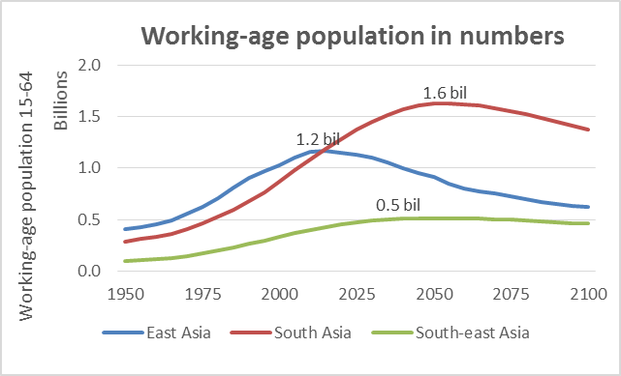 | 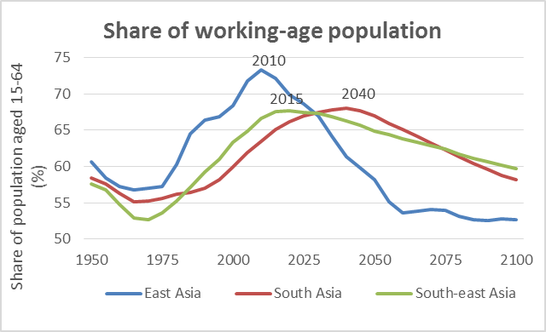

Source: Based on UN DESA 2015.

Diversity across countries in the region
In East Asia, Japan is most advanced in its transition to an ageing population, having passed its maximum number of working-age people in 1995 (Figure 3). Its share was above 60 percent in 1960 but declined to 56 percent in 2010. China and the Republic of Korea have just passed their peaks, and working-age populations are declining in numbers. The Democratic Republic of Korea and Mongolia have the youngest populations in this subregion; their numbers will continue to grow until 2040 and 2050.

In South-east Asia a majority of the countries will reach their peak working-age population between 2045 and 2055, such as Cambodia, Lao PDR, Myanmar, Malaysia, and Vietnam. Thailand and Timor-Leste are the oldest and youngest countries in this sub-region. Most countries in South Asia will have their largest number of working-age people between 2045 and 2050. India, for example, will see the maximum number in 2050, when the population aged 15-64 is expected to be larger than 1 billion. Afghanistan and Pakistan are relatively young, while Iran and Sri Lanka are ahead in the transition and have growing elderly populations. In the Pacific island countries, the share of working-age people will continue to grow until 2040, and the number beyond 2100, making it the youngest subregion in Asia-Pacific.

Figure 3: Peaks within subregions show some convergence, but with marked exceptions
Working-age population (15-64) for selected countries in Asia-Pacific, in thousands
East Asia
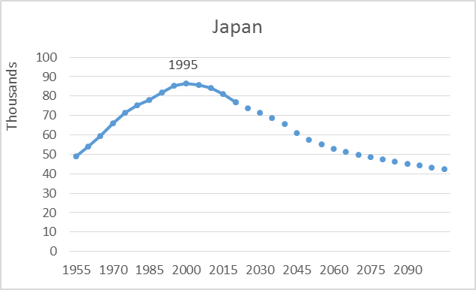 | 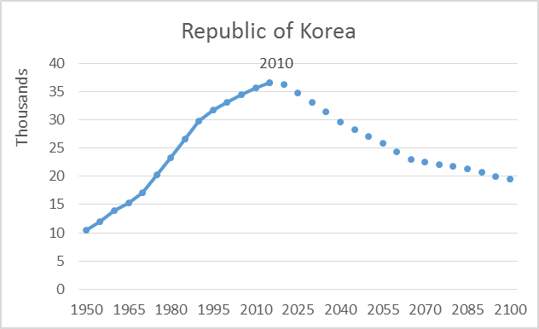 | 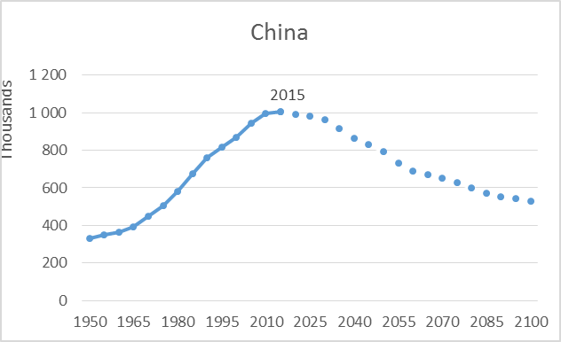
South-east Asia
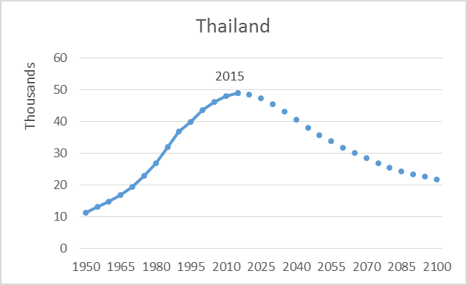 | 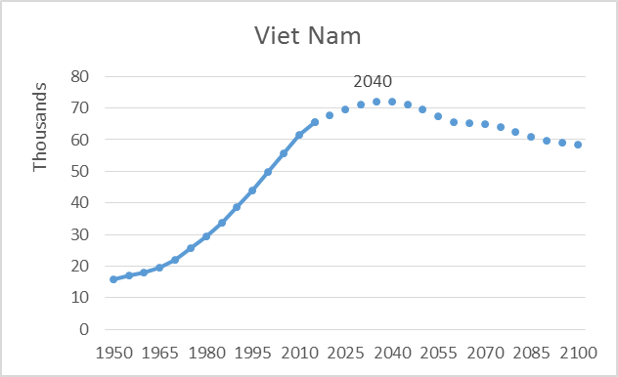 | 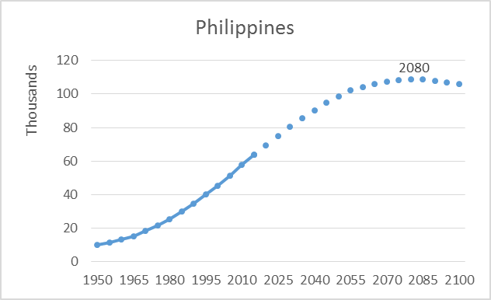
South Asia
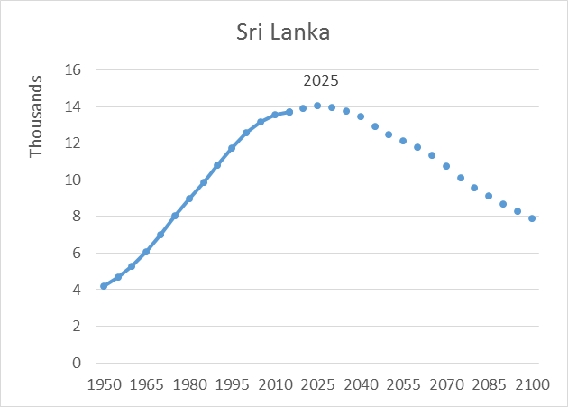 | 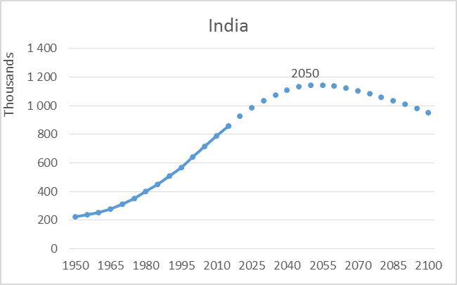 | 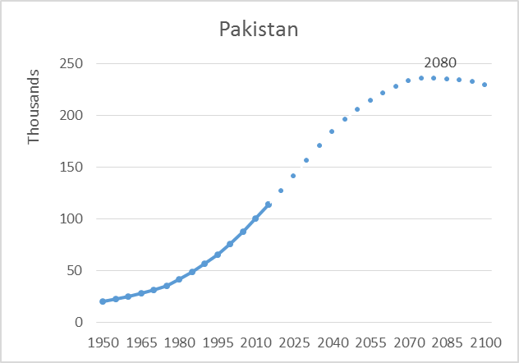
Pacific island countries
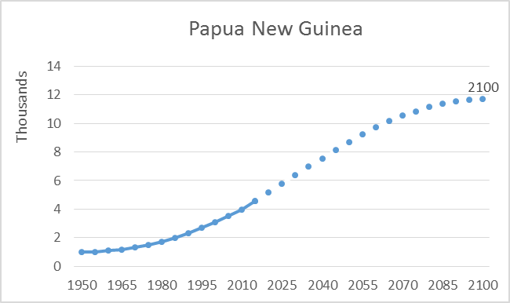 | 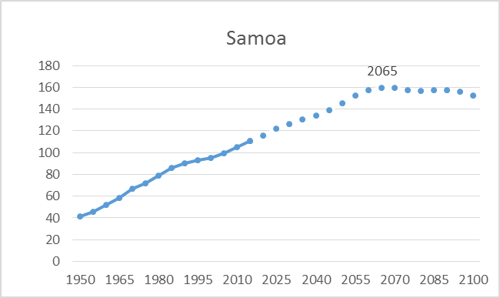 | 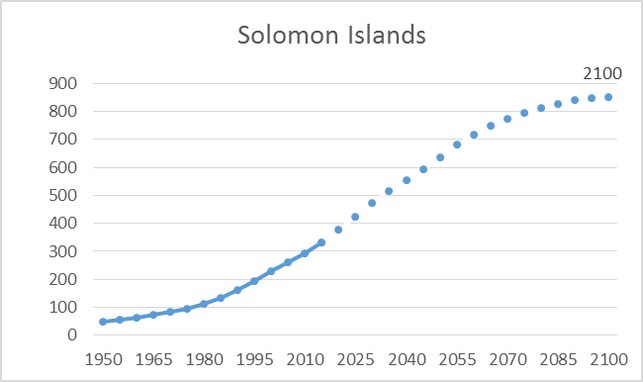
Source: Based on UN DESA 2015.

Countries are in three stages of demographic change
Table 1: Changes in the sizes of working-age populations between 2015-2030 and 2030-2050
 | 2015-2030  % change | 2030-2050  % change
Countries in advanced stages of demographic transition
Australia | 10 | 13
Brunei Darussalam | 13 | -3
China | -4 | -17
Fiji | 5 | -3
Japan | -10 | -20
Republic of Korea | -10 | -18
Mongolia | 17 | 9
New Zealand | 5 | 7
Singapore | 1 | -10
Sri Lanka | 2 | -11
Thailand | -7 | -21
Viet Nam | 8 | -2
Countries with a short window until reaching peak working-age populations
Bhutan | 20 | 0
Bangladesh | 23 | 5
Cambodia | 25 | 18
Democratic People’s Republic of Korea | 5 | -4
India | 20 | 11
Indonesia | 16 | 6
Iran (Islamic Republic of) | 14 | -9
Lao People’s Democratic Republic | 33 | 26
Maldives | 25 | 4
Malaysia | 17 | 9
Micronesia (Federated States of) | 14 | 22
Myanmar | 15 | 3
Nepal | 28 | 12
Vanuatu | 40 | 38
Countries with still young populations
Afghanistan | 59 | 41
Kiribati | 28 | 30
Philippines | 26 | 23
Papua New Guinea | 40 | 36
Pakistan | 37 | 32
Samoa | 14 | 15
Solomon Islands | 42 | 35
Tonga | 23 | 16
Timor-Leste | 43 | 52
Source: Based on UN DESA 2015.

The patterns described here define the Asia-Pacific region in three groups: countries in advanced stages of demographic transition, those nearing a peak in the working-age population with the potential to reap a demographic dividend, and those with still very young populations. The last are in the earliest phases of transition.

Countries most advanced in the transition include those that have reached their peak shares of the working-age population by 2015, although some of them are still to reach their peak numbers. China, Japan, the Republic of Korea and Thailand have passed both their peak shares and numbers, and are going to experience shrinking workforces in the coming decades. Several other countries will reach their maximum numbers of working-age people soon after 2030, including Brunei Darussalam, Fiji, Sri Lanka and Viet Nam. For the remaining countries, the working-age population will still grow but modestly (Table 1).

Countries nearing their peaks between 2015 and 2055 are mostly from South-east Asia and South Asia. They will see considerable growth in the size of the working-age population until 2030. For example, in Lao People’s Democratic Republic, Nepal and Cambodia, the working-age populations will increase by 33 percent, 28 percent and 25 percent, respectively. These countries will need to prepare for employment growth for large numbers of job market entrants.

Countries with the youngest populations, in the third category, are further behind in their demographic transitions and will continue to experience substantial growth in working-age populations beyond 2050. Relatively young countries include Afghanistan, Pakistan, the Philippines and many of the Pacific island countries where fertility rates are still high.

Different population patterns have implications for migration within the region, which is already considerable. Countries such as Brunei Darussalam, Japan, Malaysia and Singapore are now pulling in large numbers of young people from South-east and South Asian countries to provide low and semi-skilled labour. Given that the region as a whole is ageing rapidly, there may eventually be potential for migration from younger countries outside the region, such as those in Africa.

A Demographic Return for Human Development: Four Paths
With an historic number of people entering the labour force in Asia-Pacific, opportunities to reap a demographic dividend and advance human development will emerge, but vary by country. Common elements facilitating a dividend, however, comprise creating enough decent jobs for an expanded workforce; unleashing the productivity of workers, including through investing in the right education and skills training; and channelling higher rates of savings into productive investments. All of these both contribute to and depend on progress in human development.

Growth on the back of job creation
Figure 4: GDP growth moves with changes in working-age populations
Source: Based on UN DESA 2015 and WDI 2015.
Some countries in the region have already seen a growing labour force translate into economic growth that can be translated into human development gains. This has been the case in Japan and the Republic of Korea (Figure 4). In Japan, the growth of the working-age population was highest during the 1960s. GDP growth rates were also high, averaging 9 percent in the 1960s and 4.5 percent in the 1970s. As the expansion of the working-age population slowed, so did GDP increases. A similar relationship has occurred in the Republic of Korea.

But this connection does not hold for all countries, because many factors besides demographic change influence economic growth. If economies are unable to create enough jobs, for example, there are high risks of unemployment. In China, the number of jobs grew from 628 million to 772 million between 1991 and 2013, an increase of 144 million, but the working-age population increased by 241 million. In India, the size of the working-age population increased by 300 million during the same time, while the number of employed people increased by only 140 million—the economy absorbed less than half the new entrants into the labour market. A wider gap in India than China suggests a more limited capacity to generate employment—a serious challenge given the continued expansion of the workforce in India over the next 35 years (Figure 5).

Figure 5: China is ahead of India in generating employment for a growing workforce

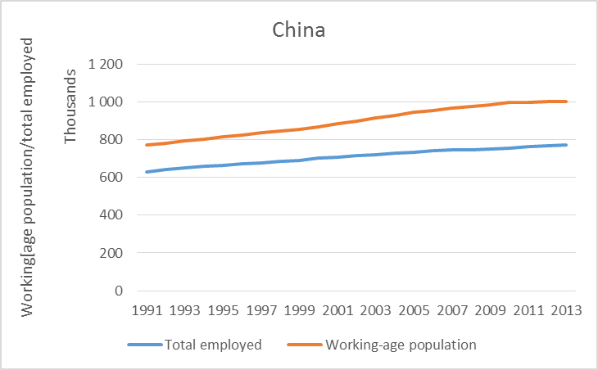 | 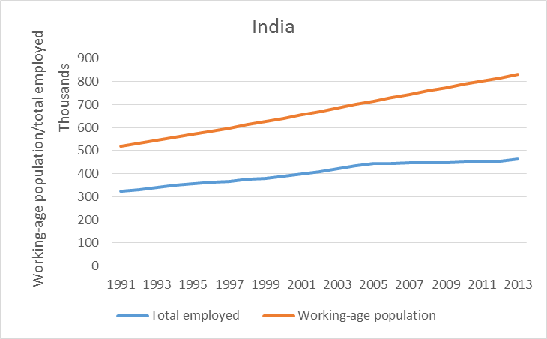
Source: Based on UN DESA 2015 and ILO KILM 2015.

Many countries in Asia-Pacific with large populations of youth and working-age people are already facing a struggle to provide more jobs. Although unemployment rates are fairly low, at a regional average of 4 percent compared to a global average of 6 percent, underemployment is pervasive. Underemployment occurs when people are involuntarily working less than full time and/or have higher skills than required for a job. It can arise from the underutilization of labour due to overstaffing or when the ratio of capital to labour is low, resulting in low productivity.

Countries can reap a larger dividend when more women participate in the labour market

Another factor limiting Asia-Pacific’s ability to fully realize the demographic dividend is low female labour force participation. While East Asia and the Pacific has one of the highest rates of women in the workforce in the world, the gender gap is particularly wide for South Asia, comparable to that of the Middle East and North Africa. The rate declined between 1990 and 2013 in Asia-Pacific, whereas it improved elsewhere in the world. Part of the reason for the decline could be that women’s labour force participation tends to fall during intensifying urbanization and shifts away from agricultural employment, where women’s work is often concentrated, particularly at low income levels. At higher income levels, women’s labour force participation rate tends to pick up again.

Particularly high gender gaps occur in Afghanistan, where the female labour force participation rate is only 16 percent, compared to 79 percent for men (Figure 6). In India, the rate for women is only 27 percent, but 80 percent for men. Samoa and Timor-Leste also rank amongst the lowest in women’s workforce participation. Social and religious factors still shut large portions of women out of the labour market, confining them to work at home or in informal occupations (Box 2.1).

Figure 6: There is significant potential to increase women’s labour force participation in South Asia and the Pacific island countries 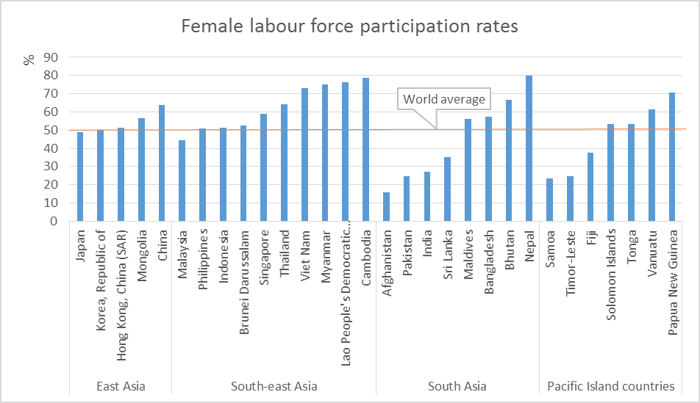
Source: Based on ILO KILM 2015.

The economic cost of women’s low labour force participation is high. For Asia-Pacific as a region, it drains somewhere between $42 and $46 billion from GDP annually. By contrast, countries that have increased women’s labour force participation have benefitted tremendously. For example, in the United States, the share of women in total employment rose from 37 percent in 1970 to nearly 48 percent in 2009, adding 38 million workers, without whom the US economy would be 25 percent smaller today. East Asian countries that benefitted from demographic changes in the last three to four decades have similarly done so with high female labour force participation rates. If other Asia-Pacific countries desire to convert demographic transition into dividends, they will need to encourage more women to work.

More productive workers can multiply output
Throughout Asia-Pacific, a fall in fertility during 1970 to 2010 was accompanied by a rise in spending on health, education and other human capital investments essential to a productive workforce (Table 2). In East Asia, the fertility rate dropped by almost two-thirds, while human capital spending per child rose by 1.28 percent per year. In South-east and South Asia, fertility declined by more than half, while investment per child rose by 1.31 to 1.44 percent per year. Improved education outcomes, including reduced gender disparities, have been one result. These have been among the main drivers of more productive workforces.

Table 2: Falling fertility has led to more spending on education and health
 | Total fertility rate |  | Growth in health, education, and other human capital spending due to total fertility rate (%)
 | 1970 | 2010 | 1970-2010
Developing Asia-Pacific | 6.3 | 3.1 | 1.28
East Asia | 5.9 | 2.0 | 1.96
South-east Asia | 6.1 | 2.9 | 1.31
Pacific | 6.5 | 3.8 | 0.98
South Asia | 6.5 | 3.0 | 1.37
Developed Asia-Pacific | 3.7 | 1.7 | 1.44

Source: Mason 2014.

Labour productivity rose rapidly and consistently across Asia-Pacific from 1990 to 2013 (Figure 7), with the fastest rates in East Asia, led by China. China’s investments in technology were instrumental, combined with investments in education and skills training that enabled workers to perform more sophisticated jobs. South Asia, South-east Asia and the Pacific also experienced consistent rises in labour productivity.
Figure 7: Growth in labour productivity has been rapid
Source: UNDP calculations based on ILO KILM 2015.

Increases in education and labour quality, however, have not been consistently met by growth in higher skilled jobs. The lack of these is a pressing issue, since it means the skills of many workers are wasted. Others migrate and seek jobs elsewhere, a brain drain that undercuts any potential demographic dividend. A critical element of maximizing labour productivity is investing in education, but equally ensuring that the growing number of working-age people find employment they are qualified to do.
Figure 8: Many jobs remain in agriculture, while the share in manufacturing lags
Source: Based on ILO KILM 2015.

Many jobs in Asia-Pacific remain concentrated in agriculture or entail unskilled labour. In global terms, agriculture in the region is second in size only to that of sub-Saharan Africa. It absorbs nearly half the labour force in South Asia (Figure 8). In South-east Asia, agricultural employment is largest in Lao People’s Democratic Republic, at 85 percent of total employment.

Manufacturing could provide more skilled and higher paying jobs, but its share of the economy in most countries is small, except for China, Indonesia, Malaysia and Thailand. High-skilled manufacturing jobs, such as in the assembly of computers, electronics and cars, are growing in a few countries. In many others, rising labour costs have begun to depress the supply of basic assembly line jobs.
While service sector employment is substantial, jobs are mainly in traditional areas such as restaurants, personal services, public administration, real estate, transport, and wholesale and retail trade. Modern service sectors, including finance, business consulting, IT and research, have yet to take off, although the IT sector in India has expanded rapidly, while the Philippines attracts a huge number of outsourced telecommunication services. Except for in China; Hong Kong, China (SAR); the Republic of Korea and Singapore, the productivity of the service sector is around 30 percent, lower than that of OECD countries.

The prevalence of low-skilled jobs explains low wages in the region (Figure 9). Twenty-four percent of working people in South Asia earn less than $1.25 a day, while 61 percent earn less than $2 a day—meaning they are trapped in dire poverty even as they are working. In Afghanistan, Bangladesh, India, Nepal and Pakistan, more than 80 percent of working people earn less than $4 daily. The size of the middle class, or workers earning from $4 to $13 a day, is growing in Bhutan, Maldives and Sri Lanka, but is still small in other parts of South Asia. A growing middle class adds an extra boost to growth and human development.
In South-east Asia and the Pacific, 11 percent of working people take home less than $1.25 a day, while another 32 percent earn less than $2 a day. Even where most people live above the poverty line, many workers hover near it, earning between $2 and $4 a day. Fifty percent of workers fall into this category in Cambodia, Indonesia, Lao People’s Democratic Republic, Marshall Islands, Myanmar, Papua New Guinea, Timor-Leste and Viet Nam. They are highly vulnerable to shocks and could easily fall back into poverty.
Figure 9: Low-skilled jobs lead to low wages and poverty traps
Source: Based on ILO KILM 2015.

East Asia is better off, mainly due to progress in China in creating better-paid jobs. The middle class there has grown rapidly; more than 40 percent of working people now earn between $4 and $13 a day. Poverty fell from 80 percent in 1993 to 28 percent in 2008.

Higher savings can be an important means for development

About half of the demographic dividend in East Asia comes from savings and capital accumulation. Growth in the savings rate is closely aligned with growth in the share of the working-age population (Figure 10). In East Asia during 1982 to 2012, the proportion of the working-age population increased from 62 percent to 72 percent, while the savings rate rose from 32 percent to 42 percent. Most of this growth was driven by China, which in 2010 had one of the highest savings rates in the world, at 52 percent.

When more people work and have fewer dependents, and know that they may live longer in retirement, they tend to save more. One additional driver of high savings in Asia is the lack of sufficient pension systems. Today, the region has savings rates higher than all other regions of the world. Savings rates in Singapore at 52 percent and in the Islamic Republic of Iran at 41 percent, for instance, are far above the global average of 22 percent.

Currently, a large share of savings ends up in non-monetary assets such as gold, silver or cash, however, since a significant number of people in the region still do not have bank accounts. Other constraints include the lack of diverse financial instruments and effective financial systems to attract domestic investors.

Figure 10: More workers means more savings
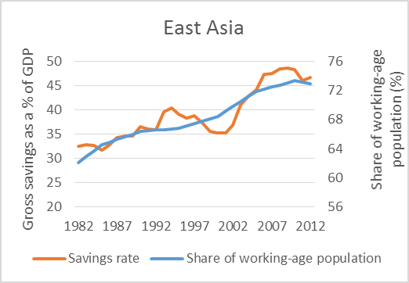 | 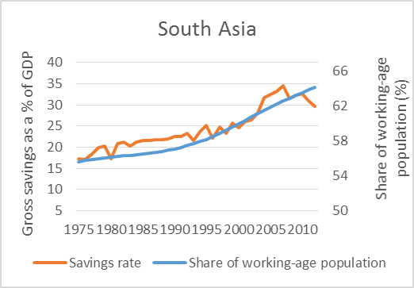
Source: Based on UN DESA 2015 and WDI 2015.

Beyond individual savings, demographic transition can allow governments to save too, including through reduced spending on social services related to children and older people, and the potential for greater taxation through a larger workforce. Accumulated savings can be channelled in a number of ways that can contribute to human development, such as business growth that creates decent work. They could help close massive infrastructure gaps—needs in East Asia in transportation, telecommunications, energy and water are estimated to be the largest in the world at $300 billion per year for the next 20 years. In some cases, expanded infrastructure can achieve multiple goods, such as higher quality of life through cleaner energy that reduces air pollution.

Achieving greater public savings may call for increasing tax revenues where collection is still limited. This depends on efficient collection systems as well as achieving a reasonable tax-to-GDP ratio. Currently, the ratio is low for a number of countries in South Asia, compared to those in East Asia. It is 9 percent in Bangladesh, lagging China at 19 percent and the Republic of Korea at 15 percent, for example. Tax collection will rise in part if more work is created in the formal economy, rather than the hard-to-tax informal one.

How Much Is the Demographic Dividend?

A widely discussed possibility is that the population changes can produce a demographic dividend leading to higher rates of economic growth (Bloom and Williamson 1998; Bloom and Canning 2001; Mason 2001; Mason and Lee 2007; Williamson 2013). In the framework used here and in many previous studies, two demographic dividends are distinguished. The first demographic dividend arises because of the increased concentration in the working-ages. If every consumer is supported by more workers, then per capita income or per capita consumption can be higher other things given.

The second dividend arises to the extent that demographic changes lead to increased accumulation of physical and human capital (Mason 2005; Lee and Mason 2006; Mason and Lee 2007). Demography’s influence on physical capital arises to the extent that societies are accumulating assets to meet pension needs. The demand for pension assets is driven higher because people are living longer after retirement and because populations are becoming more concentrated at older ages where wealth ownership is higher (Lee, Mason et al. 2003).

The effect of human capital is best understood in the context of the quantity-quality tradeoff which holds that parents will spend more on their children as they have fewer of them (and that they will have fewer children as they decide to have more) (Becker and Lewis 1973; Becker 1991). The existence of the quantity-quality tradeoff is very important for understanding the implications of population aging. Fertility decline results in fewer workers in the future, but because of the quantity-quality tradeoff those fewer workers may be much more productive than a larger, less educated workforce (Becker and Barro 1988; Lee and Mason 2010; Prettner and Prskawetz 2010).

……………………………..

To measure the impacts of changes in population age on economic growth, a simple growth model is used, as discussed in Box 1. Estimating demographic dividends using this model confirms that economic growth has been supported by favourable demographic tailwinds over the last four decades. For the world as a whole, the first and second demographic dividends combined added six-tenths of a percentage point to economic growth, compared with actual GDP growth of 1.4 percent per year—in other words, equal to about 40 percent of overall per capita economic growth. The dividend contributed one-half percentage point to world economic growth in 1970-1990, when it was in general higher among developed countries, and a full percentage point in 1990-2010, as transition began in earnest in many developing countries.

Box 1: A Model for Measuring the Size of the Demographic Dividend

The model is based on the following accounting identity:

$$\frac{Y}{N}=\frac{Y}{L}\frac{L}{N}$$
Where, $Y=GDP$, $N=$Population; $L=$ Labor force.

Taking logarithms and totally differentiating the identity gives:

$$gr\left(\frac{Y}{N}\right)=gr\left(\frac{Y}{L}\right)+gr\left(\frac{L}{N}\right)$$

Which states that the growth rate of income per capita equals the growth of labour productivity plus the growth rate of labour supply relative to the population. The second term on the right-hand side of the equation measures the first demographic dividend which is the relative size of the labour supply, while the first term measures the second demographic dividend which is the productivity level of the workforce.

For the purposes of estimation, the first demographic dividend or the relative size of the labour supply across countries has been measured using data on the number of workers between the ages of 30-49, their average wages that denote output per labour, and the total population in the country.

The second demographic dividend across countries are measured using data on human capital, including years of education and health data to denote labour productivity, as well as physical capital, using data on savings and pension.

Source: Based on Mason 2015.

Developed Asia-Pacific countries experienced their largest first dividends (0.64) during 1970-1990, led by Australia, Brunei Darussalam, Japan, New Zealand, Republic of Korea and Singapore—countries further advanced in demographic transition (Table 3). Their first dividends, however, began to fall during 1990-2010, as working-age populations began to shrink. The combined effect of the first and second dividend from 1970-2010 contributed to 42 percent of economic growth.

Table 3: Demographic dividends, 1970-1990 and 1990-2010
 | 1970-1990 |  |  | 1990-2010
 | First  dividend | Second  dividend | Combined | First  dividend | Second  dividend | Combined
Developed Asia-Pacific | 0.64 | 0.87 | 1.51 | 0.20 | 1.09 | 1.29
Developing Asia-Pacific | 0.11 | 0.39 | 0.50 | 0.59 | 0.69 | 1.29
East Asia, developing | 0.38 | 0.18 | 0.56 | 0.78 | 0.76 | 1.53
South-east Asia, developing | 0.31 | 0.12 | 0.43 | 0.57 | 0.82 | 1.39
South Asia, developing | -0.17 | 0.36 | 0.18 | 0.71 | 0.46 | 1.17
Rest of the world
Developed countries | 0.46 | 0.33 | 0.79 | 0.26 | 0.72 | 0.99
Developing countries | 0.11 | 0.30 | 0.42 | 0.47 | 0.52 | 0.99
North America | 0.61 | 0.17 | 0.78 | 0.04 | 0.80 | 0.85
Europe | 0.28 | 0.31 | 0.58 | 0.16 | 0.60 | 0.76
Latin America and the Caribbean | 0.47 | 0.43 | 0.91 | 0.54 | 0.83 | 1.36
Africa | -0.13 | 0.21 | 0.09 | 0.33 | 0.18 | 0.51
World | 0.23 | 0.32 | 0.54 | 0.40 | 0.61 | 1.01
Source: Based on Mason 2015.
during 1990-2010, given it is further behind in demographic transition. Within developing Asia, East and South-east Asia enjoyed modest first dividends in 1970-1990, of 0.38 percent and 0.31 percent, respectively. In South Asia, in contrast, the first dividend was still negative at the time, indicating that the working-age population was still small.

During 1990-2010, the first dividends picked up in all of Asia-Pacific’s developing regions, particularly in East Asia, led by China. It acquired almost 0.78 percentage points of additional growth. In South-east Asia and South Asia as well the first dividend began to rise. As fertility rates fell substantially, developing countries began to invest more resources in the education of children, leading to substantial increases in the second dividend as well. Overall, the demographic dividend contributed to 39 percent of economic growth in developing Asia-Pacific.

Elsewhere in the world, developed regions, including Europe and North America, experienced larger first dividends during 1970 and 1990, mostly as a consequence of baby boomers entering the workforce. Their dividend then became smaller during 1990-2010. In the latter period, however, the first dividend picked up in developing parts of the world, including in Latin America and the Caribbean, and modestly in Africa, where fertility rates are still high and the population is very young. The second dividend was substantial particularly in more developed regions such as North America, Latin America and the Caribbean during 1990-2010, where the favourable effects of wealth and human capital accumulation began to show.

Table 4: Demographic dividends, 2010-2020 and 2020-2050
 | 2010-2020 |  |  | 2020-2050
 | First  dividend | Second  dividend | Combined | First  dividend | Second  dividend | Combined
Developed Asia-Pacific | -0.35 | 1.12 | 0.77 | -0.50 | 0.70 | 0.20
Developing Asia-Pacific | 0.48 | 0.91 | 1.39 | 0.05 | 0.67 | 0.73
East Asia, developing | 0.28 | 1.42 | 1.70 | -0.37 | 0.99 | 0.62
South-east Asia, developing | 0.42 | 1.04 | 1.46 | -0.03 | 1.02 | 0.99
South Asia, developing | 0.68 | 0.93 | 1.61 | 0.10 | 0.43 | 0.53
Rest of the world
Developed countries | -0.16 | 1.10 | 0.94 | -0.45 | 0.69 | 0.24
Developing countries | 0.37 | 0.85 | 1.22 | 0.09 | 0.89 | 0.97
North America | -0.45 | 0.87 | 0.42 | -0.29 | 0.34 | 0.05
Europe | -0.21 | 0.90 | 0.69 | -0.42 | 0.57 | 0.15
Latin America and the Caribbean | 0.16 | 1.12 | 1.28 | -0.09 | 0.80 | 0.70
Africa | 0.41 | 0.49 | 0.91 | 0.32 | 0.81 | 1.14
Source: Based on Mason 2015.
Projections for 2010-2020 illustrate that demographics will continue to strongly favour economic growth in Asia-Pacific countries and elsewhere (Table 1.7). In developed Asia-Pacific, however, the first dividend has now begun to turn negative (Box 1.5). With population ageing, the number of consumers exceeds that of producers, slowing economic growth, although this is more than offset by the second dividend from increasing productivity and savings.

For developing Asia-Pacific, both demographic dividends will continue to be positive in the coming decades, and could add about 0.73 percentage points per year to economic growth between 2020 and 2050. Favourable effects will begin to shift during that period, however, as the share of working-age people begins to retreat, moderately for the world as a whole and rapidly for the developed countries. The largest decreases are projected for Europe and developed Asia-Pacific, followed by developing East Asia, given very low fertility and rapid population ageing. Second dividends, however, may continue to offset declining first dividends, if conditions for growth and human development exist.

What’s Been Learned in China, Japan and Thailand?
Three countries in Asia-Pacific have already passed their labour force peak: China, Japan and Thailand. Looking at their experiences can help in understanding how having a larger working-age population can accelerate economic growth and human development. Did they make the most of their demographic dividends?

China: Job creation key to maximizing the demographic dividend
China’s working-age population rose from 56 percent of the total population in 1960 to 74 percent in 2010, and increased in number from 363 million to 996 million people. During the same period, China experienced stellar economic growth rates of 6.3 percent in the 1970s, 9.4 percent in the 1980s, and 10.5 percent during the 1990s and first decade of the millennium. Many factors influenced these high rates, including the influx of people into the workforce (Figure 11). While the working-age population peaked in 2010, China has skilfully used its era of a strong labour supply by creating large numbers of jobs and boosting economic output, realizing a large demographic dividend in the process.

Economic, trade and financial policies were instrumental in creating more jobs. Since 1978, China has implemented reforms that were pro-market and pro-employment. Liberalization of trade policies opened up the economy, and trade grew much faster than any country has ever seen before. A manufacturing boom sent Chinese products to global markets, while creating a large number of jobs at home. At present, nearly 30 percent of the labour force, or about 225 million people, work in the manufacturing sector. Open market policies, including privatization and growth in labour-intensive sectors, fuelled investment and industrial expansion. Modernization of the financial sector also facilitated the growth of firms and creation of more jobs.

As the share of younger and older dependents shrunk relative to working-age people, China’s savings rate rose from 36 percent of GDP in the 1980s to 47 percent in the first decade of the 21st century. This allowed increased domestic investments, including in infrastructure. Heavy spending has improved education, and gross enrolment has risen at all levels. The greatest increase was in colleges and universities, with a tripling in enrolment between 1980 and 1997, and again from 1997 to 2006. Both political and business leaders supported this push, recognizing the need for both highly trained technicians and well-educated consumers. In tandem, a surge in productivity occurred, rising from $1,772 per worker in 1982 to $13,000 in 2010, an astonishing six-fold increase in less than 30 years. Besides the expansion of formal education, productivity grew on the back of increased use of advanced technology, on-the-job-training, growing experience, better health and rising longevity.

The Chinese boom enabled a rapid transformation in the structure of the economy, from heavy dependence on agriculture to a concentration on manufacturing and services. While economists debate the exact contribution of the increased workforce, up to one-third of China’s ‘economic miracle’ has been attributed to the demographic dividend. Better health and labour productivity have been critical factors, along with the expanded number of people working. Results from the Mason model described in Chapter 1, however, indicate that in China, the contribution of the demographic dividend to GDP was about 15 percent.

The Chinese experience suggests that having a large share of people working is not by itself sufficient to unleash economic growth. It must be accompanied by appropriate socioeconomic policies. Multiple factors drove China’s ‘growth miracle’, but effective employment of a growing labour force in particular propelled poverty reduction and improved human development.

Figure 11: China’s economy grew through the highly productive use of its workforce
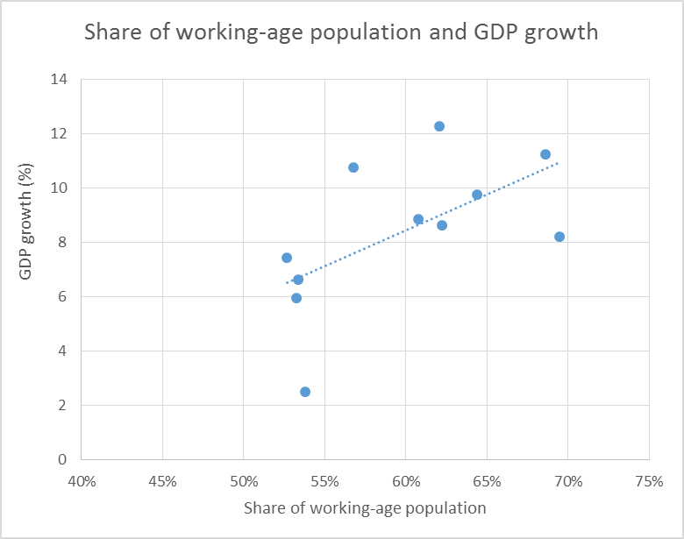
   | Five-year average GDP growth rate | Change in numbers of working-age population (in '000)
  1961-65 | 2.5 | 17942
  1966-70 | 7.4 | 24871
  1971-75 | 5.9 | 58888
  1976-80 | 6.6 | 53804
  1981-85 | 10.8 | 70944
  1986-90 | 8.8 | 86900
  1991-95 | 12.3 | 77885
  1996-00 | 8.6 | 46455
  2001-05 | 9.8 | 54813
  2006-10 | 11.2 | 79429
  2011-15 | 8.2 | 40275
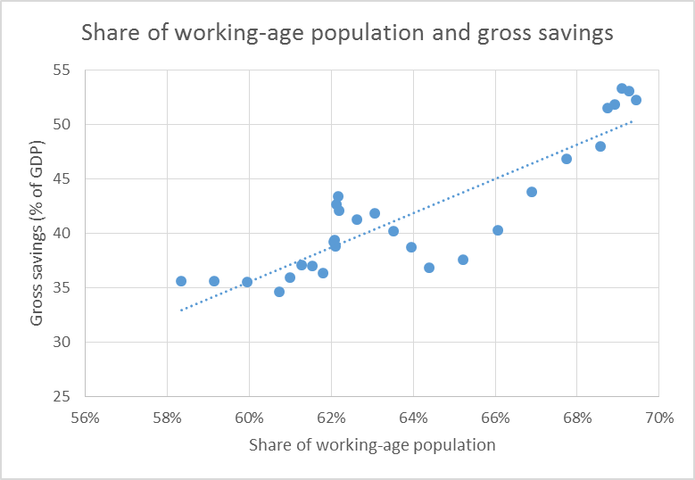 | 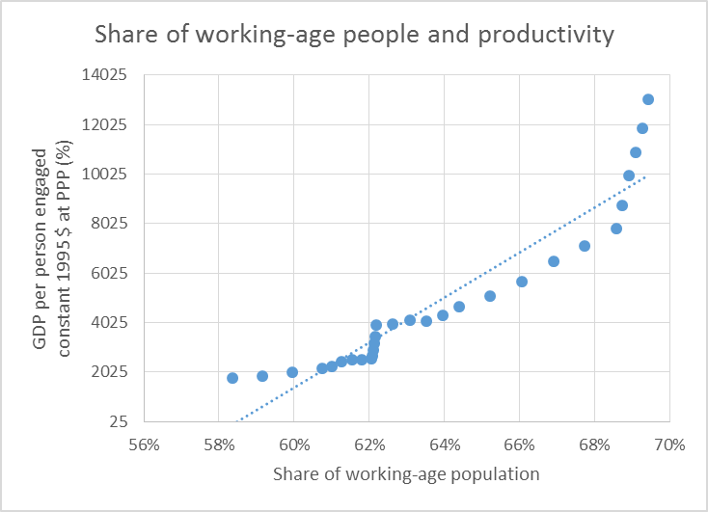
Source: Based on ILO KILM 2015, WDI 2015, UN DESA 2015.

Japan: Higher investments in education and productivity
Japan endured significant human and economic losses during World War II, but then transformed itself from a war-torn nation to a resilient, high-income economy in a few decades. GDP growth began to accelerate from the 1960s and continued until the 1980s as Japan’s economic miracle unfolded. Rapid progress came from an expanded labour supply as well as the reform of the education system, sound fiscal and monetary policies, high savings and investment rates, and increased labour productivity.

The share of working-age people hovered between 60 percent and 65 percent from the late 1960s to the mid-1990s (Figure 12). During the 1960s, the country’s 10-year average growth rate was 9.3 percent, tapering off to below 5 percent after the 1990s, around the time the labour supply began to decline. To sustain high levels of production, younger rural workers were given incentives to move to cities—Tokyo’s working population increased by 1 million during 1955-1965. This growing urban population enabled Japan to sustain high economic growth rates.

Gains in efficiency and productivity were critical drivers of growth, and accompanied the spike in the workforce. This advantage stemmed in large part from a heavy investment in education after the Second World War. During the 1950s and 1960s, major reforms increased the number of years the average worker spent in school, particularly those working outside agriculture. As income rose, investment in nutrition, vaccination and other health-related issues soared. The average life span grew substantially, from 60 years for males and 63 years for females in 1950 to over 80 for males and 87 for females in 2013.

A high investment ratio, the introduction of foreign technology and “improved and clever engineering” further boosted the surge in productivity. From around 1945 to the end of the 1960s, investment ranged from 35 percent to 40 percent of GDP, ensuring the rehabilitation of severely damaged infrastructure and enhancing competitiveness. Foreign technology was actively absorbed in key industries, including strip mills in steelmaking, electric welding in shipbuilding, and technologies for chemical fertilizers and heavy electric machinery. New industries to manufacture automobiles, synthetic fibres and consumer electronics also brought in new technology that promoted growth.

Government policies actively backed business development. The Business Rationalization Promotion Act of 1952, for instance, provided a special depreciation scheme for modernizing equipment in key industries. Government financial institutions, such as the Japan Development Bank, the ExIm Bank, and the Medium and Small Business Credit Corporation introduced long-term credit to support businesses. A healthy savings rate of 30 percent of GDP, the highest among OECD countries in the 1960s, spurred the growth of the economy.

Since the 1990s, Japan’s labour supply and productivity have fallen. The 1990s became known as the ‘lost decade’, a period of low growth rates, high unemployment, bad debt and falling investments. The savings rate dropped drastically as the country began to age, declining from around 32 percent of GDP during 1977 to 25 percent from 2000 to 2012, and contracting even as Japan’s growth rates picked up again in the early years of the 21st century, and labour participation rates increased. The latter were boosted by more women working and more people staying in the workforce beyond retirement age—over half the population aged 65-70 is still working.

Figure 12: Japan is past its working-age peak, but has successfully utilized its demographic dividend
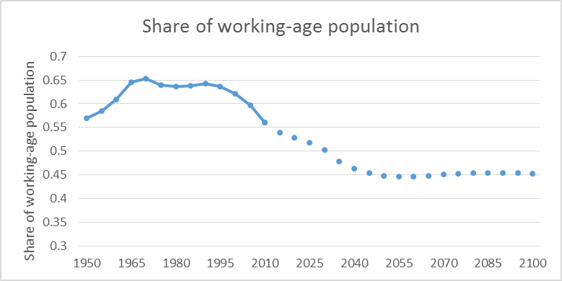
   | Five-year average GDP growth rate (%) | Change in the size of the working-age population (in '000)
  1961-1965 | 9.38 | 4769
  1966-1970 | 9.21 | 6442
  1971-1975 | 4.6 | 4850
  1976-1980 | 4.39 | 3180
  1981-1985 | 4.28 | 2863
  1986-1990 | 5.23 | 2746
  1991-1995 | 1.42 | 2104
  1996-2000 | 0.85 | 612
  2001-2005 | 1.2 | -1145
  2006-2010 | 0.39 | -2261
  2011-2015 | 0.97 | -4449
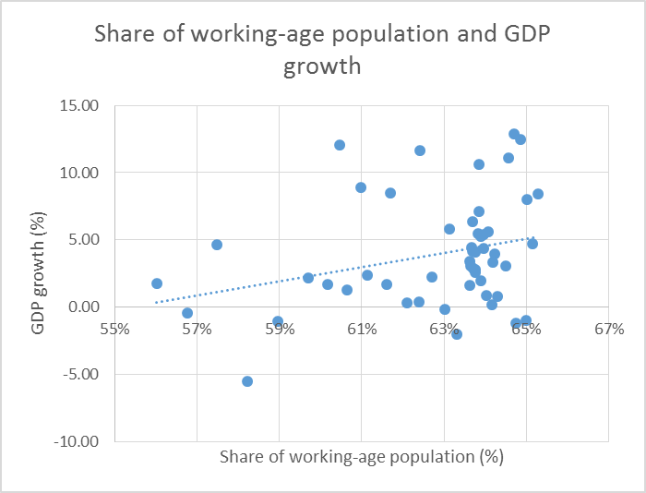 | 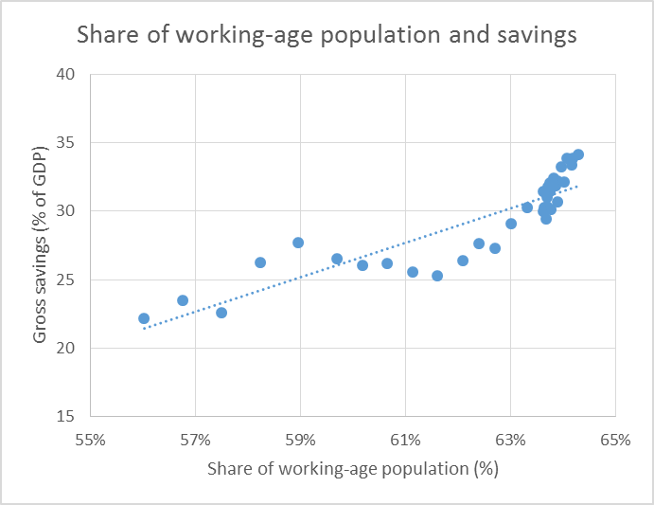
Source: Based on ILO KILM 2015, WDI 2015, UN DESA 2015.

Japan’s transition to an ageing society raises issues relating to strains on public budgets, labour shortages, and the funding of social security and health care. Nevertheless, the fact that the economy is highly advanced has enabled the country to better prepare for an era of ageing. The economy continues to grow on the basis of technology improvements, productivity growth, trade and foreign direct investment, and by continuing to bring healthy adult workers and more women to the workforce.

Thailand: Proactive family planning triggered demographic change
Among South-east Asian countries, Thailand has reached the most advanced stage of the demographic transition. Its share of working-age people peaked in 2010 at 68 percent, and the number is expected to crest in 2015. By 2050, the share is predicted to fall to 50 percent.

Thailand proactively planned its demographic transition, launching large-scale advocacy for voluntary family planning that stressed faster economic growth and a better quality of life. From 1970 to 1990, Thailand’s total fertility rate fell from 5.5 to 2.2, the fastest decline in South-east Asia, and particularly remarkable since about half of Thai people still live in rural areas where rates tend to be higher. A rapid expansion in the share of people aged 20-60 took place during 1970 to 2010 (Figure 13).

Figure 13: Thailand’s population shift was rapid from 1970-2010
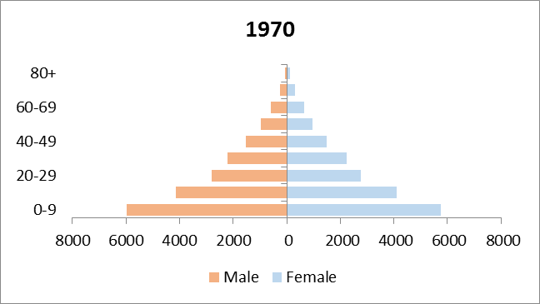 | 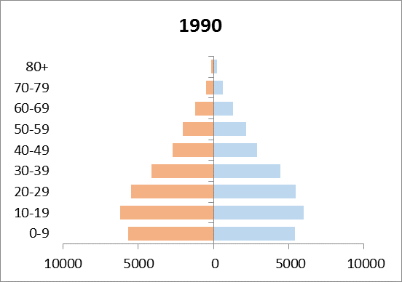 | 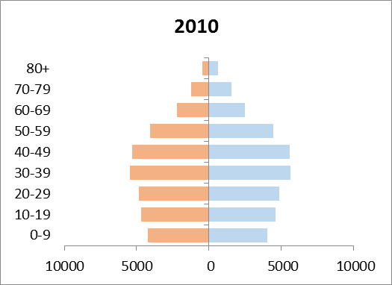
Source: Based on UN DESA 2015.

Between 1970 and 2010, as Thailand’s working-age population increased from 53 percent of the total population to 68 percent, GDP growth rates were consistently high—just above 7 percent during the 1970s through the 1990s, and around 5 percent during 2000-2010 (excluding the crisis years of 1997-1998 and 2008). During this time, Thailand transformed its economy from a low-income to an upper-middle-income one, and significantly reduced poverty. From 1960 to 2000, poverty rates fell from 60 percent to 10 percent. Per capita income increased from $100 in 1960 to about $5,800 in 2014, making Thailand the fourth richest country in South-east Asia, after Singapore, Brunei Darussalam and Malaysia.
In transitioning from a primarily agrarian to a service-based economy, improvements in transportation and telecommunication proved critical, enabling rural farmers to better connect to markets. Many agricultural workers moved to urban areas and shifted to high-paying jobs in industry. Fewer children per family coupled with improvements in education supported the transition from agriculture to industry and services.

An import substitution policy in the 1960s and 1970s accelerated industrialization, which led to an industrial processing zone in the eastern region encouraging industries to use domestic raw materials. Since the 1980s, trade policy has shifted to export promotion, including through export-processing zones and an export/import bank to finance entrepreneurs. From the late 1980s to the 2000s, the processing of high-quality agricultural and manufactured goods was fostered, along with the development of skills demanded by the labour market. Amid intensifying global competition, Thailand was drawn into regional and bilateral free-trade agreements to expand markets and increase trading partners.

Thailand’s annual economic growth rate has fluctuated considerably in recent times as the economy has recovered from the global recession. The rate of savings, at 31 percent of GDP, has been relatively stable, however. Given that the share of the working-age population will remain over 60 percent until 2030, and that the savings rate is expected to remain high, Thailand still has considerable time left to capitalize on its demographic dividend. Sustaining momentum will largely depend on a continued supply of productive jobs, investment options making the most of savings, well-managed macroeconomic policy and political stability.

Figure 14: Thailand still has time to further capitalize on its demographic dividend
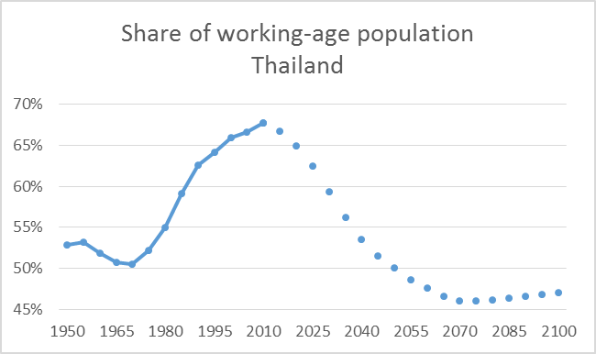 | 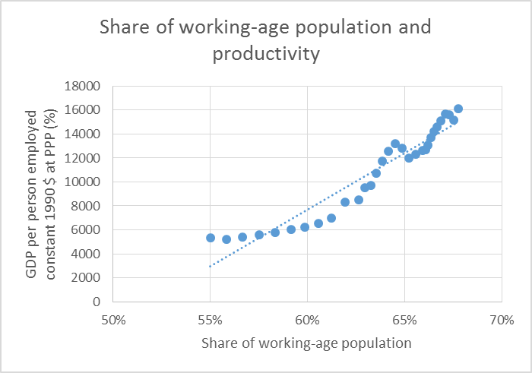
Source: Based on ILO KILM 2015, WDI 2015, UN DESA 2015.

Making the Most of Demographic Opportunities

As the experiences from China, Japan and Thailand demonstrate, a larger, more productive working-age population can yield a demographic dividend, but not by default. An effective policy framework needs to be in place, backed by an appropriate vision, commitment, strategies and incentives. A few common lessons stand out:

- A larger working-age population can be a great asset—with strategic labour market policies. These should aim at creating decent work, promoting businesses and trade, increasing diversity in employment, and ensuring a stable macroeconomic environment so that businesses can thrive.

- Equally important is paying attention to protecting worker’s rights, including by improving working conditions and the overall health and safety of workers, reaching out to informal sector workers, instituting minimum wage levels to combat working poverty, and so on.

- Countries will also need to leverage sectors and industries that can provide higher quality jobs. Many countries need to go through structural transformation, transitioning from low-productive sectors such as agriculture to those that demand higher skilled labour and provide better wages. Investments in education and skills development will be important to ensure working people are prepared for such a transition.

- A large working-age population can boost savings, among individuals and in terms of public revenues. These can be channelled into business growth, expanded infrastructure and social expenditures, and more robust pension schemes. Savings need to be effectively injected into markets, however. Public budget surpluses need to be wisely invested.

Figure 15 charts a general three-step path for the demographic dividend to accelerate human development. The following pages consider supportive policies in four broad areas: creating more jobs, improving their quality, emphasizing workers’ rights and putting savings to work. There are challenges and barriers to overcome, and new opportunities to explore.

Figure 15: A policy framework to guide the demographic dividend

Some core policy actions include:

Create more and better jobs and livelihoods
The share of people working but earning below the international poverty line is still large in Asia-Pacific, and their numbers are likely to escalate with more entrants into the labour force if current employment shortfalls continue. By 2050, more than 280 million more people will enter the job market in India alone, for instance, a one-third increase above current levels, yet between 1991 and 2013, the economy absorbed less than half of new entrants to the labour market.

Although unemployment rates across the region are fairly low, averaging 4 percent, underemployment is pervasive in many places. Large numbers of people still scrape by in marginal agriculture or informal and poorly paid work, even though the quality of employment is an essential element of the demographic dividend. While labour productivity has risen consistently, along with improved education and investments in technology, labour markets are still not robust enough, leaving many workers to migrate and seek jobs elsewhere, a drain on demographic returns.

The time has come to make job creation central to national development strategies, with a strong emphasis on protecting worker’s rights. One starting point could be new policy measures to encourage small and medium enterprises, which face many constraints despite providing two-thirds of current jobs. Structural transformation of the economy, from less to more productive activities, opens new opportunities for people to find better work, and prepares for the time when a fewer number of workers will need to produce more to sustain development gains for an ageing population.

Achieve women’s equal participation
A factor limiting Asia-Pacific’s ability to fully realize the demographic dividend as well as promote human development is low female labour force participation. The rate is below 60 percent for more than two-thirds of the 30 Asia-Pacific countries that track it. Many women are spending disproportionate time on domestic caregiving, undercutting opportunities to generate an income. East Asian countries that have already benefitted from demographic changes in the last three to four decades have done so in part due to high female labour force participation rates.

Policies designed to bring more women into the workforce will be critical for fully realizing demographic dividends. These need to ensure equal pay and rights for women, safety and security at work and in public spaces, reasonable parental leave, and reliable, cost-effective provision for child care, among others. Malaysia, for instance, is proactively engaging the private sector to bring more educated women back to the workforce by providing grants and incentives that can facilitate child care.

Women’s entrepreneurship, an untapped area for many countries, has tremendous potential. Regulations regarding establishing businesses, obtaining credit, and participating in trade need to be oriented towards diminishing gender-related barriers and improving women’s access. Women also need to be full participants in political and economic decision-making, as is their right, and because there is otherwise a lower likelihood that policies and plans will fully support their capabilities and contributions to development. Countries need to reform discriminatory laws, such as those that require women to retire at earlier ages than men, and uproot social norms that tolerate gender-based violence, even if it is against the law.

Channel more savings into productive investments
About half of the demographic dividend already achieved in East Asia has come from savings and capital accumulation closely aligned with increases in the share of the working-age population. As more people work and have smaller families, and know that they may live longer in retirement, they tend to save more. Demographic transition can allow governments to save too, including through reduced spending on social services that are more important when populations are very young or very old. Accumulated savings can be applied in several ways that contribute to human development and the demographic dividend, such as infrastructure to improve productivity.

The region as a whole needs to widen the availability of financial instruments for investing in savings—the large portion currently ending up abroad underscores gaps in domestic options. One important avenue could be developing bond markets, which can have particular value for businesses as well as municipalities aiming to keep up with rapid urbanization and expansion of infrastructure and services. Banking and other basic financial services need to reach the large shares of people and smaller businesses who currently go without them, a process that could be backed by financial literacy and education efforts.

Conclusion

Most Asia-Pacific countries today have entered or are on the verge of demographic transition. The next few decades will bring a unique opportunity to foster human development, including through the demographic dividend. But a rise in the working-age population does not guarantee this. Countries need to provide enough decent work, stimulate their economies so that growth is inclusive, and ensure people have capabilities, opportunities and freedom to progress in their lives, including through protection of their rights as workers.

Although much of the responsibility for reaping the demographic dividend lies with governments, as they can steer the process, many more actors need to be involved. Governments will need to work with private actors to support the creation of businesses and employment, with financial institutions on productive uses of savings that contribute to human development and the Sustainable Development Goals, and with individuals and firms to build skills and productivity.

UN DESA 2015.
ADB 2005.
ILO and ADB 2011.
McKinsey 2011.
Noland et al. 2013.
Bloom and Williamson 1998.
World Bank 2013.
ADB 2014.
For a detailed description of the model, see Mason 2005.
Economic growth is measured here by GDP per equivalent consumer (GDP/N) rather than the more traditional GDP per person. Growth of GDP/N is a better measure of gains in standards of living because high-consuming age groups were growing more rapidly than low-consuming age groups between 1970 and 2010. Accounting for age structure changes leads to a downward revision of economic growth of between 0.1 and 0.2 percentage points, except in Africa, where the downward revision is only 0.04 percentage points.
Gross enrolment ratio = (persons in school x100)/(persons of school age).
Fogel 2004.
For example, Bloom, Canning and Malaney 2000.
Leung et al. (2003) argued that it is impossible to disprove the role of luck in economic growth. They claimed that Asia-Pacific countries have experienced successes and failures generated by high economic volatility, and that “luck is endogenous through learning-by investing.” As result, “good luck is a function of good policy. Luck favours those who strive.”
Otsubo 2007.
Kensuke 2011.
UNDP 2014.
Otsubo 2007.
Ibid
Corbet 2012.
Based on WDI 2015.

