Using a regional CGE model for rapid assessments of the economic implications of terrorism events: creating GRAD-ECAT (Generalized, Regional And Dynamic Economic Consequence Analysis Tool)
Report to the Terrorism Risk Assessment groups in the
Department of Homeland Security
by
Peter B. Dixon, Michael Jerie, Maureen T. Rimmer and Glyn Wittwer
Centre of Policy Studies, Victoria University, Melbourne, Australia
April 9, 2017
Contents
Acknowledgements 1
Abstract 1
Summary 2
- Introduction 7
1.1. Converting scenarios for driving factors into outcomes for economic 7
implication variables
1.2. From ECAT to GRAD-ECAT 8
- Computable General Equilibrium (CGE) modeling as an alternative to current 10
TRA practice based on input-output (I-O) modeling
- The computational and security challenges: the elasticity solution 11
- USAGE-TERM, a flexible bottom-up regional model of the U.S. 12
4.1 The USAGE model 12
4.2 USAGE-TERM 13
4.3 Coping with huge dimensions via flexible aggregation 14
4.4 Simulations, baseline runs and perturbation runs 14
- Measuring the welfare effects of a terrorism incident 14
- Estimating the elasticity coefficients, E_{A}(s,d,v), using USAGE-TERM 18
6.1 Turning 8 matrices into 340 matrices: the relevant variable approach 28
6.2 Sample elasticity matrices 31
- Computing the economic implications of three illustrative scenarios 39
- Concluding remarks 47
  - Directions for future research 48
Appendix 1 Results for the proportionality coefficients and specification of 49
relevant variables
A1.1 Overview of results for the proportionality coefficients 64
A1.2 Notes on the relevant variables 71
Appendix 2 Archives: USAGE-TERM simulations, elasticity matrices and 73
contribution calculations
A2.1 Restoring simulations from zip archive 73
A2.2 Running the simulations 74
A2.3 Processing solutions to produce elasticities E_{A}(s,d,v) and contribuitions 74
of driving factors to economic implication variables
References 75

Acknowledgements
This project was carried out over the last year by the Centre of Policy Studies, Victoria University, Australia, under a sub-award from CREATE at the University of Southern California on a contract from DHS. We received excellent administrative support from CREATE and valuable advice throughout the project from Scott Farrow (economics director at CREATE). Tony Cheesebrough from DHS Headquarters was extremely helpful in setting up the project. In working on the project we benefited from enthusiastic encouragement from the TRAs, particularly from the project managers Jessica Cox and Scott White. Throughout the project we enjoyed close collaboration with Battelle’s Dave Winkel.

Abstract:
The Terrorism Risk Assessment (TRA) groups in the Department of Homeland Security assess millions of terrorism scenarios defined by location, agent (e.g. nuclear device), and delivery method (e.g. car bomb). For each scenario they estimate deaths, injuries, property damage, clean-up and health expenses, visitor discouragement, and other damage dimensions. The TRA groups translate damages into economic measures, e.g. loss of GDP. Previously they used an input-output (I-O) model. Here we replace I-O with computable general equilibrium (CGE).
Solving CGE models is computationally time-consuming and requires specialist skills. For the TRA groups this creates two challenges: feasibility and security. A model that cannot be solved in less than a fraction of a second is infeasible for analyzing millions of scenarios. The TRAs can rely only on people with high security clearances, limiting the possibilities for obtaining specialist advice.
Our approach to these challenges was to use a CGE model to estimate elasticities that connect economic implication variables with damage or driving variables. We supplied these elasticities for use in the equation:
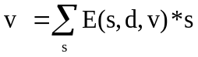
where v and s are the percentage changes in an implication variable and a driving variable. E(s,d,v) is a CGE-estimated elasticity that we supplied. It is the elasticity of v to a terrorism shock s perpetrated in target region d, e.g. the percentage effect on national welfare of destruction of 1 per cent of the capital stock in congressional district NY14.
Our elasticity approach solves both challenges. First, for any given terrorism scenario specified by a location and a vector of s variables, the elasticity equation can be computed in nanoseconds to evaluate a range of implication variables, v. Second, as outside contractors, we had no need for access to sensitive information on specific shock vectors s and target regions d.
We describe how we used a dynamic, multi-regional CGE model, USAGE-TERM, to estimate the elasticities.

JEL codes: C68; F52; R13
Key words: terrorism assessment; multi-regional, dynamic CGE

Summary
- The Terrorism Risk Assessment (TRA) groups in the Department of Homeland Security assess millions of potential terrorism scenarios. These scenarios are defined by an array of characteristics including: city and location at which the incident takes place (e.g. Miami, airport); agent (e.g. nuclear device); and delivery method (e.g. car bomb). For each scenario the TRA groups estimate deaths and injuries, property damage, clean-up expenditures, health expenditures, foreign-visitor discouragement, and several other damage dimensions.
- The TRA groups translate the damages for each scenario into summary economic measures, e.g. loss of GDP. In the past they have done this by applying an input-output (I-O) model. The aim of this project is to investigate the practicality of replacing the I-O model with a computable general equilibrium (CGE) model.
- Relative to I-O, CGE is a superior framework for: (a) recognizing constraints on the availability of resources such as labor, physical capital, government finance and foreign exchange; (b) representing price-sensitive and resilient behavior such as substitution away from oil in response to supply interruptions and price hikes; and (c) for capturing the time dimension (dynamics). In common with I-O, CGE models produce results for standard national and regional variables such as GDP, employment by industry and employment by region. In addition, CGE models can generate results for financial variables (e.g. net foreign liabilities) and welfare variables.
- GDP is often used as a measure of welfare. However, this can be misleading, especially in terrorism analysis. GDP is a measure of output. In the immediate aftermath of a terrorism event, GDP may be increased by medical, clean-up and other expenditures. This doesn’t mean that national welfare has been increased. CGE offers the possibility of measuring welfare effects by computing how a terrorism event affects a society’s ability to consume pleasure-giving goods and services. By using the dynamic facilities of CGE, the welfare measure can take account of the future path of consumption and the accumulation of debts that must be eventually paid off.
- Solving CGE models is computationally much more time-consuming than solving similar dimension I-O models. CGE models also require a higher level of specialist skills for computation and interpretation than I-O models. For the TRA groups this creates two related challenges: computational feasibility and security. A model that cannot be solved in less than a fraction of a second is infeasible as a tool for analyzing millions of scenarios. For analyzing sensitive issues, the TRAs can rely only on people with high security clearances, limiting the possibilities for obtaining adequate specialist advice on a flexible basis.
- Our approach to these two challenges was to use a CGE model to estimate elasticities (sensitivity coefficients) that connect economic implication variables (e.g. GDP) with damage or driving variables (e.g. capital destruction). We supplied these elasticities to the TRA groups for use in the equation:
(S.1)
This equation computes the economic effects of any given terrorism scenario. In the equation, v is the percentage change in an economic implication variable and s is the percentage change in a driving variable. E(s,d,v) is a CGE-estimated coefficient that we supplied to the TRA groups. It is the elasticity of v to a terrorism shock s perpetrated in target region d. For example, E(s,d,v) could be the percentage effect on national welfare of destruction of 1 per cent of the capital stock in congressional district NY14.
- Our elasticity approach offers a solution to both the computational and security challenges. First, for any given terrorism scenario specified by a location and a vector of s variables, the elasticity equation can be computed in nanoseconds to evaluate a broad range of implication variables, v. Second, as outside contractors supplying the E coefficients, we had no need for access to sensitive information concerning specific shock vectors s and target regions d.
- In estimating the E coefficients we used a dynamic, multi-regional CGE model known as USAGE-TERM. This is a regional version of the USAGE model which has been used for more than a decade by the U.S. International Trade Commission and several departments of the federal government to analyze a wide variety of topics in trade, immigration, transport infrastructure, energy and environment.
- The E coefficients that we supplied to the TRA groups cover 10 implication variables, v. These include year 1 (short run) and year 20 (long run) measures of output and employment for the nation and the target region, and two measures of national economic welfare.
- The E coefficients cover 14 driving variables, s. These include property damage, deaths, clean-up expenditures, medical expenditures, accommodation expenditures, foreign and domestic visitor discouragement, loss of food output and long-term aversion to working in the target region.
- The E coefficients cover 170 target regions, d. These are the congressional districts located in 74 cities identified by the TRA groups as potential terrorism targets.
- Clean-up, medical and other expenditures have greater short-run stimulatory effects in an economy experiencing high levels of unemployment than in an economy with normal levels. By the same token, loss of visitor expenditures has a greater short-run depressing effect in an underemployed economy where new jobs are hard to find than in an economy with normal levels of employment. These considerations led us to compute two sets of E coefficients, one for a situation in which the terrorism event takes place at a time of high unemployment and the other for a situation of normal employment. We refer to the first set as Keynesian elasticities and the second as Neoclassical elasticities.
- Altogether we supplied 47,600 E coefficients to the TRA groups: 10 implication variables (s) by 170 potential target regions (d) by 14 driving variables (s) by 2 sets of assumptions, Keynesian and Neoclassical.
- It is possible to imagine estimating the E coefficients by conducting simulations in a version of USAGE-TERM identifying the 170 potential target congressional districts plus the remainder of the U.S. For each s,d pair and macro assumption A (Keynesian or Neoclassical), we would perform a simulation to find out the effects on the 10 implication variables of a 1 per cent s shock perpetrated in congressional district d. Using this 170+ region model we would find out, for example, the sensitivity of national welfare and other implication variables to capital destruction in NY14 under Keynesian assumptions. While this is a conceptually useful way to think about the estimation of the E coefficients, it is not a description of a practical approach. First, even with large computers, it is not possible to solve a CGE model having 170+ regions and a number of industries adequate for terrorism analysis (say, 20 industries). Second, we would need to perform 4,760 simulations: 14 driving variables by 170 potential target regions by 2 sets of assumptions. This is too many simulations even for a model with moderate regional disaggregation.
- To solve the problem of excessive regional dimensionality, we used 4-region versions of USAGE-TERM in which the 4 regions are: a congressional district (one of the 170 potential targets); Rest of city; Rest of state; and Rest of U.S. We refer to the model that separately identifies congressional district d as the d-model. By performing 28 simulations (14 s shocks under 2 assumptions A) with the d-model we can obtain estimates of E_{A}(s,d,v) for all s, v and A. From a computational point of view, 28 simulations with a 4-region, 20-industry model going out 20 years is manageable: each simulations takes about 6 minutes on a high-speed desktop computer. But creating 170 d-models and performing 28 simulations with each would not be manageable, especially when it is recognized that all computations inevitably need to be repeated several times to eliminate errors and introduce improvements.
- To solve the problem of an excessive number of d-models we designed a method for using estimates of E_{A}(s,d,v) matrices derived from a small number of d-models to obtain estimates of E_{A}(s,d,v) for all d. The method relies on being able to extract from the USAGE-TERM master database values for what we call relevant variables, RV(s,d,v), such that
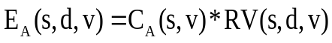 for all d (S.2)
where C_{A}(s,v) is a coefficient of proportionality, independent of d. If the RV variables can be formed and the C coefficients can be legitimately estimated, then evaluation of all the elasticities is trivial.
- The quickest way to explain this method is by an example. Consider the elasticities E_{A}(s,d,v) for all d where s refers to capital destruction and v refers to GDP. We might guess that these elasticities are proportional to the value of the capital stock in region d, that is we guess that capital stock is a relevant variable [RV(s,d,v)] for s equals capital destruction and v equals GDP. If the capital stock in congressional district CA34 is worth $100 billion and that in AZ07 is worth $50 billion, then we would expect the percentage effect on GDP of a 1 per cent capital destruction in CA34 to be twice as great as that for a 1 per cent destruction in AZ07. We can check the legitimacy of this guess by using (S.2) to calculate alternative values of C_{A}(s,v) with values of E_{A}(s,d,v) estimated from available d-models together with values of capital from the USAGE-TERM database as RV(s,d,v) values. We judge legitimacy by the closeness of the alternative estimates of C_{A}(s,v).
- We found RV variables that led to legitimate estimates of C_{A}(s,v) for v equal to welfare, national GDP and national employment. The results were less satisfactory for v equal to a regional variable e.g. employment in the target region. What this means is that we can be more confident about the estimates of the effects on national variables of a terrorism event in region d than the estimates of the effects on variables for region d itself.
- We refer to the package of elasticities [E_{A}(s,d,v)] and equation (S.1) for evaluating implication variables as GRAD-ECAT (Generalized Regional And Dynamic Economic Consequence Analysis Tool). This name was chosen to acknowledge ECAT, created by Adam Rose and his colleagues, as the key precursor of our own work. ECAT uses a national CGE model to create an Economic Consequence Analysis Tool. GRAD-ECAT generalizes ECAT by including regional and dynamic dimensions. In addition, it comes much closer than ECAT to covering the complete set scenarios of interest to the TRA groups.
- To illustrate the application of equation (S.1) with elasticities estimated via (S.2) we considered 12 hypothetical scenarios: 3 events by 2 assumptions (Keynesian and Neoclassical) and 2 locations (FL24 and CA34). The three events are: an Epidemic in which the dominant shock is loss of life; a Dirty bomb requiring large clean-up expenditures; and Food contamination involving loss of food output and considerable discouragement of foreign visitors. For analyzing and interpreting the results from a scenario it was useful to generate a decomposition matrix. For any implication variable v, this matrix shows the contribution of each shock variable s to the total effect on v.
- Conclusions from our analysis of these 12 scenarios that we think are likely to be generally applicable are as follows:
- In ranking terrorism events in terms of economic damage, the use of welfare as a metric rather than GDP is likely to lead to quite different conclusions.
- With the value of life set at $9.6 million in accordance with the recommendation of the Chief Regulatory Economist at DHS, scenarios with a significant loss of life are likely to generate much bigger welfare losses than those in which the main costs are property losses, visitor discouragement and clean-up expenses.
- For scenarios with the same array of $ shocks and deaths, the target region is unimportant in determining outcomes for national variables.
- By contrast, short-run regional outcomes depend crucially on the target region.
- The only shock with significant long-run implications for GDP and national employment is loss of life.
- The only shock with long-run implications at the regional level that are significantly different from those at the national level is sustained aversion to working in the target region.
- Long-run regional implications for employment can differ sharply from short-run implications.
- The state of the economy (recessed or non-recessed) can have a significant bearing on the short-run implications for GDP and employment of a given scenario at both the national and regional levels.
- By contrast, the state of the economy in the year of the incident has almost no bearing on the long-run implications for GDP and employment but it does have noticeable implications for welfare.
- Varying the discount rate in the welfare function within the range that is usually recommended for cost-benefit analyses is unlikely to have a major impact on the damage ranking of terrorism events.
- There are many ways in which GRAD-ECAT can be improved and extended. These include:
- better estimation of the elasticities E_{A}(s,d,v), especially for v equal to a regional variable, by increasing the number of d-models and refining of the relevant variables, RV(s,d,v).
- amplification of the estimating equation (S.1) to include non-linear terms.
- broader coverage of implication variables. For example, output by industry, employment by occupation and wage rates might be added to the list of v variables.
- further work with the TRA groups to deepen our understanding of the precise nature of the damage factors from the TRA scenarios so that we can represent these factors more accurately in the USAGE-TERM estimates of the E_{A}(s,d,v)s. We could also refine the industrial classification in USAGE-TERM with the aim of extending the range of driving variables, s, covered in GRAD-ECAT.
- consultation with specialists in welfare economics on the specification of the welfare function in GRAD-ECAT. We judge that the welfare results are the key output from GRAD-ECAT. Consequently, the credibility of GRAD-ECAT would be enhanced by expert input on issues such as the discount rate, the value of life, and the commodity composition of utility generating consumption (i.e. what should be included and excluded).
- All of the models and results generated in this project have been stored systematically in a single zip file. Careful archiving is important so that the elasticities supplied to the TRA groups can be reproduced and audited. Equally important, the archiving means that the large volume of work that has been undertaken for this project can be an immediate springboard for further development of GRAD-ECAT as a tool for analysis of terrorism events.

1. Introduction
1.1. Converting scenarios for driving factors into outcomes for economic implication variables
The Terrorism Risk Assessment (TRA) groups in the Department of Homeland Security (DHS) consider the effects of hypothetical terrorism scenarios. These scenarios have many dimensions including: perpetrator; target (e.g. airport); location; agent (e.g. nuclear device, particular type of chemical, disease, etc); indoor or outdoor; time of day; and delivery method (e.g. infected imported food, car bomb, contaminated water). Further dimensions are added in what economists call sensitivity analysis. For example, for a given scenario, a range of outcomes might be generated by considering different prevailing weather conditions. The split between the specification of a scenario and what are considered sensitivity factors depends on what the perpetrators can control. It is easy to see how variations in the scenario and sensitivity factors can lead to millions of hypothetical events.
For each of these events, the models built by the TRA groups provide economically relevant information that can be termed direct effects or driving factors. This information includes:
Driving factors:
- capital destruction;
- capital idling;
- clean-up expenditures;
- health expenditures;
- temporary accommodation and relocation expenses in target city;
- temporary accommodation and relocation expenses outside target city;
- foreign tourism discouragement in target city;
- foreign tourism discouragement outside target city;
- domestic tourism discouragement in target city;
- domestic tourism discouragement outside target city;
- interruption of food production in target state;
- interruption of food production outside target state;
- reduction in national labor supply associated with deaths and injuries;
- aversion to working in the target region (interpreted in this project as the congressional district in which the event takes place).
The TRA groups require a tool for rapidly calculating the economic implications of a large number of hypothetical terrorism events defined by these driving factors. This report describes the creation of such a tool.
We interpret economic implications as being effects on ten variables:
Economic implication variables
- national GDP in the event year (year 1)
- national employment in the event year
- GRP (gross regional product) in the target region in the event year
- employment in the target region in the event year
- national GDP in the long run (year 20)
- national employment in the long run
- GRP (gross regional product) in the target region in the long run
- employment in the target region in the long run
- present value of loss in economic welfare with a high discount rate (5%)
- present value of loss in economic welfare with a low discount rate (2%)
Thus, we see our task as being to provide an easily computed link between the 14 driving factors and these 10 economic implication variables:
Our approach relies on the estimation of elasticities of the 10 implication variables with respect to the 14 driving factors. The elasticities are estimated from a detailed regional computable general equilibrium (CGE) model of the U.S. Once the elasticities are in place, the effects on each of the 10 implication variables of any given scenario can be computed effortlessly as a weighted sum of the values of the 14 driving factors for that scenario.
In the past, the TRA groups have relied on input-output (I-O) modeling to provide the link between driving factors and economic implication variables. In section 2 we compare I-O and CGE. In brief, CGE is superior in terms of economic theory and coverage of variables. However, CGE computation is difficult and generally requires participation of specialist CGE modelers. This raises difficulties in a situation in which rapid calculations are required in a secure environment. In section 3 we describe how our elasticities approach overcomes both the computational and security challenges. The particular CGE model on which we base the elasticities is USAGE-TERM. This model is described in section 4. Section 5 sets out the measure of welfare loss that can be computed with our elasticities for each terrorism incident. Welfare is the most important implication variable. As explained in section 5, we allow for analysis of the sensitivity of welfare with respect to the discount rate and the value of life. Section 6 describes the estimation of the elasticities and appendix 1contains full technical details. Illustrative applications of the elasticities are given in section 7. Concluding remarks focusing on directions for future research are in section 8. Appendix 2 describes archiving of materials necessary for replicating the elasticities and other results in the report.
1.2. From ECAT to GRAD-ECAT
Ours is not the first attempt to use a CGE model to provide a rapid-computation link between driving factors arising from disruptive events and economic implication variables. Parallel with our work, Rose et al. (2017) and Chen et al. (2016) have created ECATs (Economic Consequence Analysis Tools). Their approach is to build a separate ECAT for different types of events, an ECAT for aviation system disruptions, an ECAT for earthquakes, etc. They start by specifying a scalar, M, that indicates the severity of an event. For example, in the aviation ECAT, M is the number of national shutdown days (if half the system is shut down for 2 days, then M = 1). Rose et al. make a judgment as to the maximum value of M that is likely to be of practical interest, e.g. M_{max} = 7. They also specify a lower bound, e.g. M_{min} = 1. Then they make judgments about the values of driving factors at the maximum and minimum values of M. In the aviation case, there are 13 driving factors, property damage and output loss in 12 industries. Values of driving factors for intermediate values of M are specified according to:
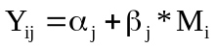 (1.1)
where
M_{i} is an intermediate value of M, e.g. M=3;
Y_{ij} is the value of the jth driving factor associated with the value M_{i} for the severity indicator; and
α_{j} and β_{j} are parameters deduced by passing a straight line through the (M,Y_{j}) points for the maximum and minimum values of M.
The next step in the construction of an ECAT is the choice of 100 values for M in the range [M_{min},M_{max}]. For each choice, the corresponding vector of driving factors is evaluated from (1.1). Together with each M choice, Rose et al. make random choices from a limited number of possibilities for dummy variables that introduce intensity levels for resilience and behavioral responses. In the aviation ECAT, for example, resilience refers to the extent (controlled by the resilience dummy) to which saved expenditure from reduced airline travel is switched to spending on alternative travel modes and general consumption. With Y and the related vectors of resilience and behavioral expenses treated as shocks, a CGE solution is obtained showing the effects on GDP and aggregate employment. Finally, the ECAT is specified as:
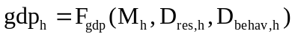 (1.2)
and
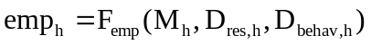 (1.3)
where
gdp_{h} and emp_{h} are the GDP and employment effects of an event of severity M_{h} with the resilience and behavioral response expenditure vectors scaled by dummies D_{res,h} and D_{behav,h}; and
F_{gdp} and F_{emp} are functions whose coefficients are determined by regressing the 100 GDP and employment results from the CGE solutions against the values for M and the dummies.
By applying (1.2) and (1.3), the GDP and employment effects of an event of the appropriate type (e.g. an aviation disruption) can be computed effortlessly after specifying the severity of the event (the M value) and the strength of the resilience and behavioral responses (the D_{res} and D_{behav} values).
The tool that we describe in this report differs from ECAT in 3 ways.
First, our approach is more general. It can be applied to any type of disaster that causes property damage, requires clean-up expenditures, requires health expenditures, etc. We don’t try to encapsulate these driving factors in a scalar measure and a limited number of resilience and behavioral dummies. Instead, the driving factors and responses can be in any configuration. This difference reflects the requirements of the TRA groups who need a tool which can handle flexibly any specified vector of shocks.
Second, we use a multi-regional CGE model. The ECATs have been created with national models (without regions). Reflecting the requirements of the TRA groups, the tool we have created can generate effects for national and regional variables of terrorism incidents specified by the congressional district in which they were perpetrated.
Third, we use a dynamic CGE model whereas the model underlying the ECATs is single period. By using a dynamic model we create a tool that shows effects in the short run (the year of the incident) and long run (notionally year 20). On a related matter, users of our tool can rank incidents according to their effects on economic welfare. To assess economic welfare we need a time-path of outcomes generated by a dynamic model. Calculation of GDP and employment effects for a single year, as in ECAT, is not an adequate basis for a welfare calculation.
In view of the pioneering status of ECAT and the similarities and differences between our approach and ECAT, we title the tool created here GRAD-ECAT (Generalized, Regional And Dynamic Economic Consequence Analysis Tool).
2. Computable General Equilibrium (CGE) modeling as an alternative to current TRA practice based on input-output (I-O) modeling
Current practice by the TRA groups is to link driving factors with economic implications via an I-O model. The TRA groups feed a subset of the driving factors, those concerned with expenditure, into an I-O model and compute outcomes for a limited subset of implication variables, national GDP and employment in year 1. Expenditures are the main focus because I-O models are essentially about working out the effects of expenditure changes, e.g. the effects of public expenditure on clean-up. The results from the I-O model then become part of C(j) in the equation:
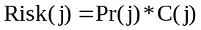 (2.1)
where
Pr(j) is an assessment by the TRA groups of the probability of event j occurring;
C(j) is a measure of the consequences of event j and includes results from the I-O model as well as components, such as fatalities, from the list (i) to (xiv); and
Risk(j) is the expected value of event j.
TRA practice is to rank events by their Risk value. The ranking then becomes a basis for prioritizing preventative policies.
I-O modeling has well known limitations. The most important of these are: (a) difficulties in handling constraints on the availability of resources such as labor, physical capital, government finance and foreign exchange; (b) lack of a time dimension; and (c) a narrow range of result variables that excludes important financial variables such as foreign liabilities.
All of the information in (i) to (xiv) can be fed into a CGE model. CGE models such as USAGE-TERM have detailed representations of resource constraints and produce annual time-series results for a wide range of variables. These cover all of the economic implication variables listed in section 1 and many others. Routine outputs from USAGE-TERM include:
- national macro variables such as GDP, employment, wage rates, aggregate private and public consumption, investment, exports, imports, the public sector deficit and foreign liabilities;
- employment in the target region (e.g. CA34, downtown LA), neighboring regions (e.g. rest of LA), rest of state (e.g. rest of California), and rest of U.S.;
- wages rates in these four regions; and
- industry outputs in these four regions.
The dynamic dimension allows capture of both an “immediate” effect in year 1 and summary measures of long-term dynamic effects. Typically we might expect to see the effects of economic stimulation in year 1 associated with immediate unfunded (deficit) public expenditure followed by subdued economic outcomes in later years arising from debt repayment and tight public-sector budgets.
Because of the potential advantages of CGE over I-O, the TRA groups commissioned this report as an investigation into the feasibility and desirability of replacing I-O with CGE as the link for connecting driving factors with economic implication variables.
3. The computational and security challenges: the elasticity solution
Computing solutions for detailed dynamic CGE models such as USAGE-TERM is non-trivial. For example, a 4-region, 23-industry, 20-year simulation with USAGE-TERM takes about 6 minutes on an advanced desktop computer. This rules out the possibility of undertaking a separate USAGE-TERM simulation for each of the TRAs thousands of hypothetical scenarios.
Another problem is that solving CGE models is not routine. Considerable experience is required to successfully carry out computations, interpret them and to check their validity. Consequently, as a practical matter it is efficient to largely outsource CGE computations to specialists in the field. But this raises a problem of security. Specialist CGE modelers are unlikely to have security clearances that would give them access to the details of the terrorism scenarios that are being considered by the TRA groups.
As set out in this report, we solve both problems by using USAGE-TERM to provide estimates of elasticity coefficients of the form E(s,d,v). The s argument in these coefficients refers to the driving factor, one of the 14 factors in the first list in section 1. In economic modeling jargon, s is the shock variable: capital destruction; clean-up expenditure; etc. The d argument refers to the target region. This is the congressional district in which the shock takes place. For this study, we include the 170 congressional districts of interest to the TRA groups, that is districts located in cities of sufficient size to be potential terrorism targets. The v argument refers to an economic implication variable, one of the ten in the second list in section 1. Thus, E(s,d,v) is the elasticity of variable v with respect to a shock of type s occurring in region d. For example, E(s,d,v) could be the elasticity of GDP in year 1(v) with respect to destruction of capital (s) in California congressional district 34 (d).
We provide 2 sets of elasticities calculated under different assumptions: Keynesian and Neoclassical. Keynesian assumptions are suitable if there are high levels of unemployment and under-utilization of capital in the year of the terrorism event. With normal levels of employment and capital utilization, Neoclassical assumptions are suitable. Our view is that Neoclassical assumptions would be suitable for events happening in 2015 or 16. The difference between the two assumptions is that expenditures (e.g. clean-up) undertaken in an underemployed economy are less costly in terms of economic welfare than expenditures undertaken in an economy with normal levels of employment. In an underemployed economy, the opportunity cost of devoting resources to clean-up etc is lower than in an economy with normal employment.
Each of the sets of elasticities E(s,d,v) contains 23,800 components: a three dimensional array with 14 s values (the types of shocks); 170 d values (the congressional districts of interest); and 10 v values (the implication variables). For any given scenario, the TRA groups can calculate the approximate values for the 10 implication variables by picking the appropriate elasticities and carrying out the computation:
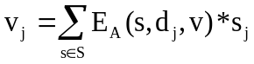 for all v∈V (3.1)
In this equation A refers to the assumption of Keynesian or Neoclassical conditions and j refers to the scenario under examination. V is the set of implication variables and v_{j} is the outcome in scenario j for variable v in V, that is the effect on GDP in year 1, etc. S is the set of shock types, that is capital destruction, etc. s_{j} is the shock applied to driving variable s in scenario j, e.g. 15 per cent capital destruction in the target region. d_{j} is the congressional district in which the scenario-j event takes place.
Equation (3.1) solves the computational problem. The computation required by the TRA groups to evaluate the effects of any given scenario j is trivial and can be performed in nanoseconds. All of the difficult CGE modeling and computations are pre-performed by the CGE specialists in the estimation of the E’s. The TRA groups simply receive the E coefficients.
Equation (3.1) also solves the security problem. The CGE team never needs to know the nature of the terrorism incidents under consideration or the values of the shocks, s_{j}.
As explained in detail in section 6 and appendix 1, we estimate the E coefficients by applying shocks in the CGE model and recording the outcomes for the economic implication variables listed in section 1. Thus, equation (3.1) is a first-order approximation of the true solution from the CGE model. Simplifying the CGE calculation of the effects of any scenario j to a set of 10 linear reduced-form equations (one for each of the 10 implication variables) comes at a cost. In equation (3.1) the elasticities E(s,d,v) are treated as parameters, whereas in the CGE model they are variables. We return to this topic in the conclusion where we consider future research directions. This report concentrates on the already quite difficult problem of obtaining central values for the E coefficients.
4. USAGE-TERM, a flexible bottom-up regional model of the U.S.
This section describes USAGE-TERM, the CGE model through which we estimate the elasticity coefficients required for equation (3.1). USAGE is an acronym for U.S. Applied General Equilibrium. TERM is an acronym for The Enormous Regional Model. Thus USAGE-TERM is a version of the USAGE model with enhanced regional detail.
4.1. The USAGE model
USAGE is a 400 industry, dynamic, CGE model of the U.S. economy. It has been created over the last 15 years at the Centre of Policy Studies (CoPS), Victoria University, in collaboration with the U.S. International Trade Commission. The model has been used by and on behalf of the U.S. International Trade Commission, the U.S. Departments of Commerce, Agriculture, Energy, Transportation and Homeland Security as well as private sector organizations such as the Cato Institute and the Mitre Corporation. Applications of the model involve preparation of baseline forecasts and analyses of a variety of issues including the effects of: trade policies; environmental regulations; carbon taxes; energy security; illegal immigration; road infrastructure; Next-Gen aviation infrastructure expenditures; the Obama stimulus package; the National Export Initiative; an H1N1 epidemic; and security-related port closures.
USAGE is essentially a national model, although it does have a facility for disaggregating national results in a top-down fashion to the 50 states and the District of Columbia. This facility is effective for working out the regional implications of national policies which are unlikely to have a significantly different effect on costs of production in one state compared with other states. A legitimate application of the top-down facility is the U.S. International Trade Commission’s analysis of the effects on the state economies of changes in import restraints (tariffs and quotas). However, a limitation of the top-down facility is that it is unsuitable for projecting the effects of policies and other shocks (including terrorism events) that are initiated at the regional level and affect costs in one region relative to those in other regions.
4.2. USAGE-TERM
To overcome this limitation, the CoPS team with considerable support from Adam Rose and colleagues at CREATE, have developed a series of bottom-up regional versions of USAGE. All of these are in the family of TERM models developed initially by CoPS for Australia.
The first USAGE-TERM model was created in 2011. This version identified the 50 states plus the District of Columbia. It treated these 51 regions as highly integrated economies connected by: trade; factor movements; and a common currency. In this version, policies such as carbon taxes levied at the state level cause changes in production costs in one state relative to those in others, and lead to changes in trade and factor flows. This allows assessments of the costs and benefits to states of state policies.
The initial version of USAGE-TERM was comparative static. In 2012-13 the model was given a dynamic dimension similar to that in the national USAGE model. Thus it became capable of tracing out effects of a shock over a number of years.
In 2013-14 we extended the regional detail from the state to the county level. This work was motivated by wanting to improve the capabilities of USAGE-TERM for modeling terrorism shocks and other disruptive events. These events occur at a localized level, often well below the state level. Thus, for analyzing such events, extending the USAGE-TERM capability to the county level is an important enhancement. We also created the version of USAGE-TERM, used in this report, in which the identified regions are the 436 congressional districts.
The key data requirements for these regional versions of USAGE are jobs matrices in which the components, J(j,r), are the number of jobs in industry j in region r. For the county version of USAGE-TERM, the main source for jobs estimates is county data for about 400 industries from the 2010 Census. For the congressional district version we also use the county data. Most congressional districts are an aggregation of counties. For these districts we derived jobs data by addition. However in some western states, counties are large and encompass several congressional districts. For these congressional districts we estimated jobs using county data with its detailed industry coverage supplemented by congressional district data available in the Census for 13 broad industries. The 13 industry coverage for congressional districts is in http://www2.census.gov/acs2011_1yr/CD113/ . For congressional districts that are contained within a county but are only part of it, we converted the 13 industries into the USAGE 400 industries by assuming that the detailed industry breakdown within each of the 13 industries is the same as that in the county to which the congressional district belongs. For a congressional district that lies across county borders, we allocated the 13 industry data for the congressional district to the relevant counties taking account of the location of cities and rural areas. Then we split the allocated 13 industry data for each of the relevant counties to the 400 level as above. Finally, we combined the 400 level data from the relevant counties to form the 400 industry breakdown for the cross-county congressional district.
Another important data requirement for regional versions of USAGE is interregional trade flows. For each region and each commodity we can estimate net trade flows from data on output and absorption (use of the commodity within the region). Then applying a modified gravity formula, initially devised by Mark Horridge (see Dixon et al., 2007a), we estimate interregional trade flows that are consistent with our estimates of net trade flows. These interregional trade estimates take into account: the tradability of commodities; home bias (the tendency to buy the local variety); and distance between supplying and consuming regions.
4.3. Coping with huge dimensions via flexible aggregation
The county version of USAGE-TERM has potentially huge dimensions: 500 industries in 3,000 counties supplying their products to 400 industries and final users in 3,000 counties. The dimensionality problem is reduced for the congressional district version where the regional dimension is 436. Nevertheless, even for the congressional district version, computations at full dimension are impractical, and even if they could be carried out, the interpretation of the results would be unnecessarily time consuming. To address this problem, CoPS has developed a flexible aggregation program that allows model users to specify the regions and industries of interest. The program then aggregates the full-dimension master database and creates a version of USAGE-TERM in which only the regions and industries of interest are identified.
4.4. Simulations, baseline runs and perturbation runs
As is the case with USAGE, a simulation with the USAGE-TERM model consists of two runs: a baseline run and a perturbation run. The baseline run is intended to be a business-as-usual forecast. It incorporates macro forecasts and forecasts for energy variables obtained from the Energy Information Administration’s publication entitled Annual Energy Outlook. We also build in trends in technology and consumer preferences. The perturbation run shows an alternative forecasts that includes an additional change in the economic environment. Usually this is a policy change, but here it is a terrorism incident. Consequently, we will sometimes refer to the perturbation run as the terrorism run. Comparison of the terrorism and baseline runs shows the economic effects of the terrorism incident.
5. Measuring the welfare effects of a terrorism incident
Economic implication variables 1 to 8 listed in section 1 refer to GDP and employment for the nation and for the target region in the short- and long-runs. GDP and employment are well understood variables and their measurement is relatively uncontroversial. Perhaps all that needs to be mentioned is that we measure employment in wagebill terms, that is, the loss of a job counts twice as heavily when it occurs in an occupation with wage rate 2 than when it occurs in an occupation with wage rate 1. In our simulations of the effects of terrorism we have found that here is little difference in the movements of the wagebill index for employment and the job-count index.
By contrast, implication variables 9 and 10, the two measures of welfare, need a full explanation.
In all our simulations the terrorism incident under examination takes place in 2015. We call this year 1. The simulations then cover the period out to 2034, year 20. We measure welfare in terms of present value in 2014, year zero. As discussed below, there are differing views on the discount rate appropriate in calculating present values. We define two welfare measures: one with a discount rate of 5 per cent and the other with a discount rate of 2 per cent.
A terrorism incident perpetrated in year 1 changes the path of the economy through all future years. Depending on the nature of the incident, there will be changes in public expenditures, changes in investment requirements and changes in foreign debt. Typically we would expect a serious incident to cause an initial blow-out in public expenditures followed by contraction as public and foreign debt is reined in. Our problem is to summarize these dynamic effects into a welfare number for each incident. This is necessary if we are to compare and rank incidents.
In popular discussions, GDP effects are often mentioned as if they are indicators of welfare. GDP is a measure of output. A terrorism incident requiring an intensive rebuilding program could increase GDP. But before we draw the conclusion that there is an associated increase in economic welfare, we need to consider the extent to which the rebuilding program draws capital and labor away from the production of goods and services that give people pleasure.
This consideration leads us to focus on private consumption as the central component in measuring welfare. But what aspects of private consumptions should be included and excluded, and what about public consumption?
For assessing the welfare effects of a terrorism incident we decided to exclude private expenditures on health and relocation from our welfare-relevant measure of consumption. Thus, we capture the idea that a terrorism event which imposes additional health and relocation costs on households is, on this account, welfare reducing. It causes households to divert expenditure away from things that give pleasure towards rehabilitation spending. This diversion might be immediate if households finance the expenditures or it might be delayed if the expenditures are subsidized by the government and paid for later by households through tighter macro policy necessitated by debt reduction. However the timing of the diversion doesn’t make any difference to the decision to exclude from welfare household rehabilitations expenditures that wouldn’t have taken place in the absence of the incident.
In general, there is a case for including public expenditure in measures of welfare. However, here we exclude it. In regions outside the target city we assume that terrorism events cause the same percentage deviation in public expenditure as in private expenditure. Under this assumption, the inclusion of public expenditure would make no difference to our calculation of welfare rankings. In the target city, we allow for public rehabilitation expenditures. As with private rehabilitation expenditures these should be excluded from welfare.
Remaining issues are distribution, timing (dynamics) and loss of life. On distribution, we have adopted a utilitarian approach. We don’t distinguish between a dollar of lost consumption for a rich household and a poor household. This is more a necessity than a carefully chosen assumption: our present model treats households in each region as a single entity.
On timing, the issue comes down to the discount rate and the terminal conditions. On the discount rate, there are arguments in the literature suggesting rates anywhere between 1 and 15 per cent. The U.S. Office of Management and Budget favors the use of U.S. bond rates as discount rates. Given the uncertainty surrounding the appropriate choice, we decided to produce results for two rates: 5 per cent which we consider a high rate and 2 per cent which we consider a low rate. A discount rate of 5 per cent means that the loss of $1 of consumption next year is equivalent to the loss of $0.95 this year while a discount rate of 2 per cent means that the loss of $1 of consumption next year is equivalent to the loss of $0.98 this year. Terminal conditions are necessary because computations must be finite. As mentioned earlier, we end the computations at year 20, 2034. At the end of year 20, we must take account of how the terrorism incident in year 1 has affected the stock of U.S. wealth. If this stock is lower at the end of year 20 in the terrorism run than in the baseline run, then this is a welfare loss additional to that associated with reductions in consumption in years 1 to 20. We measure the stock of U.S. wealth by the value of physical assets in the U.S. (buildings, machines, houses, infrastructure) less U.S. net foreign liabilities. For inclusion in our welfare measure, the stock of wealth is adjusted for inflation (that is we consider real wealth) and we also apply a time-preference discount rate of either 5 per cent or 2 per cent a year, giving a discount factor for real wealth held at the end of year 20 of 0.341 or 0.651 (= 0.95^21 or 0.98^21, which discounts from the end of year 20 to the start of year 0).
The final factor in our welfare measure is an allowance for death. Our modeling already takes account of lost output associated with reduced labor supply. What we have in mind here is pain and suffering for surviving family members. We have assumed $9.6 million per death. This is the number recommended by the Chief Regulatory Economist at DHS. As discussed below, it is relatively simple to check the sensitivity of welfare results to the assumed value for death. Re-computation of USAGE-TERM solutions is not required.
In mathematical terms we measure the welfare effect of a terrorism incident occurring in 2015 according to the formula
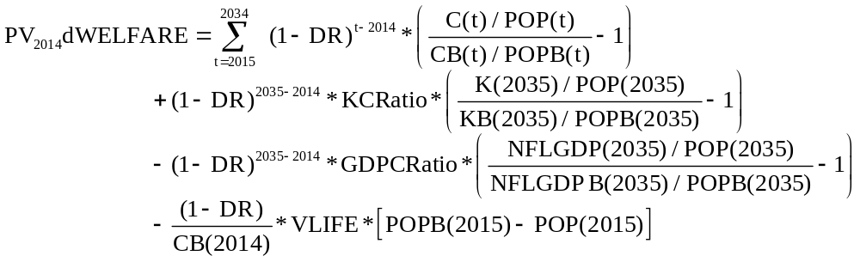 (5.1)
In this formula, the LHS is the present value in 2014 of welfare changes caused by the terrorism incident. The first term on the RHS is the present value of the deviations in private consumption per capita from 2015 to 2034 caused by the incident in 2015. This is calculated by comparing for each year t the consumption level per capita in the terrorism run, C(t)/POP(t), with the consumption level per capita in the baseline run, CB(t)/POPB(t). C(t) and CB(t) are index numbers for real private consumption, excluding rehabilitation expenditures. POP(t) and POPB(t) are population numbers. The per capita consumption deviations are discounted back to 2014 (year 0). DR is the discount rate, set at either 0.05 or 0.02.
The second term on the RHS allows for the terminal deviation in the capital stock per capita. The deviation is calculated by comparing the quantity of U.S. capital per capita in 2035 in the terrorism run, K(2035)/POP(2035), with the quantity per capita in the baseline, KB(2035)/POPB(2035). This is turned into units that are comparable with consumption by multiplying by the ratio of the value of capital stock to consumption in 2014, KCRatio. Finally we discount back to 2014 by applying the factor (1-DR)∧21.
The third term on the RHS allows for the terminal deviation in net foreign liabilities per capita. The variable we use is net foreign liabilities per capita expressed as a ratio of GDP. We compare this ratio in 2035 in the terrorism run, NFLGDP(2035)/POP(2035), with the ratio in the baseline run, NFLGDPB(2035)/POPB(2035). To convert to consumption units we multiply by the ratio of GDP to consumption in 2014, GDPCRatio. Again we discount back to 2014 by applying the factor (1-DR)∧21.
The last term on the RHS of (1) allows for deaths. We assume that these take place in 2015 and are measured by POPB(2015) minus POP(2015). The number of deaths is multiplied by the value of life, VLIFE. This product is expressed as a fraction of consumption in 2014 and discounted back one year to 2014.
As mentioned earlier, we set VLIFE at $9.6 million. The effect on welfare results of varying this number can be worked out without reference to USAGE-TERM. For example, if we wanted to set VLIFE at $7.7m with DR = 0.05, then we would modify welfare results based on VLIFE = $9.6m and DR = 0.05 according to:
Welfare(DR=0.05,VLIFE = 7.7) = Welfare(DR=0.05,VLIFE = 9.6)
+ 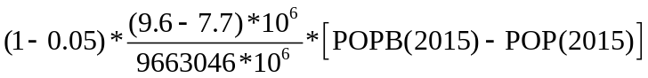 (5.2)
In (5.2), 9663046 *10⁶ is the value of CB(2014).
Given the form of (5.1), what interpretation should be attached to a simulation that produces the result:
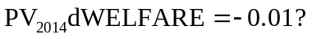 (5.3)
We should think of this as implying that the economic damage caused by the terrorism incident being examined is equivalent to a loss of 1 per cent of welfare-generating consumption in 2014. Looked at like this, we can see that (5.1) is a similar approach to measuring welfare as Compensating Variation (CV) and Equivalent Variation (EV). These measures summarize the welfare effect of a change in the economic environment by calculating what would be a comparable loss of money or income that could otherwise have been devoted to pleasure-generating consumption (utility). For example, we would need a 1 per cent boost in the present value of income to allow us to increase consumption and wealth sufficiently to compensate for the damage encapsulated in (5.3).

6. Estimating of the elasticity coefficients, E_{A}(s,d,v), using USAGE-TERM
From a conceptual point of view, the most obvious method for estimating the E coefficients is to set up a 436-region version of USAGE-TERM and then perform 14 by 170 by 2 simulations: 14 shocks applied to 170 regions of interest by 2 sets of assumptions (Keynesian or Neoclassical). Results from these simulations could be recorded for our 10 economic implication variables. Elasticities would then be formed by dividing results by shocks. For this project we have chosen to work at a 23-industry level with the solution covering 20 years. Even with this quite high level of industry aggregation and with time truncated to 20 years, computation with a 436-region model is infeasible. Consequently to estimate the elasticities for equation (3.1), we must find a different way of handling the regional dimension.
The next method we considered was to create 170 4-region models, each identifying one of the 170 congressional districts of interest as a target region together with 3 other regions that we refer to as Rest of city, Rest of state and Rest of U.S. Then, with each of the 170 models we could conduct 28 simulations (14 under each of 2 assumptions) to determine elasticities of the 10 economic implication variables with respect to the shocks. Computations with the first model would reveal E_{A}(s,1,v) for both As and all s and v. Computations with the second model would reveal E_{A}(s,2,v), and so on. In this way, we could build up estimates of E_{A}(s,d,v) for each of the 170 values of d. Computations with a 23-industry, 4-region, 20-year model are relatively straightforward. However, we judged that it would be unmanageable to build 170 models each with 4 regions, 23 industries and 20 years and then process the outputs from 28 simulations with each model. This approach would involve about 190 thousand annual solutions which, inevitably, would need to be repeated many times in the process of ironing out bugs and moving to a usable set of elasticities.
This brought us to a third method, and the one that we implemented. Instead of creating 170 4-region models, we created only 4 such models. As explained in the next subsection, we use results from these 4 models to generate elasticity estimates for terrorism incidents in all 170 congressional districts of interest.
The target congressional districts in our 4 USAGE-TERM models are FL24 in Miami, AZ07 in Phoenix, NY14 in New York and WA09 in Seattle. We judged that this selection gives a reasonable coverage of U.S. city types: medium to large; east coast, west coast and central. In each of our 4 models we used a distance algorithm to determine the congressional districts that make up “Rest of city”, “Rest of State” and “Rest of U.S.” Rest of city consists of those congressional districts, excluding the target region, whose geographic centre is no more than 25 miles from that of the target region. Together the target region and the Rest of city form the Target city. In most cases, Rest of state consists of those congressional districts whose geographic center is between 25 and 150 miles from that of the target region. All other congressional districts form Rest of U.S. We made an exception to the rule for Rest of state in the densely populated North east of the U.S. There, Rest of state is the set of congressional districts whose geographic centre is between 25 and 75 miles from that of the target region. Application of these rules leads to the definitions in Table 6.1. As can be seen from the Table, there are some cases in which there is no Rest of city: the target region and the Target city are the same. For these cases our 4-region model would have only 3 regions.
Table 6.1. Target congressional districts of interest with corresponding congressional districts in Rest of city and Rest of state
 | Target  region | Rest of city | Rest of state
1 | AL06 |  | AL01 AL02 AL03 AL04 AL05 AL07 FL01 GA02 GA03 GA04 GA05 GA06 GA07 GA11 GA13 GA14 MS01 TN04 TN05 TN07
2 | AZ02 |  | AZ03 AZ05 AZ06 AZ07 AZ08 AZ09
3 | AZ05 | AZ06 AZ07 AZ09 | AZ01 AZ02 AZ03 AZ04 AZ08
4 | AZ06 | AZ05 AZ07 AZ08 AZ09 | AZ01 AZ02 AZ03 AZ04
5 | AZ07 | AZ05 AZ06 AZ08 AZ09 | AZ01 AZ02 AZ03 AZ04
6 | AZ08 | AZ06 AZ07 AZ09 | AZ01 AZ02 AZ03 AZ04 AZ05
7 | AZ09 | AZ05 AZ06 AZ07 AZ08 | AZ01 AZ02 AZ03 AZ04
8 | CA06 | CA07 | CA01 CA02 CA03 CA04 CA05 CA09 CA10 CA11 CA12 CA13 CA14 CA15 CA16 CA17 CA18 CA19 CA20 CA21 CA22
9 | CA07 | CA06 CA09 | CA01 CA02 CA03 CA04 CA05 CA10 CA11 CA12 CA13 CA14 CA15 CA16 CA17 CA18 CA19 CA20 CA21 CA22
10 | CA08 |  | CA22 CA23 CA25 CA26 CA27 CA28 CA29 CA30 CA31 CA32 CA33 CA34 CA35 CA36 CA37 CA38 CA39 CA40 CA41 CA42 CA43 CA44 CA45 CA46 CA47 CA48 CA49 CA50 CA51 CA52 CA53 NV01 NV03 NV04
11 | CA09 | CA07 CA10 | CA01 CA02 CA03 CA04 CA05 CA06 CA11 CA12 CA13 CA14 CA15 CA16 CA17 CA18 CA19 CA20 CA21 CA22
12 | CA10 | CA09 | CA03 CA04 CA05 CA06 CA07 CA11 CA12 CA13 CA14 CA15 CA16 CA17 CA18 CA19 CA20 CA21 CA22 CA24
13 | CA11 | CA12 CA13 CA15 CA17 | CA01 CA02 CA03 CA04 CA05 CA06 CA07 CA09 CA10 CA14 CA16 CA18 CA19 CA20 CA21 CA22
14 | CA12 | CA11 CA13 CA14 | CA02 CA03 CA04 CA05 CA06 CA07 CA09 CA10 CA16 CA18 CA19 CA20 CA21
15 | CA13 | CA11 CA12 CA14 CA15 CA17 | CA02 CA03 CA04 CA05 CA06 CA07 CA09 CA10 CA16 CA18 CA19 CA20 CA21
16 | CA14 | CA12 CA13 | CA02 CA03 CA04 CA05 CA06 CA07 CA09 CA10 CA11 CA15 CA16 CA17 CA18 CA19 CA20
17 | CA15 | CA11 CA13 CA17 | CA02 CA03 CA04 CA05 CA06 CA07 CA09 CA10 CA12 CA14 CA16 CA18 CA19 CA20 CA21 CA22
18 | CA16 |  | CA03 CA04 CA05 CA06 CA07 CA09 CA10 CA11 CA12 CA13 CA14 CA15 CA17 CA18 CA19 CA20 CA21 CA22 CA23 CA24
19 | CA17 | CA11 CA13 CA15 CA18 CA19 | CA03 CA04 CA05 CA06 CA07 CA09 CA10 CA12 CA14 CA16 CA20 CA21 CA22
20 | CA19 | CA17 | CA03 CA04 CA05 CA06 CA07 CA09 CA10 CA11 CA12 CA13 CA14 CA15 CA16 CA18 CA20 CA21 CA22 CA24
Table 6.1 continues …
… Table 6.1 continued
 | Target  region | Rest of city | Rest of state
21 | CA23 |  | CA04 CA08 CA16 CA20 CA21 CA22 CA24 CA25 CA26 CA27 CA28 CA29 CA30 CA31 CA32 CA33 CA34 CA35 CA37 CA38 CA39 CA40 CA41 CA42 CA43 CA44 CA45 CA46 CA47 CA48 CA49
22 | CA27 | CA25 CA28 CA29 CA32 CA34 CA35 CA38 CA39 CA40 CA46 | CA08 CA21 CA22 CA23 CA24 CA26 CA30 CA31 CA33 CA36 CA37 CA41 CA42 CA43 CA44 CA45 CA47 CA48 CA49 CA50 CA51 CA52 CA53
23 | CA28 | CA25 CA27 CA29 CA30 CA32 CA34 CA37 CA38 CA40 CA43 CA44 | CA08 CA21 CA22 CA23 CA24 CA26 CA31 CA33 CA35 CA36 CA39 CA41 CA42 CA45 CA46 CA47 CA48 CA49 CA50 CA52 CA53
24 | CA29 | CA25 CA27 CA28 CA30 CA33 CA34 CA37 CA38 CA40 CA43 CA44 | CA08 CA21 CA22 CA23 CA24 CA26 CA31 CA32 CA35 CA36 CA39 CA41 CA42 CA45 CA46 CA47 CA48 CA49 CA50 CA52 CA53
25 | CA30 | CA25 CA28 CA29 CA33 CA34 CA37 CA40 CA43 CA44 | CA08 CA21 CA22 CA23 CA24 CA26 CA27 CA31 CA32 CA35 CA36 CA38 CA39 CA41 CA42 CA45 CA46 CA47 CA48 CA49 CA50 CA52 CA53
26 | CA31 | CA35 CA41 CA42 | CA08 CA23 CA24 CA25 CA26 CA27 CA28 CA29 CA30 CA32 CA33 CA34 CA36 CA37 CA38 CA39 CA40 CA43 CA44 CA45 CA46 CA47 CA48 CA49 CA50 CA51 CA52 CA53 NV01 NV03
27 | CA32 | CA27 CA28 CA34 CA35 CA37 CA38 CA39 CA40 CA43 CA44 CA45 CA46 CA48 | CA08 CA21 CA22 CA23 CA24 CA25 CA27 CA28 CA31 CA32 CA34 CA35 CA38 CA39 CA40 CA41 CA42 CA44 CA45 CA46 CA47 CA48 CA49 CA50 CA52 CA53
28 | CA33 | CA26 CA29 CA30 CA37 CA43 | CA08 CA21 CA22 CA23 CA24 CA25 CA27 CA28 CA31 CA32 CA34 CA35 CA38 CA39 CA40 CA41 CA42 CA44 CA45 CA46 CA47 CA48 CA49 CA50 CA52 CA53
29 | CA34 | CA27 CA28 CA29 CA30 CA32 CA37 CA38 CA39 CA40 CA43 CA44 CA46 | CA08 CA21 CA22 CA23 CA24 CA25 CA26 CA31 CA33 CA35 CA36 CA41 CA42 CA45 CA47 CA48 CA49 CA50 CA51 CA52 CA53
30 | CA35 | CA27 CA31 CA32 CA38 CA39 CA41 CA45 CA46 | CA08 CA23 CA24 CA25 CA26 CA28 CA29 CA30 CA33 CA34 CA36 CA37 CA40 CA42 CA43 CA44 CA47 CA48 CA49 CA50 CA51 CA52 CA53 NV03
31 | CA36 |  | AZ04 CA08 CA25 CA27 CA28 CA29 CA30 CA31 CA32 CA34 CA35 CA37 CA38 CA39 CA40 CA41 CA42 CA43 CA44 CA45 CA46 CA47 CA48 CA49 CA50 CA51 CA52 CA53 NV01 NV03
32 | CA37 | CA28 CA29 CA30 CA32 CA33 CA34 CA38 CA40 CA43 CA44 | CA08 CA21 CA22 CA23 CA24 CA25 CA26 CA27 CA31 CA35 CA36 CA39 CA41 CA42 CA45 CA46 CA47 CA48 CA49 CA50 CA52 CA53
33 | CA38 | CA27 CA28 CA29 CA32 CA34 CA35 CA37 CA39 CA40 CA43 CA44 CA45 CA46 CA48 | CA08 CA21 CA22 CA23 CA24 CA25 CA26 CA30 CA31 CA33 CA36 CA41 CA42 CA47 CA49 CA50 CA51 CA52 CA53
34 | CA39 | CA27 CA32 CA34 CA35 CA38 CA40 CA44 CA45 CA46 CA48 | CA08 CA21 CA22 CA23 CA24 CA25 CA26 CA28 CA29 CA30 CA31 CA33 CA36 CA37 CA41 CA42 CA43 CA47 CA49 CA50 CA51 CA52 CA53
Table 6.1 continues …

… Table 6.1 continued
 | Target  region | Rest of city | Rest of state
35 | CA41 | CA31 CA35 CA42 CA45 | CA08 CA23 CA24 CA25 CA26 CA27 CA28 CA29 CA30 CA32 CA33 CA34 CA36 CA37 CA38 CA39 CA40 CA43 CA44 CA46 CA47 CA48 CA49 CA50 CA51 CA52 CA53 NV03
36 | CA43 | CA28 CA29 CA30 CA32 CA33 CA34 CA37 CA38 CA40 CA44 CA46 | CA08 CA21 CA22 CA23 CA24 CA25 CA26 CA27 CA31 CA35 CA36 CA39 CA41 CA42 CA45 CA47 CA48 CA49 CA50 CA51 CA52 CA53
37 | CA44 | CA28 CA29 CA30 CA32 CA34 CA37 CA38 CA39 CA40 CA43 CA46 CA48 | CA08 CA21 CA22 CA23 CA24 CA25 CA26 CA27 CA31 CA33 CA35 CA36 CA41 CA42 CA45 CA47 CA49 CA50 CA51 CA52 CA53
38 | CA46 | CA27 CA32 CA34 CA35 CA38 CA39 CA40 CA43 CA44 CA45 CA48 | CA08 CA23 CA24 CA25 CA26 CA28 CA29 CA30 CA31 CA33 CA36 CA37 CA41 CA42 CA47 CA49 CA50 CA51 CA52 CA53
39 | CA47 |  | CA08 CA23 CA24 CA25 CA26 CA27 CA28 CA29 CA30 CA31 CA32 CA33 CA34 CA35 CA36 CA37 CA38 CA39 CA40 CA41 CA42 CA43 CA44 CA45 CA46 CA48 CA49 CA50 CA51 CA52 CA53
40 | CA48 | CA32 CA38 CA39 CA40 CA44 CA45 CA46 | CA08 CA23 CA24 CA25 CA26 CA27 CA28 CA29 CA30 CA31 CA33 CA34 CA35 CA36 CA37 CA41 CA42 CA43 CA47 CA49 CA50 CA51 CA52 CA53
41 | CA52 | CA53 | CA08 CA25 CA26 CA27 CA28 CA29 CA30 CA31 CA32 CA33 CA34 CA35 CA36 CA37 CA38 CA39 CA40 CA41 CA42 CA43 CA44 CA45 CA46 CA47 CA48 CA49 CA50 CA51
42 | CA53 | CA52 | CA08 CA25 CA26 CA27 CA28 CA29 CA30 CA31 CA32 CA33 CA34 CA35 CA36 CA37 CA38 CA39 CA40 CA41 CA42 CA43 CA44 CA45 CA46 CA47 CA48 CA49 CA50 CA51
43 | CO01 | CO06 CO07 | CO02 CO03 CO04 CO05
44 | CO05 |  | CO01 CO02 CO03 CO04 CO06 CO07 NM03
45 | DC98 | MD03 MD04 MD07 VA08 VA11 | MD01 MD02 MD05 MD08 NC01 PA04 PA07 PA16 VA01 VA02 VA03 VA04 VA05 VA06 VA07 VA10
46 | FL04 |  | FL02 FL03 FL05 FL06 FL07 FL08 FL09 FL10 FL11 FL12 FL13 FL14 FL15 GA01 GA02 GA08 GA12 SC01
47 | FL09 |  | FL03 FL04 FL05 FL06 FL07 FL08 FL10 FL11 FL12 FL13 FL14 FL15 FL16 FL17 FL18 FL19 FL20 FL21 FL22 FL23 FL24 FL25 FL26 FL27
48 | FL10 |  | FL03 FL04 FL05 FL06 FL07 FL08 FL09 FL11 FL12 FL13 FL14 FL15 FL16 FL17 FL18 FL19 FL20 FL21 FL22 FL23 FL25 GA01
49 | FL23 | FL21 FL22 FL24 | FL07 FL08 FL09 FL10 FL13 FL14 FL15 FL16 FL17 FL18 FL19 FL20 FL25 FL26 FL27
50 | FL24 | FL23 FL27 | FL07 FL08 FL09 FL14 FL15 FL16 FL17 FL18 FL19 FL20 FL21 FL22 FL25 FL26
Table 6.1 continues …
… Table 6.1 continued
 | Target  region | Rest of city | Rest of state
51 | FL27 | FL24 | FL08 FL09 FL16 FL17 FL18 FL19 FL20 FL21 FL22 FL23 FL25 FL26
52 | GA04 | GA05 GA06 GA07 | AL02 AL03 AL05 AL06 GA02 GA03 GA08 GA09 GA10 GA11 GA12 GA13 GA14 NC10 NC11 SC02 SC03 SC04 TN01 TN02 TN03
53 | GA05 | GA04 GA06 GA07 GA13 | AL02 AL03 AL04 AL05 AL06 GA02 GA03 GA08 GA09 GA10 GA11 GA12 GA14 NC11 SC03 SC04 TN01 TN02 TN03 TN04 TN06
54 | GA06 | GA04 GA05 GA07 GA11 GA13 | AL02 AL03 AL04 AL05 AL06 GA02 GA03 GA08 GA09 GA10 GA12 GA14 NC11 SC02 SC03 SC04 TN01 TN02 TN03 TN04 TN06
55 | GA07 | GA04 GA05 GA06 | AL03 AL05 AL06 GA02 GA03 GA08 GA09 GA10 GA11 GA12 GA13 GA14 NC10 NC11 SC02 SC03 SC04 TN01 TN02 TN03 TN04 TN06
56 | ID02
57 | IL01 | IL02 IL03 IL04 IL05 IL07 IL11 | IL06 IL08 IL09 IL10 IL13 IL14 IL15 IL16 IL17 IL18 IN01 IN02 IN03 IN04 IN05 IN07 IN08 MI02 MI03 MI06 WI01 WI02 WI04 WI05 WI06
58 | IL02 | IL01 IL03 | IL06 IL10 IL13 IL14 IL15 IL16 IL17 IL18 IN01 IN02 IN03 IN04 IN05 IN07 MI02 MI03 MI06 WI01 WI02 WI04 WI05 WI06
59 | IL03 | IL01 IL02 IL04 IL05 IL07 IL08 IL09 IL11 | IL06 IL10 IL13 IL14 IL15 IL16 IL17 IL18 IN01 IN02 IN03 IN04 IN05 IN07 MI02 MI03 MI06 WI01 WI02 WI04 WI05 WI06
60 | IL05 | IL01 IL03 IL04 IL06 IL07 IL08 IL09 IL10 IL11 | IL02 IL13 IL14 IL16 IL17 IL18 IN01 IN02 IN03 IN04 IN05 IN07 MI02 MI03 MI06 WI01 WI02 WI04 WI05 WI06 WI08
61 | IL06 | IL05 IL08 IL09 IL10 IL14 | IL01 IL02 IL03 IL04 IL07 IL11 IL13 IL16 IL17 IL18 IN01 IN02 IN04 MI02 MI06 WI01 WI02 WI04 WI05 WI06 WI08
62 | IL07 | IL01 IL03 IL04 IL05 IL08 IL09 IL10 IL11 | IL02 IL06 IL13 IL14 IL16 IL17 IL18 IN01 IN02 IN03 IN04 IN05 IN07 MI02 MI03 MI06 WI01 WI02 WI04 WI05 WI06 WI08
63 | IL11 | IL01 IL03 IL04 IL05 IL07 IL08 IL14 | IL02 IL06 IL09 IL10 IL13 IL15 IL16 IL17 IL18 IN01 IN02 IN03 IN04 IN05 IN07 MI02 MI06 WI01 WI02 WI04 WI05 WI06
64 | IN03 |  | IL01 IL02 IL03 IL04 IL05 IL07 IL09 IL10 IL11 IN01 IN02 IN04 IN05 IN06 IN07 IN09 KY03 KY04 MI02 MI03 MI04 MI06 MI07 MI08 MI09 MI11 MI12 MI13 MI14 OH01 OH02 OH03 OH04 OH05 OH07 OH08 OH09 OH10 OH12 OH15
65 | IN04 |  | IL01 IL02 IL03 IL04 IL05 IL06 IL07 IL08 IL09 IL10 IL11 IL13 IL14 IL15 IL16 IN01 IN02 IN03 IN05 IN06 IN07 IN08 IN09 KY02 KY03 MI03 MI06 OH01 OH04 OH05 OH08 OH10 WI01 WI04
66 | KS04 |  | KS01 KS02 OK01 OK03 OK04 OK05
Table 6.1 continues …
… Table 6.1 continued
 | Target  region | Rest of city | Rest of state
67 | KY03 |  | IL15 IN03 IN04 IN05 IN06 IN07 IN08 IN09 KY01 KY02 KY04 KY05 KY06 OH01 OH02 OH04 OH08 OH10 TN02 TN03 TN05 TN06
68 | KY06 |  | IN05 IN06 IN07 IN09 KY02 KY03 KY04 KY05 NC11 OH01 OH02 OH03 OH04 OH07 OH08 OH10 OH12 OH15 TN01 TN02 TN03 TN06 WV03
69 | LA02 |  | AL01 LA01 LA03 LA05 LA06 MS03 MS04
70 | LA06 |  | LA01 LA02 LA03 LA04 LA05 MS02 MS03 MS04
71 | MA04 | MA05 MA07 MA08 RI01 | CT02 ME01 MA02 MA03 MA06 MA09 NH01 NH02 RI02 VT00
72 | MA05 | MA03 MA04 MA06 MA07 MA08 | CT02 ME01 MA02 MA09 NH01 NH02 RI01 RI02 VT00
73 | MA07 | MA04 MA05 MA06 MA08 | CT02 ME01 MA02 MA03 MA09 NH01 NH02 RI01 RI02 VT00
74 | MA08 | MA04 MA05 MA06 MA07 | CT02 ME01 MA02 MA03 MA09 NH01 NH02 RI01 RI02 VT00
75 | MD02 | MD03 MD04 | DE00 MD01 MD05 MD08 PA04 PA06 PA07 PA16 VA01 VA02 VA03 VA04 VA05 VA06 VA07 VA08 VA10 VA11
76 | MD03 | MD02 MD04 MD07 DC98 | DE00 MD01 MD05 MD08 PA04 PA06 PA07 PA16 VA01 VA02 VA03 VA04 VA05 VA06 VA07 VA08 VA10 VA11
77 | MD04 | MD02 MD03 MD07 DC98 | DE00 MD01 MD05 MD08 PA04 PA06 PA07 PA16 VA01 VA02 VA03 VA04 VA05 VA06 VA07 VA08 VA10 VA11
78 | MD07 | MD03 MD04 MD08 DC98 | MD01 MD02 MD05 PA04 PA07 PA16 VA01 VA02 VA03 VA04 VA05 VA06 VA07 VA08 VA10 VA11
79 | MD08 | MD07 | MD01 MD02 MD03 MD04 MD05 PA04 PA07 PA16 VA01 VA02 VA03 VA04 VA05 VA06 VA07 VA08 VA10 VA11 WV02 DC98
80 | ME01 |  | ME02 NH01 NH02 VT00
81 | MI03 |  | IL01 IL02 IL03 IL04 IL05 IL07 IL08 IL09 IL10 IN01 IN02 IN03 IN04 IN05 MI02 MI04 MI05 MI06 MI07 MI08 MI09 MI10 MI11 MI12 MI13 MI14 OH04 OH05 OH09 WI01 WI04
82 | MN03 | MN05 MN06 | IA01 IA04 MN01 MN02 MN04 MN07 MN08 WI03 WI07
83 | MN04 | MN05 | IA01 IA04 MN01 MN02 MN03 MN06 MN08 WI03 WI07
84 | MN05 | MN03 MN04 | IA01 IA04 MN01 MN02 MN06 MN07 MN08 WI03 WI07
85 | MO01 | MO02 | IL12 IL13 IL15 IL17 IL18 MO03 MO08
86 | MO02 | MO01 | IL12 IL13 IL15 IL17 IL18 MO03 MO04 MO08
87 | MO05 |  | IA02 IA03 KS02 KS03 MO03 MO04 MO06 MO07
Table 6.1 continues …
… Table 6.1 continued
 | Target  region | Rest of city | Rest of state
88 | NC01 |  | NC02 NC03 NC04 NC06 NC07 NC08 NC12 NC13 SC07 VA01 VA02 VA03 VA04 VA05 VA06 VA07 VA08 VA10 VA11 DC98
89 | NC09 | NC12 | GA09 GA10 NC02 NC04 NC05 NC06 NC07 NC08 NC10 NC11 NC13 SC01 SC02 SC03 SC04 SC05 SC06 SC07 TN01 VA05 VA09 WV03
90 | NC12 | NC09 | NC01 NC02 NC03 NC04 NC05 NC06 NC07 NC08 NC09 NC12 SC07 VA01 VA02 VA03 VA04 VA05 VA06 VA07
91 | NC13 |  | NC01 NC02 NC03 NC04 NC05 NC06 NC07 NC08 NC09 NC12 SC07 VA01 VA02 VA03 VA04 VA05 VA06 VA07
92 | NE01 |  | IA03 IA04 NE02
93 | NE02 |  | IA03 IA04 KS02 KS03 NE01
94 | NJ08 | NJ06 NJ09 NJ10 NJ11 NY05 NY06 NY07 NY08 NY09 NY10 NY11 NY12 NY13 NY14 NY15 NY16 NY17 | CT03 CT04 CT05 NJ01 NJ03 NJ04 NJ05 NJ07 NJ12 NY02 NY03 NY04 NY18 PA01 PA02 PA08 PA13
95 | NJ09 | NJ08 NJ10 NJ11 NY05 NY06 NY07 NY08 NY09 NY10 NY11 NY12 NY13 NY14 NY15 NY16 NY17 | CT03 CT04 CT05 NJ01 NJ03 NJ04 NJ05 NJ06 NJ07 NJ12 NY02 NY03 NY04 NY18 NY19 PA01 PA02 PA08 PA13
96 | NJ10 | NJ06 NJ08 NJ09 NJ11 NJ12 NY05 NY06 NY07 NY08 NY09 NY10 NY11 NY12 NY13 NY14 NY15 NY16 | CT03 CT04 CT05 NJ01 NJ02 NJ03 NJ04 NJ05 NJ07 NY02 NY03 NY04 NY17 NY18 PA01 PA02 PA08 PA13
97 | NM01 |  | NM02 NM03 TX16
98 | NV01 | NV03 | AZ04 CA08 CA31 CA36 NV04
99 | NV02 |  | NV04
100 | NY05 | NJ06 NJ08 NJ09 NJ10 NY03 NY04 NY06 NY07 NY08 NY09 NY10 NY11 NY12 NY13 NY14 NY15 NY16 | CT03 CT04 CT05 NJ01 NJ03 NJ04 NJ05 NJ07 NJ11 NJ12 NY01 NY02 NY17 NY18 PA08 PA13
101 | NY06 | NJ08 NJ09 NJ10 NY03 NY04 NY05 NY07 NY08 NY09 NY10 NY11 NY12 NY13 NY14 NY15 NY16 NY17 | CT01 CT03 CT04 CT05 NJ03 NJ04 NJ05 NJ06 NJ07 NJ11 NJ12 NY01 NY02 NY18 PA08 PA13
102 | NY07 | NJ06 NJ08 NJ09 NJ10 NY03 NY04 NY05 NY06 NY08 NY09 NY10 NY11 NY12 NY13 NY14 NY15 NY16 NY17 | CT03 CT04 CT05 NJ01 NJ03 NJ04 NJ05 NJ07 NJ11 NJ12 NY01 NY02 NY18 PA02 PA08 PA13
103 | NY08 | NJ06 NJ08 NJ09 NJ10 NY03 NY04 NY05 NY06 NY07 NY09 NY10 NY11 NY12 NY13 NY14 NY15 NY16 | CT03 CT04 CT05 NJ01 NJ03 NJ04 NJ05 NJ07 NJ11 NJ12 NY01 NY02 NY17 NY18 PA01 PA02 PA08 PA13
104 | NY09 | NJ06 NJ08 NJ09 NJ10 NY03 NY04 NY05 NY06 NY07 NY08 NY10 NY11 NY12 NY13 NY14 NY15 NY16 | CT03 CT04 CT05 NJ01 NJ03 NJ04 NJ05 NJ07 NJ11 NJ12 NY01 NY02 NY17 NY18 PA01 PA02 PA08 PA13
Table 6.1 continues …
… Table 6.1 continued
 | Target  region | Rest of city | Rest of state
105 | NY10 | NJ06 NJ08 NJ09 NJ10 NJ11 NY04 NY05 NY06 NY07 NY08 NY09 NY11 NY12 NY13 NY14 NY15 NY16 NY17 | CT03 CT04 CT05 NJ01 NJ03 NJ04 NJ05 NJ07 NJ12 NY01 NY02 NY03 NY18 PA01 PA02 PA08 PA13
106 | NY11 | NJ04 NJ06 NJ08 NJ09 NJ10 NJ11 NJ12 NY05 NY06 NY07 NY08 NY09 NY10 NY12 NY13 NY14 NY15 | CT03 CT04 CT05 NJ01 NJ02 NJ03 NJ05 NJ07 NY02 NY03 NY04 NY16 NY17 NY18 PA01 PA02 PA08 PA13
107 | NY12 | NJ06 NJ08 NJ09 NJ10 NY03 NY04 NY05 NY06 NY07 NY08 NY09 NY10 NY11 NY13 NY14 NY15 NY16 NY17 | CT01 CT03 CT04 CT05 NJ03 NJ04 NJ05 NJ06 NJ07 NJ11 NJ12 NY01 NY02 NY18 NY19 PA08 PA13
108 | NY13 | NJ08 NJ09 NJ10 NY03 NY04 NY05 NY06 NY07 NY08 NY09 NY10 NY11 NY12 NY14 NY15 NY16 NY17 | CT01 CT03 CT04 CT05 NJ03 NJ04 NJ05 NJ06 NJ07 NJ11 NJ12 NY01 NY02 NY18 NY19 PA08 PA13
109 | NY14 | NJ08 NJ09 NJ10 NY03 NY04 NY05 NY06 NY07 NY08 NY09 NY10 NY11 NY12 NY13 NY15 NY16 NY17 | CT01 CT03 CT04 CT05 NJ03 NJ04 NJ05 NJ06 NJ07 NJ11 NJ12 NY01 NY02 NY18 PA08 PA13
110 | NY15 | NJ08 NJ09 NJ10 NY03 NY04 NY05 NY06 NY07 NY08 NY09 NY10 NY11 NY12 NY13 NY14 NY16 NY17 | CT01 CT03 CT04 CT05 NJ03 NJ04 NJ05 NJ06 NJ07 NJ11 NJ12 NY01 NY02 NY18 PA08 PA13
111 | NY16 | CT04 NJ08 NJ09 NJ10 NY03 NY04 NY05 NY06 NY07 NY08 NY09 NY10 NY12 NY13 NY14 NY15 NY17 | CT01 CT03 CT05 NJ03 NJ04 NJ05 NJ06 NJ07 NJ11 NJ12 NY01 NY02 NY11 NY18 NY19 PA08
112 | NY25 |  | NY23 NY24 NY26 NY27
113 | NY26 |  | NY23 NY25 NY27 OH13 OH14
114 | OH01 |  | IN02 IN03 IN04 IN05 IN06 IN07 IN08 IN09 KY02 KY03 KY04 KY05 KY06 MI07 OH02 OH03 OH04 OH05 OH06 OH07 OH08 OH09 OH10 OH12 OH15
115 | OH03 | OH12 OH15 | IN03 IN05 IN06 KY04 KY05 KY06 MI07 MI08 MI09 MI11 MI12 MI13 MI14 OH01 OH02 OH04 OH05 OH06 OH07 OH08 OH09 OH10 OH11 OH13 OH14 OH16 WV01 WV02 WV03
116 | OH09 |  | IN03 MI03 MI05 MI07 MI08 MI09 MI10 MI11 MI12 MI13 MI14 OH01 OH02 OH03 OH04 OH05 OH06 OH07 OH08 OH10 OH11 OH12 OH13 OH14 OH15 OH16
117 | OH11 |  | MI07 MI08 MI09 MI10 MI11 MI12 MI13 MI14 OH03 OH04 OH05 OH06 OH07 OH09 OH12 OH13 OH14 OH15 OH16 WV01
118 | OH12 | OH03 OH07 | MI09 MI10 MI11 MI12 MI13 MI14 OH03 OH06 OH07 OH09 OH11 OH12 OH14 OH15 OH16 PA03 PA14 PA18 WV01 WV02
119 | OH13 |  | MI09 MI10 MI11 MI12 MI13 MI14 OH03 OH06 OH07 OH09 OH11 OH12 OH14 OH15 OH16 PA03 PA14 PA18 WV01 WV02
Table 6.1 continues …
… Table 6.1 continued
 | Target  region | Rest of city | Rest of state
120 | OH15 | OH03 | IN03 IN06 KY04 KY05 KY06 MI07 MI09 MI12 MI13 MI14 OH01 OH02 OH04 OH05 OH06 OH07 OH08 OH09 OH10 OH11 OH12 OH13 OH14 OH16 VA09 WV01 WV02 WV03
121 | OK01 |  | AR03 KS02 KS03 KS04 MO07 OK02 OK04 OK05 TX04
122 | OK05 |  | KS04 OK01 OK02 OK03 OK04 TX03 TX04 TX12 TX24 TX26 TX30 TX32 TX33
123 | OR03 |  | OR01 OR04 OR05 WA02 WA03 WA06 WA07 WA08 WA09 WA10
124 | PA01 | NJ01 PA02 PA06 PA08 PA13 | DE00 MD01 MD02 NJ02 NJ03 NJ04 NJ05 NJ06 NJ07 NJ08 NJ09 NJ10 NJ11 NJ12 NY08 NY09 NY10 NY11 PA07 PA15 PA16 PA17 VA01 VA02 VA08 VA10 VA11 DC98
125 | PA02 | NJ01 PA01 PA06 PA08 PA13 | DE00 MD01 MD02 NJ02 NJ03 NJ04 NJ05 NJ06 NJ07 NJ08 NJ09 NJ10 NJ11 NJ12 NY07 NY08 NY09 NY10 NY11 NY12 PA07 PA15 PA16 PA17 VA01 VA02 VA08 VA10 VA11 DC98
126 | PA07 | PA06 PA16 | DE00 MD01 MD02 MD03 MD04 MD07 MD08 NJ01 NJ02 NJ03 NJ07 NJ12 PA01 PA02 PA04 PA08 PA11 PA13 PA15 PA17 VA01 VA02 VA03 VA07 VA08 VA10 VA11 DC98
127 | PA13 | NJ01 PA01 PA02 PA06 PA08 | DE00 MD02 NJ02 NJ03 NJ04 NJ05 NJ06 NJ07 NJ08 NJ09 NJ10 NJ11 NJ12 NY05 NY06 NY07 NY08 NY09 NY10 NY11 NY12 NY13 NY14 NY15 PA07 PA11 PA15 PA16 PA17 VA01 VA02 VA08 VA10 VA11 DC98
128 | PA14 | PA12 PA18 | MD06 OH06 OH07 OH09 OH11 OH12 OH13 OH14 OH15 OH16 PA03 PA09 VA06 VA10 WV01 WV02 WV03
129 | TN05 |  | AL04 AL05 AL06 GA14 IL12 IN08 IN09 KY01 KY02 KY03 MS01 TN03 TN04 TN06 TN07 TN08
130 | TN09 |  | AL04 AR01 AR02 IL12 MS01 MS02 MO08 TN07 TN08
131 | TX02 | TX07 TX18 TX29 | OK02 OK04 OK05 TX01 TX04 TX05 TX06 TX08 TX12 TX17 TX25 TX26 TX30 TX31 TX33
132 | TX03 | TX24 TX32 | OK02 OK04 OK05 TX01 TX04 TX05 TX06 TX08 TX12 TX17 TX25 TX26 TX30 TX31 TX33
133 | TX04 |  | AR04 LA04 OK01 OK02 OK04 OK05 TX01 TX03 TX05 TX06 TX08 TX12 TX17 TX24 TX25 TX26 TX30 TX32 TX33
134 | TX05 |  | LA04 OK02 TX01 TX02 TX03 TX04 TX06 TX07 TX08 TX09 TX10 TX12 TX14 TX17 TX18 TX22 TX24 TX25 TX26 TX29 TX30 TX31 TX32 TX33 TX36
135 | TX06 | TX30 | OK04 TX01 TX02 TX03 TX04 TX05 TX07 TX08 TX09 TX10 TX12 TX17 TX18 TX22 TX24 TX25 TX26 TX29 TX31 TX32 TX33 TX35 TX36
Table 6.1 continues …

… Table 6.1 continued
 | Target  region | Rest of city | Rest of state
136 | TX07 | TX02 TX09 TX18 TX22 TX29 | TX01 TX05 TX06 TX08 TX10 TX14 TX17 TX25 TX27 TX31 TX35 TX36
137 | TX08 |  | LA04 TX01 TX02 TX03 TX04 TX05 TX06 TX07 TX09 TX10 TX12 TX14 TX17 TX18 TX22 TX24 TX25 TX26 TX27 TX29 TX30 TX31 TX32 TX33 TX35 TX36
138 | TX09 | TX07 TX18 TX22 TX29 | TX01 TX02 TX05 TX06 TX08 TX10 TX14 TX17 TX25 TX27 TX31 TX35 TX36
139 | TX10 |  | TX01 TX02 TX05 TX06 TX07 TX08 TX09 TX14 TX15 TX17 TX18 TX20 TX21 TX22 TX24 TX25 TX27 TX29 TX30 TX31 TX32 TX33 TX35 TX36
140 | TX12 |  | OK03 OK04 TX19
141 | TX13 |  | OK03 OK04 TX19
142 | TX14 | TX29 | LA03 LA04 TX01 TX02 TX05 TX07 TX08 TX09 TX10 TX17 TX18 TX22 TX27 TX31 TX36
143 | TX16 |  | NM01 NM02
144 | TX18 | TX02 TX07 TX09 TX29 | LA03 LA04 TX01 TX05 TX06 TX08 TX10 TX14 TX17 TX22 TX27 TX31 TX35 TX36
145 | TX19 |  | TX11 TX13
146 | TX20 |  | TX10 TX11 TX15 TX17 TX21 TX22 TX25 TX27 TX28 TX31 TX34 TX35
147 | TX21 |  | TX10 TX11 TX15 TX17 TX20 TX25 TX27 TX28 TX31 TX35
148 | TX22 | TX07 TX09 | TX11
149 | TX23 |  | TX11
150 | TX24 | TX03 TX26 TX30 TX32 TX33 | OK02 OK04 OK05 TX01 TX04 TX05 TX06 TX08 TX10 TX12 TX17 TX25 TX31
151 | TX26 | TX24 TX33 | OK02 OK04 OK05 TX01 TX03 TX04 TX05 TX06 TX08 TX12 TX17 TX25 TX30 TX31 TX32
152 | TX27 |  | TX02 TX07 TX08 TX09 TX10 TX14 TX15 TX17 TX18 TX20 TX21 TX22 TX25 TX28 TX29 TX31 TX34 TX35 TX36
153 | TX28 |  | TX15 TX20 TX21 TX27 TX34 TX35
154 | TX29 | TX02 TX07 TX09 TX14 TX18 | LA03 LA04 TX01 TX05 TX06 TX08 TX10 TX17 TX22 TX27 TX31 TX35 TX36
155 | TX30 | TX06 TX24 TX32 TX33 | OK02 OK04 OK05 TX01 TX03 TX04 TX05 TX08 TX10 TX12 TX17 TX25 TX26 TX31 TX35
156 | TX33 | TX24 TX26 TX30 TX32 | OK02 OK04 OK05 TX01 TX03 TX04 TX05 TX06 TX08 TX10 TX12 TX17 TX25 TX31 TX35
157 | TX35 |  | TX02 TX06 TX07 TX08 TX09 TX10 TX11 TX12 TX15 TX17 TX18 TX20 TX21 TX22 TX25 TX27 TX28 TX29 TX30 TX31 TX33
158 | TX36 |  | LA03 LA04 LA05 TX01 TX02 TX05 TX06 TX07 TX08 TX09 TX10 TX14 TX17 TX18 TX22 TX27 TX29
Table 6.1 continues …
… Table 6.1 continued
 | Target  region | Rest of city | Rest of state
159 | VA02 |  | MD01 MD05 NC01 NC03 NC13 VA01 VA03 VA04 VA05 VA07 VA08 VA10 VA11 DC98
160 | VA08 | VA11 DC98 | MD01 MD02 MD03 MD04 MD05 MD07 MD08 NC01 PA04 VA01 VA02 VA03 VA04 VA05 VA06 VA07 VA10
161 | WA01 |  | WA02 WA03 WA04 WA06 WA07 WA08 WA09 WA10
162 | WA02 |  | OR01 OR03 WA01 WA03 WA06 WA07 WA08 WA09 WA10
163 | WA05 |  | ID01 WA04
164 | WA06 |  | OR01 OR03 OR05 WA01 WA02 WA03 WA07 WA08 WA09 WA10
165 | WA07 | WA09 | OR01 OR03 OR05 WA01 WA02 WA03 WA04 WA06 WA08 WA10
166 | WA08 |  | OR01 OR03 WA01 WA02 WA03 WA04 WA06 WA07 WA09 WA10
167 | WA09 | WA07 | OR01 OR03 OR05 WA01 WA02 WA03 WA04 WA06 WA08 WA10
168 | WA10 |  | OR01 OR03 OR05 WA01 WA02 WA03 WA06 WA07 WA08 WA09
169 | WI02 |  | IL01 IL02 IL03 IL04 IL05 IL06 IL07 IL08 IL09 IL10 IL11 IL14 IL16 IL17 IL18 IN01 IA01 IA02 WI01 WI03 WI04 WI05 WI06 WI07 WI08
170 | WI04 | WI01 | IL01 IL02 IL03 IL04 IL05 IL06 IL07 IL08 IL09 IL10 IL11 IL14 IL16 IL17 IN01 IN02 IN04 MI02 MI03 MI06 WI02 WI05 WI06 WI08
In the event, none of the congressional districts with no Rest of city was used in our elasticity calculations. More generally, the Table shows that while we use the expressions Rest of city and Rest of state, the regions to which we are referring are not literally the rest of city and the rest of state. This should not cause any interpretation difficulties. The 10 economic implication variables with which we are concerned (listed in section 1) refer only to the target region and the nation as a whole. There is no ambiguity about the regional dimension of those concepts.
6.1. Turning 8 matrices into 340 matrices: the theory of the relevant variable approach
We used our 4 models to compute 8 matrices: E_{A}(•,FL24, •), E_{A}(•,AZ07, •), E_{A}(•,NY14,v) and E_{A}(•,WA09, •) for both assumptions A (Keynesian and Neoclassical). This was a large but manageable computational task requiring 4480 annual solutions (4 models times 20 years times 14 shocks times 2 runs times 2 assumptions), repeated several times to incorporate refinements following analysis of preliminary results. How should we use these 8 matrices to develop Keynesian and Neoclassical matrices for all 170congressional districts?
One idea that can be quickly dismissed is that we should use the same Keynesian and Neoclassical matrices for each congressional district, some sort of average of matrices obtained from the USAGE-TERM simulations for the 4 models. However it is clear that the matrices should vary across congressional districts. For example, the effect on GDP of destruction of x per cent of the capital in a congressional district depends on the quantity of capital in that congressional district: the effect will be greater for districts that have a lot of capital than for districts that have only a small amount of capital. We would expect destruction of x per cent of the capital in a congressional district with $150 billion worth of capital to reduce the nation’s GDP by about twice as much as the destruction of x per cent of the capital in a congressional district with $75 billion worth of capital. This leads us to the idea of relevant variables.
For each s, v and A, can we find an observable variable RV(s,d,v) for which there exists a coefficient, C_{A}(s,v), independent of d, such that:
for all d? (6.1)
We refer to RV as a relevant variable. The idea of the relevant variable is to capture data differences across regions that explain elasticity differences across regions. If a relevant variable exists for s and v, and we know the value for a particular d of the elasticity, E_{A}(s,d,v), then we can deduce the value of the coefficient C_{A}(s,v). From there we can compute E_{A}(s,d,v) for all d.
To clarify, we consider the example of s equals capital destruction and v equals GDP. As we have already suggested it is reasonable to suppose that the elasticity of the nation’s GDP in year 1 with respect to capital destruction in any congressional district is proportional to the amount of capital in that district, that is, there exists a factor of proportionality, which we can denote by C, such that
for all d (6.2)
where
E_{A}(K-destruct,d, GDP) is the elasticity of GDP in year 1 with respect to capital destruction in region d under assumption A;
RV(K-destruct,d,GDP) is the quantity of capital in region d, or more conveniently the share of the nation’s capital that is located in region d; and
C_{A}(K-destruct, GDP) is the factor of proportionality under assumption A.
If we have evaluated E_{A} for a particular d, say FL24, and we know the values of the RV’s, then we can evaluate C_{A}(K-destruct, GDP) as
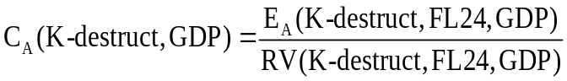 (6.3)
allowing us to estimate E_{A}(K-destruct,d, GDP) for all d via (6.2).
How can we find relevant variables and how can we know that they are legitimate, that is have the proportionality property described in (6.1)?
From our knowledge of the theory and data of USAGE-TERM we make guesses of relevant variables. For example, we have guessed that
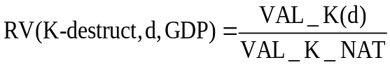 (6.4)
is a legitimate relevant variable for s equals capital destruction and v equals GDP
where
VAL_K(d) is the value of capital in region d; and
VAL_K_NAT is the value of capital in the nation.
To check the validity of the guesses for the relevant variable for any s,v pair we can calculate
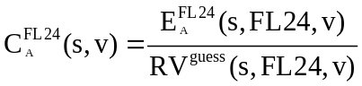 (6.5)
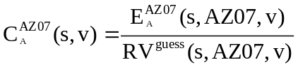 (6.6)
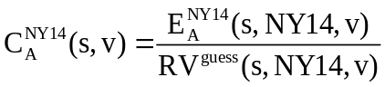 (6.7)
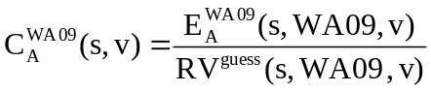 (6.8)
where
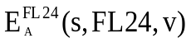, 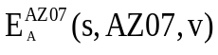, etc, are elasticities calculated from our 4 models, which we take as the true elasticities;
RV^{guess} refers to our guess for the relevant variable, e.g. capital share; and
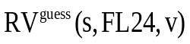, 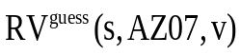, etc are the observed values of this variable for FL24, AZ07 etc.
We say that RV^{guess} is a legitimate relevant variable for the s,v pair if there is little variation across the 4 values 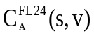, 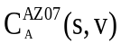, 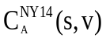 and 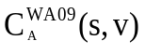 for each A.
If for a given A the 4 values are not close, then we must think more deeply about the theory and data of the model to come up with a refined guess of the relevant variable. As well as meeting the immediate requirement of obtaining proportionality factors (C coefficients) that are consistent across our 4 models, the process of finding legitimate relevant variables is a valuable way of understanding key features of USAGE-TERM and of checking for unrealistic specifications and errors. Once we were satisfied that the C coefficients were as uniform as possible across the 4 models, we averaged them and calculated the elasticities for the TRA groups according to:
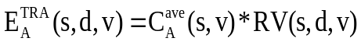 (6.9)
where
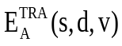 is the value supplied to the TRA groups for the elasticity under assumption A (Keynesian or Neoclassical) of implication variable v with respect to shock s occurring in region d;
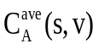 is the average value across the four models of the s,v-coefficients under assumption A; and
RV(s,d,v) is the value for region d of the relevant variable for shock s and implication variable v.
The results from the four models for the coefficients, C_{A}(s,v), and the definitions of the relevant variables, RV(s,d,v), are set out and discussed in appendix 1.

6.2. Sample elasticity matrices
On the basis of (6.9) we supplied the TRA groups with 170x2 matrices of elasticities (170 target regions times 2 assumptions). Each matrix has 14 rows (shock variables) and 10 columns (implication variables). Sample elasticity matrices are given in Tables 6.2 to 6.5.
Understanding the nature of the underlying shocks and the resulting elasticities
Focusing on Table 6.2, we see that the first entry is -0.0013. This means under Keynesian assumptions that the destruction of 1 per cent of the capital in FL24 would reduce the nation’s GDP in year 1 (2015) by 0.0013 per cent. Moving along the first row we see that destruction of 1 per cent of capital in FL24 would reduce national employment in year 1 by 0.0009 per cent. The percentage effects in FL24 would be much greater. This can be seen in the 3rd and 4th entries in the first row which imply reductions in FL24’s output (GRP) and employment of 0.7828 per cent and 0.6304 per cent. Continuing along the first row, we see that the long run (year 20) effects on national output and employment of capital destruction in FL24 are negligible. Even in FL24, the long-run effects are small (-0.0145 per cent and 0.0078 per cent). Although the economy would recover from capital destruction in FL24, the event would have a noticeable negative effect on national economic welfare. This is shown in the last two columns of row 1. Under a 5 per cent discount rate, replacement of destroyed capital (requiring extra savings and loss of consumption) would reduce national welfare accumulated over years 1 to 20 by an amount equivalent to the loss of 0.0076 per cent of a single year’s consumption. When future losses of consumption are discounted at a lower rate (2 per cent rather than 5 per cent) the national welfare loss from destruction of 1 per cent of FL24’s capital becomes 0.0101 per cent.
Row 2 of Table 6.2 shows under Keynesian assumptions the percentage effects on the 10 implication variables of a reactivation of 1 per cent of FL24’s capital taking place at the beginning of year 2. Elasticities in this row can be used in conjunction with those in row 1 to handle scenarios in which there is both capital destruction and temporary capital contamination. For example, for a scenario in which 10 per cent of capital in FL24 is taken out of use in year 1, with 7 per cent being destroyed and 3 per cent being contaminated, we would conduct a simulation in which 10 per cent is “destroyed” in year 1 and 3 per cent is reactivated at the beginning of year 2. The effects of the 10 per cent capital destruction would be captured via elasticities from row 1 while the effects of capital reactivation would be captured via elasticities from row 2. In this way, we would ascertain the effects of losing 7 per cent of FL24’s capital permanently but losing the use of 3 per cent only temporarily (for one year). While literally we allow for capital idling for exactly one year, we can adjust shocks to encompass scenarios with other possibilities. For example, if the 3 per cent of FL24’s capital is decontaminated in 6 months rather than a year, then we could treat this situation as destruction of 8.5 per cent (= 7 +1.5) of capital and reactivation one year later of 1.5 per cent. Reactivation of capital at the beginning of year 2 has zero effect on variables in 1 and negligible effects in year 20. The welfare effects are approximately the same as those for capital destruction but with opposite sign.
Row 3 of Table 6.2 shows under Keynesian assumptions the percentage effects on the 10 implication variables of a temporary 1 per cent boost in public expenditure throughout FL24’s city. These elasticities are used in calculating the effects of clean-up expenditures. Notice that unlike capital destruction, we assume that clean-up expenditures take place

Table 6.2. Elasticities for incident in FL24 with Keynesian assumptions: % effects on implication variables of 1% shocks to driving variables
Driving variables | Implication variables | National GDP  Year 1 | National employment  Year 1 | Target region GRP  Year 1 | Target region employment Year 1 | National GDP  Year 20 | National employment  Year 20 | Target region GRP  Year 20 | Target region employment  Year20 | National welfare  accumulated years 1 to 20, discount rate 0.05 | National welfare  accumulated years 1 to 20, discount rate 0.02
1. Value of capital taken out of use in target region |  | -0.0013 | -0.0009 | -0.7828 | -0.6304 | 0.0000 | 0.0000 | -0.0145 | 0.0078 | -0.0076 | -0.0101
2. Value of capital returned to use after 1yr in target region |  | 0.0000 | 0.0000 | 0.0000 | 0.0000 | 0.0000 | -0.0001 | 0.0324 | -0.0011 | 0.0073 | 0.0101
3. Public expenditure in target city, clean-up |  | 0.0017 | 0.0016 | 0.0866 | 0.0917 | 0.0000 | 0.0000 | -0.0012 | -0.0002 | -0.0001 | -0.0005
4. Public health expenditures in target city |  | 0.0001 | 0.0001 | 0.0073 | 0.0088 | 0.0000 | 0.0000 | 0.0000 | 0.0000 | 0.0000 | 0.0000
5. Accommodation expenses in target city |  | 0.0002 | 0.0002 | 0.0073 | 0.0080 | 0.0000 | 0.0000 | 0.0002 | 0.0001 | -0.0001 | -0.0001
6. Accommodation expenses outside target city |  | 0.0303 | 0.0280 | 0.0132 | 0.0108 | 0.0002 | 0.0001 | 0.0000 | 0.0000 | -0.0138 | -0.0229
7. Loss of foreign visitor expenditure in target city |  | -0.0012 | -0.0010 | -0.0448 | -0.0402 | 0.0000 | 0.0000 | 0.0000 | 0.0000 | -0.0008 | -0.0008
8. Loss of foreign visitor expenditure outside target city |  | -0.0126 | -0.0104 | -0.0114 | -0.0096 | 0.0000 | 0.0000 | 0.0000 | 0.0000 | -0.0086 | -0.0090
9. Loss of domestic traveler expenditure in target city |  | 0.0000 | 0.0000 | -0.0804 | -0.0708 | 0.0000 | 0.0000 | -0.0003 | -0.0003 | 0.0000 | 0.0000
10. Loss of domestic traveler expenditure outside target city |  | -0.0360 | -0.0284 | -0.0237 | -0.0191 | 0.0000 | -0.0001 | 0.0000 | -0.0001 | -0.0263 | -0.0238
11. Loss of food production in target state |  | -0.0012 | -0.0009 | -0.0335 | -0.0261 | 0.0000 | 0.0000 | 0.0001 | 0.0001 | -0.0009 | -0.0010
12. Total loss of food production in U.S. including target state |  | -0.1421 | -0.1012 | -0.1310 | -0.1179 | -0.0004 | -0.0005 | -0.0013 | -0.0004 | -0.0999 | -0.1020
13. Deaths & serious injuries, permanent removal from work (people) |  | -0.5470 | -0.6131 | -51.3175 | -56.4681 | -0.9546 | -0.9873 | -0.0130 | -0.0096 | -298.6371 | -307.3186
14. Aversion, per cent reduction in labor supply to target region |  | 0.0000 | 0.0000 | -0.4354 | -0.4796 | 0.0000 | 0.0000 | -0.8123 | -0.8927 | 0.0000 | 0.0000
Table 6.3. Elasticities for incident in FL24 with Neoclassical assumptions: % effects on implication variables of 1% shocks to driving variables
Driving variables | Implication variables | National GDP  Year 1 | National employment  Year 1 | Target region GRP  Year 1 | Target region employment Year 1 | National GDP  Year 20 | National employment  Year 20 | Target region GRP  Year 20 | Target region employment  Year20 | National welfare  accumulated years 1 to 20, discount rate 0.05 | National welfare  accumulated years 1 to 20, discount rate 0.02
1. Value of capital taken out of use in target region |  | -0.0013 | -0.0009 | -0.7828 | -0.6304 | 0.0000 | 0.0000 | -0.0145 | 0.0078 | -0.0076 | -0.0101
2. Value of capital returned to use after 1yr in target region |  | 0.0000 | 0.0000 | 0.0000 | 0.0000 | 0.0000 | -0.0001 | 0.0324 | -0.0011 | 0.0073 | 0.0101
3. Public expenditure in target city, clean-up |  | 0.0007 | 0.0013 | 0.0211 | 0.0430 | 0.0000 | 0.0000 | -0.0009 | -0.0003 | -0.0006 | -0.0009
4. Public health expenditures in target city |  | 0.0000 | 0.0001 | 0.0023 | 0.0044 | 0.0000 | 0.0000 | 0.0000 | 0.0000 | 0.0000 | -0.0001
5. Accommodation expenses in target city |  | 0.0001 | 0.0001 | 0.0035 | 0.0053 | 0.0000 | 0.0000 | 0.0003 | 0.0002 | -0.0001 | -0.0002
6. Accommodation expenses outside target city |  | 0.0085 | 0.0129 | 0.0018 | 0.0041 | 0.0000 | 0.0000 | -0.0001 | 0.0000 | -0.0231 | -0.0324
7. Loss of foreign visitor expenditure in target city |  | -0.0002 | -0.0003 | -0.0089 | -0.0115 | 0.0000 | 0.0000 | -0.0002 | -0.0001 | -0.0004 | -0.0005
8. Loss of foreign visitor expenditure outside target city |  | -0.0020 | -0.0029 | -0.0020 | -0.0039 | 0.0000 | 0.0000 | 0.0001 | 0.0000 | -0.0040 | -0.0045
9. Loss of domestic traveler expenditure in target city |  | 0.0000 | 0.0000 | -0.0182 | -0.0218 | 0.0000 | 0.0000 | -0.0002 | 0.0000 | 0.0000 | 0.0000
10. Loss of domestic traveler expenditure outside target city |  | -0.0044 | -0.0064 | -0.0019 | -0.0054 | 0.0002 | 0.0000 | 0.0002 | 0.0000 | -0.0125 | -0.0102
11. Loss of food production in target state |  | -0.0013 | -0.0011 | -0.0133 | -0.0101 | 0.0000 | 0.0000 | 0.0000 | 0.0000 | -0.0002 | -0.0002
12. Total loss of food production in U.S. including target state |  | -0.0539 | -0.0373 | -0.0208 | -0.0479 | 0.0003 | 0.0000 | 0.0012 | -0.0001 | -0.0631 | -0.0655
13. Deaths & serious injuries, permanent removal from work (people) |  | -0.2086 | -0.3564 | -19.8407 | -33.3864 | -0.9552 | -0.9910 | -0.0145 | -0.0099 | -298.6014 | -307.2679
14. Aversion, per cent reduction in labor supply to target region |  | 0.0000 | 0.0000 | -0.1478 | -0.2488 | 0.0000 | 0.0000 | -0.8142 | -0.8930 | 0.0000 | 0.0000
Table 6.4. Elasticities for incident in CA34 with Keynesian assumptions: % effects on implication variables of 1% shocks to driving variables
Driving variables | Implication variables | National GDP  Year 1 | National employment  Year 1 | Target region GRP  Year 1 | Target region employment Year 1 | National GDP  Year 20 | National employment  Year 20 | Target region GRP  Year 20 | Target region employment  Year20 | National welfare  accumulated years 1 to 20, discount rate 0.05 | National welfare  accumulated years 1 to 20, discount rate 0.02
1. Value of capital taken out of use in target region |  | -0.0019 | -0.0012 | -0.8668 | -0.6980 | 0.0000 | 0.0000 | -0.0160 | 0.0087 | -0.0109 | -0.0146
2. Value of capital returned to use after 1yr in target region |  | 0.0000 | 0.0000 | 0.0000 | 0.0000 | 0.0000 | -0.0001 | 0.0359 | -0.0013 | 0.0104 | 0.0145
3. Public expenditure in target city, clean-up |  | 0.0069 | 0.0063 | 0.0579 | 0.0613 | 0.0000 | 0.0000 | -0.0008 | -0.0001 | -0.0002 | -0.0021
4. Public health expenditures in target city |  | 0.0005 | 0.0005 | 0.0050 | 0.0061 | 0.0000 | 0.0000 | 0.0000 | 0.0000 | 0.0000 | -0.0002
5. Accommodation expenses in target city |  | 0.0011 | 0.0010 | 0.0134 | 0.0147 | 0.0000 | 0.0000 | 0.0003 | 0.0002 | -0.0005 | -0.0008
6. Accommodation expenses outside target city |  | 0.0294 | 0.0271 | 0.0151 | 0.0124 | 0.0001 | 0.0001 | 0.0000 | 0.0001 | -0.0133 | -0.0222
7. Loss of foreign visitor expenditure in target city |  | -0.0010 | -0.0008 | -0.0088 | -0.0079 | 0.0000 | 0.0000 | 0.0000 | 0.0000 | -0.0007 | -0.0007
8. Loss of foreign visitor expenditure outside target city |  | -0.0129 | -0.0106 | -0.0116 | -0.0098 | 0.0000 | 0.0000 | 0.0000 | 0.0000 | -0.0088 | -0.0092
9. Loss of domestic traveler expenditure in target city |  | 0.0000 | 0.0000 | -0.0172 | -0.0151 | 0.0000 | 0.0000 | -0.0001 | -0.0001 | 0.0000 | 0.0000
10. Loss of domestic traveler expenditure outside target city |  | -0.0360 | -0.0284 | -0.0282 | -0.0228 | 0.0000 | -0.0001 | 0.0000 | -0.0001 | -0.0263 | -0.0238
11. Loss of food production in target state |  | -0.0048 | -0.0034 | -0.0634 | -0.0495 | -0.0001 | -0.0001 | 0.0002 | 0.0001 | -0.0038 | -0.0041
12. Total loss of food production in U.S. including target state |  | -0.1421 | -0.1012 | -0.2754 | -0.2479 | -0.0004 | -0.0005 | -0.0027 | -0.0009 | -0.0999 | -0.1020
13. Deaths & serious injuries, permanent removal from work (people) |  | -0.5470 | -0.6131 | -8.5104 | -9.3645 | -0.9546 | -0.9873 | -0.0270 | -0.0198 | -298.6371 | -307.3186
14. Aversion, per cent reduction in labor supply to target region |  | 0.0000 | 0.0000 | -0.4425 | -0.4874 | 0.0000 | 0.0000 | -0.8256 | -0.9073 | 0.0000 | 0.0000
Table 6.5. Elasticities for incident in CA34 with Neoclassical assumptions: % effects on implication variables of 1% shocks to driving variables
Driving variables | Implication variables | National GDP  Year 1 | National employment  Year 1 | Target region GRP  Year 1 | Target region employment Year 1 | National GDP  Year 20 | National employment  Year 20 | Target region GRP  Year 20 | Target region employment  Year20 | National welfare  accumulated years 1 to 20, discount rate 0.05 | National welfare  accumulated years 1 to 20, discount rate 0.02
1. Value of capital taken out of use in target region |  | -0.0019 | -0.0012 | -0.8668 | -0.6980 | 0.0000 | 0.0000 | -0.0160 | 0.0087 | -0.0109 | -0.0146
2. Value of capital returned to use after 1yr in target region |  | 0.0000 | 0.0000 | 0.0000 | 0.0000 | 0.0000 | -0.0001 | 0.0359 | -0.0013 | 0.0104 | 0.0145
3. Public expenditure in target city, clean-up |  | 0.0027 | 0.0052 | 0.0141 | 0.0287 | 0.0000 | 0.0000 | -0.0006 | -0.0002 | -0.0022 | -0.0038
4. Public health expenditures in target city |  | 0.0001 | 0.0003 | 0.0016 | 0.0031 | 0.0000 | 0.0000 | 0.0000 | 0.0000 | -0.0002 | -0.0002
5. Accommodation expenses in target city |  | 0.0003 | 0.0005 | 0.0063 | 0.0096 | 0.0000 | 0.0000 | 0.0006 | 0.0003 | -0.0008 | -0.0012
6. Accommodation expenses outside target city |  | 0.0082 | 0.0125 | 0.0021 | 0.0047 | 0.0000 | 0.0000 | -0.0001 | 0.0000 | -0.0224 | -0.0314
7. Loss of foreign visitor expenditure in target city |  | -0.0002 | -0.0002 | -0.0017 | -0.0023 | 0.0000 | 0.0000 | 0.0000 | 0.0000 | -0.0003 | -0.0004
8. Loss of foreign visitor expenditure outside target city |  | -0.0021 | -0.0030 | -0.0020 | -0.0039 | 0.0000 | 0.0000 | 0.0001 | 0.0000 | -0.0041 | -0.0046
9. Loss of domestic traveler expenditure in target city |  | 0.0000 | 0.0000 | -0.0039 | -0.0047 | 0.0000 | 0.0000 | 0.0000 | 0.0000 | 0.0000 | 0.0000
10. Loss of domestic traveler expenditure outside target city |  | -0.0044 | -0.0064 | -0.0023 | -0.0064 | 0.0002 | 0.0000 | 0.0002 | 0.0000 | -0.0125 | -0.0102
11. Loss of food production in target state |  | -0.0051 | -0.0045 | -0.0252 | -0.0191 | 0.0000 | 0.0000 | -0.0001 | 0.0000 | -0.0008 | -0.0009
12. Total loss of food production in U.S. including target state |  | -0.0539 | -0.0373 | -0.0438 | -0.1008 | 0.0003 | 0.0000 | 0.0026 | -0.0003 | -0.0631 | -0.0655
13. Deaths & serious injuries, permanent removal from work (people) |  | -0.2086 | -0.3564 | -3.2903 | -5.5367 | -0.9552 | -0.9910 | -0.0300 | -0.0205 | -298.6014 | -307.2679
14. Aversion, per cent reduction in labor supply to target region |  | 0.0000 | 0.0000 | -0.1502 | -0.2529 | 0.0000 | 0.0000 | -0.8275 | -0.9075 | 0.0000 | 0.0000

throughout the Target city (FL24 plus nearby congressional districts, see Table 6.1). It is reasonable to suppose that clean-up would be conducted by the use of capital and labor located in the Target city, not just the target congressional district, FL24. Under Keynesian assumptions, a 1 per cent increase in public expenditure in FL24’s city stimulates the nation’s output and employment in year 1 by 0.0017 and 0.0016 per cent, and FL24’s output and employment by 0.0866 and 0.0917 per cent. By year 20, the output and employment effects have faded away at the national level and are tiny negatives at the FL24 level (-0.0012 and
-0.0002). Despite stimulation of the economy in year 1, the national welfare effects of the 1 per cent boost in public expenditure in FL24’s city are negative (-0.0001 and -0.0005 with 5 per cent and 2 per cent discount rates). Extra public expenditure in year 1 leads to higher public debt. This induces tighter fiscal policy which reduces consumption (and therefore welfare) after year 1.
Row 4 of Table 6.2 shows under Keynesian assumptions the percentage effects of a temporary (one year) 1 per cent boost in public health expenditure throughout FL24’s city. These elasticities are much smaller than those in Row 3 because public health expenditure is small relative to total public expenditure. The long-run effects of a 1 per cent boost in public health expenditure in FL24’s city are too small to register at 4 decimal places.
The TRA scenarios contain separate items for accommodation expenditure in the Target city and outside the Target city for displaced people. Rows 5 and 6 of Table 6.2 show, under Keynesian assumptions, elasticities with respect to accommodation expenditure in FL24’s city and outside FL24’s city. At the national level, a 1 per cent increase in accommodation expenditure in FL24’s city has only small effects (output and employment effects of 0.0002 per cent in year 1and zero in year 20). A 1 per cent increase in accommodation expenditure outside FL24’s city is a much larger shock. Consequently, the year-1 national elasticities in row 6 (0.0303 and 0.0280) are much larger than the corresponding elasticities in row 5. Even for FL24, the year-1 elasticities are greater for accommodation expenditure outside FL24’s city than for accommodation expenditure in FL24’s city. Despite the year-1 boosts in the output and employment from increased accommodation expenditure, the welfare effects in rows 5 and 6 of Table 6.2 are negative.
Similarly, the TRA scenarios contain separate items for loss of foreign visitor expenditure in the target city and outside the target city. Rows 7 and 8 of Table 6.2 show, under Keynesian assumptions, elasticities with respect to a temporary loss of foreign visitor expenditure in FL24’s city and outside FL24’s city. As with rows 5 and 6, the year-1 national elasticities in row 8 for the shock outside FL24’s city are much larger in absolute size than those in row 7 for the shock in FL24’s city. Again, this reflects the much larger magnitude of the shocked variable for outside FL24’s city than for in FL24’s city. By contrast with rows 5 and 6, the elasticities for year-1 output and employment in FL24 are larger in absolute size for the own city shock than for the outside city shock (-0.0448 and -0.0402 in row 7 compared with
-0.0114 and -0.0096 in row 8). This reflects the high level of importance of foreign tourism to FL24’s city (Miami).
The next pair of rows in Table 6.2 (rows 9 and 10) show, under Keynesian assumptions, elasticities with respect to temporary loss of domestic visitor expenditure in FL24’s city and outside FL24’s city. The pattern of results for this pair of rows is qualitatively similar to that in the previous pair of rows: non-negligible year-1 national elasticities only for the outside shock (-0.0360 and -0.0284); relatively large year-1 FL24 elasticities for the shock to FL24’s city (-0.0804 and-0.0708); and significant negative welfare elasticities only for the outside shock (-0.0263 and -0-0238).
The setup of the next pair of rows, 11 and 12, is slightly different from that of the previous pairs. Row 11 gives Keynesian elasticities with respect to loss of food production in FL24’s state, namely Florida, holding constant total U.S. food output, and row 12 gives elasticities with respect to loss of food production in the U.S. holding constant food production in Florida. The difference between the set up in rows 11 and 12 and the earlier pairs is the “holding constant” condition. Even though U.S. food output is held constant in row 11, (implying the reduction in Florida is offset by an increase in the rest of the U.S.) the year-1 national output and employment elasticities are negative (-0.0012 and -0.0009). This is because the replacement of lost food from Florida requires diversion of resources towards food production in the rest of the U.S. and away from other productive activities. Even though Florida food output is held constant in row 12, the year-1 FL24 output and employment elasticities are negative (-0.1310 and -0.1179). This is because FL24 is damaged by its connection through trade with the Rest of the U.S. As in the earlier rows, the year-20 elasticities in rows 11 and 12 for output and employment at the national and regional levels are small. This reflects long-run recovery of the economy from the shock (in this case temporary loss of food production) imposed in year 1. Also consistent with the earlier rows, the negative shocks in year 1 produce negative accumulated welfare effects.
Row 13 shows effects of a loss of 1 per cent of the population through deaths. These elasticities look very large relative to the other elasticities in Table 6.2. The row-13 elasticities are large because the shock is large, about 3.2 million deaths. With a life valued at $9.6 million (see section 5), 3.2 million deaths translates into $30.72 trillion, about 3 times the value of a year’s consumption. This is the reason that the welfare entries in the last two columns of row 13 are about -300 per cent. There are also large entries for the year-1 FL24 output and employment elasticities (-51.3175 and -56.4681). In computing these elasticities, we assume that half the people who die are in the labor force and that in year 1, only half the deceased workers in FL24’s city are replaced by incoming workers. Thus, there is a net loss of 800 thousand workers in FL24’s city. This translates into large percentage loses in employment and output in each of the city’s 3 congressional districts, including FL24. Compared with earlier rows, row 13 shows relatively large negative year-20 national output and employment elasticities (-0.9546 and -0.9873). The loss of workers is permanent.
Row 14 shows aversion elasticities. These are elasticities of implication variables with respect to a permanent 1 per cent reduction in labor supply to FL24. By this we mean a permanent shift in the supply curve so that at any given real wage, 1 per cent less labor is supplied to FL24. Reflecting the permanent nature of the shock, there are significantly negative year-20 elasticities for FL24’s output and employment (-0.8123 and -0.8927). By contrast, the national effects in both the short and long-runs are zero. Aversion merely changes the regional allocation of economic activity without affecting its total level.
Neoclassical elasticities versus Keynesian elasticities
Table 6.3 gives the elasticity matrix calculated under Neoclassical assumptions for an event in FL24. Comparison of Tables 6.2 and 6.3 shows the effects of moving from Keynesian assumptions (high levels of unemployment and underutilization of capital in year 1) to Neoclassical assumptions (normal levels of unemployment and capital utilization in year 1).
The first two rows of Table 6.3 are the same as those in Table 6.2. We assume that capital destruction and reactivation have the same effects under the two assumptions. This makes sense if we assume that the particular capital which is destroyed or reactivated was fully used even in the Keynesian situation.
Rows 3 to 6 in Table 6.3 give Neoclassical elasticities for the 10 implication variables with respect to public expenditure, public health expenditure and accommodation expenditure. All of the year-1 elasticities in these rows have smaller positives values than the corresponding elasticities in Table 6.2. For example, in row 3 of Table 6.3 the Neoclassical elasticity of national GDP in year 1 with respect to public expenditure in FL24 is 0.0007 whereas the corresponding Keynesian elasticity in Table 6.2 is 0.0017. Under Neoclassical assumptions there is less scope for increased expenditures to cause short-run stimulation of the economy. With less favorable short-run impacts of expenditures, Table 6.3 shows less favorable accumulated welfare elasticities. For example, in row 6 of Table 6.3, the Neoclassical elasticity of welfare (5 per cent discount) with respect to accommodation expenditures outside the target city is -0.0231. Table 6.2 shows the corresponding Keynesian elasticity as
-0.0138.
Neoclassical elasticities for the effects of reductions in foreign and domestic visitor expenditures are in rows 7 to 10 of Table 6.3. The year-1 elasticities in these rows are negative but smaller in absolute terms than the corresponding Keynesian elasticities in Table 6.2. In an economy experiencing normal levels of employment (Neoclassical assumptions), loss of tourism expenditures has a less depressing effect than is the case in an underemployed economy (Keynesian assumptions). Reflecting this, the accumulated welfare effects in rows 7 to 10 of Table 6.3 are less strongly negative than those in Table 6.2.
For loss of food output at the national level (row 12), the relationship between the Neoclassical elasticities in Table 6.3 and the Keynesian elasticities in Table 6.2 follows the same pattern as the elasticities in rows 7 to 10: the year-1 elasticities and welfare effects in Table 6.3 are negative but smaller in magnitude than those in Table 6.2. Loss of food output at the state level holding constant national output (row 11) has negligible national effects under either Keynesian or Neoclassical assumptions. At the regional level the year-1 Neoclassical elasticities are smaller in absolute size than the corresponding Keynesian elasticities. Again, the reason is that negative shocks do more damage in an under-employed economy than in an economy with normal levels of employment.
Comparison of row 13 (deaths) in Table 6.3 with that in Table 6.2 follows the usual pattern: negative year-1 elasticities and welfare elasticies that are smaller in absolute size in Table 6.3 than in Table 6.2. The row-13 welfare elasticities are only slightly smaller in absolute size in Table 6.3 than in Table 6.2 because the values of these elasticities are overwhelmingly determined by the direct contribution from loss of life which is the same in both tables.
Permanent aversion to working in FL24 has similar long-run national, regional and welfare effects under Neoclassical assumptions (row 14, Table 6.3) as under Keynesian assumptions (row 14, Table 6.2). The year-1 effects of aversion are less severe for FL24’s economy under Neoclassical conditions than under Keynesian conditions (elasticities of -0.1478 and -0.2488 in Table 6.3 compared with -0.4354 and -0.4796 in Table 6.2 ).
Elasticities for events in one region compared with those for another region
Tables 6.4 and 6.5 give Keynesian and Neoclassical elasticities for shocks occurring in CA34. Qualitatively, the elasticities in these tables are similar to those in Tables 6.2 and 6.3. They all have the same signs and moving from Table 6.4 to Table 6.5, that is going from Keynesian to Neoclassical assumptions in CA34, shows similar effects to those we saw in comparing Tables 6.2 and 6.3 for FL24. In all cases, the differences between the elasticities in Tables 6.4 and 6.5 have the same signs as the differences between those in Tables 6.2 and 6.3.
While Tables 6.4 and 6.5 are qualitatively similar to Tables 6.2 and 6.3, the comparison shows at a quantitative level that the region in which an event takes place is potentially important. The differences in the elasticities as we move from one region to another reflect differences in the size and structure of the regional economies. To illustrate this, we consider a few examples starting with the elasticities in rows 1 and 2. The entries in these rows in Tables 6.4 and 6.5 are larger in absolute size than the corresponding entries in Tables 6.2 and 6.3. This reflects features of the USAGE-TERM database which shows a greater value for capital in CA34 than in FL24 and a larger capital share in the income of CA34 than in the income of FL24. For row 3, the greater absolute values for the year-1 national elasticities and welfare elasticities in Tables 6.4 and 6.5 than in Tables 6.2 and 6.3 are explained by CA34’s city having larger total public expenditure than FL24’s city. By contrast the year-1 regional elasticities in row 3 of Tables 6.4 and 6.5 are smaller in absolute size than the corresponding elasticities in Tables 6.2 and 6.3. This is because public expenditure activity in CA34’s city is less important to the economy of CA34 than is the case for public expenditure activity in FL24’s city in the economy of FL24. As a final example, consider row 7. Foreign visitors spend approximately the same amount of money in CA34’s city as in FL24’s city. Consequently the year-1 national elasticities and welfare elasticities are similar in row 7 of Tables 6.4 and 6.5 to those in row 7 of Tables 6.2 and 6.3. On the other hand, the year-1 regional elasticities are much smaller in absolute size in row 7 of Tables 6.4 and 6.5 than the corresponding elasticities in row 7 of Tables 6.2 and 6.3. This is because foreign visitor expenditure in CA34’s city is not important to CA34 whereas foreign visitor expenditure in FL24’s city is a major driver of activity in FL24.
7. Computing the economic implications of three illustrative scenarios
This section illustrates how GRAD-ECAT converts shocks (s) into outcomes (v). Table 7.1 sets out shocks for 3 scenarios. Initially we will assume that the target region is FL24. Then we will look briefly at some results with the target region being CA34 rather than FL24.
The three scenarios are hypothetical and have no significance other than illustrating the workings of GRAD-ECAT. However, it is useful to give them labels. We refer to the first scenario as S1: Epidemic. This scenario has a large number of deaths (38,181), considerable public health expenditures ($3,068.06m), and large losses in foreign-visitor expenditure ($8,836.55m and $46,098.62m). In the second scenario the standout item is an enormous clean-up bill ($62,691.14m). This is combined with a significant death toll (1,645). We refer to the second scenario as S2: Dirty bomb. The third scenario involves losses in agriculture/food production in the target state. There is no loss outside the target state. We refer to this scenario as S3: Food contamination.
Before we can apply GRAD-ECAT the shocks must be converted into percentages. Assuming that the target region is FL24, this requires 2014 data available in USAGE-TERM for: the value of capital in FL24; the value of public expenditures in FL24’s city (FL24, FL23 & FL27, see Table 6.1); the value of public health expenditure in FL24’s city; the values of accommodation expenses in FL24’s city and outside the city; the values of foreign and domestic visitor expenditure in FL24’s city and outside the city; the values of agriculture and food production in FL24’s state (city plus FL07-09, FL14-22, FL25-26) and in the U.S.; and the U.S. population. The three scenarios from Table 7.1 converted to percentage change form with the target region being FL24 are in Table 7.2. Table 7.3 shows the three scenarios in percentage change form with the target region as CA34. All of the differences between

Table 7.1. Three example scenarios
Driving factors | S1: Epidemic  (death, health & tourism scare) | S2: Dirty bomb  (decontamination & aversion) | S3: Food contamination
1. Value of capital taken out of use in target region ($m) | 0.00 | 2621.59 | 0.00
2. Value of capital returned to use after 1yr in target region ($m) | 0.00 | 2621.59 | 0.00
3. Public expenditure in target city, clean-up ($m) | 393.30 | 62691.14 | 48.61
4. Public sector health expenditures ($m) | 3068.06 | 128.43 | 65.30
5. Accommodation expenses in target city ($m) | 0.00 | 215.27 | 0.00
6. Accommodation expenses outside target city ($m) | 0.00 | 215.27 | 0.00
7. Loss of foreign visitor expenditure in target city ($m) | 8836.55 | 5847.72 | 3569.97
8. Loss of foreign visitor expenditure outside target city ($m) | 46098.62 | 22180.09 | 18623.84
9. Loss of domestic traveler expenditure in target city ($m) | 14.57 | 1652.55 | 6.38
10. Loss of domestic traveler expenditure outside target city ($m) | 0.00 | 0.00 | 0.00
11. Loss of food production in target state ($m) | 0.00 | 0.00 | 210.00
12. Total loss of food production in U.S. including target state ($m) | 0.00 | 0.00 | 210.00
13. Deaths & serious injuries, permanent removal from work (people) | 38,181 | 1,645 | 493
14. Aversion, per cent reduction in labor supply to target region | 0 | 10 | 0

Tables 7.2 and 7.3 are due to differences in the 2014 data for FL24 and CA34. For example, Cleanup in each of the three scenarios has a percentage shock that is 4.0346 times larger in Table 7.2 than in Table 7.3. This is because public expenditure in FL24’s city is1/4.0346 times that in CA34’s city.
Tables 7.4 and 7.5 set out the GRAD-ECAT calculations of the effects of the Epidemic scenario occurring in FL24 under Keynesian and Neoclassical assumptions. The top panel in Table 7.4 is the Keynesian FL24 elasticity matrix, reproduced from Table 6.2. The shaded column at the top right of Table 7.4 shows the percentage shocks for the Epidemic scenario, reproduced from Table 7.2. The lower panel is calculated by multiplying the elasticities by the shocks. Each component of the lower panel shows the contribution of the shock identified in the row to the outcome for the implication variable identified in the column. For example the contribution to national GDP in year 1 of the 2.4951 per cent increase in public expenditures in FL24’s city (row 3CleanUp) under Keynesian assumptions is 0.00429 per cent (= 2.4951*0.0017). The total percentage effect of all the shocks on implication variables is the column sum of the contributions, shown in the last row. Table 7.5 sets out the calculations using Neoclassical elasticities from Table 6.3.
Comparing Tables 7.4 and 7.5, we see that the year-1 total effects for national variables are more negative under Keynesian assumptions than under Neoclassical assumptions. GDP and national employment decline by 0.35435 and 0.28808 per cent under Keynesian assumptions (last row, first two columns of Table 7.4) whereas under Neoclassical assumptions they decline by only 0.05340 and 0.07339 per cent (Table 7.5). This can be explained by looking at the contribution matrices. Under Keynesian assumptions the declines in visitor expenditures caused by the Epidemic make much larger negative contributions than under Neoclassical assumptions. For example, in row 8 column 1 of the contribution matrices we see a negative contribution to year-1 GDP from lost foreign-visitor expenditure of 0.32036 under Keynesian assumptions whereas the corresponding Neoclassical contribution is a negative of only 0.05143. This illustrates the point that losing visitor expenditures in an under-employed economy where new jobs are hard to obtain is much more economically damaging than in a normally-employment economy. Positive public expenditure shocks make larger positive year-1 contributions under Keynesian assumptions than under Neoclassical assumptions. For example, the Clean-up contribution to year-1 GDP under Keynesian assumptions is 0.00429, whereas under Neoclassical assumptions it is 0.00165. However, in the Epidemic scenario the stimulatory effects of extra public expenditures are only a minor offset to the depressing effects of lost foreign-visitor expenditures under either assumption.
Detailed study of the contribution matrices allows us to unravel seemingly mysterious results. For example, why does the Epidemic simulation show a negative year-1 employment result for the target region, FL24, under Keynesian assumptions (-0.57989) but a positive result under Neoclassical assumptions (0.11128)? Under both sets of assumptions the increases in public expenditure rows 3 and 4 are stimulatory for FL24’s employment while the cuts in foreign visitor expenditures in rows 7 and 8 are contractionary. Keynesian assumptions magnify both stimulatory and contractionary effects relative to Neoclassical assumptions. However, the magnification effect is weaker for labor intensive activities, such as public expenditures on clean-up and health, than for more capital intensive activities, such as providing hotel accommodation for foreign visitors. This can be seen by looking at the Public health and Lost foreign visitor contributions in rows 3 and 7 to year-1 regional employment. In Table 7.5 the Public health contribution is 1.08661 compared with 2.15220 in Table 7.4, a
Table 7.2. Three example scenarios in percentage change form for target region FL24
Driving factors | S1: Epidemic  (death, health & tourism scare) | S2: Dirty bomb  (decontamination & aversion) | S3: Food contamination
1. Value of capital taken out of use in target region | 0.0000 | 2.8338 | 0.0000
2. Value of capital returned to use after 1yr in target region | 0.0000 | 2.8338 | 0.0000
3. Public expenditure in target city, clean-up | 2.4951 | 397.7188 | 0.3084
4. Public sector health expenditures | 244.4013 | 10.2307 | 5.2018
5. Accommodation expenses in target city (% of h’hold expenditure on hotels & restaurants in target city) | 0.0000 | 7.8594 | 0.0000
6. Accommodation expenses outside target city (% of h’hold expenditure on hotels & restaurants outside target city) | 0.0000 | 0.0487 | 0.0000
7. Loss of foreign visitor expenditure in target city | 50.7424 | 33.5796 | 20.5000
8. Loss of foreign visitor expenditure outside target city | 25.3712 | 12.2072 | 10.2500
9. Loss of domestic traveler expenditure in target city | 0.0773 | 8.7624 | 0.0338
10. Loss of domestic traveler expenditure outside target city | 0.0000 | 0.0000 | 0.0000
11. Loss of food production in target state | 0.0000 | 0.0000 | 1.3976
12. Total loss of food production in U.S. including target state | 0.0000 | 0.0000 | 0.0195
13. Deaths & serious injuries, permanent removal from work (% of US population) | 0.0119 | 0.0005 | 0.0002
14. Aversion, per cent reduction in labor supply to target region | 0.0000 | 10.0000 | 0.0000

Table 7.3. Three example scenarios in percentage change form for target region CA34
Driving factors | S1: Epidemic  (death, health & tourism scare) | S2: Dirty bomb  (decontamination & aversion) | S2: Food contamination
1. Value of capital taken out of use in target region | 0.0000 | 2.1222 | 0.0000
2. Value of capital returned to use after 1yr in target region | 0.0000 | 2.1222 | 0.0000
3. Public expenditure in target city, clean-up | 0.6185 | 98.5943 | 0.0764
4. Public sector health expenditures | 60.5861 | 2.5362 | 1.2895
5. Accommodation expenses in target city (% of h’hold expenditure on hotels & restaurants in target city) | 0.0000 | 1.3123 | 0.0000
6. Accommodation expenses outside target city (% of h’hold expenditure on hotels & restaurants outside target city) | 0.0000 | 0.0502 | 0.0000
7. Loss of foreign visitor expenditure in target city | 62.8414 | 41.5862 | 25.3879
8. Loss of foreign visitor expenditure outside target city | 24.9115 | 11.9860 | 10.0643
9. Loss of domestic traveler expenditure in target city | 0.0849 | 9.6319 | 0.0372
10. Loss of domestic traveler expenditure outside target city | 0.0000 | 0.0000 | 0.0000
11. Loss of food production in target state | 0.0000 | 0.0000 | 0.3205
12. Total loss of food production in U.S. including target state | 0.0000 | 0.0000 | 0.0195
13. Deaths & serious injuries, permanent removal from work (% of US population) | 0.0119 | 0.0005 | 0.0002
14. Aversion, per cent reduction in labor supply to target region | 0.0000 | 10.0000 | 0.0000

Table 7.4. Converting shocks into outcomes: Epidemic scenario, FL24, Keynesian
 | Elasticities FL24 Keynesian |  |  |  |  |  |  |  |  |  | Shocks
 | GDPy1 | EMPy1 | GRPy1 | RegEMPy1 | GDPy20 | EMPy20 | GRPy20 | RegEMPy20 | Welf05 | Welf02
1KDestruct | -0.0013 | -0.0009 | -0.7828 | -0.6304 | 0.0000 | 0.0000 | -0.0145 | 0.0078 | -0.0076 | -0.0101 | 0.0000
2KReturn | 0.0000 | 0.0000 | 0.0000 | 0.0000 | 0.0000 | -0.0001 | 0.0324 | -0.0011 | 0.0073 | 0.0101 | 0.0000
3CleanUp | 0.0017 | 0.0016 | 0.0866 | 0.0917 | 0.0000 | 0.0000 | -0.0012 | -0.0002 | -0.0001 | -0.0005 | 2.4951
4PubHealth | 0.0001 | 0.0001 | 0.0073 | 0.0088 | 0.0000 | 0.0000 | 0.0000 | 0.0000 | 0.0000 | 0.0000 | 244.4013
5AccomTarCity | 0.0002 | 0.0002 | 0.0073 | 0.0080 | 0.0000 | 0.0000 | 0.0002 | 0.0001 | -0.0001 | -0.0001 | 0.0000
6AccOutsideTC | 0.0303 | 0.0280 | 0.0132 | 0.0108 | 0.0002 | 0.0001 | 0.0000 | 0.0000 | -0.0138 | -0.0229 | 0.0000
7LostFgnVisTC | -0.0012 | -0.0010 | -0.0448 | -0.0402 | 0.0000 | 0.0000 | 0.0000 | 0.0000 | -0.0008 | -0.0008 | 50.7424
8LostFgnVisOuTC | -0.0126 | -0.0104 | -0.0114 | -0.0096 | 0.0000 | 0.0000 | 0.0000 | 0.0000 | -0.0086 | -0.0090 | 25.3712
9LostDomVisTC | 0.0000 | 0.0000 | -0.0804 | -0.0708 | 0.0000 | 0.0000 | -0.0003 | -0.0003 | 0.0000 | 0.0000 | 0.0773
10LostDomVisOutTC | -0.0360 | -0.0284 | -0.0237 | -0.0191 | 0.0000 | -0.0001 | 0.0000 | -0.0001 | -0.0263 | -0.0238 | 0.0000
11LostFoodTarStaste | -0.0012 | -0.0009 | -0.0335 | -0.0261 | 0.0000 | 0.0000 | 0.0001 | 0.0001 | -0.0009 | -0.0010 | 0.0000
12LostFoodNation | -0.1421 | -0.1012 | -0.1310 | -0.1179 | -0.0004 | -0.0005 | -0.0013 | -0.0004 | -0.0999 | -0.1020 | 0.0000
13LostNationLab | -0.5470 | -0.6131 | -51.3175 | -56.4681 | -0.9546 | -0.9873 | -0.0130 | -0.0096 | -298.6371 | -307.3186 | 0.0119
14AversionToTarReg | 0.0000 | 0.0000 | -0.4354 | -0.4796 | 0.0000 | 0.0000 | -0.8123 | -0.8927 | 0.0000 | 0.0000 | 0.0000
 | Contributions of shocks
1KDestruct | 0.00000 | 0.00000 | 0.00000 | 0.00000 | 0.00000 | 0.00000 | 0.00000 | 0.00000 | 0.00000 | 0.00000
2KReturn | 0.00000 | 0.00000 | 0.00000 | 0.00000 | 0.00000 | 0.00000 | 0.00000 | 0.00000 | 0.00000 | 0.00000
3CleanUp | 0.00429 | 0.00392 | 0.21607 | 0.22880 | -0.00002 | 0.00001 | -0.00311 | -0.00044 | -0.00015 | -0.00128
4PubHealth | 0.03031 | 0.03055 | 1.78266 | 2.15220 | 0.00024 | 0.00000 | -0.00269 | -0.00929 | -0.00269 | -0.00929
5AccomTarCity | 0.00000 | 0.00000 | 0.00000 | 0.00000 | 0.00000 | 0.00000 | 0.00000 | 0.00000 | 0.00000 | 0.00000
6AccOutsideTC | 0.00000 | 0.00000 | 0.00000 | 0.00000 | 0.00000 | 0.00000 | 0.00000 | 0.00000 | 0.00000 | 0.00000
7LostFgnVisTC | -0.06206 | -0.05120 | -2.27407 | -2.03736 | 0.00071 | 0.00056 | -0.00051 | -0.00107 | -0.04130 | -0.04237
8LostFgnVisOuTC | -0.32036 | -0.26404 | -0.29004 | -0.24427 | -0.00033 | -0.00107 | 0.00030 | -0.00074 | -0.21895 | -0.22885
9LostDomVisTC | 0.00000 | 0.00000 | -0.00621 | -0.00547 | 0.00000 | 0.00000 | -0.00002 | -0.00002 | 0.00000 | 0.00000
10LostDomVisOutTC | 0.00000 | 0.00000 | 0.00000 | 0.00000 | 0.00000 | 0.00000 | 0.00000 | 0.00000 | 0.00000 | 0.00000
11LostFoodTarStaste | 0.00000 | 0.00000 | 0.00000 | 0.00000 | 0.00000 | 0.00000 | 0.00000 | 0.00000 | 0.00000 | 0.00000
12LostFoodNation | 0.00000 | 0.00000 | 0.00000 | 0.00000 | 0.00000 | 0.00000 | 0.00000 | 0.00000 | 0.00000 | 0.00000
13LostNationLab | -0.00653 | -0.00732 | -0.61232 | -0.67378 | -0.01139 | -0.01178 | -0.00016 | -0.00011 | -3.56334 | -3.66693
14AversionToTarReg | 0.00000 | 0.00000 | 0.00000 | 0.00000 | 0.00000 | 0.00000 | 0.00000 | 0.00000 | 0.00000 | 0.00000
Total effects | -0.35435 | -0.28808 | -1.18391 | -0.57989 | -0.01078 | -0.01227 | -0.00617 | -0.01167 | -3.82643 | -3.94871

Table 7.5. Converting shocks into outcomes: Epidemic scenario, FL24, Neoclassical
 | Elasticities FL24 Neoclassical |  |  |  |  |  |  |  |  |  | Shocks
 | GDPy1 | EMPy1 | GRPy1 | RegEMPy1 | GDPy20 | EMPy20 | GRPy20 | RegEMPy20 | Welf05 | Welf02
1KDestruct | -0.0013 | -0.0009 | -0.7828 | -0.6304 | 0.0000 | 0.0000 | -0.0145 | 0.0078 | -0.0076 | -0.0101 | 0.0000
2KReturn | 0.0000 | 0.0000 | 0.0000 | 0.0000 | 0.0000 | -0.0001 | 0.0324 | -0.0011 | 0.0073 | 0.0101 | 0.0000
3CleanUp | 0.0007 | 0.0013 | 0.0211 | 0.0430 | 0.0000 | 0.0000 | -0.0009 | -0.0003 | -0.0006 | -0.0009 | 2.4951
4PubHealth | 0.0000 | 0.0001 | 0.0023 | 0.0044 | 0.0000 | 0.0000 | 0.0000 | 0.0000 | 0.0000 | -0.0001 | 244.4013
5AccomTarCity | 0.0001 | 0.0001 | 0.0035 | 0.0053 | 0.0000 | 0.0000 | 0.0003 | 0.0002 | -0.0001 | -0.0002 | 0.0000
6AccOutsideTC | 0.0085 | 0.0129 | 0.0018 | 0.0041 | 0.0000 | 0.0000 | -0.0001 | 0.0000 | -0.0231 | -0.0324 | 0.0000
7LostFgnVisTC | -0.0002 | -0.0003 | -0.0089 | -0.0115 | 0.0000 | 0.0000 | -0.0002 | -0.0001 | -0.0004 | -0.0005 | 50.7424
8LostFgnVisOuTC | -0.0020 | -0.0029 | -0.0020 | -0.0039 | 0.0000 | 0.0000 | 0.0001 | 0.0000 | -0.0040 | -0.0045 | 25.3712
9LostDomVisTC | 0.0000 | 0.0000 | -0.0182 | -0.0218 | 0.0000 | 0.0000 | -0.0002 | 0.0000 | 0.0000 | 0.0000 | 0.0773
10LostDomVisOutTC | -0.0044 | -0.0064 | -0.0019 | -0.0054 | 0.0002 | 0.0000 | 0.0002 | 0.0000 | -0.0125 | -0.0102 | 0.0000
11LostFoodTarStaste | -0.0013 | -0.0011 | -0.0133 | -0.0101 | 0.0000 | 0.0000 | 0.0000 | 0.0000 | -0.0002 | -0.0002 | 0.0000
12LostFoodNation | -0.0539 | -0.0373 | -0.0208 | -0.0479 | 0.0003 | 0.0000 | 0.0012 | -0.0001 | -0.0631 | -0.0655 | 0.0000
13LostNationLab | -0.2086 | -0.3564 | -19.8407 | -33.3864 | -0.9552 | -0.9910 | -0.0145 | -0.0099 | -298.6014 | -307.2679 | 0.0119
14AversionToTarReg | 0.0000 | 0.0000 | -0.1478 | -0.2488 | 0.0000 | 0.0000 | -0.8142 | -0.8930 | 0.0000 | 0.0000 | 0.0000
 | Contributions of shocks
1KDestruct | 0.00000 | 0.00000 | 0.00000 | 0.00000 | 0.00000 | 0.00000 | 0.00000 | 0.00000 | 0.00000 | 0.00000
2KReturn | 0.00000 | 0.00000 | 0.00000 | 0.00000 | 0.00000 | 0.00000 | 0.00000 | 0.00000 | 0.00000 | 0.00000
3CleanUp | 0.00165 | 0.00324 | 0.05269 | 0.10726 | -0.00003 | 0.00001 | -0.00227 | -0.00063 | -0.00138 | -0.00234
4PubHealth | 0.00855 | 0.01564 | 0.57361 | 1.08661 | 0.00000 | 0.00000 | 0.00660 | -0.00855 | -0.00953 | -0.01466
5AccomTarCity | 0.00000 | 0.00000 | 0.00000 | 0.00000 | 0.00000 | 0.00000 | 0.00000 | 0.00000 | 0.00000 | 0.00000
6AccOutsideTC | 0.00000 | 0.00000 | 0.00000 | 0.00000 | 0.00000 | 0.00000 | 0.00000 | 0.00000 | 0.00000 | 0.00000
7LostFgnVisTC | -0.00969 | -0.01385 | -0.45049 | -0.58455 | 0.00030 | 0.00036 | -0.00827 | -0.00335 | -0.01984 | -0.02299
8LostFgnVisOuTC | -0.05143 | -0.07416 | -0.05056 | -0.09798 | 0.00104 | 0.00015 | 0.00198 | 0.00030 | -0.10128 | -0.11371
9LostDomVisTC | 0.00000 | 0.00000 | -0.00140 | -0.00169 | 0.00000 | 0.00000 | -0.00001 | 0.00000 | 0.00000 | 0.00000
10LostDomVisOutTC | 0.00000 | 0.00000 | 0.00000 | 0.00000 | 0.00000 | 0.00000 | 0.00000 | 0.00000 | 0.00000 | 0.00000
11LostFoodTarStaste | 0.00000 | 0.00000 | 0.00000 | 0.00000 | 0.00000 | 0.00000 | 0.00000 | 0.00000 | 0.00000 | 0.00000
12LostFoodNation | 0.00000 | 0.00000 | 0.00000 | 0.00000 | 0.00000 | 0.00000 | 0.00000 | 0.00000 | 0.00000 | 0.00000
13LostNationLab | -0.00249 | -0.00425 | -0.23674 | -0.39837 | -0.01140 | -0.01182 | -0.00017 | -0.00012 | -3.56291 | -3.66632
14AversionToTarReg | 0.00000 | 0.00000 | 0.00000 | 0.00000 | 0.00000 | 0.00000 | 0.00000 | 0.00000 | 0.00000 | 0.00000
Total effects | -0.05340 | -0.07339 | -0.11290 | 0.11128 | -0.01008 | -0.01130 | -0.00215 | -0.01235 | -3.69495 | -3.82002

magnification effect as we go from Neoclassical to Keynes of about 2. The Foreign visitor contribution is -0.58455 in Table 7.5 compared with -2.03736 in Table 7.4, a magnification of about 3.5. By magnifying the bad news by more than the good news, the adoption of Keynesian assumptions turns the year-1 employment effect for FL24 from positive to negative.
The Epidemic scenario has very little effect on economic activity in the long run under either Keynesian or Neoclassical assumptions. For year 20, Tables 7.4 and 7.5 show total effects for national and regional output and employment that are smaller in absolute size than 0.01235 per cent. The only sustained negative effect in the long run flows from the reduction in population. This contributes nearly all of the year-20 effects on GDP and national employment, row 13 in the contribution matrices. Recall that the epidemic kills 38,181 people which is about 0.012 per cent of the population.
The 38,181 deaths make the overwhelmingly dominant contribution to the welfare effect of the Epidemic scenario. With a discount rate of 0.05 and Keynesian assumptions, this contribution is -3.56334 per cent of a year’s consumption which is 93.1 per cent of the total welfare effect (=100*3.56334/3.82643). With a discount rate of 0.02 and Keynesian assumptions, deaths contribute 92.9 per cent of the total welfare effect (=100*3.66693/3.94871). These contribution shares are even higher under Neoclassical assumptions, 96.4 per cent when the discount rate is 0.05 and 96.0 per cent when the discount rate is 0.02.
A notable aspect of the contributions to welfare in the Epidemic scenario under both Keynesian and Neoclassical assumptions and both discount rates is that they are negative for all the non-zero shocks. This is true even for Clean-up and Public health (rows 3 and 4) which show positive year-1 effects for output and employment. As explained in section 5, following a serious terrorism or other disruptive shock, there is an initial blow-out in public expenditures (clean-up and health in the Epidemic scenario). This is followed by contraction as public and foreign debt are reined in. With the initial expenditures being of a non-welfare-creating nature, the required subsequent contraction in consumption causes the accumulated welfare effect to be negative.
Table 7.6 shows welfare effects for all three scenarios with the target regions being FL24 and CA34. The FL24 results were calculated with the elasticity matrices from Table 6.2 and 6.3 and the percentage shocks from Table 7.2. The CA34 results were calculated with the elasticity matrices from Table 6.4 and 6.5 and the percentage shocks from Table 7.3.
There are four outstanding features of Table 7.6. First, the target region makes almost no difference to the results. What this result means is that the $ amount of the shocks and the number of deaths is just about all that counts in national welfare. Where the shocks are delivered is unimportant from a national welfare point of view.
Second, the Epidemic scenario is easily the worst. Analysis of contribution results quickly shows that the welfare effect of the 38,181 deaths in the Epidemic scenario in the dominant factor.
Third, the state of the economy (Keynes versus Neoclassical) at the time of the event can make a noticeable difference to the eventual welfare result. For the Epidemic scenario we saw that the year-1 effects were relatively negative under Keynesian assumptions. This was explained by a larger magnification factor, as we go from Neoclassical to Keynes, for the negative visitor effects than for the positive public expenditure effects. Reflecting the contributions to welfare of the year-1 effects, the Epidemic scenario shows larger negative
Table 7.6. Three example scenarios: welfare effects measured as percentage loss in a year’s consumption
Target region & macro assumption | S1: Epidemic  (death, health & tourism scare) |  | S2: Dirty bomb  (decontamination & aversion) |  | S3: Food contamination
Discount rate | 0.05 | 0.02 | 0.05 | 0.02 | 0.05 | 0.02
FL24 (Miami)
Keynesian | -3.8263 | -3.9485 | -0.3120 | -0.5021 | -0.1545 | -0.1607
Neoclassical | -3.6947 | -3.8198 | -0.4396 | -0.6041 | -0.0968 | -0.1048
CA34 (Los Angeles)
Keynesian | -3.8263 | -3.9485 | -0.3121 | -0.5021 | -0.1544 | -0.1606
Neoclassical | -3.6947 | -3.8198 | -0.4397 | -0.6041 | -0.0968 | -0.1047

welfare outcomes under Keynesian than under Neoclassical assumptions. The main shocks in the Dirty bomb scenario are public expenditures. The magnification of the positive effect of these expenditures is sufficient to make the year-1 effects more favorable under Keynes than under Neoclassical. Thus, the welfare effects for the Dirty bomb scenario are less negative under Keynes than under Neoclassical. The Food contamination scenario is similar to the Epidemic scenario in having large Lost-visitor-expenditure shocks relative to Public-expenditure shocks. This explains why the eventual welfare effects for the Food contamination scenario are more negative under Keynes than under Neoclassical.
Fourth, a lower discount rate means a bigger computed welfare loss. This is because a low discount rate gives a relatively high weight to consumption that is foregone in the future to pay for Clean-up, Health and other Public expenditures that are unfinanced in the year of the terrorism event.
8. Concluding remarks
The aim of the project described in this report was to test the practicality of using a detailed CGE model as the link between driving factors in TRA scenarios and economic implication variables.
The theoretical advantages of CGE relative to I-O (the previous linking tool) are well known: short-run and long-run perspective; increased variable coverage; and better recognition of resource constraints, price effects, and debt accumulation. But the practicality of using CGE had not been established. To do this we needed to overcome two related problems: (1) computation; and (2) security.
Through our elasticity approach, implemented in GRAD-ECAT, we have provided a solution to both problems. We have shown that CGE can be adapted to the needs of the TRAs and deliver insights well beyond those available from I-O. The main insights arising from the GRAD-ECAT analysis of the sample scenarios presented in section 7 are as follows:
- In ranking terrorism events in terms of economic damage, the use of welfare as a metric rather than GDP is likely to lead to quite different conclusions.
- With life valued at $9.6 million, scenarios with a significant loss of life are likely to generate much bigger welfare losses than those in which the main costs are property losses, visitor discouragement and clean-up expenses.
- For scenarios with the same array of $ shocks and deaths, the target region is unimportant in determining outcomes for national variables.
- By contrast, short-run regional outcomes depend crucially on the target region.
- The only shock with significant long-run implications for GDP and national employment is loss of life.
- The only shock with long-run implications at the regional level that are significantly different from those at the national level is aversion.
- Long-run regional implications for employment can differ sharply from short-run implications.
- The state of the economy (recessed or non-recessed) can have a significant bearing on the short-run implications for GDP and employment of a given scenario at both the national and regional levels.
- By contrast, the state of the economy in the year of the incident has almost no bearing on the long-run implications for GDP and employment but it does have noticeable implications for welfare.
- Varying the discount rate for welfare within the range that is usually recommended for cost-benefit analyses is unlikely to have a major impact on the damage ranking of terrorism events.
The CGE model underlying GRAD-ECAT is USAGE-TERM. This is a new variant of USAGE, with a greatly enhanced regional dimension. The estimation of elasticities, E(s,d,v), for GRAD-ECAT was the first major application of USAGE-TERM. In the course of applying USAGE-TERM for this project we learnt several technical lessons about the model. These lead to improvements in: (1) computation through a better treatment of zero data points; (2) estimation of interregional trade flows through more realistic gravity formulas; and (3) delineation of regions. With regard to this last point, our initial plan was to set up 4-region versions of USAGE-TERM in which the regions were: Target congressional district; Rest of city; Rest of state; and Rest of USA. This did not prove adequate for coping with joint cities such as NewYork and Newark or for cities on state borders such as Kansas City. Although we retained the original nomenclature, we defined the regions in the 4-region versions of USAGE-TERM by reference to distances from the centre of the target congressional district.
8.1. Directions for future research
There are many ways in which GRAD-ECAT can be improved and developed further. Here we discuss five.
First, we could improve the estimation of the elasticities, E_{A}(s,d,v). Detailed examination of the tables in appendix 1containing the proportionality coefficients, C(s,v), reveals that for some of the driving factors, s, and some of the implication variables v, especially regional variables, there is considerable variation across our estimates. This means that the relevant variables, RV(s,d,v), do not fully encapsulate all of the factors in USAGE-TERM that explain differences across target regions d in the reaction of implication variable v to shocks of type s. Further research on the RV(s,d,v)s would allow us to improve the estimation of elasticities by bringing the estimates of the proportionality coefficients C(s,v) more closely into line. There are also possibilities for improving the consistency of the estimates of the C(s,v)s by making improvements in the specification of USAGE-TERM. For example, in appendix 1 we pinpointed a problem with the treatment of indirect taxes that led to inconsistencies in the C(s,v) estimates for s equals food loss in the U.S. and v equals year-1 regional variable.
Second, we could reduce doubt about the legitimacy of the E_{A}(s,d,v) estimates by basing them on more than four models. Initially we made estimates of the E_{A}(s,d,v)s based on three 4-region models. In these models the target regions were FL24, AZ07 and WA09. Subsequently we added a fourth model with the target region being NY14. The addition of the fourth model lead to noticeable modifications in some of the elasticity estimates. On this basis it seems worthwhile to make further increases in the number of 4-region models underlying the elasticity estimation.
Third, we could improve the equations for estimating the effects of scenarios on implication variables. In the present version of GRAD-ECAT these equations have the linear form:
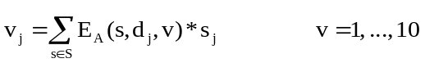 , (8.1)
where the notation was explained with reference to equation (3.1). Through (8.1), GRAD-ECAT provides a linear approximation to the USAGE-TERM relationships between driving factors and implication variables. In future research we should test the adequacy of these linear equations by comparing their outcomes for implication variables with those obtained from simulations with USAGE-TERM. Starting from these comparisons it is likely that we could find non-linear versions of (8.1) that would more accurately approximate the USAGE-TERM relationships between driving and implication variables.
Fourth, we could continue to work closely with the TRA groups to improve our understanding of the precise nature of the driving factors in the TRA scenarios. This would lead to improved representation in USAGE-TERM of these driving factors. We could also change the industrial/commodity classifications in USAGE-TERM to be more suited to TRA requirements. For example, it would be possible to provide more disaggregation of food and agriculture than in the versions of USAGE-TERM used for this project.
Finally, the present project suggests that the specification of the welfare function is an important part of GRAD-ECAT. Further research together with consultation with economists specializing in welfare economics could be expected to generate improvements in the specification of the welfare function, including the discount rate, the value of life, and the treatment of public-sector expenditures. As described in section 5, we have allowed users of GRAD-ECAT to conduct sensitivity analysis with respect to both the discount rate and the value of life.
Appendix 1. Results for the proportionality coefficients and specification of relevant variables
Tables A1 to A14 contain the proportionality coefficients computed in (6.5) to (6.8) with our final guesses for the relevant variables. There is one table for each of the 14 shock variables, s. The tables have two sections, one for coefficients calculated under Keynesian assumptions and the other for coefficients calculated under Neoclassical assumptions. In each section there are 5 panels. The first four contain the 10 coefficients (one for each implication variable) calculated from each of the four models. The fifth panel gives averages of results from the first four. It is the results from the fifth panel that we used in (6.9) to calculate the elasticities supplied to the TRA groups. The relevant variables are described at the foot of each table.

Table A1. Coefficients, C(s,v), for capital destruction (s=1)
 | Target region (d) | FL24 |  | AZ07 |  | NY14 |  | WA09 |  | Average
 | Implication variables (s) | 2015 | 2034 | 2015 | 2034 | 2015 | 2034 | 2015 | 2034 | 2015 | 2034
Keynesian
 | National
1 | GDP | -0.69 | 0.015 | -0.69 | 0.011 | -0.74 | -0.008 | -0.76 | -0.002 | -0.72 | 0.004
2 | Employment | -0.41 | 0.013 | -0.42 | 0.013 | -0.51 | 0.007 | -0.55 | -0.003 | -0.47 | 0.007
3a | Welfare, 0.05 discount rate |  | -0.041 |  | -0.038 |  | -0.045 |  | -0.044 |  | -0.042
3b | Welfare, 0.02 discount rate |  | -0.055 |  | -0.052 |  | -0.060 |  | -0.058 |  | -0.056
 | Target region
4 | GRP | -2.36 | -0.042 | -2.40 | -0.051 | -2.42 | -0.042 | -2.33 | -0.041 | -2.38 | -0.044
5 | Employment | -1.90 | 0.027 | -1.93 | 0.021 | -1.95 | 0.028 | -1.88 | 0.020 | -1.92 | 0.024
Neoclassical
 | National
1 | GDP | -0.69 | 0.015 | -0.69 | 0.011 | -0.74 | -0.008 | -0.76 | -0.002 | -0.72 | 0.004
2 | Employment | -0.41 | 0.013 | -0.42 | 0.013 | -0.51 | 0.007 | -0.55 | -0.003 | -0.47 | 0.007
3a | Welfare, 0.05 discount rate |  | -0.041 |  | -0.038 |  | -0.045 |  | -0.044 |  | -0.042
3b | Welfare, 0.02 discount rate |  | -0.055 |  | -0.052 |  | -0.060 |  | -0.058 |  | -0.056
 | Target region
4 | GRP | -2.36 | -0.042 | -2.40 | -0.051 | -2.42 | -0.042 | -2.33 | -0.041 | -2.38 | -0.044
5 | Employment | -1.90 | 0.027 | -1.93 | 0.021 | -1.95 | 0.028 | -1.88 | 0.020 | -1.92 | 0.024
Note: In our simulations, capital destruction has the same effects on the economy under Keynesian and Neoclassical assumptions. Consequently, the upper and lower sections of this table are identical. As can be seen in later tables, demand stimulation shocks (e.g. clean-up in Table 3) generate quite different coefficients in the short run (2015) under Keynesian and Neoclassical assumptions.
Relevant variables.
National: Target region’s capital as share of national capital
Regional: Capital income as share of target region’s GRP
Table A2. Coefficients, C(s,v), for reactivation of idle capital (s=2)
 | Target region (d) | FL24 |  | AZ07 |  | NY14 |  | WA09 |  | Average
 | Implication variables (s) | 2015 | 2034 | 2015 | 2034 | 2015 | 2034 | 2015 | 2034 | 2015 | 2034
Keynesian
 | National
1 | GDP | 0.00 | -0.003 | 0.00 | 0.007 | 0.00 | 0.022 | 0.00 | 0.013 | 0.00 | 0.010
2 | Employment | 0.00 | -0.038 | 0.00 | -0.039 | 0.00 | -0.036 | 0.00 | -0.028 | 0.00 | -0.036
3a | Welfare, 0.05 discount rate |  | 0.039 |  | 0.038 |  | 0.043 |  | 0.041 |  | 0.040
3b | Welfare, 0.02 discount rate |  | 0.055 |  | 0.053 |  | 0.060 |  | 0.056 |  | 0.056
 | Target region
4 | GRP | 0.00 | 0.096 | 0.00 | 0.106 | 0.00 | 0.100 | 0.00 | 0.092 | 0.00 | 0.099
5 | Employment | 0.00 | -0.006 | 0.00 | -0.001 | 0.00 | -0.007 | 0.00 | 0.000 | 0.00 | -0.003
Neoclassical
 | National
1 | GDP | 0.00 | -0.003 | 0.00 | 0.007 | 0.00 | 0.022 | 0.00 | 0.013 | 0.00 | 0.010
2 | Employment | 0.00 | -0.038 | 0.00 | -0.039 | 0.00 | -0.036 | 0.00 | -0.028 | 0.00 | -0.036
3a | Welfare, 0.05 discount rate |  | 0.039 |  | 0.038 |  | 0.043 |  | 0.041 |  | 0.040
3b | Welfare, 0.02 discount rate |  | 0.055 |  | 0.053 |  | 0.060 |  | 0.056 |  | 0.056
 | Target region
4 | GRP | 0.00 | 0.096 | 0.00 | 0.106 | 0.00 | 0.100 | 0.00 | 0.092 | 0.00 | 0.099
5 | Employment | 0.00 | -0.006 | 0.00 | -0.001 | 0.00 | -0.007 | 0.00 | 0.000 | 0.00 | -0.003
Note: The coefficients in this table are derived from simulations of the effects of bringing capital back on line at the beginning of 2016 (year 2). Consequently, the 2015 columns in this table contain only zeros: there are no effects in 2015 (year 1). As in Table 1, the upper and lower sections of this table are identical. We assume that bringing capital back on line has the same effects under Keynesian and Neoclassical assumptions.
Relevant variables.
National: Target region’s capital as share of national capital
Regional: Capital income as share of target region’s GRP
Table A3. Coefficients, C(s,v), for clean-up expenditures (s=3)
 | Target region (d) | FL24 |  | AZ07 |  | NY14 |  | WA09 |  | Average
 | Implication variables (s) | 2015 | 2034 | 2015 | 2034 | 2015 | 2034 | 2015 | 2034 | 2015 | 2034
Keynesian
 | National
1 | GDP | 1.81 | 0.000 | 1.84 | -0.009 | 1.87 | -0.008 | 1.84 | -0.014 | 1.84 | -0.007
2 | Employment | 1.65 | 0.013 | 1.68 | 0.006 | 1.71 | 0.006 | 1.69 | -0.001 | 1.68 | 0.006
3a | Welfare, 0.05 discount rate |  | -0.001 |  | -0.001 |  | 0.000 |  | -0.001 |  | -0.001
3b | Welfare, 0.02 discount rate |  | -0.006 |  | -0.006 |  | -0.005 |  | -0.006 |  | -0.005
 | Target region
4 | GRP | 0.64 | -0.009 | 0.56 | -0.008 | 0.56 | -0.007 | 0.50 | -0.008 | 0.57 | -0.008
5 | Employment | 0.72 | -0.002 | 0.59 | -0.001 | 0.56 | -0.001 | 0.53 | -0.001 | 0.60 | -0.001
Neoclassical
 | National
1 | GDP | 0.71 | -0.014 | 0.72 | -0.009 | 0.71 | -0.009 | 0.71 | -0.017 | 0.71 | -0.012
2 | Employment | 1.39 | 0.007 | 1.40 | 0.012 | 1.38 | 0.004 | 1.38 | -0.001 | 1.39 | 0.006
3a | Welfare, 0.05 discount rate |  | -0.005 |  | -0.007 |  | -0.006 |  | -0.006 |  | -0.006
3b | Welfare, 0.02 discount rate |  | -0.009 |  | -0.011 |  | -0.010 |  | -0.010 |  | -0.010
 | Target region
4 | GRP | 0.16 | -0.007 | 0.13 | -0.006 | 0.14 | -0.005 | 0.12 | -0.006 | 0.14 | -0.006
5 | Employment | 0.35 | -0.003 | 0.27 | -0.002 | 0.26 | -0.001 | 0.24 | -0.001 | 0.28 | -0.002
Relevant variables.
National: Public consumption in Target city as share of national GDP
Regional: Public consumption share of Target city’s GRP
Table A4. Coefficients, C(s,v), for public health expenditures (s=4)
 | Target region (d) | FL24 |  | AZ07 |  | NY14 |  | WA09 |  | Average
 | Implication variables (s) | 2015 | 2034 | 2015 | 2034 | 2015 | 2034 | 2015 | 2034 | 2015 | 2034
Keynesian
 | National
1 | GDP | 1.63 | 0.002 | 1.68 | 0.011 | 1.70 | 0.009 | 1.64 | 0.005 | 1.66 | 0.007
2 | Employment | 1.64 | -0.004 | 1.69 | 0.007 | 1.70 | 0.007 | 1.67 | 0.007 | 1.67 | 0.004
3a | Welfare, 0.05 discount rate |  | -0.002 |  | -0.002 |  | -0.001 |  | -0.002 |  | -0.002
3b | Welfare, 0.02 discount rate |  | -0.005 |  | -0.005 |  | -0.004 |  | -0.006 |  | -0.005
 | Target region
4 | GRP | 0.66 | 0.000 | 0.62 | -0.002 | 0.65 | -0.001 | 0.73 | -0.001 | 0.66 | -0.001
5 | Employment | 0.84 | -0.004 | 0.73 | -0.004 | 0.73 | -0.002 | 0.90 | -0.004 | 0.80 | -0.003
Neoclassical
 | National
1 | GDP | 0.46 | -0.005 | 0.48 | 0.001 | 0.46 | 0.013 | 0.46 | 0.010 | 0.46 | 0.005
2 | Employment | 0.87 | -0.008 | 0.89 | -0.002 | 0.85 | 0.007 | 0.85 | 0.005 | 0.86 | 0.001
3a | Welfare, 0.05 discount rate |  | -0.005 |  | -0.006 |  | -0.005 |  | -0.004 |  | -0.005
3b | Welfare, 0.02 discount rate |  | -0.008 |  | -0.009 |  | -0.008 |  | -0.007 |  | -0.008
 | Target region
4 | GRP | 0.21 | 0.003 | 0.19 | 0.003 | 0.20 | 0.001 | 0.26 | 0.004 | 0.21 | 0.002
5 | Employment | 0.44 | -0.005 | 0.35 | -0.002 | 0.35 | -0.003 | 0.48 | -0.003 | 0.40 | -0.003
Relevant variables.
National: Public health expenditure in Target city as share of national GDP
Regional: {Public health expenditure in Target city times share of target region in supplying health services to Target city} divided by GRP of target region
Table A5. Coefficients, C(s,v), for temporary accommodation expenses in Target city (s=5)
 | Target region (d) | FL24 |  | AZ07 |  | NY14 |  | WA09 |  | Average
 | Implication variables (s) | 2015 | 2034 | 2015 | 2034 | 2015 | 2034 | 2015 | 2034 | 2015 | 2034
Keynesian
 | National
1 | GDP | 1.54 | 0.042 | 1.55 | 0.006 | 1.58 | 0.007 | 1.56 | 0.015 | 1.56 | 0.018
2 | Employment | 1.41 | 0.049 | 1.42 | 0.006 | 1.46 | 0.005 | 1.45 | 0.019 | 1.44 | 0.020
3a | Welfare, 0.05 discount rate |  | -0.006 |  | -0.008 |  | -0.006 |  | -0.007 |  | -0.007
3b | Welfare, 0.02 discount rate |  | -0.010 |  | -0.012 |  | -0.011 |  | -0.012 |  | -0.011
 | Target region
4 | GRP | 0.64 | 0.027 | 0.76 | 0.016 | 1.01 | 0.015 | 0.72 | 0.014 | 0.78 | 0.018
5 | Employment | 0.81 | 0.021 | 0.81 | 0.009 | 1.03 | 0.007 | 0.79 | 0.008 | 0.86 | 0.011
Neoclassical
 | National
1 | GDP | 0.43 | -0.010 | 0.42 | -0.001 | 0.42 | 0.008 | 0.41 | -0.007 | 0.42 | -0.002
2 | Employment | 0.66 | -0.012 | 0.65 | -0.005 | 0.64 | 0.001 | 0.62 | -0.011 | 0.64 | -0.007
3a | Welfare, 0.05 discount rate |  | -0.011 |  | -0.013 |  | -0.011 |  | -0.011 |  | -0.011
3b | Welfare, 0.02 discount rate |  | -0.016 |  | -0.018 |  | -0.016 |  | -0.015 |  | -0.016
 | Target region
4 | GRP | 0.42 | 0.032 | 0.33 | 0.031 | 0.43 | 0.039 | 0.31 | 0.033 | 0.37 | 0.034
5 | Employment | 0.71 | 0.024 | 0.49 | 0.015 | 0.61 | 0.016 | 0.45 | 0.017 | 0.57 | 0.018
Relevant variables.
National: 0.75 times household expenditure on Hotels & restaurants in Target city as share of national GDP
Regional: 0.75 times {household expenditure on Hotels & restaurants in Target city} times {share of target region in supplying Hotels & restaurants to Target city} divided by GRP of target region

Table A6. Coefficients, C(s,v), for temporary accommodation expenses outside Target city (s=6)
 | Target region (d) | FL24 |  | AZ07 |  | NY14 |  | WA09 |  | Average
 | Implication variables (s) | 2015 | 2034 | 2015 | 2034 | 2015 | 2034 | 2015 | 2034 | 2015 | 2034
Keynesian
 | National
1 | GDP | 1.54 | 0.009 | 1.54 | 0.007 | 1.54 | 0.007 | 1.54 | 0.008 | 1.54 | 0.008
2 | Employment | 1.42 | 0.006 | 1.42 | 0.006 | 1.42 | 0.006 | 1.42 | 0.008 | 1.42 | 0.006
3a | Welfare, 0.05 discount rate |  | -0.007 |  | -0.007 |  | -0.007 |  | -0.007 |  | -0.007
3b | Welfare, 0.02 discount rate |  | -0.012 |  | -0.012 |  | -0.012 |  | -0.012 |  | -0.012
 | Target region
4 | GRP | 2.42 | 0.039 | 3.74 | -0.011 | 4.17 | -0.013 | 2.03 | 0.000 | 3.09 | 0.004
5 | Employment | 2.15 | 0.033 | 2.93 | 0.004 | 3.51 | -0.007 | 1.51 | 0.014 | 2.53 | 0.011
Neoclassical
 | National
1 | GDP | 0.43 | 0.004 | 0.43 | -0.002 | 0.43 | 0.004 | 0.43 | -0.004 | 0.43 | 0.000
2 | Employment | 0.66 | 0.001 | 0.66 | -0.002 | 0.66 | 0.005 | 0.66 | -0.004 | 0.66 | 0.000
3a | Welfare, 0.05 discount rate |  | -0.011 |  | -0.012 |  | -0.011 |  | -0.012 |  | -0.012
3b | Welfare, 0.02 discount rate |  | -0.016 |  | -0.017 |  | -0.016 |  | -0.017 |  | -0.016
 | Target region
4 | GRP | -0.06 | 0.003 | 0.71 | -0.040 | 0.92 | -0.041 | 0.13 | -0.011 | 0.42 | -0.022
5 | Employment | 1.37 | -0.003 | 1.02 | -0.015 | 1.34 | -0.023 | 0.14 | 0.016 | 0.97 | -0.006
Relevant variables.
National: 0.75 times household expenditure on Hotels & restaurants outside Target city as share of national GDP
Regional: Share of target region’s output that is sold to Rest of state & Rest of USA times 0.75 times [{household expenditure on Hotels & restaurants outside Target city} divided by GRP in Rest of state & Rest of USA]

Table A7. Coefficients, C(s,v), for foreign tourism discouragement in Target city (s=7)
 | Target region (d) | FL24 |  | AZ07 |  | NY14 |  | WA09 |  | Average
 | Implication variables (s) | 2015 | 2034 | 2015 | 2034 | 2015 | 2034 | 2015 | 2034 | 2015 | 2034
Keynesian
 | National
1 | GDP | -1.19 | -0.001 | -1.18 | 0.002 | -1.21 | 0.001 | -1.16 | 0.055 | -1.18 | 0.014
2 | Employment | -0.98 | -0.001 | -0.97 | -0.007 | -1.00 | -0.004 | -0.97 | 0.055 | -0.98 | 0.011
3a | Welfare, 0.05 discount rate |  | -0.009 |  | -0.009 |  | -0.008 |  | -0.006 |  | -0.008
3b | Welfare, 0.02 discount rate |  | -0.010 |  | -0.010 |  | -0.008 |  | -0.005 |  | -0.008
 | Target region
4 | GRP | -1.30 | -0.007 | -1.24 | 0.001 | -1.45 | 0.001 | -0.99 | 0.004 | -1.24 | 0.000
5 | Employment | -1.19 | -0.004 | -1.11 | 0.001 | -1.28 | -0.001 | -0.88 | 0.001 | -1.11 | -0.001
Neoclassical
 | National
1 | GDP | -0.19 | 0.001 | -0.19 | -0.013 | -0.19 | 0.005 | -0.18 | 0.030 | -0.18 | 0.006
2 | Employment | -0.27 | -0.001 | -0.27 | -0.012 | -0.27 | 0.003 | -0.26 | 0.037 | -0.26 | 0.007
3a | Welfare, 0.05 discount rate |  | -0.004 |  | -0.005 |  | -0.004 |  | -0.002 |  | -0.004
3b | Welfare, 0.02 discount rate |  | -0.005 |  | -0.006 |  | -0.004 |  | -0.002 |  | -0.004
 | Target region
4 | GRP | -0.28 | -0.014 | -0.24 | -0.003 | -0.27 | 0.000 | -0.20 | -0.001 | -0.25 | -0.005
5 | Employment | -0.38 | -0.007 | -0.29 | 0.000 | -0.37 | 0.000 | -0.24 | -0.001 | -0.32 | -0.002
Relevant variables.
National: Spending by foreign visitors in Target city as share of national GDP
Regional: Share of target region’s GRP that is devoted to supplying goods and services to foreign visitors in Target city

Table A8. Coefficients, C(s,v), for foreign tourism discouragement outside Target city (s=8)
 | Target region (d) | FL24 |  | AZ07 |  | NY14 |  | WA09 |  | Average
 | Implication variables (s) | 2015 | 2034 | 2015 | 2034 | 2015 | 2034 | 2015 | 2034 | 2015 | 2034
Keynesian
 | National
1 | GDP | -1.17 | -0.002 | -1.17 | -0.002 | -1.17 | -0.001 | -1.17 | 0.000 | -1.17 | -0.001
2 | Employment | -0.97 | -0.005 | -0.97 | -0.004 | -0.97 | -0.004 | -0.97 | -0.003 | -0.97 | -0.004
3a | Welfare, 0.05 discount rate |  | -0.008 |  | -0.008 |  | -0.008 |  | -0.008 |  | -0.008
3b | Welfare, 0.02 discount rate |  | -0.008 |  | -0.009 |  | -0.008 |  | -0.008 |  | -0.008
 | Target region
4 | GRP | -1.40 | 0.012 | -0.75 | -0.004 | -1.26 | -0.006 | -0.83 | 0.003 | -1.06 | 0.001
5 | Employment | -1.30 | 0.001 | -0.58 | -0.006 | -1.05 | -0.007 | -0.65 | 0.000 | -0.89 | -0.003
Neoclassical
 | National
1 | GDP | -0.19 | 0.002 | -0.19 | 0.005 | -0.19 | 0.005 | -0.19 | 0.004 | -0.19 | 0.004
2 | Employment | -0.27 | -0.001 | -0.27 | 0.002 | -0.27 | 0.001 | -0.27 | 0.000 | -0.27 | 0.001
3a | Welfare, 0.05 discount rate |  | -0.004 |  | -0.004 |  | -0.004 |  | -0.004 |  | -0.004
3b | Welfare, 0.02 discount rate |  | -0.004 |  | -0.004 |  | -0.004 |  | -0.004 |  | -0.004
 | Target region
4 | GRP | -0.09 | 0.012 | -0.15 | 0.005 | -0.32 | 0.004 | -0.18 | 0.008 | -0.19 | 0.007
5 | Employment | -0.47 | 0.001 | -0.21 | 0.001 | -0.48 | 0.001 | -0.27 | 0.001 | -0.36 | 0.001
Relevant variables.
National: Spending by foreign visitors outside Target city as share of national GDP
Regional: Spending by foreign visitors outside Target city as share of national GDP

Table A9. Coefficients, C(s,v), for domestic visitor discouragement in Target city (s=9)
 | Target region (d) | FL24 |  | AZ07 |  | NY14 |  | WA09 |  | Average
 | Implication variables (s) | 2015 | 2034 | 2015 | 2034 | 2015 | 2034 | 2015 | 2034 | 2015 | 2034
Keynesian
 | National
1 | GDP | 0.00 | 0.000 | 0.00 | 0.000 | 0.00 | 0.000 | 0.00 | 0.000 | 0.00 | 0.000
2 | Employment | 0.00 | 0.000 | 0.00 | 0.000 | 0.00 | 0.000 | 0.00 | 0.000 | 0.00 | 0.000
3a | Welfare, 0.05 discount rate |  | 0.000 |  | 0.000 |  | 0.000 |  | 0.000 |  | 0.000
3b | Welfare, 0.02 discount rate |  | 0.000 |  | 0.000 |  | 0.000 |  | 0.000 |  | 0.000
 | Target region
4 | GRP | -1.27 | 0.000 | -1.16 | -0.001 | -1.22 | -0.014 | -1.15 | -0.003 | -1.20 | -0.004
5 | Employment | -1.15 | 0.002 | -1.01 | 0.000 | -1.08 | -0.016 | -1.00 | -0.004 | -1.06 | -0.005
Neoclassical
 | National
1 | GDP | 0.00 | 0.000 | 0.00 | 0.000 | 0.00 | 0.000 | 0.00 | 0.000 | 0.00 | 0.000
2 | Employment | 0.00 | 0.000 | 0.00 | 0.000 | 0.00 | 0.000 | 0.00 | 0.000 | 0.00 | 0.000
3a | Welfare, 0.05 discount rate |  | 0.000 |  | 0.000 |  | 0.000 |  | 0.000 |  | 0.000
3b | Welfare, 0.02 discount rate |  | 0.000 |  | 0.000 |  | 0.000 |  | 0.000 |  | 0.000
 | Target region
4 | GRP | -0.38 | -0.003 | -0.24 | -0.003 | -0.20 | -0.002 | -0.27 | -0.003 | -0.27 | -0.003
5 | Employment | -0.50 | 0.000 | -0.29 | -0.001 | -0.23 | 0.002 | -0.28 | -0.002 | -0.33 | 0.000
Relevant variables.
National: Domestic visitor expenditure is allocated away from the Target city but national expenditure by domestic visitors is held constant. Thus, the expected effects at the national level are zero. Consequently, we set the relevant variable at zero.
Regional: Share of target region’s GRP that is devoted to supplying goods and services to domestic visitors in Target city

Table A10. Coefficients, C(s,v), for domestic visitor discouragement outside Target city (s=10)
 | Target region (d) | FL24 |  | AZ07 |  | NY14 |  | WA09 |  | Average
 | Implication variables (s) | 2015 | 2034 | 2015 | 2034 | 2015 | 2034 | 2015 | 2034 | 2015 | 2034
Keynesian
 | National
1 | GDP | -2.39 | -0.002 | -2.38 | -0.003 | -2.38 | -0.002 | -2.38 | -0.002 | -2.38 | -0.002
2 | Employment | -1.89 | -0.008 | -1.89 | -0.009 | -1.88 | -0.008 | -1.88 | -0.008 | -1.89 | -0.008
3a | Welfare, 0.05 discount rate |  | -0.017 |  | -0.018 |  | -0.017 |  | -0.017 |  | -0.017
3b | Welfare, 0.02 discount rate |  | -0.016 |  | -0.016 |  | -0.016 |  | -0.016 |  | -0.016
 | Target region
4 | GRP | -11.46 | 0.050 | -7.18 | -0.010 | -7.50 | -0.018 | -5.13 | 0.004 | -7.82 | 0.007
5 | Employment | -10.15 | -0.019 | -5.37 | -0.042 | -5.92 | -0.036 | -3.79 | -0.021 | -6.31 | -0.029
Neoclassical
 | National
1 | GDP | -0.29 | 0.011 | -0.29 | 0.009 | -0.29 | 0.010 | -0.29 | 0.012 | -0.29 | 0.011
2 | Employment | -0.42 | 0.000 | -0.42 | -0.001 | -0.42 | -0.001 | -0.42 | 0.002 | -0.42 | 0.000
3a | Welfare, 0.05 discount rate |  | -0.008 |  | -0.008 |  | -0.008 |  | -0.008 |  | -0.008
3b | Welfare, 0.02 discount rate |  | -0.007 |  | -0.007 |  | -0.007 |  | -0.007 |  | -0.007
 | Target region
4 | GRP | -0.25 | 0.091 | -0.66 | 0.057 | -1.17 | 0.040 | -0.43 | 0.058 | -0.63 | 0.062
5 | Employment | -3.66 | 0.025 | -0.98 | 0.002 | -1.81 | -0.002 | -0.68 | 0.002 | -1.78 | 0.007
Relevant variables.
National: Domestic visitor expenditure by U.S. residents as a share of national GDP.
Regional: Share of target region’s output that is sold to Rest of state & Rest of USA times [{domestic visitor expenditure outside Target city} divided by GRP in Rest of state & Rest of USA]

Table A11. Coefficients, C(s,v), for loss of food production in Target state (s=11)
 | Target region (d) | FL24 |  | AZ07 |  | NY14 |  | WA09 |  | Average
 | Implication variables (s) | 2015 | 2034 | 2015 | 2034 | 2015 | 2034 | 2015 | 2034 | 2015 | 2034
Keynesian
 | National
1 | GDP | -2.74 | -0.030 | -2.19 | -0.054 | -2.55 | -0.032 | -2.50 | 0.006 | -2.50 | -0.027
2 | Employment | -1.96 | -0.038 | -1.54 | -0.063 | -1.82 | -0.030 | -1.89 | 0.003 | -1.80 | -0.032
3a | Welfare, 0.05 discount rate |  | -0.019 |  | -0.017 |  | -0.024 |  | -0.019 |  | -0.020
3b | Welfare, 0.02 discount rate |  | -0.021 |  | -0.019 |  | -0.026 |  | -0.020 |  | -0.022
 | Target region
4 | GRP | -5.18 | 0.023 | -3.59 | 0.006 | -4.42 | 0.004 | -4.29 | 0.012 | -4.37 | 0.011
5 | Employment | -4.44 | 0.011 | -2.64 | 0.005 | -3.19 | 0.008 | -3.37 | 0.007 | -3.41 | 0.008
Neoclassical
 | National
1 | GDP | -2.61 | 0.012 | -2.72 | -0.013 | -2.37 | -0.014 | -2.90 | -0.002 | -2.65 | -0.004
2 | Employment | -2.35 | 0.009 | -2.49 | -0.008 | -1.92 | -0.008 | -2.71 | 0.017 | -2.37 | 0.003
3a | Welfare, 0.05 discount rate |  | -0.001 |  | -0.003 |  | -0.008 |  | -0.005 |  | -0.004
3b | Welfare, 0.02 discount rate |  | 0.000 |  | -0.005 |  | -0.008 |  | -0.006 |  | -0.005
 | Target region
4 | GRP | -1.94 | 0.011 | -1.43 | -0.012 | -1.97 | -0.013 | -1.60 | -0.005 | -1.73 | -0.005
5 | Employment | -1.87 | -0.001 | -0.92 | -0.001 | -1.30 | 0.003 | -1.16 | 0.001 | -1.31 | 0.000
Relevant variables.
National: Target state’s value added in agriculture and food production as a share of national GDP. In this simulation we hold constant national output of agriculture and food. Nevertheless, the national economy is adversely affected. With damage to the Target state’s ability to produce agriculture and food, the nation as a whole needs to devote more resources to maintain the initial national levels of output of these commodities.
Regional: Share of target region’s GRP that is accounted for by production of agriculture and food plus share of target region’s sales of all commodities that goes to Rest of target city times share of Rest of target city’s GRP that is accounted for by production of agriculture and food plus share of target region’s sales of all commodities that goes to Rest of target state times share of Rest of target state’s GRP that is accounted for by production of agriculture and food.
Table A12. Coefficients, C(s,v), for loss of food production in the U.S. (s=12)
 | Target region (d) | FL24 |  | AZ07 |  | NY14 |  | WA09 |  | Average
 | Implication variables (s) | 2015 | 2034 | 2015 | 2034 | 2015 | 2034 | 2015 | 2034 | 2015 | 2034
Keynesian
 | National
1 | GDP | -5.25 | -0.012 | -5.26 | -0.001 | -5.25 | -0.001 | -5.25 | -0.050 | -5.25 | -0.016
2 | Employment | -3.74 | -0.013 | -3.75 | -0.011 | -3.74 | -0.011 | -3.74 | -0.037 | -3.74 | -0.018
3a | Welfare, 0.05 discount rate |  | -0.037 |  | -0.036 |  | -0.036 |  | -0.039 |  | -0.037
3b | Welfare, 0.02 discount rate |  | -0.037 |  | -0.037 |  | -0.037 |  | -0.040 |  | -0.038
 | Target region
4 | GRP | -9.73 | 0.387 | -14.32 | -0.019 | -13.26 | -0.031 | -9.75 | -0.801 | -11.76 | -0.116
5 | Employment | -9.91 | 0.184 | -12.59 | -0.079 | -11.92 | -0.051 | -7.94 | -0.203 | -10.59 | -0.037
Neoclassical
 | National
1 | GDP | -1.99 | 0.009 | -1.99 | 0.010 | -1.99 | 0.010 | -1.99 | 0.010 | -1.99 | 0.010
2 | Employment | -1.38 | 0.000 | -1.38 | 0.001 | -1.37 | 0.000 | -1.38 | 0.001 | -1.38 | 0.001
3a | Welfare, 0.05 discount rate |  | -0.023 |  | -0.023 |  | -0.023 |  | -0.023 |  | -0.023
3b | Welfare, 0.02 discount rate |  | -0.024 |  | -0.024 |  | -0.024 |  | -0.024 |  | -0.024
 | Target region
4 | GRP | 0.18 | 0.205 | -2.98 | 0.089 | -3.09 | 0.047 | -1.59 | 0.106 | -1.87 | 0.112
5 | Employment | -5.35 | -0.036 | -4.58 | -0.005 | -4.79 | -0.001 | -2.51 | -0.012 | -4.31 | -0.013
Relevant variables.
National: Share of agriculture and food in national GDP.
Regional: In this simulation output of agriculture and food in the Target state is held constant. The target region is damaged through its connections with the Rest of the U.S. To capture this, we set the relevant variable as:
share of production in target region that is sold to the Rest of the U.S. times the share of agriculture and food in Rest of U.S. production plus
share of production in target region that is sold to the Rest of target city times the share of Rest of target city’s production that is sold to the Rest of U.S. times share of agriculture and food in Rest of U.S. production plus
share of production in target region that is sold to the Rest of target state times the share of Rest of target state’s production that is sold to the Rest of U.S. times share of agriculture and food in Rest of U.S. production

Table A13. Coefficients, C(s,v), for reduction in U.S. labor supply through death and injury (s=13)
 | Target region (d) | FL24 |  | AZ07 |  | NY14 |  | WA09 |  | Average
 | Implication variables (s) | 2015 | 2034 | 2015 | 2034 | 2015 | 2034 | 2015 | 2034 | 2015 | 2034
Keynesian
 | National
1 | GDP | -0.51 | -0.920 | -0.49 | -0.929 | -0.59 | -1.007 | -0.59 | -0.964 | -0.55 | -0.955
2 | Employment | -0.57 | -0.952 | -0.55 | -0.970 | -0.67 | -1.037 | -0.67 | -0.990 | -0.61 | -0.987
3a | Welfare, 0.05 discount rate |  | -2.990 |  | -2.979 |  | -2.989 |  | -2.987 |  | -2.986
3b | Welfare, 0.02 discount rate |  | -3.079 |  | -3.064 |  | -3.077 |  | -3.074 |  | -3.073
 | Target region
4 | GRP | -0.23 | -0.018 | -0.27 | -0.022 | -0.38 | -0.073 | -0.37 | -0.023 | -0.31 | -0.034
5 | Employment | -0.27 | -0.010 | -0.30 | -0.013 | -0.41 | -0.065 | -0.41 | -0.013 | -0.35 | -0.025
Neoclassical
 | National
1 | GDP | -0.19 | -0.928 | -0.19 | -0.918 | -0.23 | -1.011 | -0.23 | -0.964 | -0.21 | -0.955
2 | Employment | -0.32 | -0.962 | -0.32 | -0.956 | -0.39 | -1.052 | -0.39 | -0.993 | -0.36 | -0.991
3a | Welfare, 0.05 discount rate |  | -2.989 |  | -2.978 |  | -2.989 |  | -2.988 |  | -2.986
3b | Welfare, 0.02 discount rate |  | -3.078 |  | -3.062 |  | -3.077 |  | -3.075 |  | -3.073
 | Target region
4 | GRP | -0.10 | -0.021 | -0.10 | -0.026 | -0.14 | -0.077 | -0.14 | -0.028 | -0.12 | -0.038
5 | Employment | -0.17 | -0.011 | -0.17 | -0.014 | -0.24 | -0.065 | -0.24 | -0.014 | -0.20 | -0.026
Relevant variables.
National: The shock is the percentage reduction in the workforce through death and injury. We anticipate that national variables do not depend on the target region. Thus we set RV at one.
Regional: For 2015 we use 1/LabSupSh(target city), that is the reciprocal of the Target city’s share in national labor supply.
For 2034 we use [ LabSupSh(target city) + 0.01]/ LabSupSh(target city).

Table A14. Coefficients, C(s,v), for permanent aversion to working in target region (s=14)
 | Target region (d) | FL24 |  | AZ07 |  | NY14 |  | WA09 |  | Average
 | Implication variables (s) | 2015 | 2034 | 2015 | 2034 | 2015 | 2034 | 2015 | 2034 | 2015 | 2034
Keynesian
 | National
1 | GDP | 0.00 | 0.000 | 0.00 | 0.001 | 0.00 | -0.004 | 0.00 | -0.004 | 0.00 | -0.001
2 | Employment | 0.00 | 0.000 | 0.00 | 0.001 | 0.00 | -0.005 | 0.00 | -0.004 | 0.00 | -0.002
3a | Welfare, 0.05 discount rate |  | 0.000 |  | 0.000 |  | 0.000 |  | 0.000 |  | 0.000
3b | Welfare, 0.02 discount rate |  | 0.000 |  | 0.001 |  | -0.001 |  | 0.000 |  | 0.000
 | Target region
4 | GRP | -0.72 | -1.445 | -0.83 | -1.528 | -0.85 | -1.533 | -0.82 | -1.506 | -0.81 | -1.503
5 | Employment | -0.83 | -1.669 | -0.91 | -1.651 | -0.92 | -1.639 | -0.90 | -1.649 | -0.89 | -1.652
Neoclassical
 | National
1 | GDP | 0.00 | 0.000 | 0.00 | 0.001 | 0.00 | -0.004 | 0.00 | -0.004 | 0.00 | -0.002
2 | Employment | 0.00 | 0.000 | 0.00 | 0.001 | 0.00 | -0.005 | 0.00 | -0.004 | 0.00 | -0.002
3a | Welfare, 0.05 discount rate |  | 0.000 |  | 0.000 |  | 0.000 |  | 0.000 |  | 0.000
3b | Welfare, 0.02 discount rate |  | 0.000 |  | 0.000 |  | -0.001 |  | 0.000 |  | 0.000
 | Target region
4 | GRP | -0.27 | -1.448 | -0.28 | -1.532 | -0.28 | -1.537 | -0.27 | -1.510 | -0.27 | -1.507
5 | Employment | -0.46 | -1.670 | -0.46 | -1.651 | -0.46 | -1.639 | -0.46 | -1.649 | -0.46 | -1.652
Relevant variables.
National: The shock is aversion to working in the target region, introduced in the simulations by an inward movement of the labor-supply curve to that region. We anticipate no discernable effect on national variables. Consequently, we set the RV at zero.
Regional: Labor share in target region’s GRP

A1.1. Overview of results for the proportionality coefficients
Recall that our objective was to find relevant variables such that for any given shock variable (s), implication variable (v) and assumption A, the four coefficients , , and calculated in (6.5) to (6.8) have closely matching values. Looking through the 14 tables we see that this objective is largely met when v is a year-1 national variable or an accumulated welfare variable. For example, in Table A1, the four Keynesian coefficients for v equals year-1 national GDP and s equals capital destruction are
-0.69, -0.69, -0.74 and -0.76. The average is -0.72. Each coefficient is within 6 per cent of the average. The impression that the four coefficients are satisfactorily consistent if v is a year-1 national variable or accumulated welfare variable and s is any shock variable is reinforced in Figures 1 to 4 and 9 to 12. These figures are graphical presentations of coefficients from Tables A1 to A14 for year-1 national variables and accumulated welfare variables, and all shocks. For example, the first four bars in Figure 1 represent the year-1 GDP coefficients under Keynesian assumptions for the capital destruction shock (that is,
-0.69, -0.69, -0.74, -0.76). The only somewhat ragged outcomes in Figures 1 to 4 and 9 to 12 are for the target-region food shock (indicated in the figures by T11, derived from Table A11). This implies that we can be less confident about elasticities for year-1 national variables and accumulated welfare variables with respect to food destruction shocks than about elasticities for these variables with respect to other shocks.
The results for year-1 regional variables shown in Figures 5 to 8 are less satisfactory than those for year-1 national variables (Figures 1 to 4). What this means is that we have been less successful in finding relevant variables when v is a regional variable than when v is a national variable. Put another way, we understand better how USAGE-TERM generates national results than regional results. An implication is that while we might be quite confident about our calculations of the national year-1 effects and accumulated welfare effects of a shock of type s occurring in region d, we can be less confident about the effects in region d itself.
What about the year-20 coefficients for output and employment at the national and regional levels? For all of the shocks except deaths and aversion (shocks 13 and 14) we would expect long-run output and employment effects to be approximately zero. This is borne out in Tables A1 to A12 which show very small year-20 coefficient values for national and regional output and employment. These small coefficients lead to small elasticities implying, realistically, that the national and regional economies will return to normal over the long run following shocks such as capital destruction, clean-up expenditures, loss of visitors etc. Consequently, it is not important that the year-20 coefficients for a given shock variable are not even consistent in sign across our four models. For example, Table A1 shows the four Keynesian coefficients for v equals year-20 national GDP and s equals capital destruction as 0.015, 0.011, -0.008 and -0.002. While these may seem quite different, the right interpretation is that they are consistent in the sense of being close to zero.
Deaths (shock 13) reduce long-run labor supply. Consequently, the year-20 coefficients for national and regional output and employment in Table A13 are quite large relative to the corresponding year-1 coefficients. In fact for national output and employment the year-20 coefficients are larger in absolute size than the year-1 coefficients. For example, the average
Figure 1. Year-1 GDP coefficients for the 14 driving factors under Keynesian assumptions
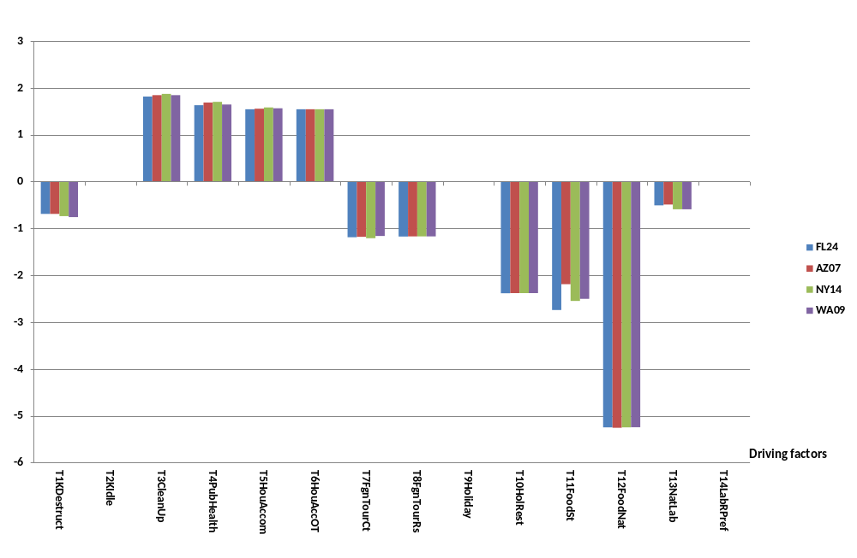

Figure 2. Year-1GDP coefficients for the 14 driving factors under Neoclassical assumptions
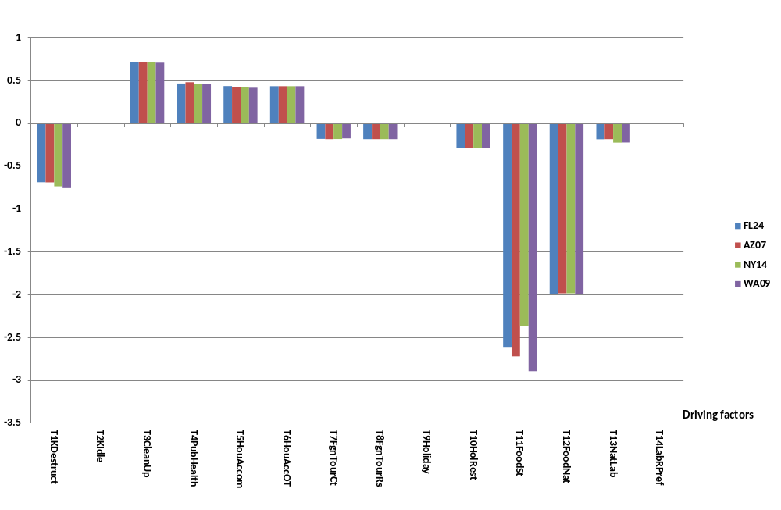
Figure 3. Year-1 National employment coefficients for the 14 driving factors under Keynesian assumptions
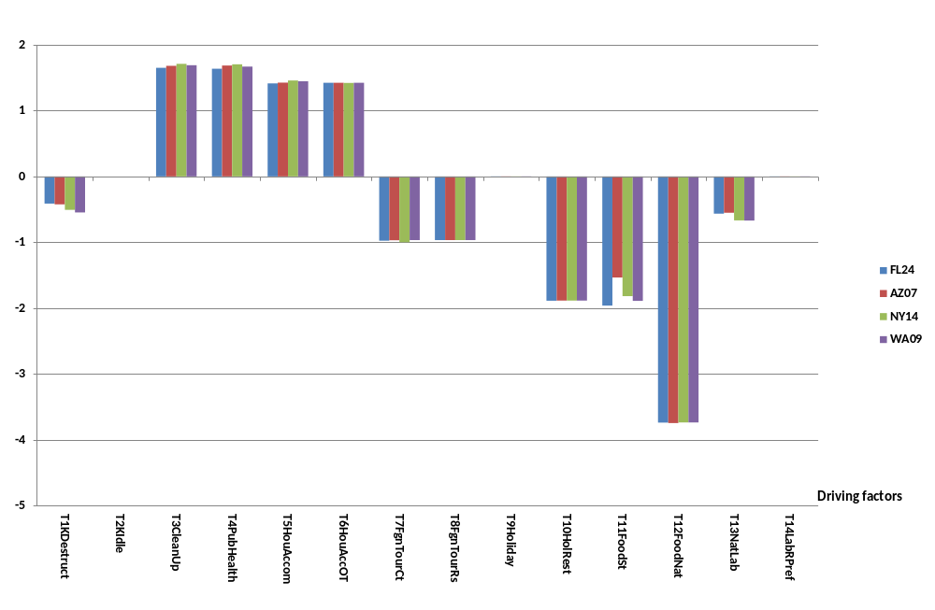

Figure 4. Year-1 National employment coefficients for the 14 driving factors under Neoclassical assumptions
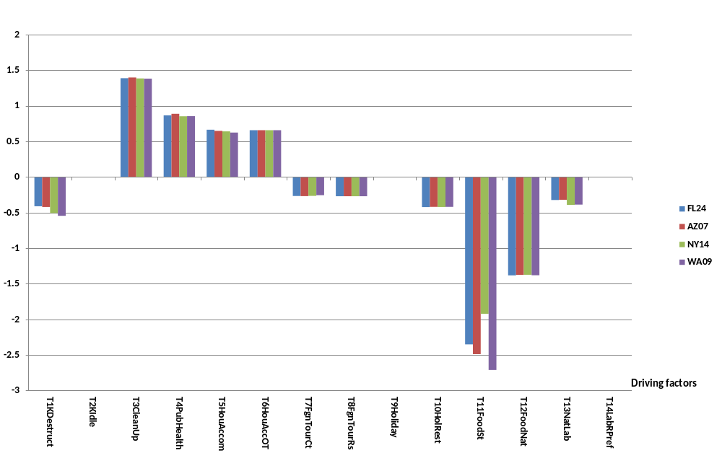

Figure 5. Year-1 GRP coefficients for the 14 driving factors under Keynesian assumptions
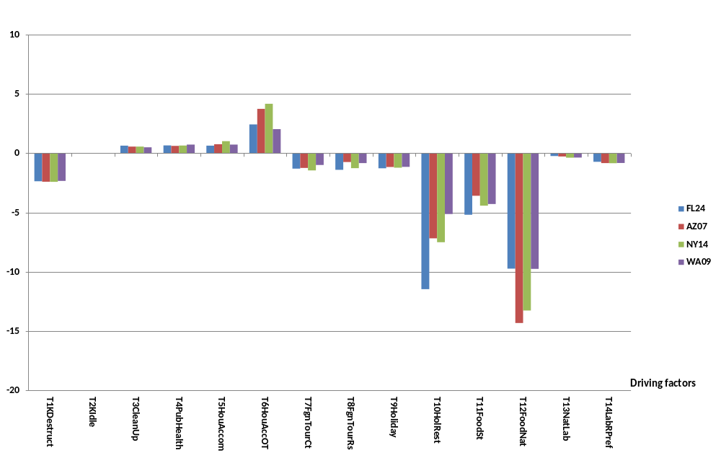

Figure 6. Year-1 GRP coefficients for the 14 driving factors under Neoclassical assumptions
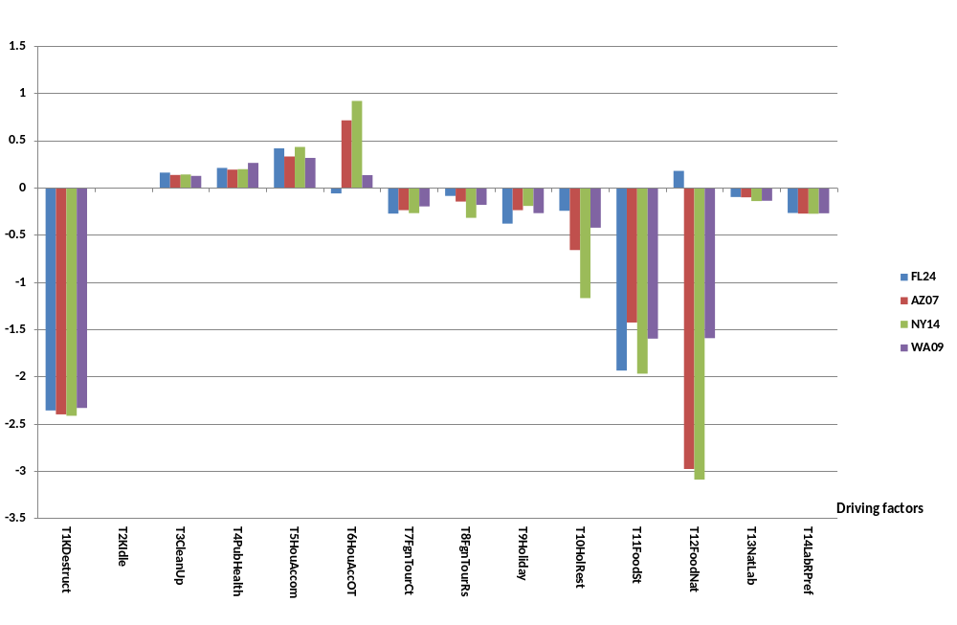

Figure 7. Year-1 target region employment coefficients for the 14 driving factors under Keynesian assumptions
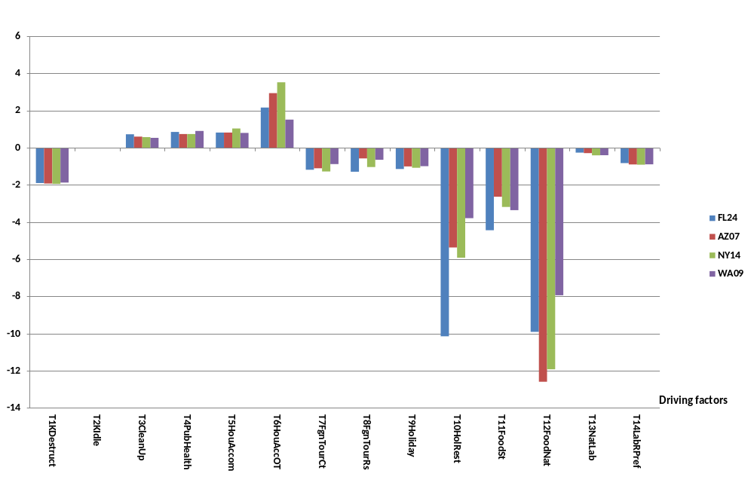

Figure 8. Year-1 target region employment coefficients for the 14 driving factors under Neoclassical assumptions
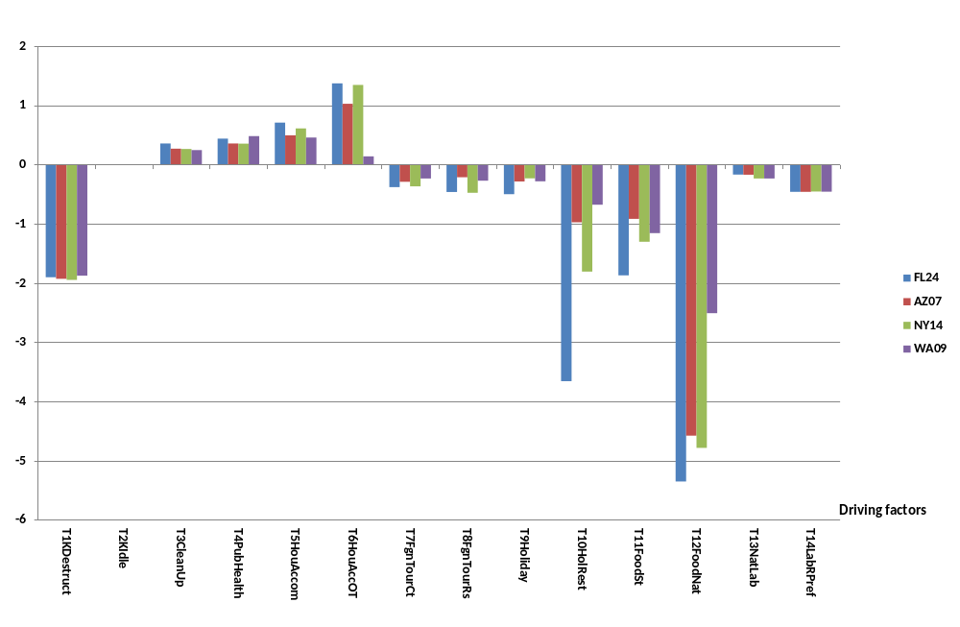
Figure 9. Coefficients for cumulative welfare with discount rate 0.05 for the 14 driving factors under Keynesian assumptions
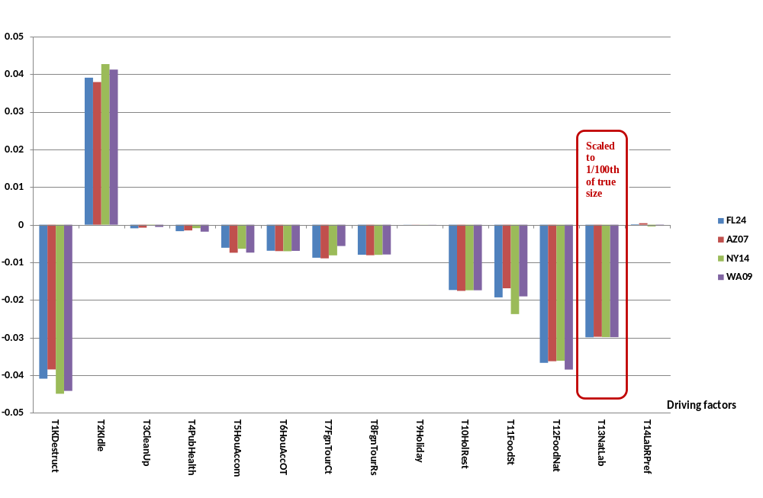

Figure 10. Coefficients for cumulative welfare with discount rate 0.05 for the 14 driving factors under Neoclassical assumptions
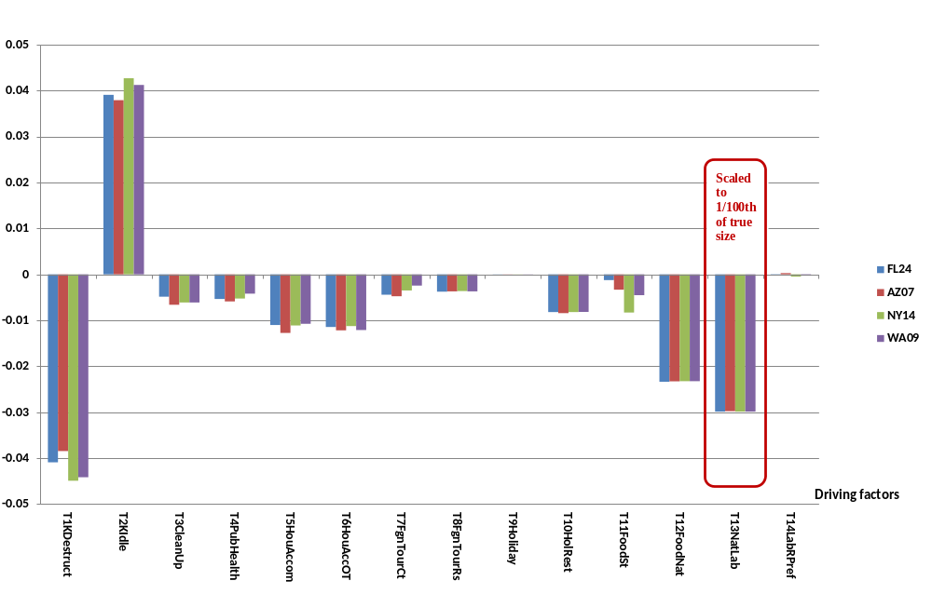
Figure 11. Coefficients for cumulative welfare with discount rate 0.02 for the 14 driving factors under Keynesian assumptions
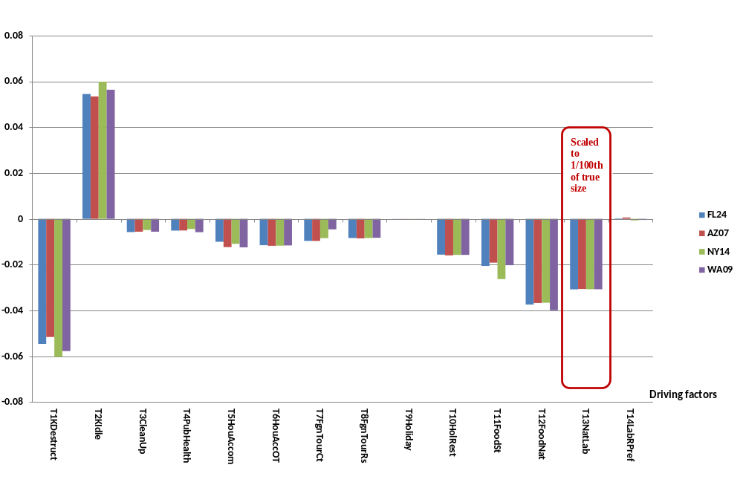

Figure 12. Coefficients for cumulative welfare with discount rate 0.02 for the 14 driving factors under Neoclassical assumptions
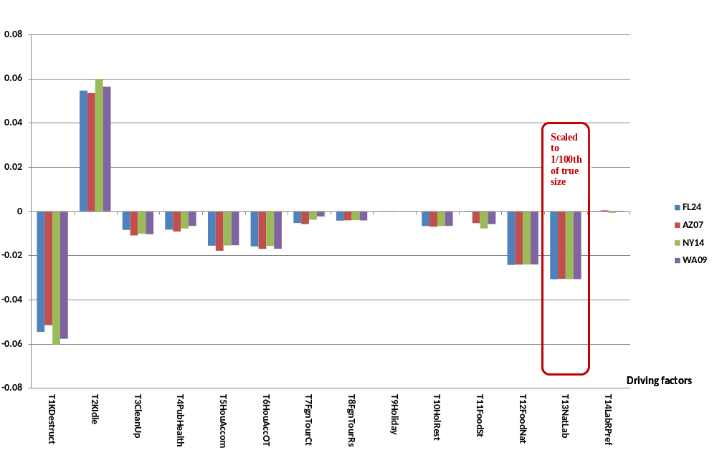

year-20 Keynesian coefficient for GDP is -0.955 whereas the corresponding year -1 coefficient is -0.55. In the short run loss of workers is compensated to some extent by a reduction in unemployment. This effect disappears in the long run when the unemployment rate returns to its normal level. Similar to the situation with the year-1 coefficients, the year-20 coefficients for output and employment exhibit a satisfactory level of consistency for all shocks across our four models at the national level but are less satisfactory at the regional level.
Aversion (shock 14) has regional effects but negligible national effects. The regional effects are sustained. Consequently, Table A14 shows relatively large year-20 coefficients for regional output and employment. These are consistent across our four models. Consequently we can be reasonably confident about the long-run elasticities of regional output and employment with respect to aversion.
A1.2. Notes on the relevant variables
In most cases the choice of relevant variable was straightforward and is adequately explained by the notes in Tables A1 to A14. Here we provide some additional notes on the more difficult cases.
The first case for which further explanation is warranted is the relevant variable in Table A4 for s equals public health and v equals regional output and employment. In designing this relevant variable we assumed that the target region maintains its share in the production of the Target city’s public health services. This gave us the numerator of the relevant variable. The denominator is the target region’s GRP. Thus the relevant variable is an estimate of the percentage impact boost to the target region’s economy of a 1 per cent increase in public health expenditures in the Target city.
In Table A5 the relevant variable for s equals accommodation expenditure and v equals regional output and employment reflects a similar approach to that for the regional RV in Table A4. In simulating the effects of accommodation expenditures, we assume that only 75 per cent are “additional”. We assume that the remaining 25 per cent is financed by reductions in household expenditure on other items. This explains the appearance of “0.75” in the definitions of the relevant variables at the foot of Table A5. The same explanation applies to the “0.75” in the RVs in Table A6 for accommodation expenses outside the Target city.
For understanding the regional RV variable in Table A6, the easiest place to start is the term in square brackets. This indicates the importance to the economy outside the Target city of a boost in accommodation expenditure. To translate this into implications for the target region we multiply by the share of the target region’s output that is sold outside the Target city. A similar approach was used in defining the regional RV in Table A10.
The shock variable in Table A8 is foreign visitor expenditure outside the Target city. The notes at the foot of the table indicate that foreign tourism expenditure outside the Target city as a share of GDP was used as the RV for both national and regional variables. This was satisfactory for the national implication variables. However, at the regional level the coefficients showed considerable instability. We tried various other specifications for the regional RV including adding a multiplicative term (as in Table A6) to take account of sales from the target region to outside the Target city. However, the results were not improved.
In defining the regional RV variable in Table A11 we take account of the target region’s own production of agriculture and food. We also recognize that the target region loses from its connections with the Rest of the target city and the Rest of the target state. Both these latter regions are directly affected by loss of food production.
The regional RV in Table A12 captures second-round effects as well as first-round effects. The first-round effect comes through the share of the target region’s sales that goes to the Rest of U.S. multiplied by the damage to the Rest of U.S. encapsulated by the share of U.S. output accounted for by agriculture and food. The second-round effects come through the share of the target region’s sales that go to Rest of city and Rest of state multiplied by the first-round effects on these latter two regions. We went to this level of complexity in a long search for a satisfactory regional RV. As can be seen from the results in Table A12, we were not successful, at least for year-1 GRP under Neoclassical assumptions. There, the four coefficients are inconsistent even in sign: 0.18, -2.98, -3.09 and -1.59. The GRP result (0.18) for FL24 is particularly strange, especially in light of the regional employment coefficient
(-5.35) which is broadly in line with the other regional employment coefficients.
Eventually, we traced the strange Neoclassical FL24 result for the GRP coefficient to the treatment of indirect taxes in USAGE-TERM. Loss of food production in the U.S. stimulates international trade, both exports and imports. Imports are stimulated directly by the necessity to supplement diminished supplies of agricultural and food products. This weakens the exchange rate and stimulates exports. Import and export flows carry taxes that are credited in USAGE-TERM to the GRPs of the regions in which imports enter the U.S. and exports leave the U.S. FL24 has a major port which is not the case for AZ07, NY14 and WA09. Stimulation of tax-carrying flows (in this case trade flows) increases GRP of the region to which the taxes are credited. This doesn’t necessarily increase the region’s employment. Thus we get the lopsided result for FL24 in which it looks as though loss of U.S. food production is good for the region’s GRP but bad for employment.
This result is not realistic and the treatment of indirect taxes should be revised in future versions of USAGE-TERM. Without such revision we should have ignored the Neoclassical FL24 year-1 GRP coefficient in Table A12: there is no reason to suppose that the true GRP coefficient, uncontaminated by faulty treatment of indirect taxes, is out of line with the coefficients for the other three target regions. Fortunately however the damage to the elasticity estimates supplied to the TRA groups is limited, even for the Neoclassical elasticities of year-1 GRP with respect to loss of U.S. food output. This is because it is only the average coefficient (-1.87) that enters the elasticity calculations. It would have been preferable to set this average at -2.55, the average of -2.98, -3.09 and -1.59.
The last relevant variables for which we will provide explanations are the pair of regional RVs at the foot of Table A13. This is the only example of separate RVs for year 1 (2015) and year 20 (2034). The interpretation of the year-1 regional RV is straightforward. If the target region has x per cent of the nation’s employment and y per cent of the nation’s workforce is killed or injured in the target region, then 100*y/x per cent of the target region’s labor force is killed or injured. We are assuming that scenarios are feasible in the sense that y is less than x. Our choice of regional RV for year 1 is then based on the assumption that for a given y, damage to the target region is proportional to 1/x. Our first guess for the regional RV for year 20 was one. We expected the long-run effect on the target region of any given y to be independent of the target region. This would be the case if the recovery of a target region was completed by year 20 leaving its percentage labor-force loss no greater than that of other regions. However, our simulations suggest that target-region recovery takes more than 20 years. We attempted to capture this idea by making the year-20 regional RV one plus 0.01/x. The “0.01” was chosen to achieve as much consistency as possible across the year-20 regional coefficients while 1/x reflects the initial damage from which the target region is recovering. Despite considerable experimentation, it is apparent from Table A13 that our final choice for the year-20 regional RV was not highly successful. For example, the Keynesian year-20 coefficients for target region GRP vary between -0.073 and -0.018.
Appendix 2. Archives: USAGE-TERM simulations, elasticity matrices and contribution calculations
This project has required the construction of 4 USAGE-TERM models each with a different Target region. Using these models we have conducted 104 simulations: 4 models, each with 14 driving factors and including two assumptions, Keynesian and Neoclassical, for all but two of the driving factors (104= 4*14 * 2 – 4*2). Recall that we need only one assumption for the two capital driving factors because we assume that the effects of capital destruction and capital idling are the same under Keynesian and Neoclassical assumptions.
Using results from the 104 simulations together with data items (the RVs), we have computed proportionality coefficients, C_{A}(s,v), and estimated elasticities, E_{A}(s,d,v). In total we supplied 47,600 elasticities to the TRA groups: 14 shock variables (s); 170 Target regions (d); 10 implication variables (v) and 2 assumptions (A). We have also computed contribution matrices for sample scenarios.
Considerable effort was needed to store all of the information generated in this project. We have stored the 4 models and the ingredients for the 104 simulations so that they can be rerun. We have also stored the elasticity calculations, made according to equation (6.9) with the proportionality coefficients from equations (6.5) to (6.8) and relevant variables defined at the foot of Tables A1 to A14. Finally, we have stored the contribution calculations described in section 7.
Making this storage effort is required so that the elasticities supplied to the TRA groups can be reproduced and audited. Equally important, careful archiving means that the large volume of work that has been undertaken for this project can be an immediate springboard for further development of GRAD-ECAT as a tool for analysis of terrorism events.
The method we have used to solve the problem of archiving and replication is to create a single zip file, allzip.zip. Using this zip requires GEMPACK software. The zip and the associated GEMPACK software are available from the Centre of Policy Studies. For the zip contact Glyn.Wittwer@vu.edu.au and for the software contact Michael.Jerie@vu.edu.au.
Apart from GEMPACK related programs the zip contains this paper together with an extended version of the instructions given here.
A2.1. Restoring simulations from archive
The zip file Allzip.zip contains all the files necessary to replicate the simulations, elasticity estimates and contribution calculations described in this report.
It is important to use exactly the folder names as described in the archive. Any variation from this will create problems with using the *.ds1 files which contain RunDynam simulation details.
- Create new directory c:\DHSarchive. Save the archive Allzip.zip to this directory.
- In a DOS box in this directory type
unzip Allzip.zip
Before the next step, ensure that you do not have directory c:\rundynam\seattle, c:\rundynam\phoenix, c:\rundynam\NewYork and c:\rundynam\miami on your PC.
- Then run the batch file restore [this assumes that the zips are in c:\DHSarchive]
[Note that this paper will be restored as TRA_CoPSreport_070317.docx to the c:\DHSarchive directory]
- Next go to the directory c:\rundynam and in DOS type
dir rundynam*.exe
- If you have only one rundynam.exe, type the following in DOS:
Copy rundynam.exe rundynam2.exe
Copy rundynam.exe rundynam3.exe
Copy rundynam.exe rundynam4.exe
Without the above step, the various batch files which run the simulations will only work for Phoenix.
A2.2. Running the simulations
- The next step is to check that the ingredients are present for a single simulation. On page 5 of this document, the RunDynam closure/shock page is shown for Phoenix1n. Open RunDynam, and under File – Load Simulation Details … go to the c:\rundynam\Phoenix directory and restore ingredients Phoenix1n.ds1. This should look like the first RunDynam view shown on page 5. You may wish to check the ingredients for a single run for all four cities before attempting to run the simulations.
- Close Rundynam. In a DOS box in c:\rundynam\Phoenix, type PhoenixRuns. This batch if run successfully will do 26 simulations for Phoenix.
- While this is running, open a new DOS box in c:\rundynam\NewYork. This time, type NewYorkRuns. This will run 26 simulations of New York using Rundynam2.
- Next, open a DOS box in c:\rundynam\Miami. This time, type MiamiRuns. This will run 26 simulations of Miami using Rundynam3.
- Next, open a DOS box in c:\rundynam\Seattle. This time, type SeattleRuns. This will run 26 simulations of Seattle using Rundynam4.
- To undertake all 26 simulations for the four cities may take three hours or so on a quad processor PC.
A2.3. Processing solutions to produce elasticities E_{A}(s,d,v) and contributions of driving factors to economic implication variables
- In a DOS box in c:\rundynam\Seattle, type RnAllSol.
[Produces: row01n.har; Row02k.har & Row02n.har; …; Row14k.har & Row14n.har. Note Row01k.har is not included as it is equal to Row01n.har. The Header “Tab4” in these files populates the coefficients C(s,v) in Tables A1 to A14 in Appendix 1.]
- Change to c:\rundynam\Seattle\elastic. In a DOS box, type
cmbhar –sti cmbrows.sti
[Produces: allrowS.har, a combination of the Row har files produced at step 12]
- To obtain a set of solution files for macros and relevant variables, type
cmbhar –sti cmbLONG.sti
[Produces diagnostic material used in checking]
- Then type
elastic2 –cmf elastic2.cmf
[This produces elastic2.har which contains elasticities E_{A}(s,d,v) for 170 target regions. In the Keynesian case, these are in header “KCEL”, and in the Neoclassical case they are in “NCEL”.
Header KCEL(all, FL24,all) contains Table 6.2
Header KCEL(all, CA34,all) contains Table 6.4
Header NCEL(all, FL24,all) contains Table 6.3
Header NCEL(all, CA34,al,) contains Table 6.5 ]
- Type
tablo –pgs scenarios
- Type
gemsim –cmf scenarios.cmf
[Scenarios.cmf reads 4 input files and produces 1 output file
The input files are:
Infile = Elastic2.har; This is the elasticity header file produced step 15
Shocks = Shock.har; This is the Header file of shocks reported in Table 7.1
WeightElas = WeightElas.har; This is a data file provide by CoPS
QCAPmaster = QCAPmaster.har; This is another data file provide by CoPS

The output file is
Outfile = scenarios.har; This file contains the contributions to the results for the 10 implication variables of the shocks to the 14 driving factors for all 170 target regions and for Keynesian assumption (Header “PCKY”) and Neoclassical assumptions (Header “PCNE”).
Header “PCKY” (all,all,FL24) contains the lower panel of Table 7.4 which contains the contributions of driving factors to economic implication variables in FL24 for the shocks in Table 7.2 under Keynesian assumptions.
Header “PCNE” (all,all,FL24) contains the lower panel of Table 7.5 which contains the contributions of driving factors to economic implication variables in FL24 for the shocks in Table 7.2 under Neoclassical assumptions.

Also in this header array file are the shocks in percentage change format for all 170 congressional districts of interest. Header “PC0K” (All,FL24,All) contains the shocks in Table 7.2 of the paper and Header “PC0K” (All,CA34,All) contains the shocks in Table 7.3.]
References
Chen, Z., A. Rose, F. Prager and S. Chatterjee (2016), “Economic consequences of aviation systems disruptions: a reduced-form computable general equilibrium analysis”, Transportation Research Part A, http://dx.doi.org/10.1016/j.tra.2016.09.027 .
Dixon, P.B. and M.T. Rimmer (2002), Dynamic General Equilibrium Modelling for Forecasting and Policy: a Practical Guide and Documentation of MONASH, Contributions to Economic Analysis 256, North-Holland Publishing Company, Amsterdam, pp. xiv+338.
Dixon, P.B. and M.T. Rimmer (2004), “The US economy from 1992 to 1998: results from a detailed CGE model”, Economic Record, Vol. 80(Special Issue), September, pp.S13-S23.
Dixon, P.B. and M.T. Rimmer (2010), “Validating a detailed, dynamic CGE model of the U.S.”, Economic Record, 86(Special issue), September, 2010, pp. 22-34.
Dixon, P.B. and M.T. Rimmer (2011), “You can’t have a CGE recession without excess capacity”, Economic Modelling, Vol. 28(1-2), January-March, pp. 602-13.
Dixon, P.B. and M.T. Rimmer (2013), “Validation in CGE modeling”, chapter 19 in P.B. Dixon and D.W. Jorgenson (editors) Handbook of Computable General Equilibrium Modeling, Elsevier, Amsterdam.
Dixon, P.B., M.T. Rimmer and M.E. Tsigas (2007a), “Regionalizing results from a detailed CGE model: macro, industry and state effects in the U.S. of removing major tariffs and quotas”, Papers in Regional Science, Vol. 86(1), March, pp. 31-55.
Dixon, P.B., S. Osborne and M.T. Rimmer (2007b), “The economy-wide effects in the United States of replacing crude petroleum with biomass”, Energy and Environment, 18(6), pp. 709-722.
Dixon, P.B., Bumsoo Lee , Todd Muehlenbeck , Maureen T. Rimmer, Adam Z. Rose and George Verikios (2010) “Effects on the U.S. of an H1N1 epidemic: analysis with a quarterly CGE model” Journal of Homeland Security and Emergency Management: Vol. 7 : Iss. 1, Article 75.
Dixon, P.B., M. Johnson and M.T. Rimmer (2011a), “Economy-wide effects of reducing illegal immigrants in U.S. employment” Contemporary Economic Policy, Vol. 29(1), January, pp. 14-30.
Dixon, P.B., J.A. Giesecke, M.T. Rimmer and A. Rose, (2011b) "The economic costs to the U.S. of closing its borders: a computable general equilibrium analysis". Defence and Peace Economics. Vol. 22(1), February, pp. 85–97.
Dixon, P.B., R.B. Koopman and M.T. Rimmer (2013), “The MONASH style of CGE modeling: a framework for practical policy analysis”, chapter 2 in P.B. Dixon and D.W. Jorgenson (editors) Handbook of Computable General Equilibrium Modeling, Elsevier, Amsterdam.
Dixon, P.B., M.T. Rimmer and B.W. Roberts (2014) “Restricting employment of low-paid immigrants: a general equilibrium assessment of the social welfare implications for legal U.S. wage-earners” Contemporary Economic Policy, vol. 32(3), pp. 639-52.
Fox, A., W. Powers and A. Winston (2008) , “Textile and Apparel Barriers and Rules of Origin: What’s Left To Gain after the Agreement on Textiles and Clothing?”, Journal of Economic Integration, Vol. 23(3), pp. 656-84.
Garnaut, R. (2016), “Economic analysis versus business rent seeking: the eclipse of analysis in Australia”, chapter 3 in Hal Hill and Jayant Menon (editors), Managing globalization in the Asian century, ISEAS Yusof Ishak Institute, Singapore.
Gehlhar, M., A. Somwaru, P.B. Dixon, M.T. Rimmer and A.R. Winston (2010), “Economywide Implications from US Bioenergy Expansion”, American Economic Review: Papers & Proceedings, Vol. 100(3), May, pp. 172-77.
Giesecke, J.A. (2011) “Development of a large-scale single U.S. region CGE model using IMPLAN data: A Los Angeles County example with a productivity shock application” Spatial Economic Analysis, vol. 6(3).
Giesecke, J.A., W. Burns, A. Barret, E. Bayrak, A. Rose, P. Slovic and M. Suher (2013), “Assessment of the regional economic impacts of catastrophic events: CGE analysis of resource loss and behavioral effects of an RDD attack scenario”. Risk Analysis, 32(4), pp. 583-600.
Harrison M. (2010), Valuing the Future: the social discount rate in cost-benefit analysis, Productivty Commission, Australian Government, Canberra, pp. IX + 175, available at https://papers.ssrn.com/sol3/papers.cfm?abstract_id=1599963 .
Horridge, J.M., J.R. Madden and G. Wittwer (2005), “Impact of the 2002-03 Drought on Australia”, Journal of Policy Modeling, 27(3), pp. 285-308.
Partnoy, F. (2012), “The cost of a human life, statistically speaking”, available at http://www.theglobalist.com/the-cost-of-a-human-life-statistically-speaking/ .
Rose, A., F. Prager, Z. Chen and S. Chatterjee (2017), Economic consequence analysis tool (E-CAT), Springer, Tokyo.
United States International Trade Commission (2004, 2007, 2009, 2011 & 2013), The Economic Effects of Significant U.S. Import Restraints: Fourth, Fifth, Sixth, Seventh & Eighth Update, Investigation no. 332-325, Publications 3701, 3906, 4094, 4253 & 4440.
Wittwer G. editor, (2012), Economic Modeling of Water: the Australian CGE experience, Springer, Dordrecht, Heidelberg, Germany.
Zahniser, S., T. Hertz, P.B. Dixon and M.T. Rimmer (2012), “Immigration policy and its possible effects on U.S. agriculture and the market for hired farm labor: a simulation analysis”, American Journal of Agricultural Economics, vol. 94(2), January, pp. 477-82.

This contains data for 400 industries in 436 congressional districts.
This refers to capital being taken out of use temporarily during, for example, a decontamination period.
An elasticity is the percentage effect on one variable of a 1 per cent change in another variable.
The theory underlying USAGE is based on Dixon and Rimmer (2002).
Applications of USAGE by the U.S. International Trade Commission can be found in USITC(2004, 2007, 2009, 2011 and 2013).
Published USAGE papers include: Dixon and Rimmer (2004, 2010, 2011 and 2013); Dixon et al. (2007a&b, 2010, 2011a&b, 2013 and 2014); Fox et al. (2008); Gehlhar et al. (2010); Giesecke (2011); Giesecke et al. (2012); and Zahniser et al. (2012).
See Dixon et al. (2007a).
See U.S. International Trade Commission (2004).
See Horridge et al. (2005).
See http://www2.census.gov/econ2010/CBP_CSV/ .
See, for example, Wittwer (2012).
These are real discount rates, that is they are applied after correcting values of future variables for changes in the price level.
See for example, Harrison (2010) and Garnaut (2016, section 3.1).
See https://www.federalregister.gov/documents/2011/02/11/2011-3044/discount-rates-for-cost-effectiveness-analysis-of-federal-programs .
We assume zero inflation or equivalently that next year’s dollar is adjusted for inflation.
DHS is following the Department of Transportation, see https://www.transportation.gov/sites/dot.gov/files/docs/VSL%20Guidance%202016.pdf . For earlier estimates of the value of life see Partnoy, (2012).
This is an average of the numbers used by the Environmental Protection Agency, the Food and Drug Administration and the Department of Transformation in 2012, see Partnoy (2012).
CV is the amount of money in the changed situation that households would need to be given to allow them to achieve the same level of utility as in the initial simulation. In the estimation of CV, commodity prices applying in the changed situation are used. EV is the amount of money in the initial situation that households would be willing to pay to avoid moving to the changed situation. In the estimation of EV, commodity prices applying in the initial situation are used. In USAGE-TERM, changes in real consumption between the initial and changed situations in each year are calculated using prices about half-way between the initial and changed prices. Thus, USAGE-TERM results for welfare effects computed as real consumption deviations are typically between those indicated by CV and EV.
This is calculated as 170 models times 20 years times 14 shocks times 2 runs (baseline & perturbation) times 2 sets of assumptions (Keynesian and Neoclassical).
Latitudes and longitudes for geographic centers of congressional districts can be obtained from U.S. Census data at http://www.census.gov/geo/maps-data/data/gazetteer2013.html . Approximate distances can then be calculated by applying Pythagoras to differences in latitudes and differences in longitudes.
E_{A}(•,d,•) is the 14 by 10 matrix with components E_{A}(s,d,v).
Notice that we assume that the same relevant variable will be adequate under either assumption A. This is not theoretically necessary but proved to be a non-damaging simplification.
After one year, public expenditure returns to its baseline path. We adopt this approach for all of the expenditure shocks (rows 3 to 6).
Includes outputs of all agricultural and processed food products.
As can be seen from Table 6.1, FL24’s “state” doesn’t cover the whole of Florida. Nevertheless, for convenience we will refer to it as Florida.
This means small in absolute size relative to the corresponding year-1 coefficient. For example, the average year-20 Keynesian coefficient for GDP with respect to capital destruction (0.004) is small relative the corresponding year-1 coefficient (-0.72), see Table A1.

