Is Japanese economic growth possible under a decrease in population? : Policy implication of dynamic spatial CGE model with endogenous growth mechanism

Abstract
This paper tried to measure influences of population decline in matured economy like Japan with consideration of mutual relations of technological progress and population growth. The spatial dynamic computable general equilibrium model (SD-CGE model) was used to concretely show the future situation of economy. The simulation results demonstrated that (i)technological progress caused by knowledge capital stocks is critical for keeping the GDP level as the present situation in Japan where population is decreasing, (ii) in urban area, such as Kanto region, GDP can continue to increase, because inflow of fund and labor force occurs, but other regions face serious decline in GDP, (iii) Japan cannot achieve 600 trillion yen ( 5.5 trillion dollars) of GDP in the future under population decline, which is the policy target of Japan, even if the past invested capital stocks in our society was taken into accounts, (iv) furthermore, the more serious problem will happen after the 2030's, and GDP turns into decrease due to a decrease in knowledge capital stocks. To avoid such decrease in GDP, the government should keep demand for manufacturing products by enhancing children support program for an increase in birth rate of young generations.

1.Introduction
Japanese government aims to achieve 6 trillion dollars of gross domestic production (GDP) in 2020, which is 1.13 times higher than present GDP level. A growth in GDP is easy if population increases in the future, but Japanese population is now decreasing and total population will be 2/3 of present population in 2050. Hence, there are some big questions on whether Japan can increase its GDP under population decline and whether such growth is sustainable or not. To answer such questions is important and interesting for policy making.
In general, one of the most effective measures to increase GDP under population decline is to increase in efficiency of industrial production (Solow, 1956; Swan, 1956; Yoshikawa, 2016). Research and development (R&D) investment and public investment, such as road construction and irrigation and farmland consolidation, can contribute to such purpose. However, such prescription on decreasing population economy is based on an independency of population change and technological progress. If these two factors relate each other, optimal policy for matured economy would be completely different from common theory. There is no information on how much effects can emerge in Japan. Furthermore, the R&D investments improve different industries, and industries which are influenced by these investments are differently located in each region. Hence, regional impacts of these investments are probably different in regions, and hence there are two different influences of these investments regarding the regional gaps in gross production. Based on such aspects of these measures for two kinds investments, we also need to consider effects of both types investments simultaneously to evaluate regional impacts.
To tackle these issues, this study aims to analyze future Japanese economic situation, when research and development investment and public investment stay at the present level. We use dynamic spatial computable general equilibrium model which endogenizes private R&D investment and its influence on industrial production and considers effects of public facilities, such as road, irrigation facilities and consolidated farmland, on total factor productivity of agriculture, distribution industries and electricity and gas industry. We also simulate future economic growth and gaps of regional production by such DS-CGE model.

2．Method
- CGE Model
The model used here is the recursive-dynamic spatial CGE model (SD-CGE model) with multiple regions. The structure of our model is based on the work of Bann (2007), which uses GAMS (GAMS Development Corporation) and MPSGE (a modeling tool using the mixed complementary problem), as developed by Rutherford (1999). The basic model structure is as follows.
The cost functions derived from the production functions are defined as nested-type CES (constant elasticity of substitution) forms. The structure of production part is shown in Figure 1. In this part, degrees of spatial dependence among regional products for intermediate inputs are represented by spatial trade substitution elasticities (σ^{r}). The spatial substitution elasticities on commodity flows were measured by empirical studies Koike et al. (2012) showed these values were less than one, showing inelastic situation of spatial commodity flows and low spatial dependence. On the other hand, Tsuchiya et al. (2005) showed that these values used in previous SCGE models differed from 0.40 to 2.87 and were higher than substitution elasticities between domestic goods and imported goods. There were big differences in these values according to data, methods and kinds of commodities. Furthermore, spatial substitution elasticities differ according to time span considered in the study. In the long run, these values probably become higher than the case of short run. Considering these features of spatial substitution elasticities, this study took adopted two scenarios in which Japanese economy keeps inelastic spatial dependence and elastic spatial dependence for comparison of influences of climate change.
Figure 1: Production Structure of Spatial Dynamic CGE Model
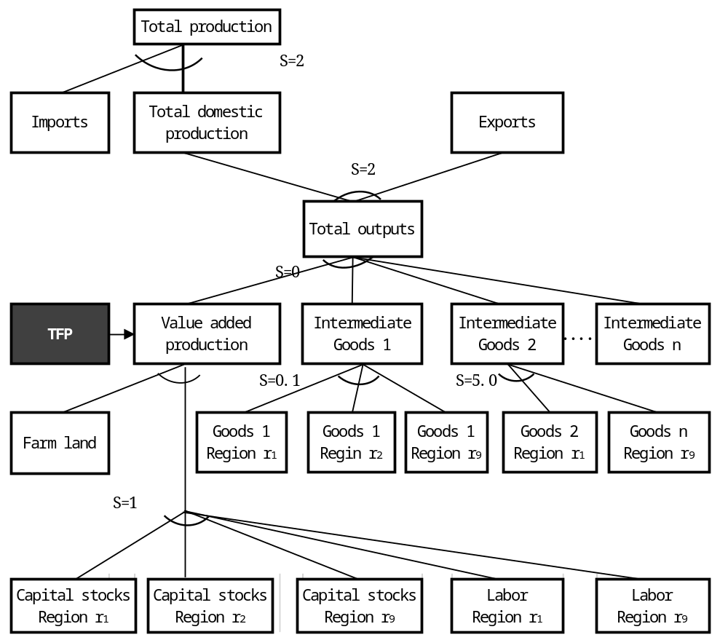

The elasticity of substitution of farmland to other input factors, which was not used in Bann (2007), is assumed to be 0.2 for agriculture. Egaitsu (1985) concluded that the substitutability of farmland for other input factors was low, but the substitutability between capital and labour was high, according to empirical evidence on Japanese rice production from several studies. Based on these findings, we assumed that farmland is a semi-fixed input for agricultural production and cannot really be substituted by other factors.
Consumption is defined by the nested type function (Figure 2). The first nest is defined by the linear expenditure system (LES) function derived from consumers’ maximization assumption on utility with Stone-Geary form. The second nest shows spatial dependence among commodities produced in different regions. As is the case of intermediate inputs in cost function, the spatial substitution elasticities take two different values, i.e. 0.5 and 5.0, showing low and high spatial dependence in economy. Other elasticity values of substitution in the consumption, import, and export functions are set to be the same as those used by Bann (2007), which were based on the GTAP database. The government consumption and government investment are Leontief type fixed share function.
Figure 2: Consumers’ Utility Structure in the Model
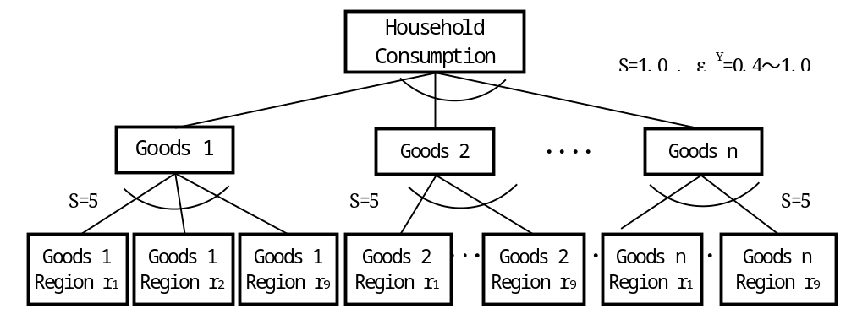

Figure 3 shows the government spending structure assuming Leontief substitution elasticity.
Figure 3: Government Spending
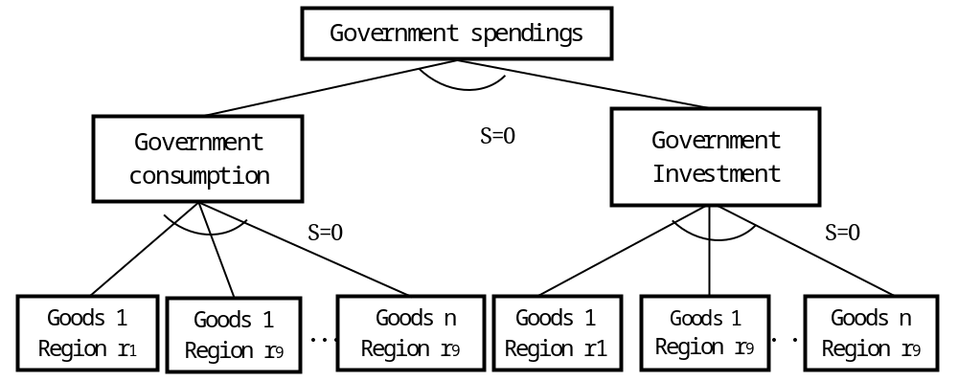

- Modification of CGE model for consideration of endogenous growth
Technological progress of each industry measured by the total factor productivity (TFP) is, in our model, assumed to occur based on knowledge capital stocks accumulated by the research and development (R&D) investment. The level of R&D investment (IK^{P}) is defined by the production level of related industry as:
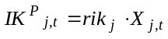 (1)
Here, rik is the rate of R&D investment spent by total production of each industry classified by j sector in year t. X is the total production of related industry. As shown by Eq. (), R&D investment is endogenously defined by economic growth, and economic growth its self is influenced by the R&D investment level via knowledge capital and TFP.
In real economy, more than 70 % of the R&D investment is done by the private company, and the lest of them is invested by the public sector, such as government and university. These public R&D investment is exogenously provided and allocated in public budget.
The knowledge capital stocks (KK^{P} and KK^{G}) are accumulated by the R&D investment as:
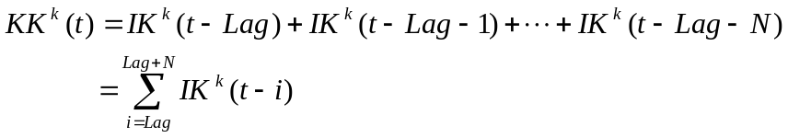 (2)
Here, superscript k (k ∈ P and G) shows public or private knowledge capital stocks, Lag is the gestation period of R&D investment, and N is the obsolescence period of knowledge. Lag is assumed to be 3 years for private R&D investment and 7 years for public R&D investment, and N is 12 years for private sector and 8 years for public sector. These periods are based on the questionnaire research of Science and Technology Agency (1999).
TFP of each industry is defined by knowledge capitals stocks, public capital stocks of infrastructure and management scale of agriculture farms as:
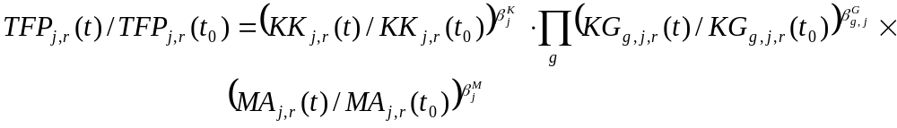 (3)
Here, g, j and r respectively show kinds of public infrastructure (roads and agricultural base facilities), industry and region. KK, KG and MA are knowledge capital stocks, public infrastructure stocks and average management scale of agriculture farms representing economies of scale. The subscript t₀ shows the initial year (2010) in our model. 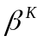, 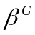 and 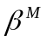 are respectively elasticities of knowledge capital, public infrastructure capital and average scale of agricultural farms. These elasticities are measured by the econometric estimation and statistic data and shown in Table 1.

Table 1 Elasticity values of TFP with respect to factors by industries.
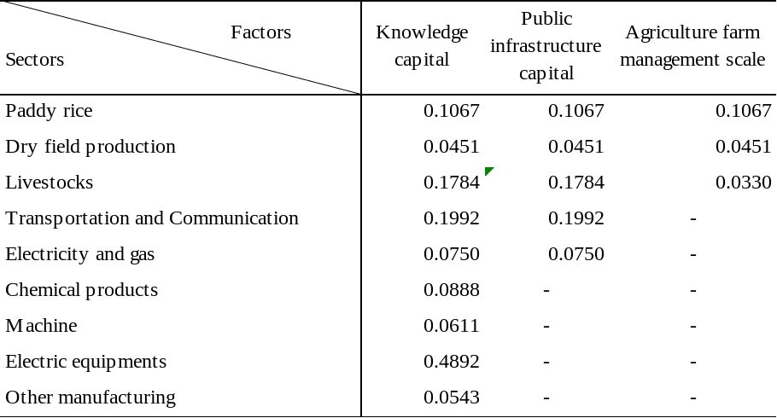

To form the recursive dynamic path, the capital stock equation is defined by annual investment (I) and depreciation rate (δ= 0.04), as follows.
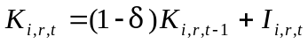 (4)
In this model, K_{i,r,t} shows capital stocks in i-th industry of r-th region at year t, and is defined for every year from I, which is endogenously defined by the CGE model as follows.
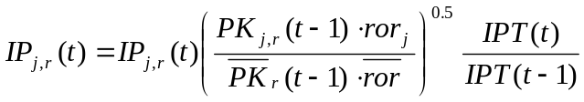 (5)
Here, I_{i,r,t0} is initial level of investment in i-th industry of r-th region, PK is service price of capital stocks representing rate of return of capital stocks and 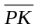 is average service price among industries. 0.5 represents the adjustment speed of investment.
Public infrastructure capital stocks, such as road facilities and agricultural base facilities like irrigation and drainage canals, are defined as:
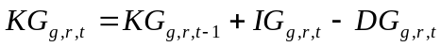 (6)
Here, g ∈ road facilities and agricultural base facilities, depreciation value of stocks is derived from actual data on public facilities (Japanese Social Infrastructure Capital, Japanese Cabinet Office, 2012). In our model, KG_{g,r,t=2010}, IG_{g,r,t} and DG_{g,r,t} are assumed to be exogenously defined.
Labor forces and investment, which forms capital stocks, are assumed to move among regions, but farmland cannot move. Considering these features, regional allocation function on these resources were formed. Labor supply which is one of exogenous variables was assumed to decrease according to the changes in Japanese population, but regional labor supply was considered labor force inter-regional immigration based on wage differences as follows.
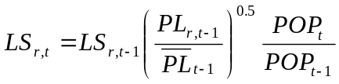 (7).
Here, LS is labor supply, PL is wage rate, 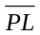 is whole country average wage rate, and 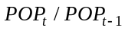 is the growth rate of population. The future population is exogenously provided according to the prediction of National Institute of Population and Social Security Research (http://www.ipss.go.jp/).
Total farmland supply, FS, is assumed to decrease by gr which is set as -0.4 % with consideration of actual decreasing tendency of farmland area in Japan and is almost the same as population growth rate.
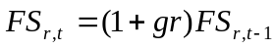 (8).
Government savings, international trade balance and inter-regional money transfer were assumed to be fixed as the present level. Although TFP in paddy sector changed as Eq. (1), TFP growth rate of other sectors is assumed to be zero in order to make comparison simple.

- Data
Farm management area per farm organization, MA, were also collected from Cost Research for Rice Production (Ministry of Agriculture, Forestry and Fishery; MAFF). Knowledge capital stocks, KK, were calculated based on Kunimitsu et al. (2015) by using annual expenditure of R&D investment published in Investigation Report on R&D Expenditures for Scientific Technology (Statistics Bureau of Ministry of Public Management, Home Affairs, Posts and Telecommunications, every year). Public infrastructure capital stocks, KG, and public investment, IG, were obtained from Japanese Social Infrastructure Capital (Cabinet Office, 2012) and Kunimitsu and Nakata (2015c).
To calibrate the parameters of the CGE model, the social accounting matrix (SAM) was estimated based on Japan’s 2005 inter-regional input-output table published by the Ministry of Economy, Trade and Industry (http://www. meti.go.jp/statistics/ tyo/entyoio/ result/result_13. html). In order to analyze sectoral production more precisely, the rice sector, transportation sector and research and development sector were separated from the aggregated sectors in the IO table by using regional tables (404 × 350 sectors). Subsequently, the sectors were reassembled into 16 sectors: (1) paddy (pady); (2) other agriculture, forestry and fishery (oaff); (2) mining and fuel (minf); (4) food processing (food); (5) chemical products (chem); (6) general machinery (mach); (7) electrical equipment and machinery (elem); (8) other manufacturing (omfg); (9) construction (cnst); (10) electricity and gas (elga); (11) water (watr); (12) transportation (tpts); (13) research and development(rese); (14) wholesale and retail sales (trad); (15) financial services (fina); and (16) other services (serv). Regions consisted of 9 regions: Hokkaido; Tohoku; Kanto including Niigata prefecture; Chubu; Kinki; Chugoku; Shikoku; Kyushu; and Okinawa.
The factor input value of farmland, not shown in the Japanese I/O table, was estimated using farmland cultivation areas (Farmland statistics, Ministry of Agriculture, Forestry, and Fishery, and every year) and multiplying the areas by farmland rents. The factor input value of farmland was subtracted from the operation surplus in the original IO table. The value of capital input was subsequently composed of the remaining operational surplus and the depreciation value of capital.
Most elasticity values of substitution in the production, consumption, import and export functions were set at the same values as Bann (2007), which were based on the GTAP database. The substitution elasticity of farmland and other input factors in agriculture was assumed to be 0.2. This elasticity value is based on empirical studies on Japanese agriculture, indicating that farmland, as an input factor, is less substitutable to labor and capital stocks in agricultural production (Egaitsu, 1986).
Spatial substitution elasticity values on Japanese economy were estimated by Koike et al. (2012) and Tsuchiya et al.(2005), showing that those values differed from 0.3 to 8.0, but were about 2 times higher than substitution elasticity values on foreign trade. Hence, the spatial substitution elasticity value for intermediate and consumption demand was set as 4.0.

- Simulation cases
In order to predict future situation, the simulation is conducted for 40 years from 2010 to 2050. The four simulation scenarios are considered. Among them, Case 1 to 3 except for Case 0 are all business as usual with different perspectives and model settings.
Case 0 (reference case):
This is for the reference of other simulation and KK_{t} / KK_{t0} in Eq. (3) is set as 1.0, which shows no consideration of changes in knowledge capital stocks.
Case 1 (pessimistic exogenous growth of R&D investment)
This case takes no change in the level of R&D investment. The R&D investment for knowledge capital stocks is assumed to continue at the same level as year 2010 level for 40 years (see Case 1 in Fig. 1).
Case 2 (optimistic exogenous growth of R&D investment)
This case increases R&D investment in accordance with past chronological trend of investment level (see Case 2 in Fig. 1).
Case 3 (endogenous growth of R&D investment)
This case sets R&D investment as endogenously defined by the SD-CGE model based on Eqs. (1) to (3).

Figure 4 Chronological settings of exogenous R&D investment
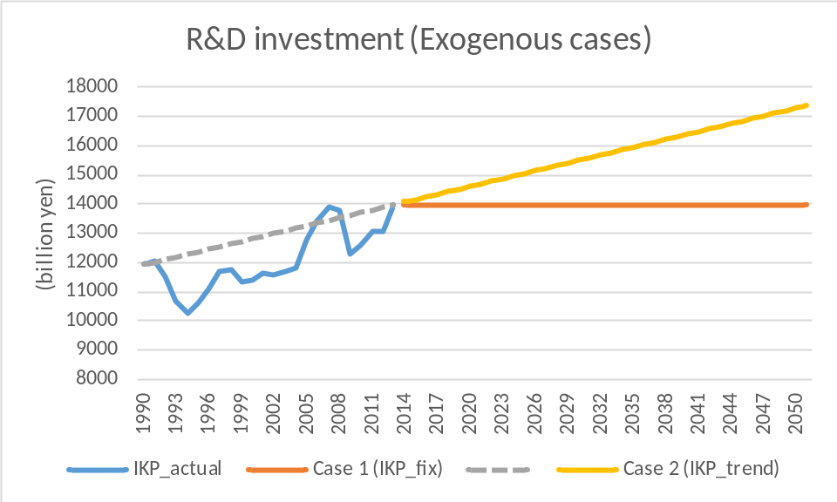

3．Results
- Prediction of knowledge capital stocks
Figure 5 shows the prediction path of knowledge capital stocks in each case, and figure 6 is the prediction path of TFP in each case. Case 3 is the only case which was calculated by the SD-CGE model. Other cases were set as exogenous variables.
The knowledge capital stocks of the endogenous growth of R&D investment (Case 3) was lower than even Case 1 which shows pessimistic settings. Therefore, there is great possibility of which economy cannot achieve enough technological progress as shown by Fig. 6.

Figure 5 Chronological change in private knowledge capital stocks by cases
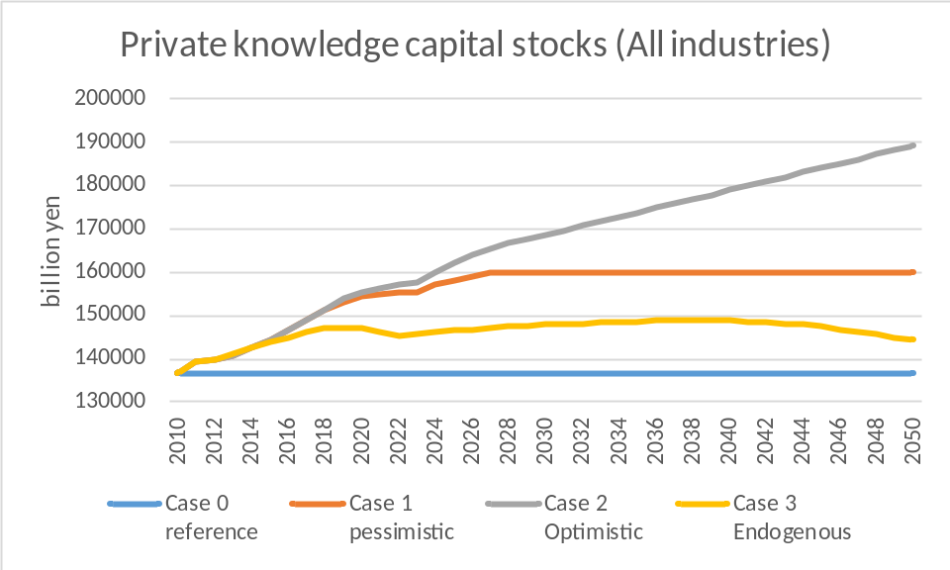

Big differences were found in TFP change among industries due to the different level of knowledge capital stocks and chronological change of them. Manufacturing industries, such as chemical products, general machinery, electrical equipment and machinery, and other manufacturing, hold greater level of knowledge capital stocks, but changes in knowledge capital stocks by cases were also greater than other industries. Especially, differences between Case 2 (optimistic view) and Case 3 (endogenous growth) are huge.

Figure 6 Private knowledge capital stocks in 2050 by industries and cases
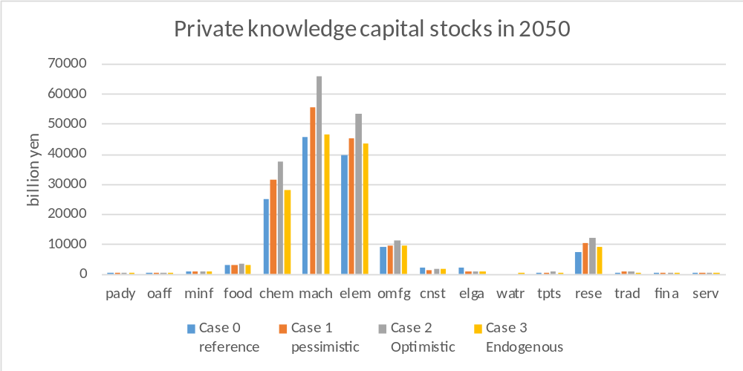

- Prediction of GDP
Figure 7 shows prediction results of GDP by regions and cases. Only 5 regions and whole country case were chosen because of a limitation of the space.
Case 0 which shows no technological progress marked the lowest GDP growth and the top level GDP was almost the same as present level. In this sense, technological progress is the must for Japanese economy where population is decreasing.
Among Case 1 to Case 3, Case 3 marked the lowest level of GDP in the future. This is of course due to the lower level of R&D investment in Case 3. Population was decreasing in all cases, but only Case 3 changes R&D investment according to the future economic situation in Japan. Most of manufacturing industries as well as the first and third industries can increase their production until 2030, but these industries decrease their production level after that. This happened due to a decrease in demand based on population and a decrease in R&D investment adjusting to their own production level.
The GDP growth path among regions were completely different. Only Kanto region which includes Tokyo and Yokohama could avoid serious decrease in GDP level, but other regions could not. This is because of different population change among regions and transfer of labor force to Kanto region in accordance with GDP growth level.

Figure 7. Chronological change in GDP by regions and cases.
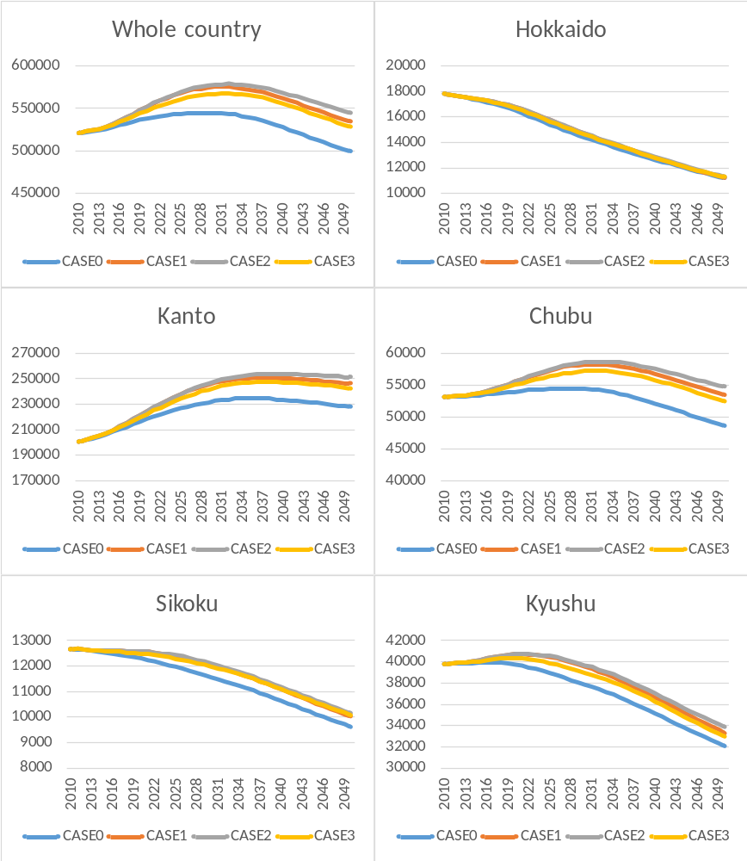

Even so, GDP level of Kanto region in Case 3 decreased a bit, although such decrease was lower than other regions. Therefore, influence of population decline was serious in Japanese economy.

4. Summary and conclusion
This paper tried to measure influences of population decline in matured economy like Japan with consideration of mutual relations of technological progress and population growth. We used spatial dynamic computable general equilibrium model (SD-CGE model) to concretely show the future situation of economy.
The simulation results demonstrated the following points. First, technological progress caused by knowledge capital stocks is critical for keeping the GDP level as the present situation in Japan where population is decreasing. If technological progress does not occur, a decrease in gross domestic production is unavoidable.
Second, in urban area, such as Kanto region, GDP can continue to increase, because inflow of fund and labor force occurs, but other regions face serious decline in GDP. These opposite effects bring about an expansion of regional gaps in gross production. In order to ease such opposite situations, revitalization policy, such as public investment for agricultural base which is mostly located in the local areas, is useful and effective.
Third, Japan cannot achieve 600 trillion yen ( 5.5 trillion dollars) of GDP in the future under population decline, which is the policy target of Japan, even if the past invested capital stocks in our society was taken into accounts.
Fourth, the more serious problem will happen after the 2030's, and GDP turns into decrease due to a decrease in knowledge capital stocks. This happens because of a decrease in supply and demand for manufacturing products under decreasing population and a decrease in R&D investment in accordance with production.
Therefore, the government should keep demand for manufacturing products by enhancing children support program for an increase in birth rate of young generations in order to avoid such decrease in GDP. This is not only Japanese problem but also OECD countries where their population will not increase or decrease.

<Reference>
Solow, R. M. (1956). "A contribution to the theory of economic growth". Quarterly Journal of Economics. Oxford Journals. 70 (1): 65–94. doi:10.2307/1884513.
Swan, T. W. (1956). "Economic growth and capital accumulation". Economic Record. Wiley. 32 (2): 334–361. doi:10.1111/j.1475-4932.
Yoshikawa, H. (2016) Population and Japanese Economy, Chyuou Koron shya.
National Institute of Science and Technology Policy (1999) Investigation on the quantitative evaluation technique for the economic effect of research and development policies (Interim report), NISTEP REPORT 64，http://data.nistep.go.jp/dspace/handle /11035/611.

