Introducing the Ag-Incentives Consortium and Database

by

Simla Tokgoz, David Laborde, Tess Lallemant, Fahd Majeed and Will Martin

International Food Policy Research Institute

Washington DC

15 April 2017

Abstract
Prior to the 1980s, information on agricultural incentives provided by governments was extremely limited and difficult to access. Much debate took place on the basis of participants’ preferred alternative facts. During the 1980s, the OECD began to collect detailed information on agricultural incentives in member countries, but data remained fragmentary for developing countries. The only close-to-global information on agricultural distortions was provided by a one-off study undertaken by Kym Anderson at the World Bank, completed in 2009. The objective of this initiative is to bring together information on agricultural incentives from five key institutions: FAO-MAFAP; the Inter-American Development Bank; IFPRI; the OECD and the World Bank. The resulting data are presented in a consistent format at http://www.ag-incentives.org This paper will discuss the methods used and the coverage of this database, and its potential value to economic modelers.

Keywords: agricultural incentives, Nominal Rate of Protection, Nominal Rate of Assistance, Producer Support Estimate, NRP

Acknowledgement: We thank, in particular, the CGIAR Program on Policies, Institutions and Markets for support for this project.

1. Introduction

Prior to the 1980s, the available evidence on the changes in incentives provided by governments to farmers was extremely poor. While Josling (FAO 1973) had provided a widely-agreed methodology for measuring these changes, few studies were undertaken and those that were undertaken were frequently of limited commodity coverage and duration. Debates about assistance were therefore based on limited information, with participants frequently choosing arguments based on their own preferred sets of alternative facts.
This changed during the 1980s, when the OECD began to monitor the producer support provided by governments in OECD countries. The famous Krueger, Schiff and Valdes (1988) studies of agricultural distortions in developing countries provided detailed information for 18 such countries. These two sets of studies yielded two key stylized facts—that agriculture in developed countries was typically highly protected, while it was generally taxed—and frequently highly taxed—in developing countries.
During the early 2000s, the large set of studies coordinated by Kym Anderson provided information on approximately 80 countries (including estimates based on OECD monitoring) and updated our assessment of developments. The estimates for OECD countries showed a clear downward trend from their peak levels around 1986-88, while protection rates were trending up strongly in developing countries.
It has become clear that—rather than relying on intermittently-produced one-off studies of agricultural protection—there is a need for continuously-updated estimates. Fortunately, the key elements of such a database can be assembled based on work that is ongoing in a number of key international organizations—the FAO-MAFAP; the Inter-American Development Bank; the OECD; the World Bank. IFPRI is providing the framework in which these data will be presented in a common format at http://www.ag-incentives.org. By working together, these organizations will be able to provide useful, continuously-updated and relatively comprehensive information to users at relatively low cost.
Because of differences in databases, methodologies, and time spans, it has been relatively difficult for analysts to obtain consistent long-term measurements of agricultural distortions across all developed and developing countries. This made it difficult for policy makers to correctly measure, compare, and interpret the impact of their policy designs across commodities, countries, and time spans. To improve on this situation, an Agricultural (Ag) Incentives Consortium including the major organizations active in measurement of agricultural incentives--OECD, FAO-MAFAP, IDB, IFPRI, World Bank and CGIAR PIM. The Ag-Incentives Consortium focuses on organizing collaboration among IOs in order to provide better estimates of agricultural incentives, and to contribute to better policies. One pillar of this coordination involves generating a common set of clearly defined and well-documented common indicators, with a focus on price incentives. A second pillar is about expanding country and product coverage. A third pillar is providing a platform for tackling new issues and improving methodologies.
In this paper, we first present a summary of the efforts in the literature to measure distortions and the relevant methodological discussions. Next, we present a synopsis of the Consortium and its goals, as well as data processing conducted for the databases of members of the Consortium. We, then, present and discuss the NRPs computed based on, but not limited to, the Ag-Incentives Consortium efforts followed by a conclusion.
2. Methodologies in the literature

One broad approach to measurement of trade distortions focusses on the measures actually used to provide protection (or taxation). Databases such as UNCTAD TRAINS database consolidate measures of tariffs and nontariff measures, including taking the tariff equivalents of specific, mixed and compound tariffs. The WTO provides measures of both applied tariff rates and the schedules of commitments (bound tariffs) made by countries in WTO negotiations. The WITS software provides easy access to these databases (www.wits.worldbank.org).
While tariff-based measures are relatively easy to interpret and analyse, much agricultural protection and/or taxation is implemented using nontariff barriers such as tariff-rate-quotas, licenses, bans and sanitary and phytosanitary measures. For these, it is important to have measures of frequency and coverage, such as are provided by the UNCTAD TRAINS database (www.unctad.org). Unfortunately converting this information into measures of the extent to which trade is distorted, or producers are supported, is not straightforward. Simply knowing that imports of a particular good are limited to 10,000 tonnes tells us nothing about the trade restrictive impact of a quota unless we know what imports would have been in the absence of the quota. The usual approach taken to dealing with this problem is to estimate the ad valorem tariff that would, under specified conditions, have the same effect on trade to the tariff.
Given the wide variety of policy instruments used to influence agricultural prices and outputs, the primary method for estimating the tariff equivalents of agricultural trade barriers is comparison of internal and external prices at a common reference point. If an import quota, for instance, reduces the availability of the good in the domestic market enough to increase its price by 20 percent relative to the external price, then that quota is viewed as being equivalent in its effect to a 20 percent ad valorem tariff.
This approach was used by Krueger, Schiff and Valdes (1988) to estimate the tariff equivalents of the range of policy interventions that changed the domestic prices for agricultural goods relative to their external prices in a range of developing countries. This effect was measured as the proportional difference between the Producer Price (PP) and border prices adjusting for distribution, storage, transport, and other marketing costs (the Reference Price, RP). This measure is essentially a tariff-equivalent, t, of the measures used to influence domestic prices. The NRP is measured as:
(1) NRP_{i} = ((PP_{i} / RP_{i}) – 1)

Anderson et al. (2008) expanded this effort by measuring, in addition, the Nominal Rate of Assistance to agriculture, NRA, which includes policy measures other than trade barriers that affect the incentives for agricultural production in a country. They also outlined many of the methodological issues involved in deriving such numbers. Different components of NRA were identified and defined, such as NRA to farm output conferred by border price support, NRA to output conferred by domestic price support, NRA to inputs, among others. Furthermore, there is clearer identification of non-distortionary price wedges such as transportation and processing costs relative to distortionary price wedges introduced by policy, which help in location and evaluation of prices being transmitted along the value chain.
For direct measurement of policies, OECD has a major effort with, the Producer Support Estimate, PSE (OECD 2015). For OECD, the PSE is a part of the Total Support Estimate, which is an indicator of the annual monetary value of all gross transfers from taxpayers and consumers arising from policy measures that support agriculture, net of the associated budgetary receipts. Here, the percentage PSE represents policy transfers to agricultural producers, measured at the farm gate and expressed as a share of gross farm receipts.
The PSE and the NRP are fundamentally different and comparing them directly is a common—and frequently major—source of error. Fortunately, there is a simple mapping between the NRP and the PSE that is frequently useful in comparing them. If, for simplicity, we consider the quantity of a good that costs $1 at the border, then an NRP of t means that good has a domestic value of (1+t). The PSE for this good is
(2) ${PSE}_{i}= \frac{t}{1+t}$

This formula also has the useful feature of showing that the PSE must always lie between 0 and 1 for a positive rate of protection. The NRP, by contrast, can take any value. Rearranging equation (2) also allows us to move in the opposite direction:
(3) t = $\frac{PSE}{1-PSE}$

OECD also calculates the Nominal Protection Coefficient (NPC) that includes budgetary outlays and treats input markets differently. It is the Producer Price plus the value per unit of payments based on output relative to the Reference Price.

NPC = (PP + (payments based on output or production quantity) / RP)
Transfers counted in the PSE include market price support, budgetary payments, and of revenue foregone by the government. The PSE has evolved from being just a measure of market price support to including payments based on output as well as well as expanding beyond taking into account just direct payments to multiple sources of payments. The Market Price Support (MPS) for a commodity is estimated either by adding together transfers to producers from consumers and taxpayers or by multiplying the quantity of production by the market price differential (the difference between farm and border price). The MPS component of PSE is similar to the NRP in that it also depends on price gaps.
FAO-MAFAP (MAFAP 2016) and IDB-Agrimonitor (2016) use methodologies developed by the World Bank (NRA) and OECD (PSE) respectively. The World Bank has recently completed studies of three important South Asian countries—India, Pakistan and Sri Lanka—using the Anderson et al (2008) methodology.

3. Consortium structure and database

The objectives of Ag-Incentives Consortium are to bring together the findings from the organizations active in this field on a continuing basis in order to develop a global view of incentives, and to shine a light on incentives in some of the smaller economies where distortions to agricultural incentives have a particular impact on the poor. The Ag-Incentives Consortium achieves these objectives through creation of a community of practice, and harmonization and consolidation of a database. As can be seen from Table 1, these IOs publish measurements of distortions with some overlap across geographical and sectoral coverage and time span. In particular, the FAO-MAFAP and IADB add coverage of a number of countries in Africa and in the Americas where own-country incentives have important implications for poor people. The goals of the Consortium, therefore, include maintaining the mandate and the independency of each IO, and creating a collaborative approach for database, with a clear recognition of the intellectual property rights of each partner.

Table 1: Country and commodity coverage by IOs
International Organization | Economic Clusters Covered | Number of countries | Time Period | Total Commodities | Metrics Reported
OECD | OECD + Emerging | 23* | 1986-2014 | 58 individual, NONMPS, Total | PSE, MPS, NPC, MPD
FAO-MAFAP | Selected African | 9 | 2005-2013 | 27 individual | NRA
IDB-AGRIMONITOR | Latin America and Caribbean | 17 | 2004-2013 | 37 individual | PSE, MPS
World Bank | South Asia | 3 | 2004-
Note: Not all countries report all data for all commodities listed and all years. * Including the EU28.

The initial focus of the Consortium has been on price distortions, with a consolidated indicator based on each IO database. We selected to compute the NRP, based on Krueger, Schiff, and Valdes (1988). As noted above, the NRP is the ratio between the price gap and the observed reference price measured at the same point in the value chain.
We use the method for Direct NRP from Krueger, Schiff, Valdes (1988) to create a consolidated NRP with the underlying price metadata from IOs. We also compute average NRPs for the agricultural sector of countries, and a global NRP for commodities.
NRP_{TOTAL} = ( ( sum_{c}(PP_{c}*Q_{c})/ sum_{c} (RP_{c} *Q_{c}) ) – 1 )
where summation over c refers to the commodities for which we have estimates in a particular country.

NRP_{COMMODITY} = ( ( sum_{i}(PP_{i}*Q_{i})/ sum_{i} (RP_{i} *Q_{i}) ) – 1 )
where summation over index i refers to production of the commodity in different countries.
Because of the wide variety of policy instruments used to influence agricultural incentives —ad valorem tariffs, specific tariffs, quotas, licenses, tariff-rate-quotas etc.—it is not feasible to evaluate agricultural protection using measures such as the tariff rate. We therefore use measures of distortions based on the price comparison approach, which captures the complete impact of whatever distortions are applied. It does this based on the law of one price, where the goods must be comparable (in terms of quality, processing level, and location). The reference price is the border price evaluated at the official nominal exchange rate adjusted for transport, storage, distribution, processing, and for quality differences based on input data provided by each IO.
The first step before computing NRPs, is creation of a harmonized metadata template that incorporates input data for all IOs involved and deals with and computes NRPs for commodities and countries as described in Figure 1.
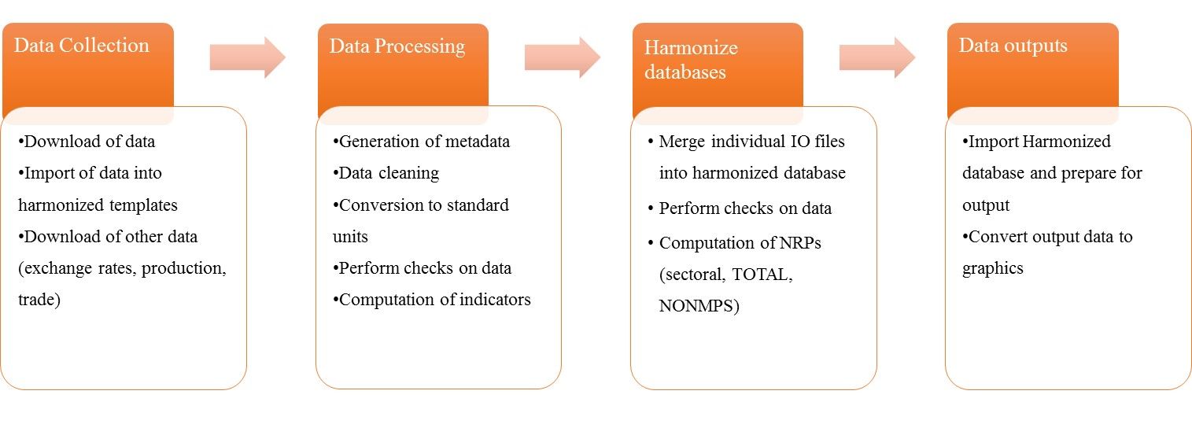
Figure 1: Harmonized data template process

We construct the harmonized metadata template to identify the path of price transmission across the Value Chain and to measure changes in prices along this path while computing the reference price at the same point in the value chain. This is described in Figure 2.

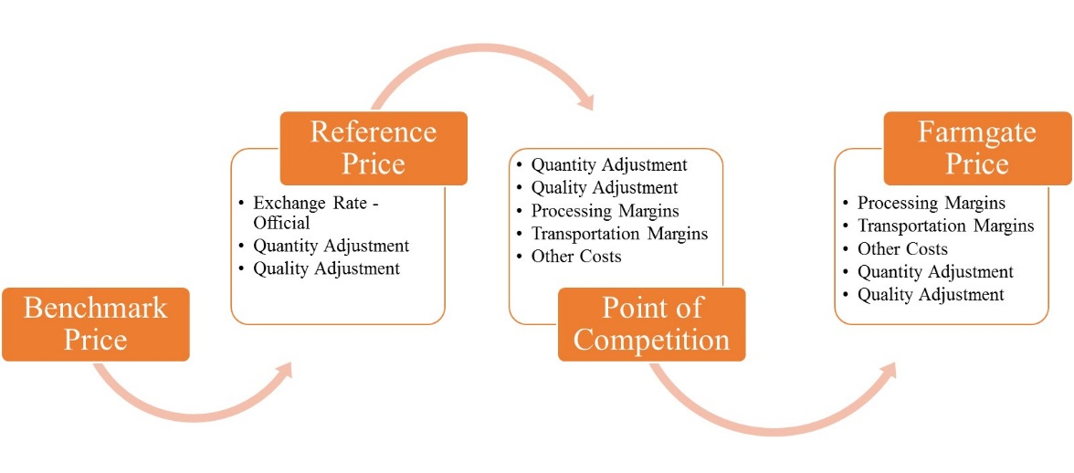
Figure 2: Price Transmission across Value Chain
Based on input data from the member IOs, we compute a continuous series of NRPs. Since there is some overlap across IOs in terms of commodity and country coverage, we use a hierarchy to select the final NRP. When there is an overlap for a period, country or commodity, the first selection for the composite NRP is the OECD database, followed by MAFAP-FAO, and IDB. This selection process may create NRP coverage for a country where one commodity NRP is from one data set and another NRP is from another data set. The same issue exists for the time span of a commodity coverage.

4. What do we learn from NRPs?

Figure 3 below presents average global NRPs weighted by production quantity as seen in the above equations. Figure 3 also includes the FAO Food Price Index based on international prices weighted with the average export shares for 2002-2004. As seen below, there appears to be a tendency for the global NRP for the agricultural sector to rise over time, although values are positive (except for 2008), showing that overall agricultural policies have protected farmers in the countries providing protection, as long as the depressing impact of protection on world prices is not taken into account. As expected, we see that the average NRP and the average Food Price Index move in opposite directions. When global food prices are rising, governments are insulating consumers, by reducing or eliminating import duties or adding export taxes that in turn reduce protection afforded to producers. The clearest example is in the 2008 and 2011 food price crises, with the drop in global average NRP and the jump in the global Food Price Index. This effect reflects two factors—a tendency for policy makers to resist increases in world prices by lowering protection, and the tendency for such declines in protection to raise world prices by increasing demand for food and, in the case of export restrictions, by reducing the supply of food onto world markets.

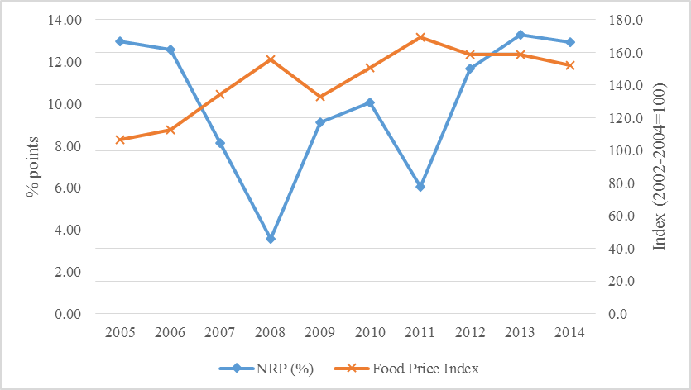
Figure 3: Average NRPs for agricultural sector globally and FAO Food Price Index.

In Figure 4, we present the average NRPs for the agricultural sector categorized by income levels of countries. For the period shown, high income countries have generally provided higher protection for their farmers, although the average protection rate has declined in the last decade. Middle income countries had lower NRPs on average than high income countries. Low income countries had negative NRPs in the period shown in Figure 3, partly because this was a period of relatively high prices and partly because the agricultural sector is seen as a source of government revenue (mostly in Africa) and export commodities are frequently taxed (Anderson 1995). One thing to note is the difference in NRPs for countries during the 2008 food price crisis. High and middle income countries had slightly lower NRPs in 2008 and 2011 food price crises, whereas low income countries had higher NRPs during these price crises.
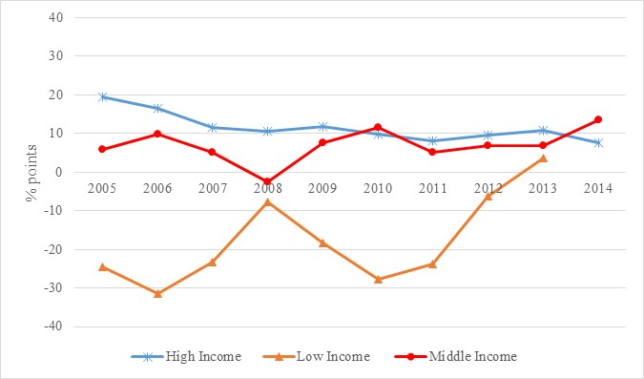
Figure 4: Average NRPs for agricultural sector by income category.

In Table 2, we present global NRPs by commodity. We observe the variation to be even higher at individual commodity level, relative to the agricultural sector NRP. Producers in livestock and dairy sectors have much higher protection relative to crop sectors. Cash crops, such as coffee and tea, have negative NRPs, as these are export commodities with exports taxes keeping farm gate prices down. Another example of this is negative palm oil NRP, with demand for palm oil exports increasing.

Table 2: Global NRPs by Commodity (%)
Commodity | 2005 | 2007 | 2009 | 2011 | 2013
Bovine Meat | 17.45 | 13.53 | 14.28 | 6.51 | 29.13
Cassava | -3.93 | -10.45 | -4.34 | 2.32 | 6.98
Coffee | 3.38 | -1.19 | -0.94 | -2.96 | -4.00
Maize | 8.89 | 6.52 | 5.06 | -1.04 | 9.79
Milk | 28.89 | 6.56 | 20.19 | 10.78 | 7.83
Palm oil | -1.56 | -6.24 | 0.01 | -21.84 | -15.00
Pig meat | 6.08 | 3.32 | 14.67 | 14.51 | 12.77
Poultry meat | 11.60 | 13.06 | 15.19 | 11.28 | 8.25
Soybeans | 2.30 | -1.96 | -2.29 | -5.53 | 2.65
Tea | -9.76 | -13.22 | -12.72 | -20.74 | -25.62
Wheat | -0.74 | 4.90 | 11.12 | 1.25 | 10.04

3. Conclusions

The Agricultural Incentives Consortium is a broad collaborative effort on part of multiple IOs to create a common set of indicators that measure distortions to agricultural incentives, with a focus on prices. The Consortium also aims to create a community of practice that can help exchange ideas and information between organizations. These data will be available to all following the launch of the database on May 4, 2017.
The initial output of the Consortium is to provide a global data set of NRPs based on combined IO data. This paper presents NRPs based on, but not limited to, the Ag-Incentives Consortium efforts. The results show that global average NRP moves in the opposite direction to the global Food Price index, suggesting that government policies, on average, reacted to food price crises of 2008 and 2011. Furthermore, it shows that trends in NRPs differed by income category, with high income countries lowering protection of producers, and middle income countries increasing protection. There is significant variation in average agricultural sector NRPs for low-income countries, which are now mostly in Africa.
One aim of this exercise is to provide a unified measurement of distortions by agricultural policies for a wide audience of academics and non-academics. This type of unified approach would help governments design policies and measure them effectively. The global NRPs rely on the same methodology, utilizing each IO database, in a consistent manner. They provide continuous and consistent measurement across a wide sectoral and geographical coverage, allowing stakeholders interpret the implications of agricultural policy design in an effective manner. We look forward to comments and feedback that can help improve the value of the information provided.

REFERENCES

Anderson, K. (1995), ‘Lobbying Incentives and the Pattern of Protection in Rich and Poor Countries’ Economic Development and Cultural Change 43(2): 401-23.

Anderson, K., Kurzweil, M. Martin, W., Sandri, D. and Valenzuela, E. (2008), ‘Measuring distortions to agricultural incentives, revisited’ World Trade Review 7(3): 675-704.
FAO (1973), Agricultural Protection: Domestic Policy and lnternational Trade (C/73/LIM/9), Rome
IDB-Agrimonitor (2016) PSE Agricultural Policy Monitoring System, <http://www.iadb.org/en/topics/agriculture/agrimonitor/agrimonitor-pse-agricultural-policy-monitoring-system,8025.html>, Inter-American Development Bank, Washington, DC.
Krueger A. O., Schiff M., Valdes A. (1988) Agricultural Incentives in Developing Countries: Measuring the Effect of Sectoral and Economywide Policies, The World Bank Economic Review, 2 (3), 255-271.
MAFAP (2016) Monitoring and Analysing Food and Agricultural Policies, < http://www.fao.org/in-action/mafap/home/en/> FAO, Rome.
OECD (2015) Agricultural Policy Monitoring and Evaluation 2015, OECD Publishing, Paris http://dx.doi.org/10.1787/agr_pol-2015-en

