Preliminary Work – Do Not Cite or Quote without Permission

Growing old gracefully: fiscal policy for ageing society
Jason DeBacker, Richard W. Evans, Jonathan Pycroft, Magdalena Zachłod-Jelec4

This version: 14 June 2018

Abstract

The Italian population is shrinking and ageing. The old-age dependency ratio is projected to rise considerably over the coming decades from 33.7% in 2015 to 61.2% in 2060. The Monti’s government of 2011-13 has introduced some measures to address these issues debt sustainability projections from the European Commission point to significant pressure on Italy’s public finances in the medium-term.
In this paper, we evaluate the macroeconomic and intergenerational impact of realistic demographic trends in Italy with a new overlapping generations model named OG-ITA, which is heavily inspired by the open-source model for the United States, OG-USA. Key features of the model include an overlapping generations structure that considers individuals of ages 21 to 100, who are split into seven income-earning ability types. By integrating microeconomic data and simulations from the EUROMOD microsimulation model into the overlapping generations macro model, we can address the dynamic effects of fiscal policies that would counteract the fiscal challenges of ageing populations.
The demographic change effects are obtained by first running a standard version of the model with demographic projections and comparing them with a model version with fixed (as of 2015) rates of population growth. We furthermore simulate pension reforms, including raising the age at which one receives a public pension. The results confirm the desirability of combining tax and pension reforms to address the challenges of ageing societies, particularly in the case of Italy. The simulations demonstrate the balance between supporting growth and prosperity over the short run and avoiding excessive burdens for the future.

JEL Classification Numbers: D58, H3, E62
Keywords: overlapping generations, dynamic general equilibrium, demographic change

1. Introduction

Demographic change is an impending challenge for many European countries. Across much of the continent, populations are becoming smaller and older. Italy is an example of this trend, and faces increased challenges in terms of its old-age dependency ratio. In line with Eurostat (2018), the old-age dependency ratio is projected to rise considerably over the coming decades from 33.7% in 2015 to 61.2% in 2060. The demographic trend alone puts significant pressure on the workforce to provide for the elderly. Furthermore, one notes that Italy is saddled with one of the highest public debt-to-GDP ratios in the EU of around 130 percent. While we note that the Italian government has introduced some measures to tackle these issues, especially those undertaken during the Monti government of 2011-13, debt sustainability projections from the European Commission (2018) point to significant pressure on Italy’s public finances in the medium-term.
This paper models the approaching demographic change in an overlapping generations model, OG-ITA. This is a new model heavily inspired by the open-source model for the United States, OG-USA (see DeBacker et al., 2017b). In brief, the salient features of OG-ITA include the detailed representation of households, which are split into 80 adult generations and 7 income-earning ability types. Households receive utility from consumption and leaving bequests, and disutility from labour. Households optimise over their lifetime choosing how much to participate in the labour force, for which they receive earnings dependent on their ability type. They also then decide how much to consume and to save, where savings enables future consumption and bequests. Data on hours worked are calibrated using the EUROMOD microsimulation model. We match the labour elasticities estimated using micro-data, to the more aggregated individual agents of our OLG model, producing our labour supply curve. To produce realistic consumption profiles, actual wealth and bequests distributions in Italy have been incorporated into the model. Firms maximise profits generated from the production of a single good. Investment is determined by the availability of savings and by the demand for capital in the production function.
The demographic change effects are obtained by first running a standard version of the model with demographic projections and comparing them with a model version with fixed (as of 2015) rates of population growth. The consequent budget deficit due to the ageing population is balanced first by raising tax rates. We compare the effects of raising labour tax, consumption tax and capital income tax on macroeconomic outcomes and on the distributional impacts in terms of both income and age. We furthermore simulate pension reforms, including raising the age at which one receives a public pension. The results confirm the desirability of combining tax and pension reforms to address the challenges of ageing societies, particularly in the case of Italy. The simulations demonstrate the balance between supporting growth and prosperity over the short run and avoiding excessive burdens for the future.
The paper is structured as follows. Section 2 explains the construction of the realistic demographic projections in some detail, which are the crucial inputs into the model. Section 3 provides an overview of the full overlapping generations model, highlighting the key equations. Section 4 presents the simulations and results, showing how the demographic projections impact on the wider macro economy. Section 5 concludes as well as introduces the work currently underway to extend the model to the analysis of pensions.

2. Demographic Projections

Population dynamics are driven by three interacting rates of change. First, the fertility rate is the number of live births per member of the population for each age. Second, the mortality rate is the number of deaths per member of the population for each age. And third, the net immigration rate is the immigrants less emigrants per member of the population for each age.
We begin with Eurostat population data for Italy for 2015 and proceed to introduce three possible demographic projection scenarios: (i) a naïve projection, that assumes the current population structure will remain indefinitely, (ii) projections that assume that the current fertility, mortality and net immigration rates will continue into the future (constant rates projection), and (iii) projections that update fertility, mortality and net immigration rates in line with baseline Eurostat (2018) projections (updated rates projection). In order for the final model to solve, one must fix the demographic dynamics at some point in the future. We introduce updates only as far as 2060 and then keep them constant, as this is our main period of interest and estimates beyond this point become less significant due to the uncertainty of the predictions.

2.1. Calculating demographic dynamics

In order to generate the demographic projections, the following equations are employed. The first equation shows the generation of new-borns, ω_{1,t+1}, which is determined by the fertility rate for each age, f_{s,t}, plus the immigration rate of under 1 year olds, i_{1,t}. The second equation is for the rest of the population, which has a probability of dying, the mortality rate, ρ_{s,t}, which varies by age, plus the net immigration rate, i_{s+1,t}.

$ω_{1,t+1}= \sum_{s=1}^{E+S}{f_{s,t}ω_{s,t}+i_{1,t}ω_{1,t}} ∀ t$(1)
$ω_{s+1,t+1}=\left(1-ρ_{s,t}\right)ω_{s,t}+i_{s+1,t}ω_{s+1,t} ∀ t$ (2)

To solve for the steady-state and the transition path of the stationary population distribution, we write the stationary population dynamic equations in their matrix representation, where Ω represents the stationarised transition matrix incorporating the fertility, mortality and net immigration rates.
${\tilde{ω}}_{t+1}=\frac{1}{1+g_{n,t+1}}Ω{\tilde{ω}}_{t} ∀ t$ (3)

The stationary steady-state population distribution $\overline{ω}$ is the eigenvector ω with eigenvalue $\left(1+\overline{g_{n}}\right)$ of the matrix Ω that satisfies the following version of the above equation:
$$\left(1+\overline{g_{n}}\right)\overline{ω}=Ω\overline{ω}$$ (4)

2.2. Demographic projections

We consider three scenarios for demographic projections. The first we call the naïve projection, by which we mean that population dynamics are not considered and one imagines that the current population profile will persist into the future. The second, the constant rates projection, imagines that the fertility, mortality and immigration rates are steady at their 2015 values (Eurostat 2018). The third, the updated rates projection, changes the fertility, mortality and immigration rates in line with Eurostat (2018) baseline projections from 2015 to 2060, and then kept constant.
The first 100 years of population profiles for each of the three projections are shown in Figure 1 a, b, c below. In each figure, the far wall to the right traces the current (2015) population. The movement forward and to the left traces the population evolution over time. The current population peak is between approximately ages 40 to 50. In the naïve projection, this peak remains, however in the more realistic scenarios, this cohort ages and passes away. Later generations have steadily lower populations, until after 100 years, shown at the front of the figure on the left, one sees the relatively smooth projection for the lower population profile for 2115. In both the constant rates and updated rates projections, total population shrinks markedly, though it is shown that the constant rates implies a sharper population decline.

Figure 1: Population dynamics 2015 to 2115

a) Naïve projection (constant population) b) Constant rates projection (rates fixed at
2015 values)
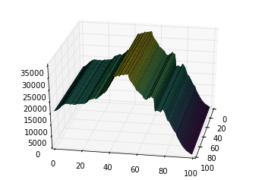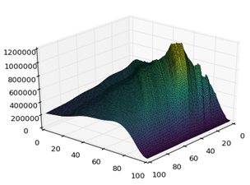

c) Updated rates projection (rates updated until 2060)
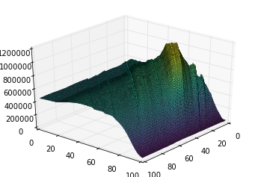

Source: own compilation

The rates that generate the above figures are shown in Figure 2. The values for the fertility, mortality and immigration rates in 2015 and 2060 are shown. In the naïve projection, the 2015 values are taken for fertility and mortality, and the immigration rates are adjusted to keep population constant (the naïve immigration rates are shown in Appendix 7.1). In the constant rates projection, the 2015 values are retained for all time periods, and in the updated rates projection, the rates begin at 2015 levels and are then updated year-by-year until 2060 after which they are kept constant.
The fertility rates are predicted to rise somewhat until 2060, though this higher level is still below replacement fertility. Mortality is predicted to fall between 2015 and 2060. Note that in the model, we do not allow lifetimes to exceed 100 years, and therefore impose a mortality rate of 1 on 99 year olds. Immigration rates are generally predicted to rise, with a similar profile to the current one with higher immigration rates by those of teen age and in their 20s and 30s.

Figure 2: Fertility rates, immigration rates and mortality rates in 2015 & Projections 2060
a) Fertility rates

b) Mortality rates

c) Immigration rates

Source: own compilation

Figure 3 compares the population projections with fixed rates (as in Figure 1) with the higher fertility rates. The blue line represents 2015 and is unchanged. The light blue line shows the increased population in 2060, especially the younger population, generated by the higher fertility. By 2100, the higher population is even more pronounced with new projections (the purple line) substantially above those with fixed rates (the red line). Note again that the increase is more pronounced for the younger ages, and that a substantial overall population decline relative to 2015 is still projected.

Figure 3: Population in 2015 & Projections 2060, 2100 (fixed vs updated rates)
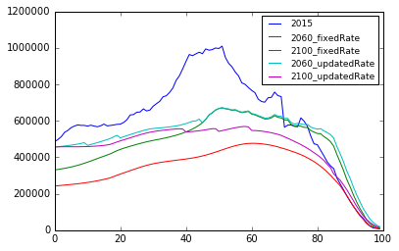

Source: own compilation

3. Modelling Methodology

The utility of OLG models for evaluating the dynamics of economic policies trace back to the work of Allais (1947), Samuelson (1958) and Diamond (1965). A major step forward in the use of applied, computable OLG models came with the publication of Dynamic Fiscal Policy (Auerbach and Kotlikoff, 1987), which made full use of the newly available computing power to solve more complex and detailed models. Most applied OLG models used today still recognise the Auerbach-Kotlikoff model as an important aspect of their heritage, despite the fact that such models have been extended and expanded across many dimensions since then (see Gorry and Hassett, 2013, for an overview of the impact of the Auerbach-Kotlikoff model and Diamond and Zodrow, 2013 for an overview of tax policy analysis using overlapping generations models).
OLG models have been also used in pension reform analysis (see e.g. Fehr (2000), Börsch-Supan, Ludwig and Winter (2006), Auerbach, Lee (2011), Agudo and García (2011), Auerbach et al. (2016), among many others). There are also a number of papers studying the macroeconomic and intergenerational effects of demographic change with the OLG model (see e.g. Fehr et al. (2008), Fehr et al. (2013), Börsch-Supan, Klaus Härtl, and Alexander Ludwig (2014), Nishiyama (2015), Georges et al. (2016), Catalano and Pezzolla (2016) among others). Fehr (2016) provides the review of CGE models application to study social security reforms.
Among many OLG models applications for policy analysis the ones with calibration based on the micro data are still quite uncommon. OG-ITA, heavily inspired by the open-source model for the United States, OG-USA (see DeBacker et al., 2017b), is one of the examples of such models. In what follows, we present the main structure of the OG-ITA.

  - Households

The OG-ITA model we have developed accounts for households maximizing their lifetime utility and making consumption, savings and labour supply decisions based on their expectations. The most remarkable characteristic of the model is the cross-sectional age heterogeneity, income distribution by abilities as well as bequests distribution by abilities. In the model, households live for a specific period of time leaving intentional and unintentional bequests to their descendants. They are forward looking and optimize their lifetime utility choosing consumption, labour supply and savings in every period. In the model, there is no uncertainty besides the one with respect to the mortality risk. On this regard, we have included realistic demographics on mortality rates, fertility rates, immigration rates and population growth and dynamic distribution. In OG-ITA we model households instead of individuals in order to avoid issues as gender, marital status or children. Usually, household is the unit of account in tax data.
    - Households lifetime earnings profiles

Among households in OG-ITA, we model both age heterogeneity and within-age ability heterogeneity. We use this ability or productivity heterogeneity to generate the income heterogeneity that we see in the data.
Differences among workers’ productivity in terms of ability is one of the key dimensions of heterogeneity to model in a micro-founded macro economy. In this chapter, we characterize this heterogeneity as deterministic lifetime productivity paths to which new cohorts of agents in the model are randomly assigned. In OG-ITA, households’ labour income comes from the equilibrium wage and the agent’s endogenous quantity of labour supply. In this section, we augment the labour income expression with an individual productivity $e_{j,s}$where j is the index of the ability type or path of the individual and s is the age of the individual with that ability path.
labour income: $x_{j,s,t}≡ w_{t}e_{j,s}n_{j,s,t} ∀j,t and E+1≤s≤E+S$
In this specification, $w_{t}$ is an equilibrium wage representing a portion of labour income that is common to all workers. Individual quantity of labour supply is $n_{j,s,t}$, and $e_{j,s}$ represents a labour productivity factor that augments or diminishes the productivity of a worker’s labour supply relative to average productivity.
We calibrate deterministic ability paths such that each lifetime income group has a different life-cycle profile of earnings. The distribution on income and wealth are often focal components of macroeconomic models. As such, we use a calibration of deterministic lifetime ability paths which is an adaptation from DeBacker et al. (2017a) that can represent earners in the top 1% of the distribution of lifetime income. Piketty and Saez (2003) show that income and wealth attributable to these households has shown the greatest growth in recent decades.
We employed survey data from Banca d'Italia. The data set is named "Archivio storico dell’Indagine sui bilanci delle famiglie italiane, 1977-2014". The Banca d'Italia dataset does not provide hourly wages. To obtain them we exploit the following information: number of worked months in a year, yearly earnings from labour income (including non-monetary benefits), and number of hours worked on average in a working week. This allows considering both full and part-time workers. We assumed 46 out of 52 weeks worked for a full-time employee in a year. The nominal wages are then converted to real wages using annual consumer price indexes (CPIs), expressed relative to the reference year 2010=100. Then, our measure of hourly real wage W is obtained as:

W = earnings / ( worked_hours * worked_months * 46/52 * CPI/100 )

In order to assign each individual in the data set to an ability group, we divided the data into six age brackets: 20 to 30, 31 to 40, 41 to 50, 51 to 60, 61 to 70, and 70 to 80. Within each bracket individuals were ranked according to their mean hourly wage. Individuals are then assigned to ability groups based on their positioning within the assigned bracket: ability group 1 if in the 24% percentile, 2 if in 25-49%, 3 if 50-69%, 4 if 70-79%, 5 if 80-89%, 6 if 90-99%, and finally 7 if 99-100%. For each of these 7 ability groups we then obtained a panel dataset by year and individual, where the age and the hourly wage of the person is observed. Separately for each ability group, we run panel fixed-effects regressions to derive the relation between age and hourly wage, according to the following cubic regression model:

log(W) ≈age + age² + age³

The coefficients obtained are then used to predict new values for the data series, for each ability group, to obtain imputed hourly wages for all age levels and all 7 abilities. Because there are few individuals above age 80 in the data, our data series were further extended up to age 100 by linearly extrapolating new wages, assuming that the hourly wage at age 100 is equal to the hourly wage at 80 divided by 1.5. Finally in order to have differentiable curves for each ability type, the data was smoothed in Stata using the command "lowess" with a 0.3 bandwidth.
Figure 4 shows a calibration for the seven deterministic lifetime ability paths e_{j,s} corresponding to labour income percentiles.

Figure 4: Exogenous life cycle income ability paths log(e_{j,s}) with S = 80 and J = 7
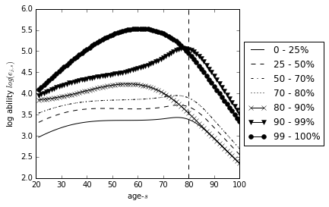
Source: own compilation

We calibrate the model such that each lifetime income group has a different life-cycle profile of earnings. Since the distribution on income and wealth are key aspects of our model, we calibrate these processes so that we can represent earners in the top 1 percent of the distribution of lifetime income. It is income and wealth attributable to these households that has shown the greatest growth in recent decades (see, for example, Piketty and Saez (2003)).

    - Households bequests’ calibration

The last term in formula (9) (see below) incorporates a warm-glow bequest motive in which individuals value having savings to bequeath to the next generation in the chance they die before the next period. Including this term is essential to generating the positive wealth levels across the life cycle and across abilities that exist in the data. The term ${BQ}_{t}$ represents total bequests from individuals who died at the end of period t-1. We assume that bequests are distributed evenly across all ages to those in the same lifetime income group. It is difficult to precisely calibrate the distribution of bequests from the data, both across income types j and across ages s.
In addition, the term $X_{j}^{b}$ the utility weight on bequests is a constant term that varies by lifetime income group j influencing the marginal utility of bequests, $b_{j,s+1,t+1}$ relative to the other arguments in the period utility function. Allowing the $X_{j}^{b}$ scale parameter on the warm glow bequest motive vary by lifetime income group is critical for matching the distribution of wealth. Since there is no income uncertainty in the model there is no precautionary savings. Calibrating the $X_{j}^{b}$ for each income group j allows us to recapture in a reduced form way some of the characteristics that individual income risk provides. To calibrate $X_{j}^{b}$ we choose 7 values ${\left\{X_{j}^{b}\right\}}_{j=1 }^{7}$to match nine moments from the data (namely each income group shares is total wealth as well as the Gini coefficient and the variance of wealth distribution). This is done by minimizing the sum of squared percent deviations between average steady-state wealth values and data values.
Because the form of the period utility function in formula (10) ensures that $b_{j,s,t}>0 ∀j,s,t$, and total bequests will always be positive: ${BQ}_{t}>0 ∀t$.

    - Labour supply calibration

In order to calibrate hours worked in OG-ITA we use the S initial-period labour supply Euler equations of the form:
$w{\left(c_{s}\right)}^{-σ}=X_{s}^{n}\left(\frac{b}{\tilde{l}}\right) {\left(\frac{n_{s}}{\tilde{l}}\right)}^{v-1}{\left[1-{\left(\frac{n_{s}}{\tilde{l}}\right)}^{v}\right]}^{\frac{1-v}{v}} ∀s$ (5),
where $w$ is gross wage (in units of consumption that a worker is paid for each unit of labour supplied), $c_{s}$ is consumption of individual of age s, $\frac{n_{s}}{\tilde{l}}$ is hours worked as a percentage of total time endowment of individual of age s, $σ$ is coefficient of risk aversion (the inverse of the intertemporal elasticity of substitution), $X_{s}^{n}$ is a scale parameter that influences the relative disutility of labour to the utility of consumption, and $b$ and $v$ are free parameters to be estimated (assuming elliptical utility for labour – for more details see ch. 5 of Evans and DeBacker, 2017).

Consumption and wage in the above equation are given in consumption units (consumption is the numeraire good).
In order to identify $X_{s}^{n}$ we have to reformulate the above equation as:

$X_{s}^{n}=\frac{w{\left(c_{s}\right)}^{-σ}}{\left(\frac{b}{\tilde{l}}\right) {\left(\frac{n_{s}}{\tilde{l}}\right)}^{v-1}{\left[1-{\left(\frac{n_{s}}{\tilde{l}}\right)}^{v}\right]}^{\frac{1-v}{v}} }$ (6).

To determine the value of $\tilde{X_{s}^{n }}$ (defined in data units) we use data on average gross wage, average consumption by individuals of age s, and data on average hours worked from the EUROMOD microsimulation model. Wage is defined as gross hourly wage from the discrete choice labour supply model (being one of the extensions to the EUROMOD microsimulation model) multiplied by the assumed total time endowment of 4000 hours per year. Average by individuals of age s is annual consumption averaged over all individuals at one age. Hours worked data are average (over all individuals at one age) weekly hours worked, further averaged over years 2008, 2010, 2012, 2014 to avoid noise. To express annual hours worked as a percentage of total time endowment we assume 4000 hours per year as total time endowment.
In order to account for the differences between the model units (i.e. consumption units) and data units (i.e. thousands of EUR) the scaling factor has been introduced for determining the steady-state variables in the model. The relation between parameter $X_{s}^{n }$ (in model units) and parameter $\tilde{X_{s}^{n }}$ (in data units) is as follows:

$X_{s}^{n } =\tilde{X_{s}^{n }}\left({factor}^{\left(σ-1\right)}\right)$ (7).
Thus, by estimating $\tilde{X_{s}^{n }}$using the data on wages, consumption, and labour supply, one can determine model parameters up to a scale. That scale is function of the model scale parameter, $factor$.

    - Budget Constraint and optimality conditions

The household lifetime optimization problem consist on choosing consumption c_{j,s,t}, labour supply n_{j,s,t}, and savings b_{j,s+1,t+1} in every period of life to maximize expected discounted lifetime utility:
$\max_{{\left\{\left(c_{j,s,t}\right), \left(n_{j,s,t}\right), \left(b_{j,s+1,t+1}\right)\right\}}_{s=E+1}^{E+S}}{\sum_{s=1}^{S}{β^{s-1}\left[\prod_{u=E+1}^{E+S}{\left(1-ρ_{u}\right)}\right]}} u\left(c_{j,s,t+s-1}, { n}_{j,s,t+s-1,}, b_{j,s+1,t+s} \right)$(8)
where $β^{s-1}$ is a discount factor, $ρ_{u}$ is mortality rate and $u(.)$ is households’ period utility function.
This is subject to budget constraints and upper-bound and lower-bound constraints. We impose the Inada condition whereby consumption is always strictly positive in equilibrium. The budget constraint for the age-s household in lifetime income group j at time t can be defined as:

$c_{j,s,t}+b_{j,s+1,t+1}=\left(1+r_{t}\right)b_{j,s,t}+w_{t}e_{j,s}n_{j,s,t}+ζ_{j,s}\frac{{BQ}_{t}}{λ_{j}ω_{s,t}}+ζ_{j,s}\frac{{TR}_{t}}{λ_{j}ω_{s,t}}-T_{s,t}$ $∀j,t$and $s≥E+1,$ (9)
where $b_{j,E+1,t}=0$, $∀j,t$ and s is the age of households; $c_{j,s,t}$is households consumption, $b_{j,s+1,t+1}$is savings for the next period, $r_{t}$ is the interest rate in the current period, $b_{j,s,t}$ is current wealth (savings from last period), $w_{t}$ is the wage, and $n_{j,s,t}$is labour supply. $ζ_{j,s}$is the share of total bequests ${BQ}_{t}$ that go to the age-s and income group-j household.

Households become economically active at s = E+1 and they live until to E+S. In making the optimal decisions households choose lifetime consumption${\left\{c_{j,s,t+s-1}\right\}}_{s=1}^{S}$ ,${\left\{n_{j,s,t+s-1}\right\}}_{s=1}^{S}, {\left\{b_{j,s+1,t+1}\right\}}_{s=1}^{S}$. Consequently, their period utility function can be defined as follows:

$u\left(c_{j,s,t}, { n}_{j,s,t,}, b_{j,s+1,t+1} \right)≡\frac{{\left(c_{j,s,t}\right)}^{1-σ}-1}{1-σ}+e^{g_{y\left(1-σ\right)}}X_{s}^{n }\left(b{\left[1-{\left(\frac{n_{j,s,t}}{\tilde{l}}\right)}^{v}\right]}^{\frac{1}{v}}\right)+X_{j}^{b}ρ_{s}\frac{{\left(b_{j,s+1,t+1}\right)}^{1-σ}-1}{1-σ} ∀j,t,$(10)

$E+1≤s≤E+S,$ where $g_{y}$ is the productivity growth rate, all remaining variables are defined as before.

The first term to the right is a constant relative risk aversion (CRRA) utility function of consumption. The second term is the elliptical disutility of labour described where $X_{s}^{n }$ adjusts the disutility of labour supply relative to consumption and can vary by age s. This is very helpful for calibrating the model to match labour market moments. This parameter needs to be multiplied by $e^{g_{y}\left(1-σ\right)}$because both consumption $c_{j,s,t}$ and savings $b_{j,s+1,t+1}$are growing at the rate of technological progress. Additionally, it keeps the relative utility values of consumption, labour supply, and savings in the same units. The final term in the utility function refers to bequests and it is a CRRA utility of savings, discounted by the mortality rate ρ_{s}. Intuitively, it captures the utility that households get if they don’t live in the next period with probability ρ_{s}. It is a utility of savings beyond its usual benefit of allowing for more consumption in the next period. This utility of bequests also has constant $X_{j}^{b}$ which adjusts the utility of bequests relative to consumption and can vary by lifetime income group j.

    - Households expectations

The 2S first order conditions for every type of household that characterize its S optimal labour supply decisions ${\left\{n_{j,s,t+s-1}\right\}}_{s=1}^{S}$ and S optimal savings decisions ${\left\{b_{j,s+1,t+s}\right\}}_{s=1}^{S}$are the following:
$\left(w_{t}e_{j,s}-\frac{∂T_{s,t}}{∂n_{s,t}}\right){\left(c_{j,s,t}\right)}^{-σ}=e^{g_{y}\left(1-σ\right)}X_{s}^{n}\left(\frac{b}{\tilde{l}}\right) {\left(\frac{n_{j,s,t}}{\tilde{l}}\right)}^{v-1}{\left[1-{\left(\frac{n_{j,s,t}}{\tilde{l}}\right)}^{v}\right]}^{\frac{1-v}{v}}$ (11)

${\left(c_{j,s,t}\right)}^{-σ}=X_{j}^{b}ρ_{s}{\left(b_{j,s+1,t+1}\right)}^{-σ}+β\left(1-ρ_{s}\right)\left(1+r_{t+1}-\frac{∂T_{s+1,t+1}}{∂b_{s+1,t+1}}\right){\left(c_{j,s+1,t+1}\right)}^{-σ} (12)$
${\left(c_{j,E+S,t}\right)}^{-σ}=X_{j}^{b}ρ_{s}{\left(b_{j,E+S+1,t+1}\right)}^{-σ}∀j,t$(13)
where $\frac{∂T_{s,t}}{∂n_{s,t}}$ is marginal tax rate on labour, $\frac{∂T_{s+1,t+1}}{∂b_{s+1,t+1}}$ is the marginal tax rate on capital, all the remaining variables and parameters are defined as before.

The household budget constraint that binds in all S periods is the following:

$c_{j,s,t}+ b_{j,s+1,t+1}= \left(1+r_{t}\right)b_{j,s,t}+w_{t}e_{j,s}n_{j,s,t}+{TR}_{t}-T_{s,t}$. (14)
where ${TR}_{t}$ are transfers that households receive and $T_{s,t}$ is total amount of taxes they pay.

  - Firms

The representative firm maximizes static profits by means of a Cobb-Douglas production function of capital and labour:
$Y_{t}= F\left(K_{t}, L_{t}\right)≡Z_{t}{\left(K_{t}\right)}^{γ}+{\left(e^{g_{y}t}L_{t}\right)}^{1-γ} ∀t$ (15)
where $Y_{t}$ is total output, $K_{t}$ is capital stock, $L_{t}$ is labour input to production, $γ$ is capital share in income, Z_{t} is total factor productivity that can be time dependent, and g_{y} is the rate of labour augmenting technological progress (constant productivity growth).

The profit function of the representative firm can be written as:
${PR}_{t}= F\left(K_{t}, L_{t}\right)-w_{t}L_{t}-\left(r_{t}+δ\right)K_{t} ∀t$ (16)
where ${PR}_{t}$ are firm’s profits, $δ$is the period depreciation rate, all the remaining variables are defined as before.
Gross income for the firms is given by the production function $F\left(K_{t}, L_{t}\right)$ because we have normalized the price of the consumption good to 1. Labour costs to the firm are $w_{t}L_{t},$ and capital costs are $\left(r_{t}+δ\right)K_{t}$.
The first derivative of profits respect to labour and capital is equal to their corresponding optimal demands:
${w_{t}=e}^{g_{y}t}Z_{t} (1-γ)\frac{Y_{t}}{e^{g_{y}t}L_{t}} ∀t$ (17)
$r_{t}= Z_{t} γ\frac{Y_{t}}{K_{t}}-δ ∀t$. (18)
  - Government

The government takes in tax revenues and uses those revenues to finance transfers, ${TR}_{t}= \sum_{s=1}^{S}{{tr}_{s,t}}.$ The transfers are distributed lump-sum to all agents, thus$tr= \frac{{TR}_{t}}{S} ∀s.$The taxes on labour and capital at this stage of model development are linear functions of labour and capital income.
The average for all households marginal tax rates on labour and capital income as well as the effective tax rate have been calculated based on the output from the EUROMOD microsimulation model. In the current version of the model we assume that government budget is balanced every period.

      - Further work – non-linear tax functions

In the version of the model currently being developed, but not yet completed, taxes will be modelled in OG-ITA as complex functions of both labour and capital income. In this way we will be able to consider also the interactions existing between the two types of income taxation, for example due to means-tested benefits or substitutions between sources of income (e.g. entrepreneurs shifting income to the lower-tax type between business income and labour or self-employed income). Our tax functions can be written as:

$$Tax Liability=f(Labour Income, Capital Income, Age, Year)$$

Tax functions are being estimated separately for year-age profiles, based on EU-SILC linked individual-household level survey data and calculations of the corresponding tax liabilities. The choice to estimate these functions separately by age reflects the desire to capture different compositions in assets and incomes, which we cannot observe in our microdata but which correlate with age and may imply different tax treatments.
More in detail, our approach to estimating marginal tax rate functions follows the methodology of DeBacker et al. (2017b). We fit the parameterized functional form to our microsimulation data in order to obtain a smooth and well-behaved representation of the real world tax code that can be used in a computable GE model. Tax liabilities and marginal tax rates also enter in the function estimation and are computed, separately for labour and capital income, using the EUROMOD microsimulation model which matches the existing tax rules in a specific year to individuals and households based on their observed demographic and socio-economic characteristics (i.e. married status, number and age of children, employment status, etc.). Finally, because the tax rates are estimated as functions of income levels in the microdata, we have to adjust the model income units to match the units of the microdata. To do this, we find a factor such that factor times the average model income at the steady-state equals the mean income in the latest year available in the microdata.

      - Further work – unbalanced government budget

We are currently working on the version of the model with government balance that need not be balanced every period (i.e. an unbalanced government budget). To this end, let $D_{t}$ denote the stock of government debt at time t and $R_{t}$ denote total government tax revenue. Thus we write the government budget constraint as:
$D_{t+1}+ R_{t}=\left(1+r_{t}\right)D_{t}+G_{t}+{TR}_{t}$ (19)

Revenues are given as a sum of corporate income tax revenue $(τ_{t}^{c}\left(Y_{t}-w_{t}L_{t}\right)-{τ_{t}^{c}δK}_{t})$ and individual income tax revenue ( $\sum_{s=1}^{S}{\sum_{j=1}^{J}{τ_{t}^{l}{{w_{t}e}_{s,j}n}_{s,t}}}+\sum_{s=2}^{S}{{τ_{t}^{k}r}_{t}}b_{s,t})$:
$R_{t}=τ_{t}^{c}\left(Y_{t}-w_{t}L_{t}\right)-{τ_{t}^{c}δK}_{t}+\sum_{s=1}^{S}{\sum_{j=1}^{J}{τ_{t}^{l}{{w_{t}e}_{s,j}n}_{s,t}}}+\sum_{s=2}^{S}{{τ_{t}^{k}r}_{t}}b_{s,t}$ (20)

To close the government budget we can alter for example the path of government spending in order to hit a target debt to GDP ratio in the steady-state.

  - Market clearance

The labour market, the capital market, and the goods market must clear in OG-ITA . According to the Walras’ Law, it is enough with two of three clearing conditions. In the model, we ignore the goods market clearing condition. The labour market clearing requires that aggregate labour demand L_{t} measured in efficiency units equal the sum of household efficiency labour supplied $e_{j,s}n_{j,s,t}$.

$L_{t}=\sum_{s=E+1}^{E+S}{\sum_{j=1}^{J}{ω_{s,t}}{λ_{j}e}_{j,s}n_{j,s,t}} ∀t$ (21)

In the capital market clearing aggregate capital demand equal the sum of capital savings and investment by households:
$K_{t}=\sum_{s=E+2}^{E+S+1}{\sum_{j=1}^{J}{ω_{s-1,t-1}}{λ_{j}b}_{j,s,t}+i_{s}ω_{s,t-1}{λ_{j}b}_{j,s,t}} ∀t$ (22)

And aggregate consumption C_{t} is defined as the sum of all household consumptions, and aggregate investment:

$Y_{t}=C_{t}+K_{t+1}-\left(\sum_{s=E+2}^{E+S+1}{\sum_{j=1}^{J}{i_{s}ω_{s,t}{λ_{j}b}_{j,s,t+1}}} \right)-\left(1-δ\right)K_{t} ∀t$ (23)
where $C_{t}≡\sum_{s=E+1}^{E+S}{\sum_{j=1}^{J}{ω_{s,t}}{λ_{j}c}_{j,s,t}}$
Note that the extra terms with the immigration rate i_{s} in the capital market clearing equation and the resource constraint accounts for the assumption that age-s immigrants in period t bring with them (or take with them in the case of out-migration) the same amount of capital as their domestic counterparts of the same age.

4. Simulations and results

We define the following simulations, which serve highlight the impact of demographics and public pension policy. For more details on the demographic simulations, see Section 2.
An additional feature of the simulations here is to introduce a highly stylised tax and transfer system, which shows some of the challenges of maintaining a public pension system with a changing demography. Individuals pay an income tax at 28% of labour income and 17.5% of capital income. This revenue is then redistributed to all individuals according to the following rule: (i) those up to retirement age receive a basic amount, and (ii) those above retirement age receive a different, larger amount. This stylised transfer system reflects the idea that government provides some universal services for all individuals (the basic amount) and also provides a universal public pension above a certain age. In the baseline, we set this age to 62, which is the current retirement age in Italy. We define three simulation scenarios to be compared with a baseline one as follows:

- BASELINE: Our baseline assumed a constant population, which we refer to as the naïve projection, because it replicates a myopic projection that the future will be the same as the present. The retirement age is kept at age 62. The idea of having this artificial baseline scenario was to determine the “pure” demographic impact onto the Italian economy.
- PENSION REFORM (RETIREMENT AGE RISE): Demography defined as in the baseline scenario. The retirement age is increased to the age of 70.
- DEMOGRAPHIC CHANGE (UPDATED DEMOGRAPHIC RATES): The rates for fertility, mortality and net immigration are in line with the Eurostat (2018) baseline projections fixed. The retirement age is kept at age 62. The transfer to non-retired individuals is kept at the baseline levels, and the remaining amount is transferred to retirees.
- PENSION REFORM WITH DEMOGRAPHIC CHANGE (UPDATED DEMOGRAPHIC RATES + RETIREMENT AGE RISE): This simulation has the same demography as UPDAT-DEMOG. However, the retirement age rises to 70. The transfer to non-retired individuals is kept at the baseline levels, and the remaining amount is transferred to retirees.

Since for the moment we keep the balanced government budget assumption, there is no fiscal deficit in the model. In simulation scenarios these assumption is being maintained by (labour) tax adjustments. In the further version of the paper the balanced government budget assumption will be relaxed and the implications of pension reforms for public debt and long-term fiscal sustainability could be analysed.

In the remaining part of this section we describe the results for individuals distinguished by age and income group of the three simulations that are compared to the BASELINE: i) DEMOGRAPHIC CHANGE, ii) PENSION REFORM and iii) PENSION REFORM WITH DEMOGRAPHIC CHANGE.
On Figure 5 below dynamic solution in a baseline scenario is presented for labour supply, consumption, savings and tax revenues. Since our OLG model is multidimensional in order to present nice 3-D graphs we have to fix one dimension. Hence we only present here the results for the forth ability group. As can be seen from graphs, labour supply is hump-shaped with young and elderly generations working less and prime-aged individuals working more. Consumption is growing with age until age 80 then it starts declining. Savings are having double hump-shaped profile over the life cycle with the second pick coming at the retirement age (62) when individual is receiving an additional transfer. Tax revenues (from personal income from labour and capital) pattern over a life cycle is a combination of labour supply and savings patterns.

Figure 5: Baseline scenario (forth ability group)
a) labour supply

b) consumption

c) savings

d) tax revenues

Source: own compilation

Before analysing the consequences of the pension reform, we wanted first to examine the pure demographic impact (DEMOGRAPHIC CHANGE scenario). To this end, we ran a scenario with actual fertility, immigration and mortality rates up to year 2060 in line with the Eurostat’s (2018) baseline projections and compared it against the (constant population) baseline scenario. Actual demographic trends result in a smaller population decline than in the constant population baseline. In Figure 6 the scenario with Eurostat’s demographic trends (DEMOGRAPHIC CHANGE scenario) is compared against the (constant population) baseline scenario. The seven workforce participation profiles are shown for each of the seven ability income-earning types representing, namely the lowest 25 percentiles, the next 25, the next 20, the next 10, the next 10, the next 9 and the top 1 percent (see Section 3 for details on ability types). Although it cannot be seen from the graphs presented here the lower earners in our OLG model have higher aggregate labour force participation. Looking at the labour force participation from age perspective, it peaks between around age 30 and age 60, before declining to very low levels in retirement years.

As is apparent from Figure 6, panel a), lower population decreases labour force participation, especially for younger workers (until age 50). Labour force participation increases slightly for elderly, but since there are far fewer labour force participants in these age groups, total aggregate labour supply falls (by 13.1%). The driver of the labour force participation effect is the wage level. The lower population leads to a 2.2% higher wage level as labour is less abundant relative to capital. Therefore the marginal utility of consumption matches the marginal disutility of labour at a lower labour force participation level. Under the higher fertility scenario (i.e. the one with actual demographic trends), consumption is significantly higher, especially for elderly, and so are savings. Aggregate steady-state consumption loss in updated rates scenario (actual Eurostat trends) is equal to 9.6% with respect to the constant population scenario and the aggregate steady-state income loss is equal to 11.2%. Higher savings of elderly until age 70 followed by lower savings of the most elderly drive greater tax revenues followed by lower tax revenues respectively for these age groups. By an assumption of government budget being balanced every period, aggregate lump-sum transfer to individuals is equal to total tax revenues. Since tax revenues on average fall, so does aggregate transfer to households.
Here for the sake of brevity only long-run (steady state) effects have been discussed. In the Appendix on Figure 7.2.1 time paths of deviations of labour supply, consumption, savings and tax revenues are presented.

Figure 6: Impact of demography (actual demographic trends versus constant population)
a) labour supply – difference (in pp.) wrt baseline b) consumption – percent changes wrt baseline
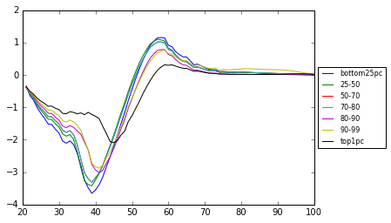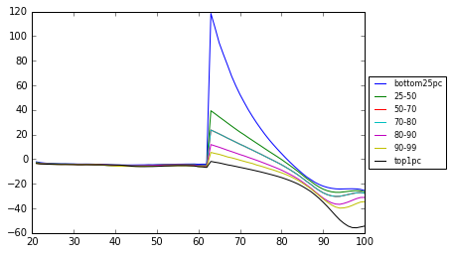

c) savings – percent changes wrt baseline d) tax revenues – percent changes wrt baseline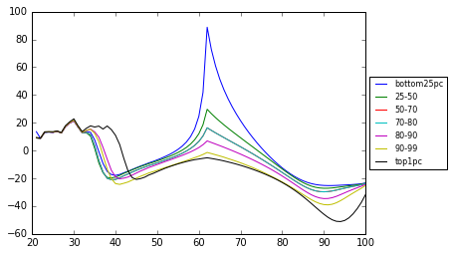 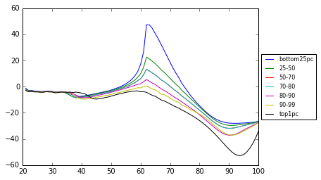
Source: own compilation

In what follows the results of raising the retirement age from 62 to 70 are discussed (PENSION REFORM scenario). The abovementioned pension reform increases transfers to individuals at retirement age. Since this is a perfect foresight model, agents at the pre-retirement age react increasing consumption and savings as compared with the baseline scenario. As can be seen in Figure 7 the reform increases labour supply of the young and prime-aged people (by around 1 pp. for young and by up to 6 pp. for elderly workers).
Younger generations (of age 21 to middle-aged) are experiencing consumption and welfare gains since they are beneficiaries of long-term welfare improve. Analysing the effects of the reform by different income groups, we can see that the lower the income group is, the bigger effect is of the reform for this group. Quite intuitively, as a result of the pension reform long-term welfare as measured by consumption is increased. Long-term aggregate consumption is greater by 10% than it would be in the absence of the reform. Long-term aggregate income is greater by 10.9% after the increase of the retirement age with aggregate capital stock being higher by 13.7% and aggregate labour supply being higher by 9% than before the reform. Tax revenues follows savings pattern. Since government budget is balance every period total transfers all households receive must equal total taxes paid by all households.
Here only long-run (steady state) effects have been discussed. In the Appendix on Figure 7.2.2 time paths of deviations of labour supply, consumption, savings and tax revenues are presented.

Figure 7: Effects of the increase of the retirement age from 62 to 70 (constant population)
a) labour supply – difference (in pp.) wrt baseline b) consumption – percent changes wrt baseline
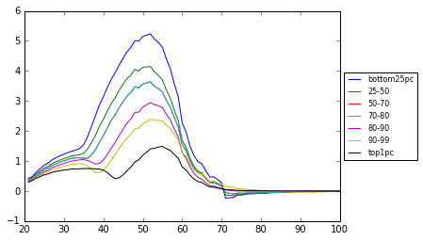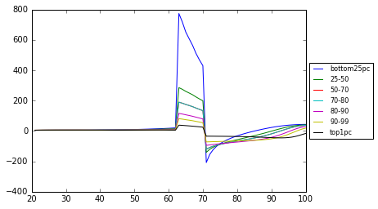

c) savings – percent changes wrt baseline d) tax revenues – percent changes wrt baseline
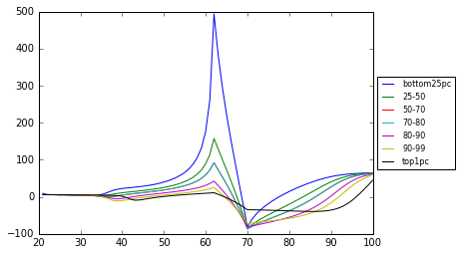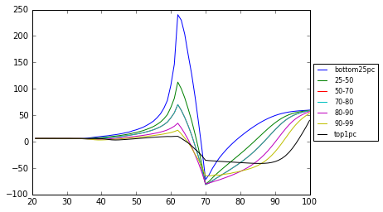
Source: own compilation

The third scenario, PENSION REFORM WITH DEMOGRAPHIC CHANGE, combines the first two scenarios, allowing us to investigate interaction effects. The steady-state results for individuals over their life cycles with the distinction of income groups are presented in Figure 8. Demographic change affects consumption, savings and tax revenues. It reduces increases of consumption and savings for those age groups that are experiencing positive effects as well as limits decreases of consumption and savings for those age groups that are experiencing negative effects. Labour supply increase is reduced under demographic change as compared to the scenario with base year (2015) demographic patterns.
All in all, presence of the demographic change is counterbalancing the positive impact of the pension reform on the long-term welfare. Aggregate long-term consumption in the pension reform scenario combined with actual demographic trends is lower by 4.1% as compared with the baseline scenario. Aggregate income is lower by 5.7% with aggregate capital being lower by 1.7% and aggregate labour being lower by 8.3% as compared to the baseline scenario.
In the Appendix on Figure 7.2.3 time paths of deviations of labour supply, consumption, savings and tax revenues are presented in addition to the just discussed long-term (steady state) effects.

Figure 8: Combined effect of the increase of the retirement age from 62 to 68 and the demographic change
a) labour supply – difference (in pp.) wrt baseline b) consumption – percent changes wrt baseline
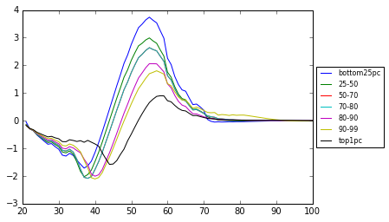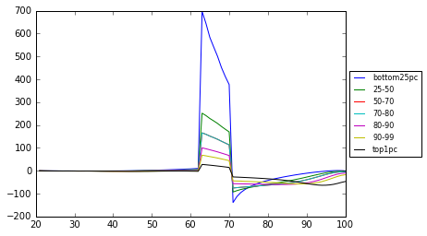

c) savings – percent changes wrt baseline d) tax revenues – percent changes wrt baseline
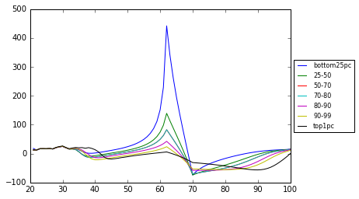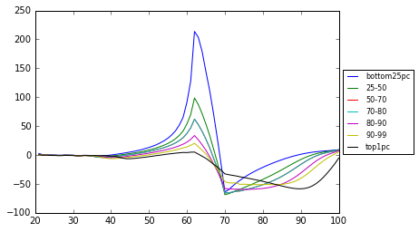
Source: own compilation
Table 1 summarises the impact of the scenarios on macroeconomic indicators. Generally, demographic change is reducing to a great extent positive effects of the retirement age increase that would occur in the absence of demographic change. Pension reform alone causes an increase in aggregate consumption (welfare) and production, but combined with the demographic change results in fall of aggregate consumption and production.
To further show that fiscal policy is greatly affected by demographic trends in Figure 9 we present old-age pension transfer as well as total (PIT) tax revenues as a percentage of GDP for the baseline and the three simulations scenarios. What is apparent from the graphs is that in the presence of the demographic change pension reform results in both tax revenues and old-age pension transfers being lower than they would be in the absence of this change. Relaxation of the assumption that government budget is balanced every period would enable to examine how pension reform and demographic change affects budget deficit. This is left for further work.

Table 1: Macroeconomic indicators (scenarios vs baseline, % or pp. change)
 | Pension reform  (retire age 70) | Demographic change  (actual demographic trends) | Pension reform & demographic change (retire age 70; actual demographic trends)
Interest rate | -0.5 pp. | -0.6 pp. | -0.8 pp.
Wage | 1.7% | 2.2% | 2.8%
Total consumption | 10.0% | -9.6% | -4.1%
Labour supply | 9.0% | -13.1% | -8.3%
Capital stock | 13.7% | -8.3% | -1.7%
Production | 10.7% | -11.2% | -5.7%
Total bequests | -4.6% | -1.2% | -6.3%
Total transfer | 10.6% | -11.7% | -6.3%
Source: own compilation

Figure 9: Combined effect of the increase of the retirement age from 62 to 68 and the demographic change
a) old-age pension transfers as a percentage of GDP
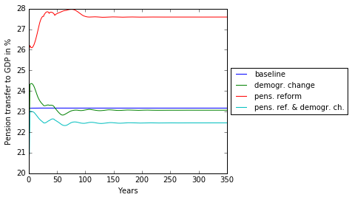
a) total tax revenues as a percentage of GDP
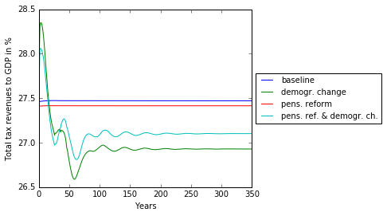
Source: own compilation

5. Conclusions and Future Developments

We have investigated the relevance of demographic trends for an exemplary pension reform scenario. We have compared two possible demographic trends both of which show a declining population. The first supposes that current demographic trends are maintained and the second uses updated demographic dynamics through to 2060, which in particular increases the fertility rates and reduces the mortality rates relative to the fixed scenario. Then we ran pension reform simulation of raising the retirement age in Italy from 62 to 70.
The overlapping generations model structure allows us to trace the impact on different age groups. What emerges from the model is that those in mid-career (from around age 45, depending on the ability type) would choose to work more hours in the actual Eurostat (2018) demographic scenario than in the constant population scenario with lower population growth, reaching a peak in the early 50s before declining. This generates additional earnings which are initially are saved, and later both consumption and savings rise. Indeed we show that consumption would be expected to increase especially for those between the ages of 50 and 90 (with the fairly small number of people over 90 showing a decline). We are also able to distinguish between the optimal paths for different income-earning ability types. For example, the top one percent of income earners shows the highest responses to labour market changes, first increasing their labour market participation the most from approximately ages 45 to 60, and then restricting it the most in later ages.
The results of the pension reform simulation showed that total welfare and income of the Italian economy as a result of the retirement age increase would rise and that the greatest beneficiaries of this reform in the long run would be younger generations. Since households in our OLG model are heterogeneous by age and income groups we were able to analyse the simulation scenarios by heterogeneous households’ groups.
Current work focuses on developing the model to accurately model public and private pension provision in Italy. Also this will address funding of additional pension expenditure through different tax types, with the intention of comparing the burden-sharing impact of raising labour taxes compared with consumption taxes. We will investigate the extent to which a trade-off between efficiency and equity is observed. The overlapping generations structure will consider the impacts that pension provision has on labour market decisions and address the policy options available given the projected population implosion. We will also address policies to address the debt-to-GDP ratio, so as to investigate the impact of reducing this ratio over different time horizons. We are also working on representing marginal and effective tax rates as non-linear functions of capital and labour incomes, thus enabling us to approximate with the OLG macro model the complexity and richness of microeconomic data. In the future version of the paper, we would also assume that government budget needs not be balanced every period, what will allow us to study the impact of policies on fiscal deficit and public debt.

6. References

Agudo, L. F. and M. Alda García (2011), Pension reform in Italy: Description and evaluation, Pensions: An International Journal, Vol. 16, No. 2, pp 96-106.
Allais M. (1947), Economie et intérêt, (two volumes) Paris: Imprimerie Nationiale.
Auerbach A. J., L. Kueng, R. Lee , Y. Yatsynovitsch (2016), Propagation and Smoothing of Shocks in Alternative Social Security Systems, version of 13th of October, available at: https://eml.berkeley.edu/~auerbach/Propagation%20and%20Smoothing%20of%20Shocks%20final.pdf
Auerbach A. J., Kotlikoff L. J. (1987), “Dynamic fiscal policy”, Cambridge: Cambridge University Press.
Auerbach A. J., R. Lee (2011), Welfare and generational equity in sustainable unfunded pension systems, Journal of Public Economics, 95, 16-27.
Börsch-Supan A., K. Härtl, and A. Ludwig (2014), Aging in Europe: Reforms, International Diversification, and Behavioral Reactions, American Economic Review: Papers & Proceedings, 104(5): 224–229.
Börsch-Supan A., A. Ludwig, and J. Winter (2006), Ageing, Pension Reform and Capital Flows: A Multi-Country Simulation Model, Economica, 73, 625–658.
Catalano M. and E. Pezzolla (2016), The effects of education and aging in an OLG model: long-run growth in France, Germany and Italy, Empirica, November, Vol. 43, Issue 4, pp. 757–800.
DeBacker, Jason, Evan Magnusson, Kerk L. Phillips, Shanthi Ramnath, and Isaac Swift (2017a), The Distributional Effects of Redistributional Tax Policy, mimeo, Open Source Macroeconomics Laboratory, January.
DeBacker, Jason, Richard W. Evans and Kerk L. Phillips (2017b), Integrating Microsimulation Models of Tax Policy into a DGE Macroeconomic Model: A Canonical Example. November, available at https://sites.google.com/site/rickecon/.
Diamond, P.A. (1965), National Debt in a Neoclassical Growth Model, American Economic Review, vol. 55, 1126-50.
European Commission (2018), Debt Sustainability Monitor 2017, European Economy Institutional Papers, No. 071, January, DG Economic and Financial Affairs.
Eurostat (2018), Population and social conditions – Population projections (proj) – Population projections at national level (2015-2080) (proj_15n)
http://ec.europa.eu/eurostat/data/database, access 5/02/2018.
Evans R.W., DeBacker J. (2017), “OG-USA: Documentation for the Large-scale Dynamic General Equilibrium Overlapping Generations Model for U.S. Policy Analysis”, December, version 2017.12.b, available at https://github.com/open-source-economics/OG-USA/tree/master/documentation
Fehr H. (2016), CGE modeling of social security reforms, Journal of Policy Modeling, 38, 475–494
Fehr H. (2000), Pension Reform during the Demographic Transition, Scandinavian Journal of Economics, 102(3), 419-443.
Fehr H. , S. Jokisch, and L. J. Kotlikoff (2008), Fertility, mortality and the developed world’s demographic transition, Journal of Policy Modeling, 30, 455–473.
Fehr H., S. Jokisch, M. Kallweit, F. Kindermann, and L. J. Kotlikoff (2013), Generational policy and aging in closed and open dynamic general equilibrium models, in: Peter B. Dixon, Dale Weldeau Jorgenson “Handbook of Computable General Equilibrium Modeling”, Volume 1, chapter 27.
Georges P., K. Lisenkova, M. Merette, and Oi Zhang (2016), An Overlapping Generations Computable General Equilibrium (OLG-CGE) Model with Age-Variable Rate of Time Preference, NIESR Discussion Paper, No. 458.
Gorry A., Hassett K. (2013), Recent Developments in the Dynamic Fiscal Policy Literature, Tax notes, December 9.
Gravelle J. G. (2014), Dynamic Scoring for Tax Legislation: A Review of Models, Congressional Research Service Report, July 8.
Mérette, M. and P. Georges (2010) Demographic Changes and the Gains from Globalisation: An Analysis of Ageing, Capital Flows, and International Trade. Global Economy Journal Volume 10, Issue 3, Article 3.
Nishiyama S. (2015), Fiscal Policy Effects in a Heterogeneous-Agent OLG Economy with an Aging Population, Economics Working Paper Series, The Department of Economics, Lancaster University Management School.
Rasmussen, T. and T. Rutherford (2004) Modeling overlapping generations in a complementarity format. Journal of Economic Dynamics and Control. 28:1383-1409.
Samuelson, P. A. (1958), “An Exact Consumption-Loan Model of Interest with or without Social Contrivance of Money”, Journal of Political Economy, vol. 66, 467-82.
Sutherland H. (2007), EUROMOD – The Tax-Benefit Microsimulation Model for the European Union, In: Harding, A., Gupta, A. (eds.), Modeling our Future: Population Ageing, Social Security and Taxation, International Symposium in Economic Theory and Econometrics, Vol. 15, Amsterdam, Elsevier.
Zodrow, G. and J. Diamond (2013), Dynamic Overlapping Generations Computable General Equilibrium Models and the Analysis of Tax Policy: The Diamond-Zodrow Model, Chapter 11 in “Handbook of CGE Modelling” – Volume One, Elsevier.

7. Appendix

7.1. Immigration rates for constant population
The naïve immigration rates are shown in comparison to the 2015 and 2060 values. These were calculated to maintain population constant for all ages. As shown in Figure A1, the values for the ages need to be both positive and negative, and for a some ages have a large absolute value.

Figure A1: Population dynamics 2015 to 2115

Source: own compilation

7.2. Results over the time path

Figure 7.2.1: Impact of demography (actual demographic trends versus constant population)
a) labour supply – percent changes wrt baseline

b) consumption – percent changes wrt baseline

c) savings – percent changes wrt baseline

d) tax revenues – percent changes wrt baseline

Source: own compilation
Figure 7.2.2: Effects of the increase of the retirement age from 62 to 70 (constant population)
a) labour supply – difference (in pp.) wrt baseline

b) consumption – percent changes wrt baseline

c) savings – percent changes wrt baseline

d) tax revenues – percent changes wrt baseline

Figure 7.2.3: Combined effect of the increase of the retirement age from 62 to 68 and the demographic change
a) labour supply – difference (in pp.) wrt baseline

b) consumption – percent changes wrt baseline

c) savings – percent changes wrt baseline

d) tax revenues – percent changes wrt baseline

Source: own compilation

DISCLAIMER: The views expressed are purely those of the authors and may not in any circumstances be regarded as stating an official position of any affiliated institution.
University of South Carolina, USA
University of Chicago, USA
European Commission, Joint Research Centre, Seville, Spain
As we do not model males and females separately, we convert the fertility rate for women into a fertility rate for the total population.
For modelling reasons, the immigrants and emigrants are assumed to be identical to the existing population of the same age, with the same dispersion of income-earning abilities. This would be an interesting assumption to relax in the future.
Note: for the steady state solution, both equations are stationarised by dividing by ($1+g_{n,t+1}$).
We employed version 9.1 (July 2017). Data and the related documentation were downloaded in January 2017, in Stata file format, from the URL: https://www.bancaditalia.it/statistiche/tematiche/indagini-famiglie-imprese/bilanci-famiglie/index.html. To transform monetary amounts from nominal to real values we employed seasonally unadjusted consumer price indexes (CPIs) downloaded from the St. Luis FRED (https://fred.stlouisfed.org).
Note that the number of individuals aged above 90 (marked as 70+ in the figure) is very small, so we are only mildly concerned with the uptick in labour force participation.
Labour supply in the OG-ITA is expressed as percentage of total time endowment, that is why its changes versus the baseline scenario are presented here in percentage points.

