Price and quantity effects of non-tariff measures: Exploring cge options with OECD metro

By
Christine Arriola, Julien Gourdon, Susan Stone and Frank Van Tongeren
OECD Trade and Agriculture

Introduction
In the last decade, non-tariff measures (NTMs) have been the object of substantial academic and policy attention. In particular policy makers and economists have turned their attention to the role played by non-tariff methods of protection. More recently, research has been looking into various types of regulatory compliance costs impacting on international trade – and ways to reducing them. To support the negotiations needed to address trade impacts of NTMs, it is important to identify those measures that merely raise trade costs or create rents, from those that also create a positive benefit by addressing a regulatory problem. The diverse and complex nature of NTMs makes their quantification within a computable general equilbirum (CGE) framework both necessary and challenging.

Objective
In order to disentangle the different forms and objectives of NTMs, this research distinguishes “non-technical” and “technical” measures, the latter type typically falling in to the SPS and TBT categories and the former including quatitative restrictions like , non automatic import licensing or quotas. Estimated price and quantity effects of these two types of NTMs are used to disentangle demand-shifting effects from pure trade costs. This opens the way to accounting for trade-enhancing effects of regulations (and their concomitant NTMs) that come from reducing information asymmetries and strengthening consumer confidence in imported products. These estimates are then applied in a CGE model where the different impacts on costs and utility are assessed.

The paper builds on the novel quantification of the impact of NTMs on price and quantity, mapped to GTAP sectors, developed by Cadot et al. (2018). It is well established that NTMs lead to multiple effects on international trade that go beyond trade costs (see for example, OECD, 2017). Thus the paper begins with a discussion of the pros and cons of the various treatments of different NTMs in CGE models (iceberg cost, tax equivalent, demand/supply-shifting) and what it means for capturing a more complete picture of the impact of differential regulation on international trade. A more nuanced approach to capturing both the costs and benefits of these measures is illustrated through a specific application of the METRO CGE model, developed by the OECD. The estimated price and quantity effects are used to perform CGE simulations in order to obtain estimates of trade and welfare effects of the removal of non-technical barriers and of regulatory cooperation on technical-barriers (SPS and TBT).

Main contribution to the existing literature
Most of the empirical evidence on the impact of non tariff measures on trade and welfare is done without distangling the different types of NTMs (technical barriers from non-technical barriers). In a pioneering work, Adriamnajaraa et al (2004) estimated price effects of NTMs from different sources collected by WTO, US, EU and UNCTAD and, together with the EIU City database, were used to calibrate a GTAP-based CGE model. All types of NTMs were aggregated to one category represented by a dummy in the gravity equation. This approach captures the NTM effect as a rent premium, however, it only measures the price effect. This approach does little to capture the various trade liberalization scenarios policymakers encounter. Different NTMs (removal of non technical barriers, regulatory cooperation on standards, etc.) tackle different issues and minimising their associated costs requires different policy actions.

Research from Fugazza and Maur (2008) discusses various treatments of NTMs in CGE modelling, including the introduction of demand-shift and supply-shift effects.They also make a distinction between rent creating NTMs and technical, cost generating, NTMs. However their modelling work only captured the trade barrier effects of those NTMs by using ad-valorem estimates from Kee et al. (2009). Another issue with this approach is the generation of government revenue when applying AVEs. Fontagne et al (2013) proposed modelling NTMs effects as iceberg or deadweight trade cost in the GTAP framework, keeping only the cost generating effect of NTMs. Egger et al (2015) follow this path but also include spillover effects from NTM cost reduction for third countries. They also argued that NTMs should be modelled as a mix of cost and rent generating barriers. Recently, Bekkers and Rojas-Romagosa (2018) then Bekkers and Francois (2018) developed a comprehensive and detailed modelling of trade related costs which include NTMs under the Armington, Melitz and Ethier‐Krugman models. They show that estimates of NTM effects can differ as a result of the methodology used to assess their cost but also because of their modelling features in CGE model. These include whether the approach used was top-down or bottom-up with studies showing smaller estimates for bottom-up appracohes.

There is even less evidence based on the different effects of NTMs - cost-generating vs rent-generating - but also demand-shifting. This is mostly due to limited availability of estimates on price and quantity effects of different types of NTMs. Those estimates have been calculated using the approach from Cadot et al (2018). This method further improves the modelling of NTM instruments in a CGE framework to achieve a more comprehensive assessment of direct and indirect effects of those measures. This paper contributes to previous bodies of work by more fully assessing the impact of different types of NTMs using these new price and quantity estimates.

The measurement of both price and quantitiy effects recognises that simply interpreting AVEs as measuring only distortions is severely misleading. Further, when the quality of suppliers is heterogeneous and unknown to buyers, regulations can overcome the information deficit and convey a signal that all producers conform to a certain standard, encouraging demand. Good regulations can facilitate trade. In such cases, NTMs affect both the product supply curve through the various costs associated with compliance and the demand curve through signalling or “catalyst” effects.

The AVEs measure the costs that exporters have to incur to comply with regulatory requirements on the importing markets. The country-average AVEs vary according to two types of composition effects.
- Origin Effects - Even if two importing countries share the same body of regulations (e.g. two EU countries) their AVEs will differ because of an origin-composition effect. For example, if one country imports more from countries with weak SPS infrastructures, its regulations will require more adaptation from origin producers, and hence will entail higher AVEs as the second country that sources more of its imports from countries with more developed SPS systems.
- Product-effects - a country importing more highly sensitive products, e.g. shrimp, will have a mechanically higher average AVE for SPS measures than a county that imports less sensitive products.

Figure 1: Ad-valoreum equavlanets of different NTMs by sector (in percent)
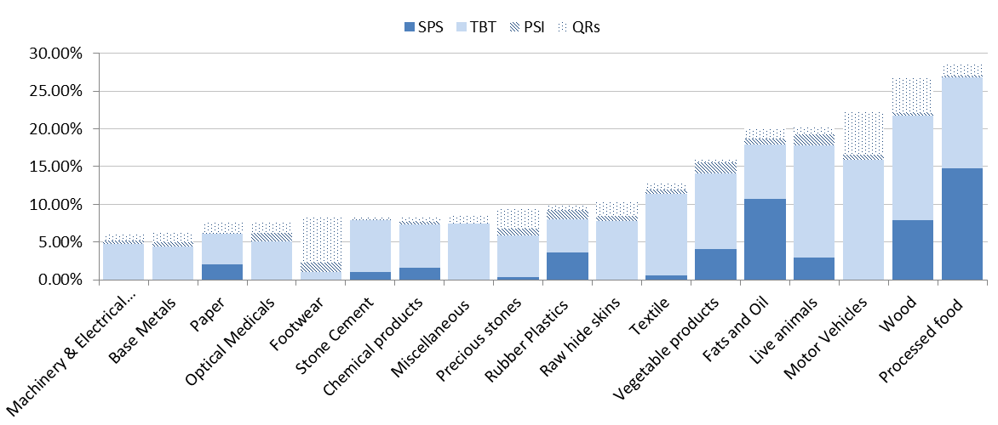

Note: SPS is Sanitary and Phytosanitary measures, TBT refer to Technical Barriers to Trade, BCM are Border Control Measures and QR are Quantitative Restricitons.
Source: Cadot, Gourdon and van Tongeren (2018)

The effect on quantities are more subtle. OECD work implies that import volumes are higher with the technical (ie SPS and TBT) NTM measures than without them (Figure 2) . This suggests that the demand-enhancing effect of technical measures is substantial; in other words, the findings lend some support to the presumption that well designed regulations and related NTMs can have a trade-facilitating effect. Trade facilitating effects can be expected to occur when the NTMs help overcome negative externalities and information asymmetries, although prices are higher than in the absence of the measures. Non-technical measures, in contrast, raise prices while reducing volumes, as they involve no demand-shifting effect

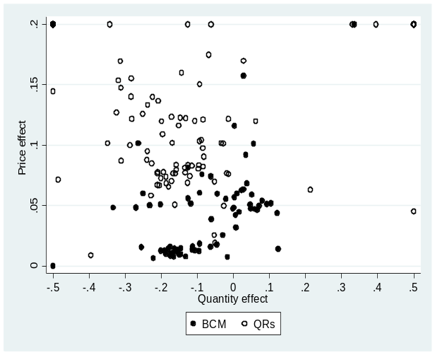
Figure 2: Price and quantitiy changes with standards (in percent)
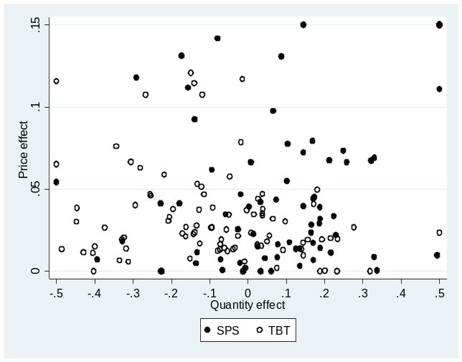
Note: SPS is Sanitary and Phytosanitary measures, TBT refer to Technical Barriers to Trade, BCM are Border Control Measures and QR are Quantitative Restricitons.
Source: Cadot, Gourdon and van Tongeren (2018)

The AVEs modelled in Cadot et al (2018) were aggregated to the GTAP sectors for the G20 economies. The average size of of the shocks are presented in Figure 3.This paper models a reduction in the costs of NTMs under a scenario where governments are able to work together to minimise policy divergence, thereby reducing unnecessary bilateral trade costs that may stem from differences in regulatory approaches across G20 economies. Given the harmonised regulatory regime existing within the European Union, NTMs among these countries are not reduced, although they are reduced between EU members and third parties. The level of actual NTM reduction varies by sector and country based on the level of bilateral trade costs and the composition of that bilateral trade by sector.

Figure 3: Average size of NTM cost reductions, by sector

Source: Authros’calculations

Modelling NTMs in METRO

The iceberg method (Samuelson, 1954) has been widely used for the analysis of NTMs with CGE models. Iceberg costs are based on the idea that the cost of transporting a good can be expressed as a portion of the transported good; similar to an iceberg, some value melts away as it is moved to more distant destinations. The iceberg variable lowers the cost of trade and increases the quantity of imports consumed relative to the quantity sent or exported, thereby increasing real GDP and welfare. The benefit of this approach is that it generates no government revenue. However, it does drive a wedge between export and import values.

The approach adopted in METRO follows the GTAP model (Hertel et al., 2001) which has two effects on trade within the Armington structure: first, the reduction of iceberg costs decreases the importer’s price causing substitution towards that good and an increase in the quantity demanded; second, it decreases the amount that needs to be imported to satisfy a given level of demand. Thus it acts as an implicit productivity increase for imports. Expansion and substitution effects work in opposite directions, although, the first effect is typically larger due to a trade elasticity greater than 1 and the total demand for imports increases as a result of decreasing the NTM, as intended. An important feature of the second effect is that the calculated quantity observed by the importer is changed in direct proportion to the size of the NTM and thus maintains the balance in the initial accounting, i.e., the value of imports of a good from country j (exports of country j) still equals price times quantity:
${QMR}_{w,c,u,r}= \frac{{QML}_{c,u,r}}{{AMS}_{w,c,u,r}}*{\left(\frac{{{PMR}_{w,c,u,r}}/{{AMS}_{w,c,u,r}}*α_{c,u,r}^{ρ^{m}}}{{PML}_{c,u,r}*δ_{w,c,u,r}^{r}}\right)}^{{-1}/{ρ^{m}+1}}$ (1) (ARMLEV2)

The Constant Elasticity of Transformation (CET) allows firms to differentiate prices across export markets. A reduction of the iceberg cost reduces the amount of export quantity required to meet the demand for a particular market. Thus, the iceberg parameter is also introduced at the second level of the CET nest.
$${QER}_{c,u,w,r}/{AMS_CET}_{c,u,w,r}={QE}_{c,u,r}$$
$${*\left(\frac{{PER}_{c,u,w,r}*{AMS_CET}_{c,u,w,r}}{{PE}_{c,u,r}*{gammar}_{c,u,w,r}*{atr}_{c,u,r}^{ρ_{c,u,r}^{e}}}\right)}^{\left(\frac{1}{ρ_{c,u,r}^{e}-1}\right)}$$

Where ${AMS_CET}_{c,w,u,r}={AMS}_{c,w,u,r} ∀ map_w_r$ (2)
While applying a reduction in NTMs in the Armington nest allows for the capture of price effects at the border, it does not fully capture the cost effects such reducitons have for suppliers. In addition, it assumes that all benefits of improved efficiency are reaped by the importing market. To account more deliberately for the costs savings to both importers and exporters, as well as for the productivity gains of improved efficiency in streamlined regualtions, the AVEs developed from the price effects of NTMs have been spread across the importer costs through a reduction in import through the tm variable which measures the ad valorem tariff rates on imported commodities and to capture potential gaisn to exporters, we also shocked the te valriable, which measures the export taxes on exported commodities. Together, these three variables make up the shock to costs associated with AVEs.

${PER}_{c,u,w,r}={PWE}_{c,u,w,r}*\left(1-{TE}_{c,u,w,r}\right)*{ER}_{r}$ (4)
${PMR}_{w,c,u,r}=\left({PWM}_{w,c,u,r}*\left(1+{TM}_{w,c,u,r}\right)+{TMS}_{w,c,u,r}\right)*{ER}_{r}$ (3)

[TO BE ADDED: higher Willngness to Pay with lower NTMs][

Outcomes of the NTM reduction on trade costs
As would be expected, when NTM costs are reduced, both imports and exports increase for all G20 economies (Figure 4). Total imports among the G20 increase by 5.5% while exports expand by 5.6%. The reduction in trade costs allows for improved resource allocation, which is what drives the gains from trade. Indeed, these carry through the rest of the economy in the form of increased incomes as domestic consumers and businesses have access to cheaper imports at the same time as they experience improved access for their exports overseas.

Figure 4 Changes in Trade Flows from NTM cost reductions, by country

Economies producing goods that encounter relatively high initial NTMs experience the largest gains in trade. For example, trade costs associated with NTMs are reduced in 13 of the 16 sectors examined for Argentina and Australia-New Zealand. This leads to substantial efficiency gains across these economies, creating relatively large increases in both production and trade. Canada and Turkey have relatively fewer sectors affected (6 out of 16), but the size of the declines in key sectors (cereal grains and motor vehicles for Canada and motor vehicles for Turkey) leads to large increases in trade for these countries as well. This same process occurs in Brazil and China. Brazil increases in imports in motor vehicles and machinery and its exports of cereal grains and meat. China increases its imports of dairy and exports of textiles and other manufacturing products. The members of the EU have relatively smaller gains because they continue to conduct the bulk of their trade amongst each other at existing levels of NTM-related trade costs.

The simulated reduction in NTM costs across the G20 economies does shift trade away from non-G20 economies. While export demand falls slightly for Latin America (0.6%), Southeast Asia and the rest of the world experience larger declines (1.7% and 1.1%, respectively). That is because these parts of the world compete more directly in sectors experiencing greater efficiency gains through the reduction of NTM costs, especially in intermediate trade. Similarly, as trade costs remain high in the non-G20 economies, exporting to them remains relatively more expensive, leading to declines in import demand. Imports decline by 1.7% in Latin America, 2.8% in Southeast Asia and 1.6% in the rest of the world. These changes translate into slightly smaller overall gains in global trade of 4% (versus over 5% among just G20 economies).

Given that many of the costs associated with NTMs stem from redundancies in processes (e.g. retooling production runs for different market specifications), when eliminated, firms are able to service more markets with existing (or even less) resource use (e.g. the same machine tooling). The resources previously used in these sectors are reallocated to other economic activities where they can be used more productively. This raises output and incomes across the economy. At the same time, reducing actual costs associated with serving external markets (e.g. costs for additional testing procedures for customs clearance) lead more directly to price reductions. These price reductions tend to increase demand and increase resource use. The ultimate impact on production in any one sector will depend on the combination of these two effects.

Figure 5 illustrates these points in the growth in intermediate and final goods exports. While businesses benefit from greater final goods exports as a result of price reductions, they also experience increased access to, as well as demand for, production inputs. The growth in intermediate exports is an outcome of the efficiency gains experienced by producers.

Figure 5 Change in exports by use

Either way, being able to access more markets more efficiently, producers can offer goods at lower prices, thus raising domestic demand (Figure 6). These gains are reflected in all sectors with the exception of a very slight decline in demand for nonferrous metals. Nonferrous metals are used almost exclusively as an intermediate input and thus the efficiencies gains from trade lead to an overall decline in demand as current needs can be met with existing production levels. Over time, as sectors using nonferrous metals continue to expand, it is expected that demand for nonferrous metals would increase.

Figure 6 Change in demand and price from NTM cost reductions across G20 countries, by sector

While the majority of policy adjustments take place in agriculture and manufacturing areas, income gains are widely spread with significant gains occurring in the services sector. These translate into significant GDP gains (Figure 7). Efficiency gains can add as much as 2.8 percentage points to GDP levels in some countries. These gains are a direct result of the spillovers experienced in the domestic economy and illustrate the important links between policy areas. While the scenario presented here focuses on NTMs in goods markets, services jobs benefit, implying that a more coordinated effort in streamlining both goods and services NTMs would generate total economic benefits that exceed the sum of the individual parts.

Figure 7 – Household and GDP changes (%)

Increases in labour income that translate into substantial gains across the G20 economies in terms of both overall output and household income, can be further disaggregated into gains to workers. Compared with the outcome of the tariff reduction household income gains per worker are more than double for many economies and 1.7 times larger over the entire G20 group of economies (Table 1). The gains to workers from improved trade through NTM cost reductions are not just bigger in total (averaging $185/worker for tariffs versus $450/worker on average for NTMs) but larger amounts occur for more countries. The distribution across economies largely reflects the relative size of the NTM cost cuts, and the sectors to which they are applied. For example, NTMs across the G20 were significant in the meat and dairy sectors, sectors in which Australia and New Zealand have a comparative advantage. Therefore, when the trade costs in these sectors are reduced, they experience relatively larger trade expansion, increasing labour demand significantly. Similarly, Canada experiences a large gain in its exports of motor vehicles, which push up labour demand, and income. Each of these three countries have a relatively small labour force, leading to large increases in income per worker.

Table 1 – Changes in National Household Income per Worker (US$)
 | Tariff Liberalisation | NTM Cost Reduction
Argentina | 193 | 477
Australia and New Zealand | 436 | 1,171
Brazil | 110 | 171
Canada | 371 | 1,356
China | 58 | 68
France | 155 | 362
Germany | 223 | 420
United Kingdom | 173 | 413
Italy | 145 | 301
European Union (24) | 133 | 249
Indonesia | 35 | 49
India | 51 | 21
Japan | 369 | 617
Republic of Korea | 1,827 | 840
Mexico | 45 | 173
Russian Federation | 237 | 392
South Africa | 189 | 227
Turkey | 278 | 512
United States | 157 | 740
Average across G20 | 185 | 450

The longstanding concern over NTMs by businesses and policymakers is validated by the results presented in this paper. Reducing trade costs associated with NTMs is estimated to increase global trade by 5.5% among G20 members and 4% worldwide. It could also lead to greater increases in workers’ incomes than tariff liberalisation alone.

The benefits of reducing unnecessary trade costs on a multilateral basis, for example by adopting internationally agreed standards, would accrue more widely. The broad-based nature of the gains subsequently reduces the potential for trade diversion, benefitting both businesses (in terms of lower compliance costs) and governments (in terms of lower enforcement costs).

What the results of this analysis highlights is that developing market regulations in isolation is costly and can put domestic industries at a competitive disadvantage when attempting to access global markets. The benefits of coordinated policy action can lead to improvements in domestic markets as well, given that the OECD has shown that reducing distortions between markets can lead to fewer distortions within markets, generating domestic gains beyond those tied to trade. In addition, many policies leading to efficiency gains can be implemented unilaterally.

OECD work has also shown that simply increasing policy transparency can be enough to reduce trade costs. Having regulatory requirements publicly available, clearly stated and consistently applied increases predictability and certainty for traders wishing to access a market. This is particularly important in today’s interconnected world, characterized by the international fragmentation of production within global value chains.

References
Andriamananjara, S., Dean, J. M., Feinberg, R., Ferrantino, M. J., Ludema, R., and M. Tsigas (2004). “The effects of nontariff measures on prices, trade and welfare: CGE implementation of policy-based price comparisons.” U.S International Trade Commission, Office of Economics Working Paper No. 2004-04.A.

Bekkers, E. and J. Francois (2018) “A Parsimonious Approach to Incorporate Firm Heterogeneity in CGE-Models” Journal of Global Economic Analysis, Volume 3, No. 2, pp. 1-68.

Bekkers, E. and H. Rojas-Romagosa (2018). “The welfare effects of free trade agreements in quantitative trade models: A comparison of studies about Transatlantic Trade and Investment Partnership”, The World Economy

Cadot, O., J. Gourdon and F. van Tongeren (2018), "Estimating Ad Valorem Equivalents of Non-Tariff Measures: Combining Price-Based and Quantity-Based Approaches", OECD Trade Policy Papers, No. 215, OECD Publishing, Paris, https://doi.org/10.1787/f3cd5bdc-en.

Egger, P., J. Francois, M. Manchin, and D. Nelson. (2015). “Non-tariff Barriers, Integration, and the Transatlantic Economy.” Economic Policy, 30(1): 539–584.

Fontagné, L., Gourdon, J., & Jean, S. (2013). « Transatlantic trade: Whither partnership, which economic consequences?” CEPII Policy Brief No. 1.

Fuggaza, M. and J.C. Maur (2008). “Non-tariff barriers in CGE models: How useful for policy?” Journal of Policy Modeling, 30 pp475–490

Kee, H.L., A. Nicita and M. Olarreaga (2009), “Estimating Trade Restrictiveness Indices”; Economic Journal
119, 172-199

OECD (2017) International regulatory co-operation and trade: understanding the trade costs of regulatory divergence and the remedies, OECD Publishing, Paris. http://dx.doi.org/10.1787/9789264275942-en

For more information on the OECD METRO model see https://www.oecd.org/tad/policynotes/METRO-OECD-trade-model.pdf
The scenario assumes that these differences across G20 countries are ‘actionable’, i.e. that countries are able to identify enough common ground to reduce the cost differential.
The scenario takes place prior to the implementation of any specific Brexit plan, thus the UK is included as part of the European Union.
http://www.oecd.org/trade/oecd-trade-scenario-1-reducing-tariffs.pdf
See for example, https://www.oecd-ilibrary.org/docserver/9789264277571-en.pdf?expires=1544027724&id=id&accname=ocid84004878&checksum=6A4ACCE261D27382B29F9762009D14E6 where reducing costs in trade facilitation measures reduces production costs in the domestic market.
OECD (2016), “Trade-Related International Regulatory Co-Operation – A Theoretical Framework”, OECD Publishing, Paris.

